Modeling Earth's Temperature

Learning Goals
On completing this module, students are expected to be able to:
- Construct an energy-balance model of Earth's climate using first-order laws describing radiation transfer.
- Identify and analyze positive and negative feedback behaviors.
- Utilize forcing data for the past 1000 years to drive the model.
- Compare the model results derived from real-world forcing data with observed and reconstructed temperature data, and analyze the reason(s) for any discrepancies.
Evaluate the magnitude of the greenhouse effect on Earth, and the effects of changes in the greenhouse effect on surface temperature.

Earth’s temperature is determined by its absorption of heat energy from the sun and re-radiation of that energy back to space. In the readings you did for class this week, you learned that the amount of energy given off by a so-called “black body radiator” is proportional to the temperature of that object raised to the fourth power:

E = σT⁴

where E = the intensity of radiation in watts per square meter, T is the temperature of the body in Kelvin, and σ is known as the Stefan-Boltzmann constant (5.67*10⁻⁸ W/m²K⁴).

We are going to use this relationship to figure out what the temperature of Earth would be if it were a perfect black body and then examine models of greater complexity that incorporate an atmosphere and various forcings (e.g. different greenhouse gas levels, volcanic eruptions, etc.).

Assuming that Earth is a perfect black body in radiative balance with the sun, the amount of energy absorbed by our planet exactly equals the amount of energy given off. As a result, we can use the solar constant (1366 W/m²K⁴) as our value for E in the equation above. Let us create a STELLA model to show this incoming energy being absorbed by Earth and then reradiated. Please type answers to every bold red question directly into this file and use a different color font so that I can find your answers easily.

Readings
Kump, L. R., J. F. Kasting and R. G. Crane, 2010, The Earth System, 3rd Edition. San Francisco: Prentice Hall, p. 36–52.

Exercises
- Select the stock tool (rectangle) in the upper left of the STELLA modeling page and click anywhere on the page. This rectangle will represent the total energy stored in Earth from its absorption of the sun’s rays. Rename the box Earth Energy.

- Select the flow tool (blue arrow with faucet). Now click and hold outside of the Earth Energy box and pull the arrow toward the box until it lights up. Let up on the mouse. Label this flow arrow Solar to Earth.
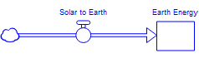

3) Select the flow tool again. This time, start inside the box and click and draw an arrow extending out of the box. Label this flow arrow Surface Heat to Space.

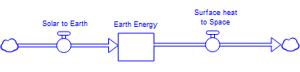

4) Now, we know from the equation above and the black body assumption that the energy given off by Earth is a function of the planet’s temperature and the Stefan-Boltzmann constant. Use the Converter tool (blue circle) to create two variables known as Temperature and Stefan Boltzmann.

5) Use the pink Connector arrow tool to connect these circles to the Surface Heat to Space flow.

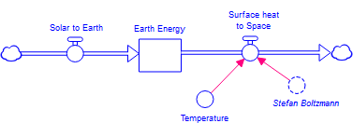

6) Earth’s temperature determines how much energy the planet radiates, but the temperature itself is a function of how much energy the planet contains in the first place. This means that we can use the pink Connector arrow to link from the Earth Energy stock to the Temperature converter.

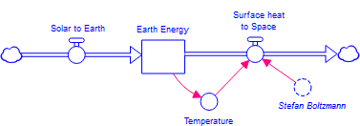

7) We are almost ready to run the model, but, as mentioned in the InTeGrate reading, we have a few housekeeping things we need to take care of first. We are using units of watts per square meter for the energy given off by the sun, but it would be more useful to us to think of the total energy being given off and absorbed in joules per year. One watt is one joule per second. We would like the Earth Energy reservoir to contain just joules. To do this, we need to make sure that the inflow and outflow arrows have units of joules per time so that when we run the model for a given time period, joules are added to and subtracted from the Earth Energy reservoir.

Let us look at the Surface Heat to Space outflow first. At present, we have the Stefan-Boltzmann constant and temperature feeding into the outflow. Since the S-B constant is in W/m²K⁴ and temperature is in K, we need something to deal with the m² if we are going to get the outflow into units of J/s. That something is the surface area of Earth, which is in m². Use the Converter tool to create a circle with a name of Earth Surface Area, and use the pink Connector arrow to link it to the Surface Heat to Space outflow.

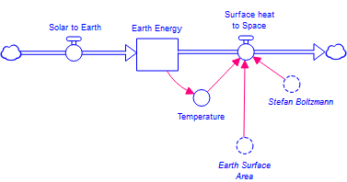

8) Double-click on the Surface Heat to Space outflow. This will bring up the Properties panel, in which you can now create the following expression: Earth_Surface_Area*Stefan_Boltzmann*Temperature^4.

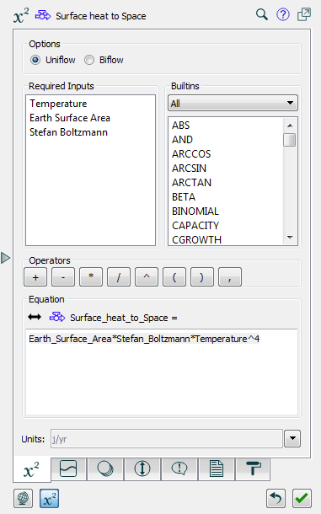

9) Earth’s surface area is a function of our planet’s radius, since surface area of a sphere equals 4πr². Create another converter to hold Earth’s radius, and link it to Earth Surface Area with a pink connector arrow. Double-click on the radius converter and put in 6,371,000, the value of Earth’s radius in m. Then, double-click on Earth_Surface_Area and enter the expression: 4*PI*(Earth_Radius^2).

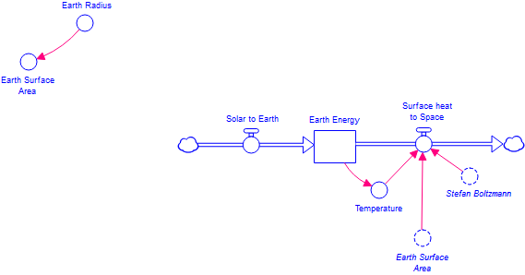

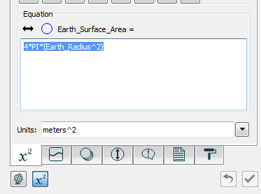

10) Earth’s temperature is measured in Kelvin, yet the Earth Energy stock is feeding the temperature converter and its holding joules. We need something to convert between these two measures, and that thing is the Heat Capacity of Earth in Joules/Kelvin. This is a measure of how many joules it takes to raise the temperature of a substance by 1 degree Kelvin. Create a converter called Heat Capacity and link it to the Temperature converter. Now double-click on the Temperature converter and enter the following expression: Earth_Energy/Heat_Capacity.

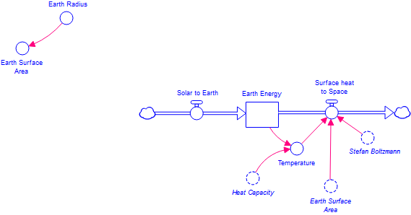

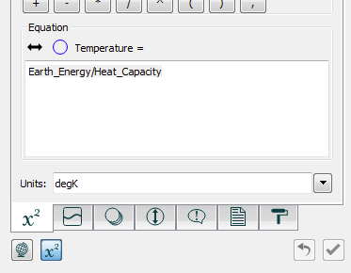

11) To determine the heat capacity of Earth, we are going to make a simplifying assumption, that being that Earth is covered in a layer of water 100 m deep (note, in the InTeGrate reading, 1 m was mentioned, but we are going to use 100 m). We will assume that all of the energy coming in from the sun is absorbed in this shallow ocean (100 m is actually pretty close to the thickness of the surface mixed layer of the oceans, and therefore a good approximation). Create three new converters called Water Depth, Water Density, and Specific Heat Water, and link these along with the Earth Surface Area converter to the Heat Capacity converter using pink connector arrows.

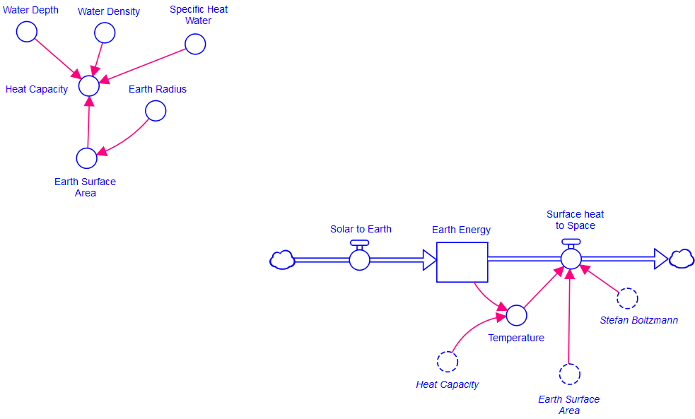

12) The specific heat of water is 4218 J/kgK. This means that it takes 4218 joules to warm one kilogram of water one degree Kelvin. Double-click on this converter and enter this value.

13) The density of water is 1000 kg/m³. Double-click on that converter and enter this value.

14) For water depth, enter a value of 100 m.

15) In the Heat Capacity converter, put in the following expression: Water_Depth*Earth_Surface_Area*Water_Density*Specific_Heat_Water.

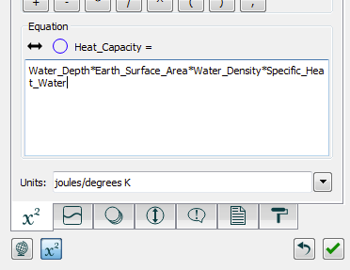

On a sheet of paper, write out all the units for the variables shown here and convince yourself that this expression reduces to Joules/Kelvin, which is what we need for the heat capacity term.

16) Now we will look at the inflow side of the model. At Earth’s distance from the sun, the amount of energy coming in is 1366 W/m², but in order to figure out how much energy actually hits Earth in joules, we need to multiply this by an area. The amount of energy hitting the Earth can be represented by the amount of energy contained in solar rays that would hit a flat disk with a radius of Earth’s. As such, we need to create another converter to hold Earth’s cross sectional area. Call it Earth Cross Section and use a pink connector arrow to link it to the Solar to Earth inflow arrow.

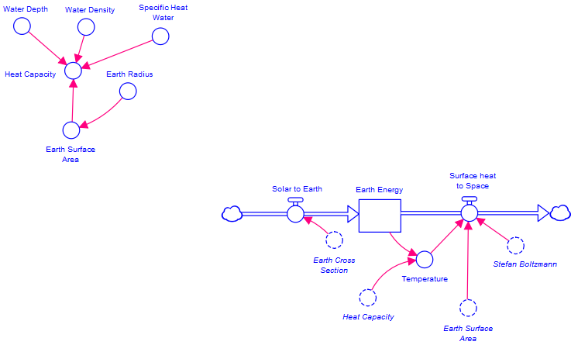

17) Now use a pink connector arrow to feed the radius of Earth into the Earth Cross Section converter. Double-click on the Earth Cross Section converter and enter the expression: PI*(Earth_Radius^2).

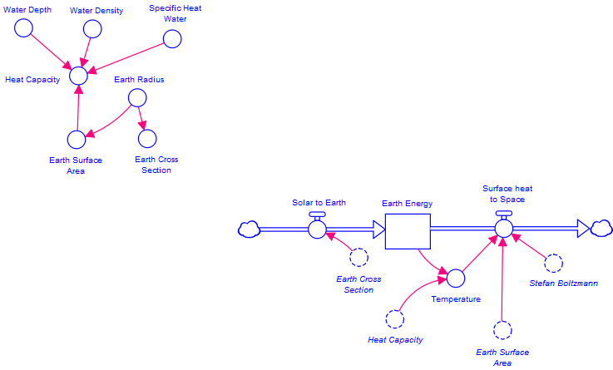

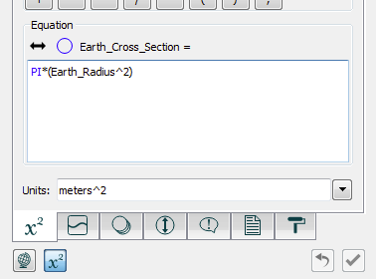

18) We have the area over which the sun’s rays are spread fed into the Solar to Earth inflow. Now we need to feed in the solar constant as well. Create a new converter called Solar Constant and link it to the Solar to Earth inflow. Double-click on the Solar to Earth inflow and enter the following expression: Solar_Constant*Earth_Cross_Section.

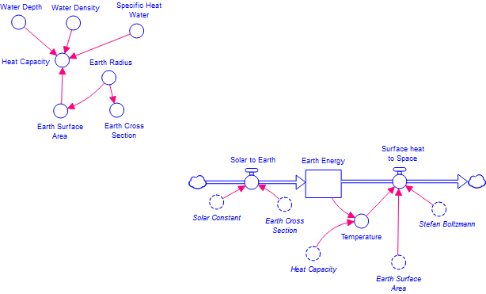

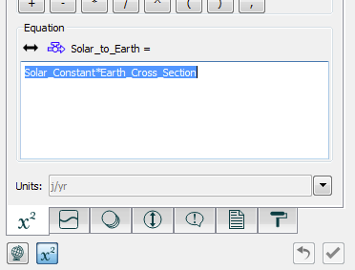

19) Our solar constant value is 1366 W/m², which is equivalent to 1366 J/sm². Let us run our model in years instead of seconds to make life easier. To do this, we simply need to multiply our solar constant value by the number of seconds contained in a year. Create a new converter called Seconds per Year and link it to the Solar Constant converter with a pink linking arrow. Double click on it and fill it with the correct value, then double-click on the Solar Constant converter and put in the appropriate expression to specify its value.

We need to do the same thing to the Stefan-Boltzmann constant – e.g. multiply by the number of seconds in a year to get it into J/yrm²K⁴.

Paste a copy of your model graphic in here before you go on.

20) We are finally ready to run our model! Click on the Graph icon in the tool bar at the top of the model page, then click anywhere on the page. Double-click on the Y-axis and tell STELLA you would like to graph Temperature.

Go to Model > Run Specs and tell STELLA you would like to run the model from 0 to 50 years with a DT of 1. Finally, go to Run > Run. Run the 1/2 DT test until you are convinced you have a good time step, then go on to answer the questions below.

21) Open up the graph of temperature and hold the mouse down while you scroll back and forth. What equilibrium temperature does Earth achieve, assuming it is a perfect black body? Paste a copy of your graph in here to accompany your answer.

How does this value compare to Earth’s actual average temperature of 15 degrees Celsius (note, 0 K = -273 C)?

22) Now add a little more complexity to your model (save it with a new name in case you want to go back to the black body model at some point). Using what you learned in your readings, incorporate the fact that Earth is not a perfect absorber of solar radiation, but instead reflects a sizable portion of the energy incident upon it. First, what do you predict will happen to Earth's surface temperature if you incorporate this reflectivity?

Next, paste a copy of your new model into your Word file so I can see what modifications you have made.

Run your model and paste a copy of your results in here. Was your prediction correct?

How does the new surface temperature compare to Earth's actual average surface temperature?

23) To this point we have neglected the fact that Earth has an atmosphere. From your Kump et al. reading you learned that Earth's atmosphere is transparent to most of the incoming radiation given off by the sun, which is in the visible part of the light spectrum, but that it is largely opaque to the infrared radiation emitted by Earth's surface. The re-radiation of energy absorbed by the atmosphere down to the surface causes Earth's surface to be warmer than it would be in the absence of an atmosphere, and is an important variable we cannot neglect.

Add a one-layer atmosphere to your model as described in Kump et al., p. 45 (save it with a new name in case you want to go back to the black body + albedo model at some point). Assume that all of the radiation given off by Earth's surface is absorbed by the atmosphere, but that none of the incoming solar radiation is absorbed. Assume also that the atmosphere radiates both to outer space and back down to Earth's surface. Some helpful values you will need to know are:

The density of air = 1.3 kg/m³
The specific heat of air is 750 J/kg-K
Thickness of the atmosphere is ~10 km

Let me take a look at your model when you are done to be sure you are on the right track.

Paste your Stella model into your Word document so I can see how you have changed your model.

Determine and report the resulting temperature of Earth's surface and of the atmosphere. How does the modeled surface temperature compare to Earth’s actual surface temperature now?

24) As you know from your readings, there are many oversimplifications in the layer model. Rather than address all of them individually, we can approximate their effects by introducing an emissivity term into our equations for how energy is absorbed and re-radiated by the atmosphere. Introduce emissivity into your model following the scheme in the InTeGrate reading accompanying this lab (see Fig. 3 there, and think about whether you need to modify your existing model by incorporating any additional flows). Save your model with a new name in case you want to go back to the one-layer atmosphere model at some point. Paste a copy of your modified model in here so that I can see what you did.

Experiment with ε until you determine what value you need to use to get a “reasonable” temperature for Earth’s surface (e.g. 288 K or 15 °C). Report the model’s surface and atmospheric temperatures, and paste a copy of your temperature graph in here.

25) Now let us explore the potential impact of the sunspot cycle on Earth's temperature. Using your model with the emissivity incorporated, allow the solar radiation reaching Earth's surface to change by +/- 1%, using a sine wave with a period of 11 years. First tell me what the equation is for this fluctuating radiation output.

Then incorporate it and describe the impact on Earth's surface and atmospheric temperatures. Include a graph of surface and atmosphere temperatures over time.

26) In the next experiment, we will add the four forcings discussed in the InTeGrate reading to see how our climate system would have responded to each over the past 1000 years. We will then compare the modeled temperature with the best estimates for what the temperature actually was over that time period to assess the relative importance of the different forcings. Solar variability, volcanic eruptions, and aerosols all change the amount of net incoming radiation, while the greenhouse gas forcing changes the fate of outgoing radiation. Given that this is true, how do we need to modify the STELLA model? Paste a copy of it in here so I can see how you have changed things and verbally explain what you did. Check with me that you have done this properly before you go on.

Once you have added the four forcings and a converter to hold the observed/reconstructed temperatures over the past 1000 years to your model, use the data from the forcing_data_spreadsheet.xlsx file found on Moodle to specify how these forcings and the observed temperature changed over time (note: the word observed here refers to reconstructed temperature based on a variety of proxies such as tree rings and coral growth bands. It is not meant to imply that human beings were measuring temperatures 1000 years ago, rather it is meant to distinguish the paleoclimatological record of temperature from the modeled temperature being calculated by STELLA).

To put the forcing data into the converters use the following steps: in the Properties panel for the converter where you want to add the forcing data, click the Graphical Function tab (the one with the wavy line) and then check on the “Graphical” check box at the top. Change the X-axis limits to 1000 and 1998 (or 1993, depending on which forcing you are working with) and tell STELLA that you want to use 999 (or 994, depending on which forcing you are working with) Data Points. Now, click on the “Points” tab. Make sure the data window is unlocked and then paste the column of data from the Excel spreadsheet into the right-hand column.

What do we need to do in order to ensure that the forcings we are adding have the same units as the original Solar to Earth flow?

27) Now that you have incorporated all of the forcings, try each separately (temporarily disabling the other three — the easiest way to do this is to multiply the forcing by 0), and verbally describe what each of them does to the model temperature and the degree to which the model temperature matches the reconstructed temperature. For each, include a graph of model surface temperature and observed/reconstructed temperature. Be sure to change the Model > Run Specs starting and ending time to reflect the calendar years in the forcings and also make any necessary adjustments to DT before you paste in your graph.

28) Now, use only the natural forcings (volcanoes + solar variability) and run the model, comparing the model temperature with the reconstructed temperature. Paste in a copy of your graph.

How well does this combination of forcings match the reconstructed temperature for the first 800 years?

How well does this combination match the reconstructed temperature for the last 200 years?

29) Now use only the anthropogenic forcings (greenhouse gases + aerosols) and run the model, comparing the model temperature with the reconstructed temperature. Paste in a copy of your graph.

How well does this combination of forcings match the reconstructed temperature for the first 800 years?

How well does this combination match the reconstructed temperature for the last 200 years?

30) Now turn on all of the forcings together and run the model. How well does the model represent reconstructed temperatures? Include a graph as part of your answer.

Can you make small changes to some aspect(s) of the model to get a slightly better fit? If so, describe what you changed, and why you thought it might improve the fit. Include a copy of your “best fit” graph of model and reconstructed temperatures.

31) What was the most challenging part of constructing the model itself? Describe one specific modeling strategy that you could use in a future lab to help minimize this challenge.

32) Were you surprised at the level of accuracy your model achieved? Why or why not?

Has this exercise changed your ideas about what questions can be addressed with relatively simple models? Why or why not?

33) Write a short (250 words or fewer) letter to your campus newspaper describing your model experiments and results and any relevant implications, for example regarding where/how your school sources its energy. Be sure to inform your readers about the strengths and limitations of your model.

