Population Modeling

Learning Goals
On completing this module, students are expected to be able to:
- Create models of population growth using STELLA.
- Differentiate between balancing (negative) and reinforcing (positive) feedbacks on population growth.
- Use a predator-prey model to explore trophic relationships and population dynamics.
- Explain how carrying capacity leads to a stabilization of population.
Experiment with an Easter Island population and resources model to explore the conditions that allow sustainable use of resources versus collapse of civilization.

Today we will explore various factors that control population growth using three different examples: 1) a predator-prey system consisting of lynx and hares adapted from a STELLA model created by isee systems (the makers of STELLA), 2) a model of a population that grows smoothly toward some carrying capacity (i.e., logistic growth), and 3) the possible collapse of the Rapanui civilization on Easter Island due to deforestation. In examining these cases, we will explore reinforcing and balancing feedback loops that lead to surprisingly complex patterns of population growth and decline in what seem to be simple systems. By the end of the exercise, you should have a good sense of why it is so difficult to determine whether global human society (far more complex than any of the modeled examples here) is headed for a catastrophic decline or whether we will achieve a level consistent with some carrying capacity.

All questions are in red. Please write their answers in here as you go along and use a font that makes it easy to find your answers.

Predator-prey cycles
Records of the Hudson’s Bay Company, fur traders in Canada from the mid-1800s to the mid-1900s, reveal a distinct periodicity in the numbers of Canada lynx and snowshoe hares (rabbits) trapped over time:

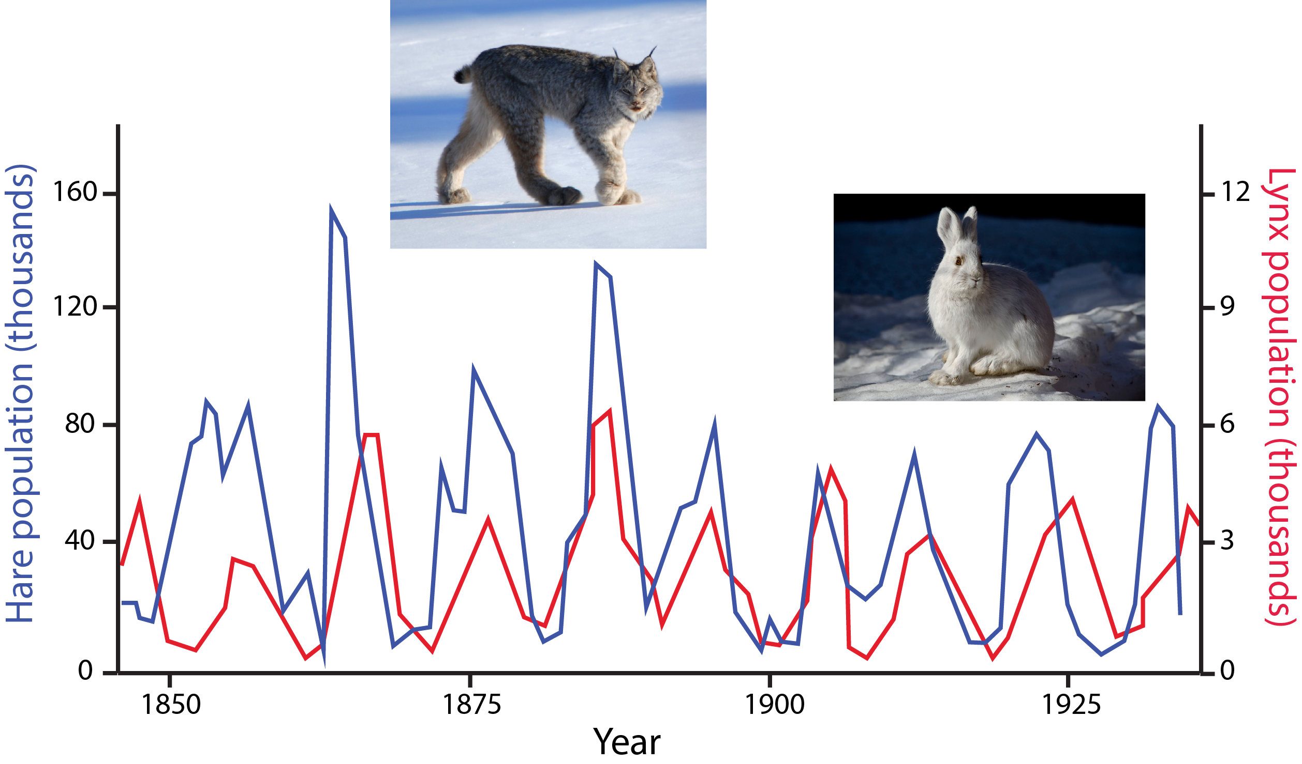

Furthermore, these records reveal that lynx and hare populations are slightly out of phase, with the lynx population rising after the hare population rises, and a rapid decline in the hare population thereafter. The behavior of this system is a classic example of a predator-prey cycle: As prey populations increase, predators increase, but as predators increase, prey decline, leading to a collapse in predators that allows prey populations to rebound.
This system can be described mathematically with a number of partial differential equations and can then be solved analytically for different times. Instead of doing that we are going to use the STELLA software package and let the computer do the heavy lifting. As you know from our first week of class, STELLA uses boxes to represent reservoirs of a particular item. These reservoirs could be water in a lake, phosphorus in soils, carbon dioxide in the atmosphere, or in our case, a population of hares.

1. Launch the STELLA software, and once it has opened, click on the Globe on the ribbon to switch from Map view to Model view:

2. Now click on the Stock icon (rectangle in the upper left corner of the window - ) and then click on the model page. Rename the Stock 1 text Hares by typing over the text. You should have something that looks like this when you are done:

The question mark in the yellow triangle means that we have not yet specified the initial population of hares. We will take care of that later.

3. For now, recall from last week that STELLA uses an arrow to represent flows into or out of a reservoir. We can create a simple model of how the hare population might change over time by connecting a flow arrow labeled hare births to the Hares reservoir.

Click on the flow arrow icon next to the stock icon in the upper left of the modeling page. Then, starting somewhere outside of the Hares reservoir, hold the mouse key down and drag the flow arrow into the Hares reservoir until the latter lights up. Rename the Flow 1 text hare births. When you are done, you should have something that looks like this:

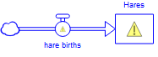

Note: if you have not succeeded in connecting the hare births flow to the Hares reservoir, you will see a cloud on both sides of your flow arrow:
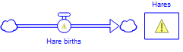
If this is the case, drag the cloud next to the arrow head into the reservoir until it turns blue; the flow should then be connected to the reservoir. If this does not work, simply click on the flow, hit the delete key, and try to draw the flow again.

In STELLA, the units associated with flows are given by taking the units of the reservoir to which they are attached and dividing by time. In our case, the births flow will be measured in units of hares/year. We will ensure that this is so later.

4. Now we know that rather than there being a fixed number of hares born every year, the births of hares depend on how many hares already exist in the population. You need at least one male and one female to reproduce, and the bigger the population, the larger the number of babies that will be produced in any given year. The number of hares born also depends on the fecundity of the population (i.e. the birth rate, or how many offspring are produced per breeding pair each year). To represent these dependencies, we add a birth rate converter and pink connector arrows to our STELLA model so that it looks like this:

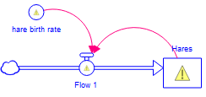

To do this, first click on the Converter circle icon in the modeling tools and then click somewhere on the modeling page. Rename the Converter 1 text hare birth rate.
5. Now click on the pink Connector arrow in the modeling tools. Place your cursor inside the Hares reservoir, hold the mouse key down and drag an arrow over to the hare births flow until you see the flow light up.

6. Click on the pink Connector arrow again, and this time, draw an arrow from the hare birth rate converter to the hare births flow.

If you mess up and accidentally get the polarity of the arrows wrong, just click on the circle at the originating end of the arrow (i.e., opposite the arrow head) until it becomes solid and then hit the delete key on your keyboard.

7. We are going to examine what happens to the population of hares over time in this simple model we have just created, but we still need to specify the initial conditions for the modeling run as well as the mathematics relating the hare births flow to the size of the hare population at any given time.

Double click on the Hares reservoir to set the initial population at one breeding pair (i.e., insert the value 2 into the window that pops up):

Now click on the green check mark in the lower right corner of the window.
Note that the question mark in the Hares reservoir box disappears, since we have now specified a starting value for the model run.

8. Now click on the hare birth rate and enter a value of 1.25. Again click on the green check mark and make sure the question mark on the hare birth rate converter disappears.

9. Click on the hare births flow arrow. The number of hares being born every year is the product of the number of hares that already exist and the birth rate. For this reason, we do not enter a fixed number into the equation box. Rather we put in the following equation: Hare births = hare birth rate * Hares. The figure on the next page shows what this should look like when you are done.

10. We are almost ready to run the model. Click on the graph icon on the menu bar, and then click anywhere on the model page. A graph will appear. Double click on the y-axis to open the Graph settings window. Under Series list, click on the green circle containing the plus sign and select the Hares reservoir to plot the hare population over time:

At this point we are ready to run the model. What do you predict the population of hares will look like over time? Will they increase, decrease, or stay the same? If you think the population will change, will the changes be linear or non-linear?

11. Let us find out if your predictions were correct. On the main menu, select Model and then Run Specs. Change the model run time from 0 to 12 to 0 to 50, and change the Unit of time to Years. Leave the DT as is for now. Click the green check mark in the lower right corner of the window.

Now click on the Run arrow in the lower left corner of the software window. Take a look at the graph at the end of the run. Then, carry out the 1/2 DT test discussed last week (e.g. open up the Run Specs again, and cut the DT in half, then re-run the model and compare the results to the first run) until you get a stable result in which the final values are no longer changing.

Paste a copy of your hare population graph in here for your final choice of DT. Describe the graph using terminology (e.g. exponential, logistic, etc.) from the reading.

What is the approximate population of hares after 50 years?

12. Note that they have reproduced like bunnies! The growth of the hare population contains a self-reinforcing feedback loop: the greater the population becomes, the more babies are born every year. Clearly this population is a bit out of control. What have we forgotten to include in our model?

Obviously we need to include the fact that the hares also die, which we could do by modifying our model to look like this:

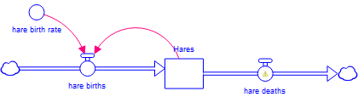

We can get more sophisticated than this, however. The numbers of hares dying each year is not a fixed value, but instead has a lot to do with the numbers of their primary predators, the lynx, so we can modify our model to include this dependency as follows:

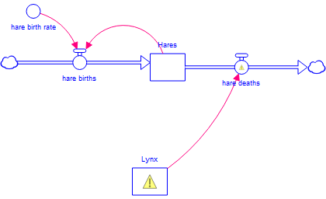

But the lynx population is not the only thing that matters. Rather, the rate at which hares can be trapped by lynx is important, and this factor itself depends on the density of hares (number per unit area) available to be trapped. If the density is low, lynx will have a hard time finding hares to feed on, whereas if the density is high, they will have plenty of food. Modify your model to include these additional components so that it looks like this:

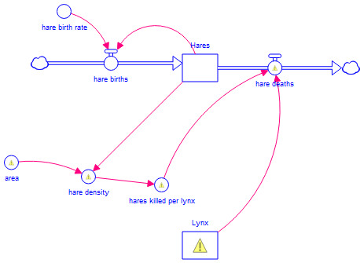
To become more sophisticated still, we want to include the life cycle of the lynx into the model. Just like rabbits, lynx also reproduce and die. Incorporate these elements into your model so that it looks like this:

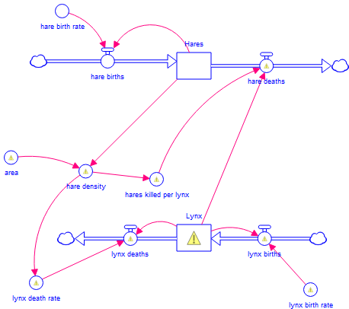

13. Note: we have drawn a pink Connector arrow from the hare density to the lynx death rate because the lower the density of hares, the more lynx starve to death, and the higher the density, the fatter and happier the lynx are. Let us fill in the remaining question marks so that we can run the model. Enter the following values by double clicking on each model element, putting in the value, and then clicking the green check mark:

Hares: change the initial population from 2 to 50,000
hare deaths: lynx * hares killed per lynx
hare density: hares/area
area: 1000 (hectares, where 1 hectare = 100 m x 100 m)
lynx: 750
lynx birth rate: 0.25
lynx births: lynx * lynx birth rate
lynx deaths: lynx * lynx death rate

14. The lynx death rate requires a bit more complicated treatment. We have already said that the death rate depends on the density of the hares, but it turns out this is not a linear relationship. Instead it is a sort of negative exponential, meaning that the death rate goes up dramatically as the density of hares decreases. To represent this nonlinear relationship we will create a graphical function of the lynx death rate based on the hare density. Click on the lynx death rate converter circle. In the window that opens up, select hare density as the value to which the lynx death rate is equivalent.

Once selected, click on the Graphical Function tab (just to the right of the x² along the bottom edge of the window). You should see something that looks like this:

Check on the Graphical check box and then set the axis limits on the hare density axis to be 0 and 100 and on the lynx death rate to be 0 and 1. Click on the Points tab and then on the padlock to unlock the data window. Enter the following data into the hare density and lynx death rate columns:

hare density | lynx death rate
0 | 0.94
10 | 0.66
20 | 0.40
30 | 0.35
40 | 0.30
50 | 0.25
60 | 0.20
70 | 0.15
80 | 0.10
90 | 0.07
100 | 0.05

What these values say is that 94% (0.94) of the lynx will die if there are no hares around, but only 5% (0.05) will die if the density is 100.

When you are done, your window should look like this:

15. We need to make a similar graph for the number of hares killed per lynx. We are going to assume that the higher the density of the hares, the higher the kill rate. Following the same kinds of steps you just used to enter data on lynx death rate as a function of hare density, modify your STELLA model to include a dependency of hares killed per lynx on hare density. See the figures on the next page for how to do this and what values to use.

16. Given the reading we have done about the lynx-hare predator-prey cycle, we are expecting the populations of both species to oscillate. Go to the STELLA help documentation and click on the Contents tab. Look for the "Choosing the appropriate algorithm and DT" section and read what it says:

Based on what you have read, should we be using the Euler or the Runge-Kutta 4 method?

Double click on the y-axis of the Graph you created earlier in order to add the population of lynx to the graph. Modify your Run Specs according to your decision of which integration method is appropriate, and then run the model with a variety of DTs until you are satisfied that you are no longer seeing any changes from run to run. What is the final value of DT you have decided upon and what integration method are you using?

17. Paste a copy of your lynx and hare populations versus time graph in here. Note, you will want to check on the Multiscale option under the Left Y-Axis selections in the Graph Settings window because otherwise you will not be able to view the oscillations in the lynx population:

What has happened to the self-reinforcing feedback loop that previously allowed the hare population to grow to astronomical levels?

What is the period of oscillation of the lynx population?

What is the period of oscillation of the hare population?

Does the timing of the peaks of the lynx population match, precede, or lag behind that of the hare population?

If the timing does not match, by how many years do the peaks differ?

How does the timing you simulate with the model compare to the actual timing recorded by the Hudson's Bay Company? Comment both on the periods of oscillation and on any leads or lags between the lynx and hare population curves.

How do the numbers of snowshoe hares and Canada lynx simulated by the model compare to the actual numbers recorded by the Hudson's Bay Company?

Can you think of any reasons why the lynx population may be underestimated by this model? Hint: You may want to consult the Internet about what Canada lynx eat.

18. Create a new graph of lynx death rate and hare density. Run the model again. Paste the graph in here and describe what you find. Does the behavior of these two parameters make sense? Why or why not?

19. Create one more graph of lynx as a function of hares. To do this, tell STELLA that you want to create a Scatter graph:

Then, with the X-Axis line highlighted, click on the green circle with the plus in it and choose hares for the X-axis.

Do the same thing to set the variable for the Y-axis to be lynx. When you are done, the Graph Settings page should look like this:

Paste a copy of your graph in here. Describe it verbally and comment on why it looks the way it does. You may want to go to the Model > Run Specs window and then change the Sim Speed to Slow to slow down the speed at which STELLA runs and draws its graphs so that you can see what is happening here.

20. Perform a couple of experiments to change birth rates of hares and lynx. Fill in the missing values in the table below. Note that two of the lines are identical.

hare birth rate | lynx birth rate | lynx max | lynx min | hares max | hares min
1 | 0.25
1.25 | 0.25
1.5 | 0.25
1.25 | 0.25
1.25 | 0.5
1.25 | 0.75

How does changing hare birth rates impact the system? Comment both on the amplitude of oscillations and on the sizes of populations.

How does changing lynx birth rates impact the system? Comment both on the amplitude of oscillations and on the sizes of populations.

21. Try one more experiment, with a hare birth rate of 0.75 and a lynx birth rate of 0.25. Paste your lynx and hare population curves as a function of time graph in here and describe the behavior of this system.

Create a graph of lynx and hare birth and death flows and run the model again if it does not automatically populate the graph with data. What has happened to the birth and death flows of the two populations? Does this make sense given the population values over time?

22. Finally, using the same birth rates as in part 21, drop the initial lynx population by 100. What happens? Paste your populations as a function of time graph in here as part of your answer.

23. Speculate on the implications of the two different system behaviors you have discovered (oscillation vs. steady state) for the rest of the ecosystem in which the lynx and hares are embedded. For example, think about what hares eat and how their browsing behavior might impact plant communities. How would this differ in a steady state case versus an oscillating case?

Logistic growth
Next we will experiment with a single population of animals or plants that is impacted by density dependent factors that lead to a carrying capacity for the population.

1. Open up a new STELLA window and create a population reservoir with flow arrows to represent births and deaths just as you did for the hares in the previous exercise.

2. Add a converter circle to represent the net population growth rate and link it to your birth and death flows. You should have something that looks like this when you are done:

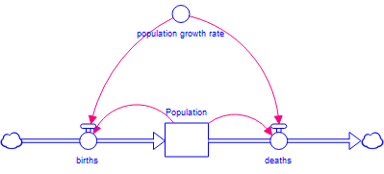

3. Looking back at your lynx-hare STELLA model, click on Model > Equation Viewer and examine the equations governing the hare population over time. You should see:

The first equation says that:
hares (t) = hares (t-dt) + (hare_births - hare_deaths)*dt

Let us rearrange this equation a little bit:
hares(t) - hares(t-dt) = (hare_births - hare_deaths)*dt

$\frac{hares(t) - hares(t-dt)}{dt}$= hare_births - hare_deaths

In the mathematical symbolism you were introduced to in the reading for this module, the left-hand side of this equation is $\frac{dN}{dt}$ because it is the change in the population (N) of hares over time, so:

$\frac{dN}{dt}$ = hare_births - hare_deaths

Now look at the inflows for the hares in the STELLA Equation Viewer and you will find that:

hare_births = hare_birth_rate*hares

If we call the hare_birth_rate b, then the hare_births = b*N, because N is the population of hares.

The outflows show that hare_deaths = hares_killed_per_lynx*lynx. We could have ignored the lynx entirely and created a model of just hares over time. Had we done so, then the hare deaths would have been equivalent to a hare death rate multiplied by the number of hares:

hare_deaths = hare_death_rate*hares.

If we were to call the hare_death_rate d, then the hare_deaths = d*N.

Since $\frac{dN}{dt}$= hare_births - hare_deaths, we would have:

$\frac{dN}{dt}$= b*N - d*N, or $\frac{dN}{dt}$= (b - d)*N

Defining λ (the net growth rate) to be equivalent to b - d gives us:

$\frac{dN}{dt}$= λN, which is the equation governing exponential growth.

The logistic growth equation says that:

$$\frac{dN}{dt}=λN*\left(\frac{K-N}{K}\right)$$

where N = population size, λ = net growth rate, and K = carrying capacity.

If we simplify this equation, we see that

$$\frac{dN}{dt}=λN*\left(1-\frac{N}{K}\right)$$

or

$$\frac{dN}{dt}=λN-λN*\frac{N}{K}$$

The λN part of the right hand side of the equation represents the new individuals who are born each year whereas the λN*(N/K) part of the equation represents the individuals who die each year.

What do we need to do to our new model to incorporate the carrying capacity?

4. Once you have decided, go ahead and modify your model accordingly. Use the following values for the model inputs:

population growth rate = 0.8
population = 2
carrying capacity = 1000

Run the model for 50 years.

Paste a graph of population vs. time in here and describe the behavior of this population.

5. What do you think will happen if you raise the population growth rate to 1 and why?

What if you were to drop the growth rate to 0.6?

Carry out these experiments and paste your graphs in here. Was your prediction correct? Why or why not?

Easter Island
The history of people and resources on Easter Island has been presented as a cautionary tale for societies that depend on finite resources. Perhaps the most famous of these accounts is that of Jared Diamond, who wrote of the island in his 2005 book Collapse: How Societies Choose to Fail or Succeed. The island is small (~160 km²) and very isolated, and was not colonized by people until at least 400 AD, when a small group arrived from Polynesia, to the west. When people first arrived, it appears that the island was almost completely covered by tall palm trees. The early settlers cut down the trees to clear space for agriculture, and they found the trees useful for firewood, for constructing boats and houses, and for transporting large stones they carved into the giant moai — the famous stone heads that dot the island.

It appears that the population grew from the original dozen or so settlers to perhaps 8,000–10,000 in the next thousand years, but by the 1700s, when the first European explorers landed there, the population was 2,000-3,000 and the island was devoid of palms. Many researchers believe that the depletion of the palm tree resource was a critical factor in the decline of the Easter Island population; some suggest that the introduction of European diseases and rats may have contributed to the collapse.

As our final exercise today, we are going to build and experiment with a model of the Easter Island system, following a scheme laid out by Bologna and Flores (2008).

1. We will start in much the same way as we did for the lynx and hare predator-prey model by creating reservoirs for the human population (N) and the area covered by palm trees (P).

We also need flow arrows that represent the births and deaths of the human population and flow arrows that represent the growth of trees and deforestation caused by humans.

Create these elements of your model and then paste what you have in here before you move on.

2. Now, the differential equation that describes the change in the human population over time is:

$$\frac{dN}{dt}=rN\left(1-\frac{N}{βP}\right)$$

where r is the net growth rate (1% or 0.01) per year, and β is a carrying capacity factor that is multiplied by the area covered by palms, P, to give the carrying capacity at any given time. You will recognize that this looks an awful lot like the logistic growth model we created in the last exercise. The difference is that we previously used the symbol K to represent the carrying capacity and gave it a fixed value. Here, since K = βP, and since P can change as the human population cuts down trees, the carrying capacity can change over time.

What are some physical reasons why the loss of the palms on the island might have led the human population to decline?

In determining β, Bologna and Flores (2008) recognized that the Easter Islanders had additional resources at their disposal besides palm trees (for example, they were able to fish in the ocean surrounding the island). Since the Bologna and Flores model only contains people and palms, however, these additional resources can be factored in by simply pretending that the island is larger than it actually is. Bologna and Flores suggest an area about three times larger, or 480 km². At its peak, they note that the population may have measured as many as 20,000 people. Combining these terms gives $β=\frac{20,000 people}{480 km^2}$.

On a sheet of notebook paper, do a dimensional analysis to show that the units on the left-hand side of the human population equation are equivalent to those on the right-hand side. Be sure to include all of the units for all of the variables in the equation.

Adjust the human population part of your Easter Island model to include the equations for the birth and death flows, making sure to create a converter circle to hold the β value and linking both it and the palm reservoir to the death flow. Consult the logistic growth model you made in the previous exercise if you find yourself getting stuck.

3. According to Bologna and Flores (2008), the equation governing the change in the area covered by palms (P) over time is:

$$\frac{dP}{dt}=r^{'}P\left(1-\frac{P}{P_{0}}\right)-αNP$$

Here, r’ is the growth rate for the palms (0.001 or .1%) per year, P₀ is the initial area (480 km²), and α is something called the degradation factor, which is a measure of the ability of people to degrade their environment (a higher value = more destruction per person), and is set by Bologna and Flores to be 2e-6.

Let us look at the right-hand side of this equation carefully. If we were to distribute the r'P to the two terms in the parentheses, we would find that:

$$\frac{dP}{dt}=r^{'}P-\left(r'P*\frac{P}{P_{0}}\right)-αNP$$

Just as we saw in the logistic growth exercise, the first part of the equation (r'P) represents the new growth every year, so this equation needs to be incorporated into the growth flow arrow feeding the palms reservoir.

The middle term on the right-hand side of the equation looks just like the death flow in the logistic growth equation, but rather than using a value called K for the carrying capacity, we instead use the value P. Remember that the island was originally completely forested, so by definition, the area of the island is the carrying capacity for the trees.

The last term in the equation above is something we have not used before and represents the amount of deforestation occurring.

Carry out a dimensional analysis on a sheet of notebook paper to figure out what the units of α must be.

The flow arrow representing the loss of palm trees must include both the natural death of trees associated with the carrying capacity of the island and the deforestation caused by humans. Incorporate the appropriate converter circles and connector arrows to finish out the model. As you think about the equations, pay particular attention to the signs of the values in the flow governing the loss of trees. Paste a copy of your completed model graphic in here.

4. Let us fill in any missing values we might still have. Set the:
initial human population = 2
initial palm tree coverage = 480 km²

Before moving on, you might want to let me take a look at your model to ensure you have all the correct elements.

Before you run the model, make a prediction about what the human population and the palm area are going to look like over time. Write that prediction here:

Set the run time to go from 400 to 1800 years, with a time step of 1 year, using Runge-Kutta 4 as the integration method.

5. Run the model and see what happens. Paste a copy of your graph showing the human population and the palm area in here (use the Multiscale option for your graph). Describe it verbally and discuss how it compares to what you predicted.

How well does this behavior fit the classical model of what really happened on Easter Island?

6. Do you think that the kind of overshoot and collapse seen in this first version of our Easter Island model is inevitable?

Carry out some experiments to try to find a set of parameters that leads to the greatest sustainable population with the minimum overshoot and collapse. You could start this search by doing some sensitivity runs in which you change each of the free variables (e.g. the growth rates for people and palms, the carrying capacity factor, and the degradation factor) and see how the human and palm populations respond. Suppose, for example, that you wanted to experiment with the rate of growth of the palm trees. One way to do this would be to manually change the value of the palm growth rate a little bit at a time and to then graph the palm and human populations over time. This would be a bit tedious, however, so STELLA allows us to create a set of model runs that it can carry out and will plot the results side by side on a graph to facilitate easy comparison of results.

To access this feature, with the Edit Mode () selected from the main tool bar, double click in the white space on the model page anywhere you like. The Model Settings window opens up. Click on the Sensitivity Analysis Setup tab:

Click on the green circle with the plus in it and select one of the variables you would like to run a sensitivity analysis on. In the example below, we will use palm growth rate.

Next, set the Specific number of runs to something like 5, choose starting and ending values for your experiments, and click on Incremental in the Distribution drop down menu. Your window should look something like this when you are done:

Click on the green check mark. The word S-Run has appeared next to the Run arrow in the lower left part of the software window:

If you click on this option, STELLA will run your Easter Island model 5 times in a row. The software will not automatically show all 5 runs on your graph, however, so there is something we still need to do. First, when doing an S-Run, we can only plot one variable at a time on a graph, so you should make two new graphs, one to hold the palm population and the other to hold the human population. As you are creating these, check on the Comparative check box in the Graph Settings window. This will allow the results of all of the runs to be displayed on the same graph:

In carrying out the various experiments, let us say that the palm growth rate cannot exceed 5%, the carrying capacity factor cannot exceed 80 people per square km (about twice its original value since 20,000 people/480 km² ~ 40 people/km²), and the degradation factor can range from half to twice its original value. You might have to extend the run time in some cases to see the system stabilize.

Paste in graphs of the palm tree and human populations for your different sensitivity experiments here. Be sure to explain what each experiment is showing (e.g., variation in palm growth rate) and to give the range of values you explored (e.g., Run 1 = 0.001, Run 5 = 0.05).

Once you have carried out your different sensitivity experiments, combine your results to create a best-case scenario (Note, this will not be an S-Run since you will be using only one value for each variable, so you will need to check off the comparative check box in the Graph Settings window for each graph and also get rid of the last parameter you tested in the Sensitivity Parameters window of the Sensitivity Analysis Setup panel). Paste your resulting graph of human population and palm area in here and write down the values of the four parameters you experimented with.

Comment on what would be necessary to achieve these values — are they reasonable, achievable, or do they require a miracle?

7. What factors discussed in your reading do not appear in this model? How might you incorporate these additional factors if you wanted to? Make a sketch on a sheet of notebook paper of any additional reservoirs and flows you might use and think about any equations you might need.

Final synthesis
Imagine that your congressional representative must decide how to vote on a bill that would provide U.S. taxpayer funding for family planning services in the United States and abroad. Given what you have learned about population growth today, write a short letter (maximum 1 page) to your representative in which you urge that person to vote in a particular way. The more detailed your letter is regarding the concepts we have covered, the better.

