A Simple Global Carbon Cycle

On completing this module, students are expected to be able to:
- Explain the different components and processes of the marine and terrestrial carbon cycle.
- Explain how the carbonate chemistry of sea water dictates how much CO₂ can be absorbed by the oceans, and how it determines the pH.
- Explain variations in atmospheric CO₂ as a consequence of carbon cycle processes.
- Evaluate the residence times within the carbon cycle and explain what these mean in terms of the behavior of the system.
- Apply systems thinking concepts to develop hypotheses about how the carbon cycle will respond to a range of changes.
- Explain how human activities affect the carbon cycle.
- Evaluate the model's performance by comparing calculations with the actual historical record.
- Use a model to predict how the amount and rate of future carbon emissions will impact the climate and the chemistry of the oceans.
We will begin with a very simple version of the carbon cycle, and then move on to a much more realistic and complicated version. We will make a steady-state version of this model with mathematical descriptions of the flows that are designed to maintain a steady state. We will do a few experiments with this model to help us see how the system responds to the anthropogenic carbon emissions due to the burning of fossil fuels.

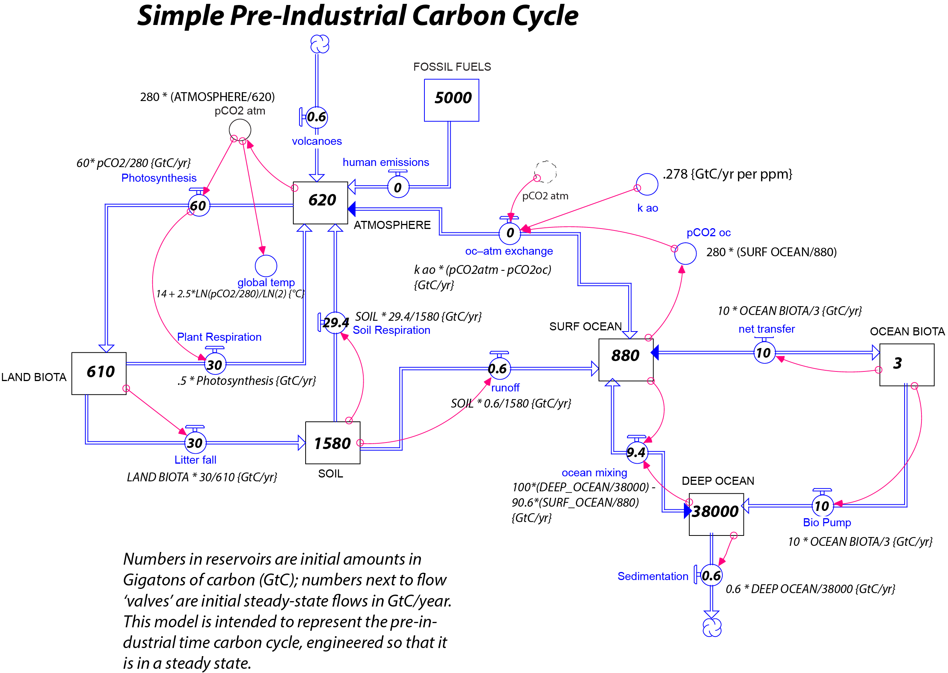

Figure 1. STELLA model of the simple pre-industrial carbon cycle, designed to be in a steady state. The numbers written inside the boxes are the initial values of the reservoirs, and the numbers inside the circles on the flows are the steady state flow values (Gt C/yr) that result from the equations written below. Credit: David Bice

When making this model, be sure to get the arrows going the right way (this is a common error that will make the system not be in a steady state). The dashed converter pCO2 atm, above the oc-atm exchange flow is a “ghosted” version of the pCO2 atm converter that is defined in the upper left corner — ghosts are just replicas of the original that help you avoid too many connecting arrows running all over the place. To make these, use the little ghost icon located on the right of the tool bar in the STELLA modeling window.

We will later modify many of these flows to better represent the actual processes of carbon transfer. This model is designed to produce a steady state — notice the flow values in and out of each reservoir sum to zero. Also, take note of how many of the flows are defined:
$$F=W(t)×\frac{F_{ss}}{W_{init}}$$

where F is the Flow value at any time, W(t) is the amount in the reservoir being drained at time t, F_{ss} is the steady state flow, and W_{init} is the initial value of the reservoir. This is a simple way to define a flow such that its value will be linearly dependent on the amount in the reservoir and will be at the steady state value when the reservoir value is the same as the initial value. The fraction in the equation above (e.g. F_{ss}/W_{init}) has units of time⁻¹ and is sometimes called a time constant; the inverse of this fraction is known as the residence time of the reservoir (assuming this is the only outflow).

1. Run the model with a time step of 0.1 for 100 years using the Runge-Kutta 4 integration method, and graph the reservoirs to make sure it is in a steady state. If it is not in a steady state, check your arrowheads on the flows and try to find which reservoir is changing first — that can often lead you to discover the problem. Once it is in a steady state, you are ready to proceed.

2. First, determine the residence times of the reservoirs, entering them in the table below. Exclude biflows as you do this.

Reservoir | Initial Value | Outflow(s) | Residence Time
Atmosphere
Land Biota
Soil
Surface Ocean
Marine Biota
Deep Ocean

3. Now we will make the human emissions be a constant value of 2 (Gt C/yr).
a) Make a prediction about what will happen. Will all of the reservoirs change? Will they all increase? Will some increase more or sooner than others? Think about how the pCO₂ of the atmosphere will change. Will it rise steadily? Will it level off at a new steady state?

b) Run the model for 500 years and see what happens — comment on the differences between your predictions and what actually happens. Paste graphs of your reservoirs and of pCO2 atm in as part of your answer.

4. Now change the human emissions flow, making it equal to TIME, and then make it a graphical function (of time). Set this up so that it is 0 for the first 20 years and then jumps to 8 (Gt C/yr) for the next 20 years and then return it to 0 — this will create a pulse of fossil fuel burning. Here is what your graph should look like:

a) First make a prediction about what will happen when the pulse ends — will the system return to steady state?

b) Now run the model for 100 years and study the response to the pulse. Does it get back to a steady state? Do some parts (reservoirs) get closer than others? What role does residence time appear to play in the response of different reservoirs to the pulse? Include graphs as part of your answer.

c) Try running the model for 5000 years now (and change the time step to 0.2) and see if it gets back into a steady state. If not, explain why, paying attention again to the residence times of the different reservoirs. Include graphs in your answer.

Carbon Cycle Experiments, Part 2

In this exercise, we will carry out a series of experiments using a modified version of the carbon cycle model we experimented with in part 1. Download and launch the complex_carbon_cycle_model.stmx file from the SERC website. This version includes the carbonate chemistry, which enables us to calculate the pCO₂ and the pH of the surface ocean. The model also includes a more realistic function for photosynthesis, as well as temperature sensitivities for photosynthesis and soil decay/respiration. Furthermore, it includes the history of fossil fuel emissions from 1880 to 2010, the history of carbon releases related to land use changes over the same time period, and the historical record of atmospheric pCO₂, so that we have something to compare our model with. This model has bypassed the marine biota reservoir of carbon, and has the biological pump going straight from the surface to the deep ocean. This model also includes a system that exchanges alkalinity between the surface and deep ocean reservoirs.

The starting point of the model is 1880, and the model is designed so that it is very close to a steady state if there are no anthropogenic (related to human activities) changes. In reality, this system is complex enough that it is hard to get it into a perfect steady state.

The experiments:

1. Comparison with observed CO₂
First, let us evaluate how well the model works by comparing its atmospheric CO₂ with the observed atmospheric CO₂ for the period from 1880 to 2010. Go to Run Specs and make sure the time goes from 1880 to 2010 with a time step of 0.01, using the Runge-Kutta 4 method. Make sure the ffb (fossil fuel burning) and land use switches (ffb_switch is to the left of the FOSSIL FUELS reservoir; land_use_switch is below the LAND BIOTA reservoir) and are on by setting them to equal 1.

Be sure that the Khs (half saturation value) is set to 60.4, the Tsens_p (sensitivity of photosynthesis to temperature) is set to 0.19 and the Tsens_sr (sensitivity of soil respiration to temperature) is set to 0.09. As mentioned in the reading, some of these parameters are not precisely known, and the idea is to select values that give the best match to the observed atmospheric pCO₂ over the historical record. This is what is known as “tuning” the model. The thinking is that if the model is “tuned” nicely, then we can trust the model’s output for the future under different emissions scenarios.

The initial surface ocean alkalinity (called init surf alk in the model and above the Alk Surf reservoir) should be 2194.36, and the initial deep ocean alkalinity (called init deep alk in the model and below the Alk Deep reservoir) should be 2302.00.

a) Make a graph to hold the Observed Atm CO2 and pCO2 atm (modeled) values. Run the model. Briefly comment on the comparison between the model result and the observed CO₂ history. Is the model well-tuned? Include a graph as part of your answer.

b) What is the total amount of carbon added to the atmosphere during this time period from the combined anthropogenic sources (look at the total anthro change reservoir value at the end of the run, which is a measure of how much carbon has been liberated by fossil fuel burning and land use changes)?

How much of the “new” carbon comes from fossil fuels (look at the ffb total reservoir value at the end of the run)?

c) What is the airborne fraction (see converter attached to the total anthro change reservoir) during the last few decades of this time period (this is a measure of how much of the carbon remains in the atmosphere as opposed to being taken up by the biosphere, diffusion in the ocean, etc.)?

Recent studies suggest that in the real world, this value is 0.4 to 0.45. What does our value suggest about how well-tuned the model is?

2. The Big Burn
In this experiment, we will investigate what happens if we burn all of the fossil fuel carbon on Earth (5000 Gt) at different rates — 3 Gt/yr, 6 Gt/yr, and 12 Gt/yr. The easiest way to do this is to turn off the land use change switch (e.g., make its value 0) and then add the different rates to the human emissions flow (ffb switch needs to be off also so that the model does not use the anthropogenic history of ffb and instead uses a fixed rate), one at a time. Before you do this, make separate plots to hold the pCO₂ of the atmosphere (pCO2 atm), pCO₂ of the surface ocean (pCO2 oc), alkalinity of the surface ocean (Alk S), dissolved inorganic carbon in the surface ocean (DIC S), bicarbonate ion concentration (HCO3), carbonate ion concentration (CO3), pH of the ocean (pH), and the Fossil Fuels reservoir. In making each of these plots, tell STELLA that you want to use the Comparative graph type. This will allow you to run all three scenarios, one at a time, and have the results show up on the same graph. Note: you will want to go to the Model > Data Manager window and make sure that the Remember data from the last xx runs has at least 3 listed. Otherwise your comparative graph may not display all of your runs. Run the model from 1880 to 5000 years with a time step of 0.1 yrs.

How does the rate of burning affect the pCO2 atm and ocean pH? Include your graphs in your answer and comment both on the maximum/minimum values achieved by each scenario and how the scenarios compare at the end of the model run. Are the values of pCO2 atm and ocean pH at the end of each run the same or different? Why do you think this might be?

Why does the pH drop to lower values when the burning rate is high than when it is low? To answer this question, carefully examine your graphs of HCO3, CO3, DIC S, and Alk S and look at the equations in the carbonate chemistry section of the InTeGrate reading. Pay particular attention to the y-axis values on the plots and to equations 3, 8, and 10. Use your graphs in your answer.

What is the approximate short-term response time of the system for the 12 GtC/yr scenario, as indicated by the decline in pCO₂ of the atmosphere after all the fossil fuels have been used up? Remember that this system has an overall very long response time, but it also has what might be called a short-term partial response time.

3. Relative importance of fossil fuel emissions vs. land use changes
Remove the extra carbon (12 Gt/yr) from the human emissions flow and now use the historical record (1880 to 2010) to figure out the relative effects of the fossil fuel burning and land use perturbations to the carbon cycle. You can do this by disabling one perturbation, running the model, and then disabling the other one (e.g., turn the switches for fossil fuel burning and land use changes on and off). Make sure to change your run length back to 1880 to 2010 years. Report the effects in the table below and then comment on which of these factors is the more important perturbation of the carbon cycle. To determine the Change in Gt C, determine the starting and ending values of each parameter and then take the difference between them.

Reservoir | Change in Gt C at t = 2010 | Change in Gt C at t = 2010
 | Fossil fuel burning only | Land use changes only
Atmosphere
Land biota
Soil
Surface Ocean
Deep Ocean
Atm pCO2
Global T
change

4. Implications of IPCC scenarios
Now we will use three Intergovernmental Panel on Climate Change (IPCC) emissions scenarios and find out what they imply in terms of atmospheric CO₂ levels, global temperature change, and economic costs. These scenarios were devised in order to allow policy makers to see what the impacts might be of different human choices regarding fossil fuel use and other activities that alter greenhouse gas levels. The ones we will use are for fossil fuel burning and cement production only; the changes related to land use are not specified, so let us hold them steady at the year 2010 level (you do not need to make any changes to the land use converter — the program will just apply the 2010 value for the rest of our model run, which will continue into the year 2100 — but make sure the land use switch is turned on).

[Note: the scenarios used here are now a bit out of date; ICPP has released some newer versions called the RCP scenarios. If you want to update this exercise, you could alter the scenarios included in this model to reflect the newer versions, which are shown at the end of this document.]

The economic costs of different IPCC scenarios are calculated following a scheme in the Dynamic Integrated Climate-Economy (DICE) model developed by Nordhaus (1993), and they occur in two forms — abatement costs (costs borne by businesses required to reduce greenhouse gas emissions) and climate damage costs (e.g. costs associated with crop failures, storms, flooding from sea level rise, etc.). Both of these costs are calculated as a fraction of the gross output of the global economy, which in our model just grows exponentially at a rate of 1.5% per year. The abatement costs are based on the difference between the A2 scenario (the business as usual, do-nothing to curb human population growth or to stop fossil fuel burning scenario; see figure below) and the others (A1B — population maxing out at 9 billion in 2050 and a mix of green and fossil fuel technologies, and B2 — population maxing out at 9 billion in 2050 and transition to green technologies). The greater the difference, the greater the costs of making the emissions reductions. These differences are expressed in the form of a fraction that is called the emissions control rate (ECR), which is then used to calculate the abatement costs. The climate damages are related to the global temperature change through an exponential equation. The costs are calculated just from 2010 to 2100.

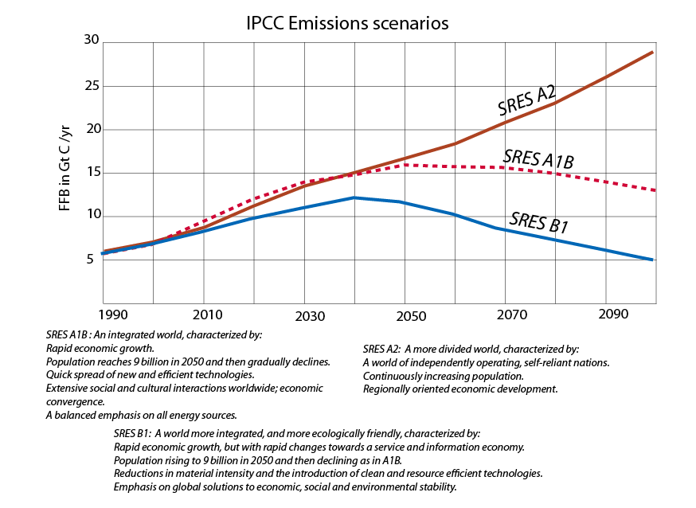

The IPCC emissions scenarios are attached to the historical record of carbon emissions beginning in 1880 and ending in 2010, and then project to the year 2100, based on the different simulations of fossil fuel burning and cement production. To do this in our model, you will have to replace the ffb converter we have been using with the ones labeled ffb A2, ffb A1B, and ffb B1, which approximate the scenarios seen in the graph above. Simply detach the connecting arrow from the ffb converter to the human emissions flow (this will result in a question mark in the human emissions flow), put a new connector arrow from the scenario of choice to the human emissions flow, and then redefine the human emissions flow equation to reflect this new connection (this will make the question mark go away). Make sure the ffb switch is turned on (1). You will also have to attach the appropriate ECR to the abatement fraction of the model (see below) by deleting one connector and making a new one. This is done on the far right of the model, where the costs are calculated.
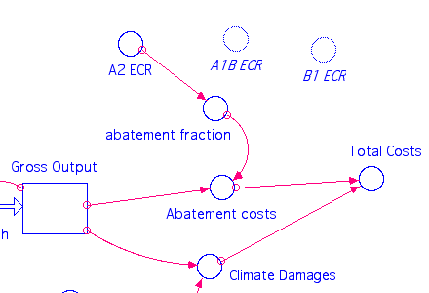

Redefine the abatement fraction as needed to get rid of the question mark as you switch from one scenario to the next.

To summarize, you will run through 3 scenarios here (A2, A1B, and B1) by connecting the appropriate ffb converter to the human emissions flow and the appropriate ECR converter to the abatement fraction. For each run, make sure the Run Specs are set so that the model goes to 2100.

Complete the table below and then comment on which scenario is favorable from an economic standpoint as well as an environmental standpoint.

Year 2100:

IPCC Scenario | Atm pCO₂ (ppmv) | Global T change (°C) | Ocean pH | Abatement Costs (Trillions of $) | Climate Damages (Trillions of $) | Total Costs (Trillions of $)
SRES A2
SRES A1B
SRES B1

What do these changes in pH mean in terms of the actual acidity of the ocean at the end of each scenario (defined as the concentration of H⁺ in terms of moles/liter)? What do you think the impacts of these changes in acidity might be on marine organisms that secrete calcium carbonate skeletons?

Write a short (250 words or fewer) email to your fiscally conservative congressperson about your results and the implications of your results for government spending on climate issues.

5. Permafrost
We discussed permafrost in the InTeGrate reading; now let us try to implement its release of carbon into our model with the SRES A2 emissions scenario. The size of the reservoir is estimated to be about 1200 Gt, about 400 Gt of which is thought to be in a form that could be released very quickly, and it is this quick-release carbon that we’ll incorporate into our model — so your permafrost reservoir should have an initial value of 400. The release of this carbon is surely temperature dependent, and there is also a threshold temperature that must be surpassed before this carbon begins to flow into the atmosphere. We will set up this flow just like the soil respiration flow:

$$F_{perm}=Permafrost×\left(\frac{.05}{400}\right)×\left(1+{\left(∆T-T_{th}\right)×Tsens}_{prm}\right)$$

Here, ΔT is the change in global temperature associated with the increasing greenhouse gas levels in the atmosphere (global temp change), T_{th} is the threshold temperature, and Tsens_{prm} is the temperature sensitivity. The threshold temperature is not exactly known, but we do know that the historical warming of about 1°C appears to have triggered permafrost melting, so we will use 1°C as our threshold temperature. In this case, the temperature sensitivity is likely to be very large — about 40. What this means is that if we increase the temperature another degree so that ΔT=2, the value of the flow (assuming the permafrost reservoir = 400 Gt C) would be about 2 Gt C/yr. We need to implement the flow with an IF THEN ELSE statement so that it is 0 below the threshold temperature and calculated via the equation above if the temperature surpasses the threshold:

IF ΔT> T_{th} THEN {insert above equation} ELSE 0

Once you have added this reservoir and flow to the model along with the necessary converters, run it and find out how much of an impact permafrost thawing has on the global temperature change. Make sure you have connected the ffb_A2 converter to the human emissions flow when you do this.

ΔT at 2100 with no permafrost =
ΔT at 2100 with permafrost =

Make a graph of the global temperature change, permafrost flow, and permafrost reservoir over time. How big is the permafrost flow at the end of the model run (in 2100)? Describe and explain why the different curves look the way they do.

6. Geoengineering the Carbon Cycle
One “fix” that has been discussed for our changing climate is to enhance the biological pump in the carbon cycle by adding iron dust to the Southern Ocean (ocean around Antarctica), where a paucity of this minor nutrient appears to limit biological productivity. Take a copy of the original complex carbon cycle model (download from Moodle again if needed), apply the high emissions scenario (A2), and then try changing the biological pump flow (Bio_Pump) beginning in the year 2020. Increase the pump by a fixed amount and hold that change until the year 2100. You can use an IF THEN ELSE statement to make the pump increase after the year 2020 (e.g., IF TIME>2020 THEN 15 ELSE 10). You can make a comparative plot to show pCO2_atm under different scenarios of the increased Bio Pump (remember to visit Model > Data Manager to increase the number of runs remembered by the software if necessary).

How big of a change in the pump is needed to bring atmospheric pCO₂ down to the year 2000 value? Does it stay at that level? If not, explain what is going on. Include a plot of your results here and be sure to explain what the values for the Bio Pump are for each model run (e.g. run 1 = 20 Gt C/yr).

Explain how changing the pump affects the atmospheric pCO₂. Be specific in your answer, discussing which reservoirs and flows are involved and why. Be sure to include supporting graphs.

