Name____________________________________________________ Date______________
OCEA10: introduction to oceanography

Reflecting on what is happening to Greenland’s ice
Scientists use a variety of methods to investigate ice sheet changes. In this exercise, you will look at graph and map data to think about how, if at all, the Greenland ice sheet seems to be changing.

Data set #1: Reflectivity graphs
Albedo is the measure of a surface’s reflectivity. An example of a material with a high albedo (high reflectivity) is fresh snow, whose albedo is approximately 0.84. In other words, fresh snow reflects approximately 84% of the incoming sunlight that strikes it. In contrast, glacial ice that is not covered with snow exhibits an albedo range of 0.2 to 0.6 (20%-60%).
Satellite observations of Greenland’s albedo are available from March 2000 to the present. Before you look at the data, let’s make some predictions about how albedo varies annually.

(1) On the grid below, please complete the following:
- Label your axes with:
  - months of the year (starting with January) on the X-axis
  - albedo (no numbers necessary—just “low albedo” and “high albedo”) on the Y-axis
- Think about what we just discussed and what you prepared for today. Based on this knowledge, sketch on your graph what you would expect a yearly albedo curve for Greenland to look like.

Above: Sketch illustrating the expected, annual albedo variation for Greenland.

(2) Once you have completed your graph, compare your graph to the ones created by the other people at your table. Discuss any discrepancies that you see, and make sure that everyone in the group agrees on the general shape before you move on.

(3) Next, each pair will be provided with some real albedo data from Greenland with time on the X-axis and albedo on the Y-axis. Your graph will either say A or B because albedo measurements were made at different elevations on the ice sheet. Study your graph with your partner and answer the following questions:
(a) Do you have graph A or B? Referring to the title of your graph, at which elevation range were your data obtained?

(b) What do the different colors on the graph represent?
(c) Why does the black curve abruptly end?

(d) Referring to the Y-axis of your graph, what albedo range is illustrated on your graph?

(e) How does the general shape of your data correspond to the predicted graph that you sketched in question 1?

(f) In general, which month of the year has the highest albedo?

(g) In general, which month of the year has the lowest albedo?

(h) Between April 1 and July 1, which year exhibited the lowest albedo?
When during the year did it occur? What was the approximate albedo?

(i) Between April 1 and July 1, which year exhibited the next lowest
albedo? When during the year did it occur? What was the approximate
albedo?
(j) Describe how the 2012 albedo compares to the 2000-2011 albedo for the
following time periods:

April 1-May 1:

May 1-June 1:

June 1-July 1:

(4) Next, you and your partner will compare your albedo graph with another pair’s graph. If you have graph A, meet up with someone with graph B. If you have graph B, meet up with someone with graph A. First, make sure that everyone is clear on the following questions that you already answered on your own:
(a) What do the different colors on the graph represent?

(b) Why does the black curve abruptly end?

(5) Complete the tables below, based on everyone’s data. In table 2, be as descriptive as possible.
Table 1: Lowest albedo, April 1-July 1
Elevation (m) | Year with lowest albedo | Approximate date within that year | Approximate  albedo (%)
1000-1500
2000-2500

Table 2: How do the 2012 albedo data compare to the 2000-2011 albedo data?
Elevation (m) | April 1-May 1 | May 1-June 1 | June 1-July 1
1000-1500
2000-2500

(6) Use the group data to answer the following questions:
(a) Based on the overall data, do the higher OR lower elevation areas in
Greenland have the greatest albedo? Offer an explanation for WHY.

(b) Which areas—high elevation OR low elevation—experienced the greatest change in albedo in 2012 compared to 2000-2011? Briefly describe HOW the albedo changed in 2012.

(7) Briefly summarize what the albedo graphs suggest could be happening to the Greenland ice sheet.

Data set #2: Reflectivity anomaly maps
Next, you will look at a Greenland reflectivity anomaly map. You already know about anomalies from yesterday’s class meeting—simply, an anomaly refers to a change from “normal”. To obtain a reflectivity anomaly, the long-term average reflectivity is subtracted from the current reflectivity. In other words:
reflectivity anomaly = current reflectivity – long-term average reflectivity

The map illustrates the reflectivity anomaly in Greenland in 2012 vs. 2000-2011. In this map, the June 2012 reflectivity is being compared with the average June reflectivity from 2000-2011. The measurements on the map are unitless but can be converted to albedo percentages (like you looked at on the graphs in data set #1) by multiplying by 100.

(8) Which colors are used to represent an anomaly of zero? ____________________________
What does an anomaly of zero mean? (circle the best answer)

The reflectivity in June 2012 was the same as the average June 2000-2008 reflectivity.

The reflectivity in June 2012 was greater than the average June 2000-2008 reflectivity.
The reflectivity in June 2012 was less than the average June 2000-2008 reflectivity.
(9) Which colors are used to represent a positive anomaly? ____________________________
What does a positive anomaly mean? (circle the best answer)
The reflectivity in June 2012 was the same as the average June 2000-2008 reflectivity.

The reflectivity in June 2012 was greater than the average June 2000-2008 reflectivity.
The reflectivity in June 2012 was less than the average June 2000-2008 reflectivity.
(10) Which colors are used to represent a negative anomaly? ____________________________
What does a negative anomaly mean? (circle the best answer)
The reflectivity in June 2012 was the same as the average June 2000-2008 reflectivity.

The reflectivity in June 2012 was greater than the average June 2000-2008 reflectivity.
The reflectivity in June 2012 was less than the average June 2000-2008 reflectivity.

(11) Why are some areas of the map white?

(12) Did any areas of Greenland show positive anomalies in 2012? If so, where? If so, which areas of Greenland showed the most pronounced positive anomaly in 2012?

(13) Did any areas in Greenland show negative anomalies in 2012? If so, where? If so, which areas of Greenland showed the most pronounced negative anomaly in 2012?

(14) Do you think that looking only at June changes how you interpret the information depicted on the map? Do you think that the data would be different if a different month of the year had been chosen?

(15) Briefly summarize what the reflectivity anomaly map suggests is happening to the Greenland ice sheet. Use evidence from the map in your answer.

Data set #3: area changes of Greenland outlet glaciers
You have just learned about marine terminating outlet glaciers in Greenland. Figure 1 below illustrates changes in the combined areas of the 34 widest marine terminating outlet glaciers in Greenland from 2001-2009. (The area is expressed in km² on the left side of the graph and mi² on the right side of the graph.) The dashed line in Figure 1 represents the straight line that fits the data best (and consequently, is called a best-fit line!) Satellite technology called MODIS is used to obtain the data necessary to generate this graph.

(16) Explain why the values on the Y-axis are negative numbers.

(17) Calculate the average rate that the area of Greenland’s marine terminating glaciers have changed from 2001-2009. (Hint: think about what you did for homework over the weekend. You did 2 calculations on rates of change, correct? Look back at these problems and see if that helps you.)

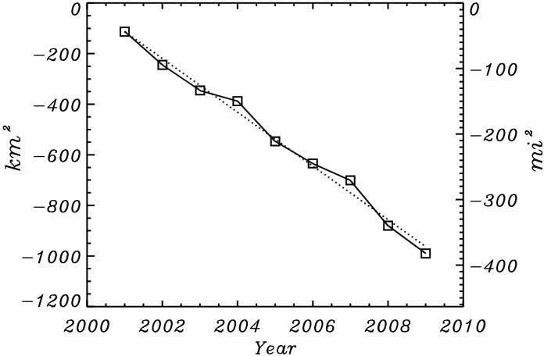
Figure 1. Data from NOAA Arctic Report Card 2009.
Next, let’s look at some updated data for 2010. Figure 2 below illustrates the 5 marine terminating outlet glaciers in Greenland that experienced the greatest cumulative loss in area between 2000 and 2010.

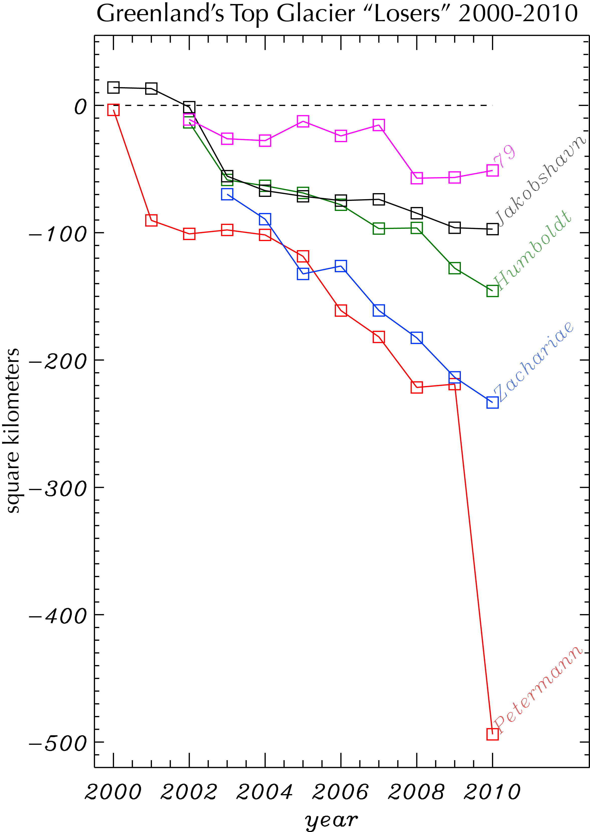
(18) Which glacier(s) did not lose area from 2009 to 2010? Explain how you know.

(19) Which glacier(s) lost area relatively consistently from 2009 to 2010?

(20) Which glacier was “the biggest loser” from 2009 to 2010?

Figure 2. Data from MODIS studies of Greenland, Byrd Polar Research Center

(21) Briefly summarize what the area change data suggests is happening to the Greenland ice sheet. Use evidence from the graphs in your answer.

(22) If asked to predict how the data for these five glaciers will look for 2011, how certain would you be in your predictions? Would you be equally certain (or uncertain) for all five of the glaciers?

