How modern societies are trying to adapt to climate change

#1: Climate change and the insurance industry
Here are three examples from the United States and abroad of how the insurance industry is responding to climate change. Please read these examples below, look at the questions on the large piece of paper, and write your answers below the questions.

- From April 25-28, 2011, over 350 tornadoes swept across the Southern, Midwestern, and Northeastern United States. Alabama was hit particularly hard by the tornado outbreak, with over 200 fatalities and insured losses of over $4 billion. Soon after the tornadoes, Alfa Insurance Company announced that it would not be renewing 73,000 property insurance policies. Most of these cancelled policies were for landlord-owned rental properties, but policies for owner-occupied houses and mobile homes were also cancelled. The president of the company stated, “While Alfa remains a financially strong insurance company, the increased frequency and severity of storms over the last decade have highlighted the need for Alfa to review its overall property portfolio. Our top priority is serving our policyholders. We have a responsibility to manage the company in order to effectively deliver on Alfa’s promise to its customers.”

- In 2010, State Farm Florida insurance company cancelled 125,000 insurance policies. Most of these policy cancellations involved properties in areas vulnerable to hurricanes. State Farm Florida stated that they were losing $20 million/month and that the cancellations would help “stem State Farm Florida’s deteriorating financial condition.”

- Swiss Re insurance, Oxfam America, and other partners started HARITA (Horn of Africa Risk Transfer for Adaptation), a weather insurance program, in 2008 in Ethiopia. Roughly 85% of Ethiopians make their living by farming—the staple crop is a cereal called teff—but because of phenomena such as increased drought, many small farms in Ethiopia are struggling. Some farmers pay their insurance premiums in cash, but the program also allows poorer farmers to pay their premiums in labor—for example, helping with community tree planting projects. HARITA also requires farmers to take risk-reducing measures such as growing heat-tolerant crops, scheduling planting dates based on past precipitation data, and making compost to use in their fields to increase soil productivity. Finally, each community elects five people to work with the insurance companies on how to improve the insurance package. HARITA participants increased from 200 households in 2008 to 13,000 households in 2010.

#2: Adaptation to extreme heat waves
Here are three examples of how the major urban centers of Chicago and New York City, as well as Wangaratta (a city in southwest Australia with fewer than 30,000 people) are adapting to heat waves. Please read the examples below, look at the questions on the large piece of paper, and write your answers below the questions.
- One of the components of Chicago’s ongoing Climate Action Plan involves identifying which parts of the city are “urban hot spots”—in other words, areas in the city that experience the greatest (top 10%) surface temperatures during the day and/or night. The map on the large piece of paper illustrates these areas. City studies of urban hot spots revealed that many of the urban hot spots corresponded to areas in the city that had the least tree cover. In 1989, Chicago Mayor Richard Daley piloted the Green Streets Initiative to increase the city’s urban tree cover. Since 1991, Chicago has planted over 600,000 trees, with an additional 1,000,000 trees to be planted by 2020.

- “Cool roofs” are designed to reflect more sunlight than traditional roofs and can be made of a variety of materials including reflective tiles, reflective shingles called cool asphalt shingles, and spray polyurethane foam. In addition, existing roofs can be transformed into cool roofs by applying coatings of reflective paint, reflective marble chips, or a protective sheet. New York City’s °CoolRoofs program encourages building owners to coat the top of their flat roofs with cool roof coating, a white membrane. Nearby, the Long Island Power Authority offers rebates for certain buildings that install new cool roofs or upgrade an existing roof into a cool roof.

- The “Rural City of Wangaratta” in Australia developed a Heatwave Response Plan in 2009. While the plan includes long-term responses to heat waves similar to programs in Chicago and New York, it also includes a short-term response plan that is implemented during heat waves. This plan includes extending the hours of operation of areas in which people can seek relief, such as air-conditioned community centers and swimming pools; suspending utility shut-offs for non-payment during heat waves; and establishing a community register. A community register is a list of residents (names, contact information, next of kin, and medical information) who are vulnerable to heat-related illnesses and/or socially isolated. People on the community register may choose to receive phone calls from volunteers or the police to check on their well-being during heat waves.

#3: Adaptation to flood hazards
The Netherlands (see location maps below) is a low-lying country in which roughly 9 million (out of the 16.5 million total population) people are living below sea level (Aerts, 2009). Because of its proximity to the North Sea and the presence of the Rhine River, the Netherlands faces flood-related hazards from sea level rise, storm surges, increased precipitation, and melting of European glaciers that feed the Rhine.
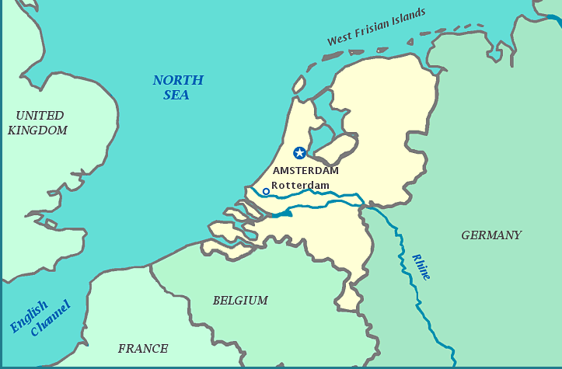
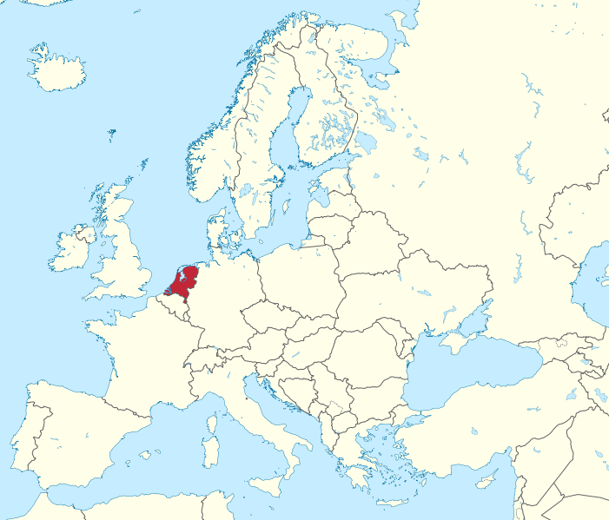
Image sources: http://www.yourchildlearns.com/online-atlas/netherlands-map.htm (left). Wikimaps (right).

Here are two examples of how the Netherlands is adapting to flood hazards. Please read the examples below, look at the questions on the large piece of paper, and write your answers below the questions.
- Much like New Orleans, areas in the Netherlands that lie below sea level have been turned into usable land by pumping water out of the low-lying areas. In rural areas in the Netherlands, a low-lying area that has been drained and is now being used for farmland is called a polder. Hundreds of years ago when the polders were drained, mounds of packed earth that, in the Netherlands, are called dikes, (in the United States, these are referred to as “earthen levees”) were built to protect the polders from flooding. The Dutch government started a program in 2006 called Room for the River that involves changing the existing landscape and flood infrastructure to give rivers more room to flow. This involves excavating (digging) to lower the elevations of floodplains; excavating the bottom of the river bed in order to make it deeper; shifting dikes’ positions and expanding the size of the floodplain; removing dikes and allowing the river to flood polders; removing obstacles like bridges that can interfere with river flow; and in densely populated areas, repairing and fortifying existing dikes. Schematic diagrams of these changes are shown on the next page. As the rivers are widened, some land that is currently occupied will be used to give the river more room, which will involve “selective relocation”. Some farmers like Jacques Broekmans, whose land lies within the polders, are being compensated for their land and relocated. In addition, the Dutch government has decided that some areas in an eastern city called Nijmegen through which the Rhine River flows, will be allowed to flood in order to protect more densely populated areas further downstream.
- Cities in the Netherlands are engaging in a variety of projects to adapt to increased flood hazards. In many cities, parking garages that are currently under construction must be built to double as drainage systems and fill with water during floods. Amsterdam, the capital city, is also building floating communities such as Ijburg and Maasbommel to allow houses to withstand floods without being damaged. The houses are made of wood, glass, and synthetic materials. Some are built on concrete tanks stationed in the water, while others are built on “floating foundations”, concrete boxes filled with plastic foam that serve as stable platforms. Docks serve as walkways and contain electric and sewage infrastructure within them. If flooding occurs, the houses rise with the floodwaters without being damaged.
Images below from http://www.ruimtevoorderivier.nl/meta-navigatie/english/types-of-measures/

Lowering floodplains (shown with arrow) to give the river more room when at flood stage.
Deepening the river bed
Dike relocation
Dike removal to allow polders to flood

Removal of obstacles
