#2: Adaptation to extreme heat waves
The number of days per year over 100°F is increasing in many parts of the United States. The map below illustrates the June 1-August 31, 2012 data.

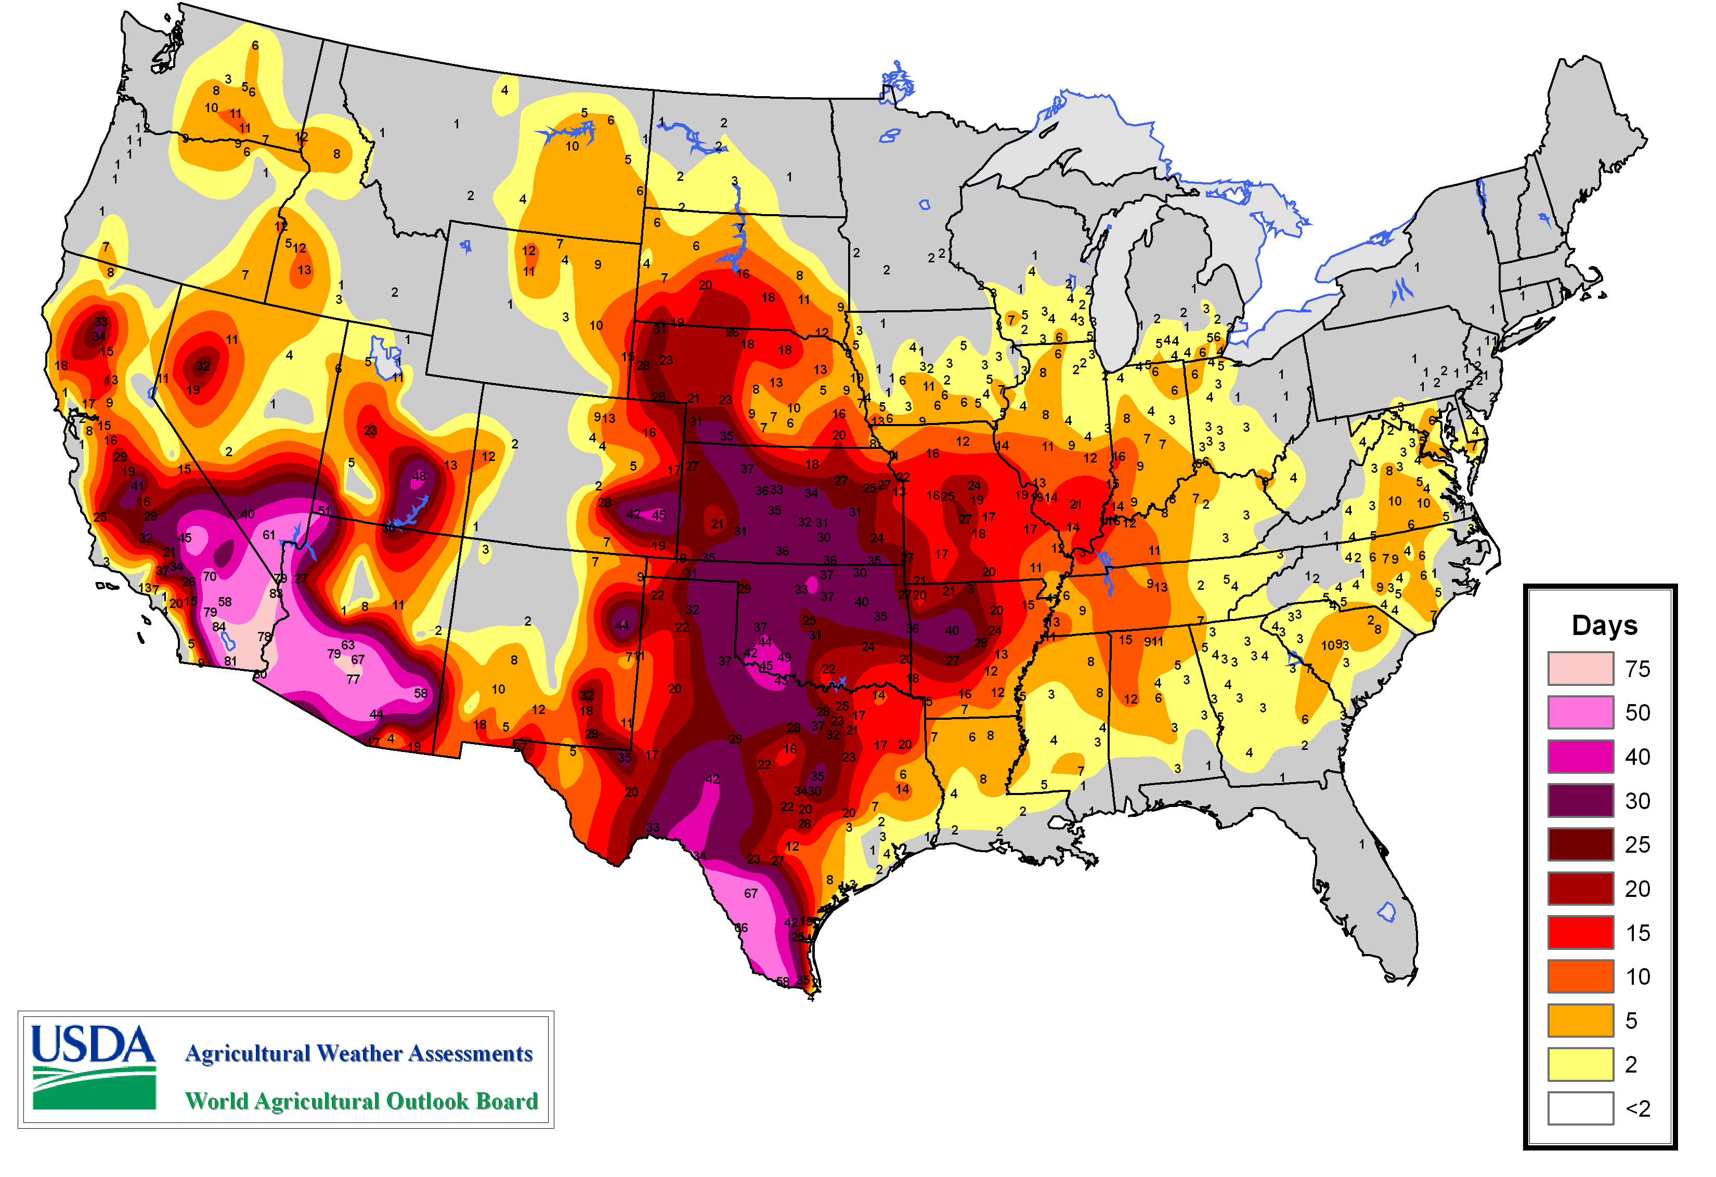

(1) What do the data show for your area?

Heat waves have several negative impacts, including:
- Heat-related illnesses and deaths. For example, in 1995, 739 people in Chicago died as a result of a 5-day heat wave (Hertsgaard, 2011).
- Greater demand for police, ambulance, and fire personnel.
- Greater demand for electricity to power air conditioners, which may lead to widespread power outages and more cases of heat-related illness and deaths.
- Increased emission of greenhouse gases by air conditioners.

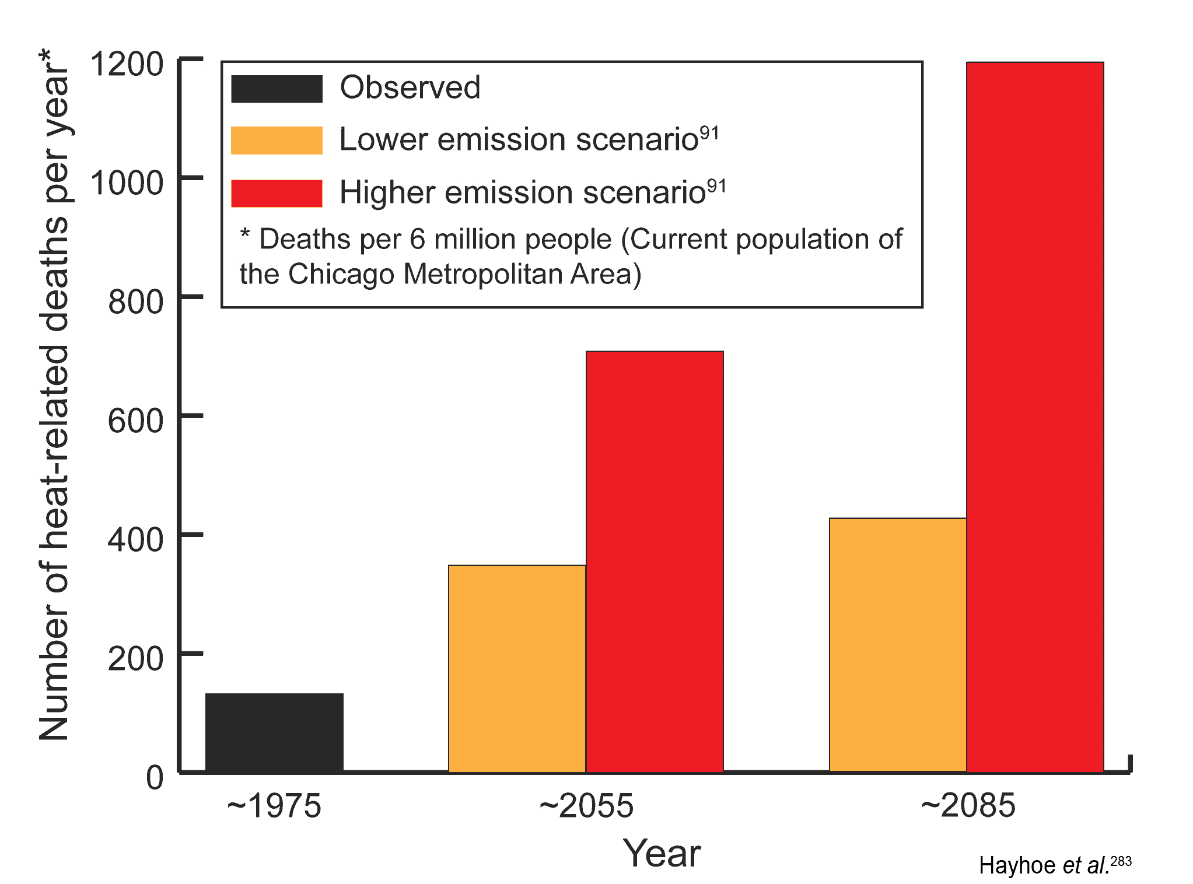
(2) The graph on the left illustrates some predictions for heat-related deaths in Chicago per 6 million people (the current population of the city). Thinking about the social vulnerability index, name two groups that would be particularly susceptible to heat waves and heat wave-related deaths.

Here are three examples of how the major urban centers of Chicago and New York City, as well as Wangaratta (a city in southwest Australia with fewer than 30,000 people) are adapting to heat waves. Please read these examples—then, with your group, visit the “heat wave” questions and write your answers below the questions.
- One of the components of Chicago’s ongoing Climate Action Plan involves identifying which parts of the city are “urban hot spots”—in other words, areas in the city that experience the greatest (top 10%) surface temperatures during the day and/or night. The map below illustrates these areas. City studies of urban hot spots revealed that many of the urban hot spots corresponded to areas in the city that had the least tree cover. In 1989, Chicago Mayor Richard Daley piloted the Green Streets Initiative to increase the city’s urban tree cover. Since 1991, Chicago has planted over 600,000 trees, with an additional 1,000,000 trees to be planted by 2020.

- “Cool roofs” are designed to reflect more sunlight than traditional roofs and can be made of a variety of materials including reflective tiles, reflective shingles called cool asphalt shingles, and spray polyurethane foam. In addition, existing roofs can be transformed into cool roofs by applying coatings of reflective paint, reflective marble chips, or a protective sheet. New York City’s °CoolRoofs program encourages building owners to coat the top of their flat roofs with cool roof coating, a white membrane. Nearby, the Long Island Power Authority offers rebates for certain buildings that install new cool roofs or upgrade an existing roof into a cool roof.

- The “Rural City of Wangaratta” in Australia developed a Heatwave Response Plan in 2009. While the plan includes long-term responses to heat waves similar to programs in Chicago and New York, it also includes a short-term response plan that is implemented during heat waves. This plan includes extending the hours of operation of areas in which people can seek relief, such as air-conditioned community centers and swimming pools; suspending utility shut-offs for non-payment during heat waves; and establishing a community register. A community register is a list of residents (names, contact information, next of kin, and medical information) who are vulnerable to heat-related illnesses and/or socially isolated. People on the community register may choose to receive phone calls from volunteers or the police to check on their well-being during heat waves.

