#3: Adaptation to flood hazards
Increased flood hazards are becoming a reality for many parts of the United States, whether the floods are related to increased precipitation, hurricane storm surges, or sea level rises.

The Netherlands (see location maps on the next page) is a low-lying country in which roughly 9 million (out of the 16.5 million total population) people are living below sea level (Aerts, 2009). Because of its proximity to the North Sea and the presence of the Rhine River, the Netherlands faces flood-related hazards from sea level rise, storm surges, increased precipitation, and melting of European glaciers that feed the Rhine.

Here are two examples of how the Netherlands is adapting to flood hazards. Please read the examples—then, with your group, visit the “flood” questions and write your answers below the questions.
- Much like New Orleans, LA, areas in the Netherlands that lie below sea level have been turned into usable land by pumping water out of the low-lying areas. In rural areas in the Netherlands, a low-lying area that has been drained and is now being used for farmland is called a polder. Hundreds of years ago when the polders were drained, mounds of packed earth that, in the Netherlands, are called dikes, (in the United States, these are referred to as “earthen levees”) were built to protect the polders from flooding. The Dutch government started a program in 2006 called Room for the River that involves changing the existing landscape and flood infrastructure to give rivers more room to flow. This involves excavating (digging) to lower the elevations of floodplains; excavating the bottom of the river bed in order to make it deeper; shifting dikes’ positions and expanding the size of the floodplain; removing dikes and allowing the river to flood polders; removing obstacles like bridges that can interfere with river flow; and in densely populated areas, repairing and fortifying existing dikes. Descriptions of these changes are shown on the next pages. As the rivers are widened, some land that is currently occupied will be used to give the river more room, which will involve “selective relocation”. Some farmers like Jacques Broekmans, whose land lies within the polders, are being compensated for their land and relocated. In addition, the Dutch government has decided that some areas in an eastern city called Nijmegen through which the Rhine River flows, will be allowed to flood in order to protect more densely populated areas further downstream.
- Cities in the Netherlands are engaging in a variety of projects to adapt to increased flood hazards. In many cities, parking garages that are currently under construction must be built to double as drainage systems and fill with water during floods. Amsterdam, the capital city, is also building floating communities such as Ijburg and Maasbommel to allow houses to withstand floods without being damaged. The houses are made of wood, glass, and synthetic materials. Some are built on concrete tanks stationed in the water, while others are built on “floating foundations”, concrete boxes filled with plastic foam that serve as stable platforms. Docks serve as walkways and contain electric and sewage infrastructure within them. If flooding occurs, the houses rise with the floodwaters without being damaged.

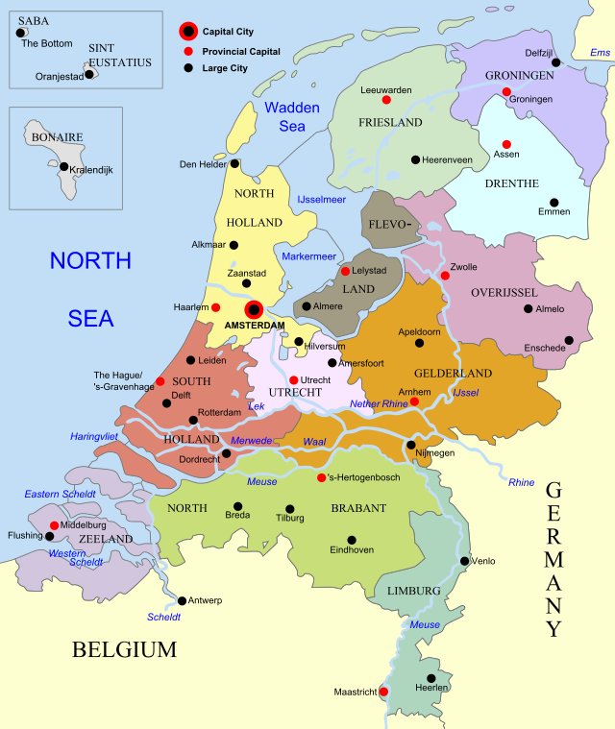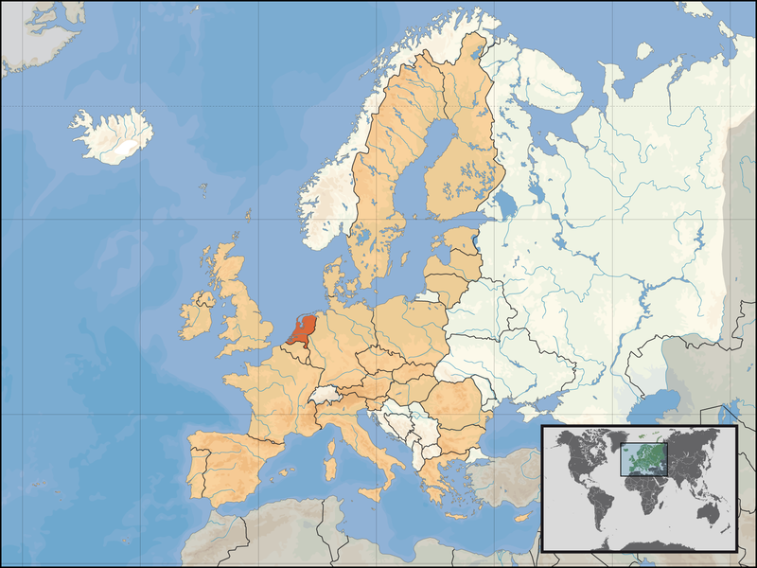
Image credit: Wikipedia
Sources: http://en.wikipedia.org/wiki/List_of_islands_of_the_Netherlands (left)
http://commons.wikimedia.org/wiki/Atlas_of_the_Netherlands (right)

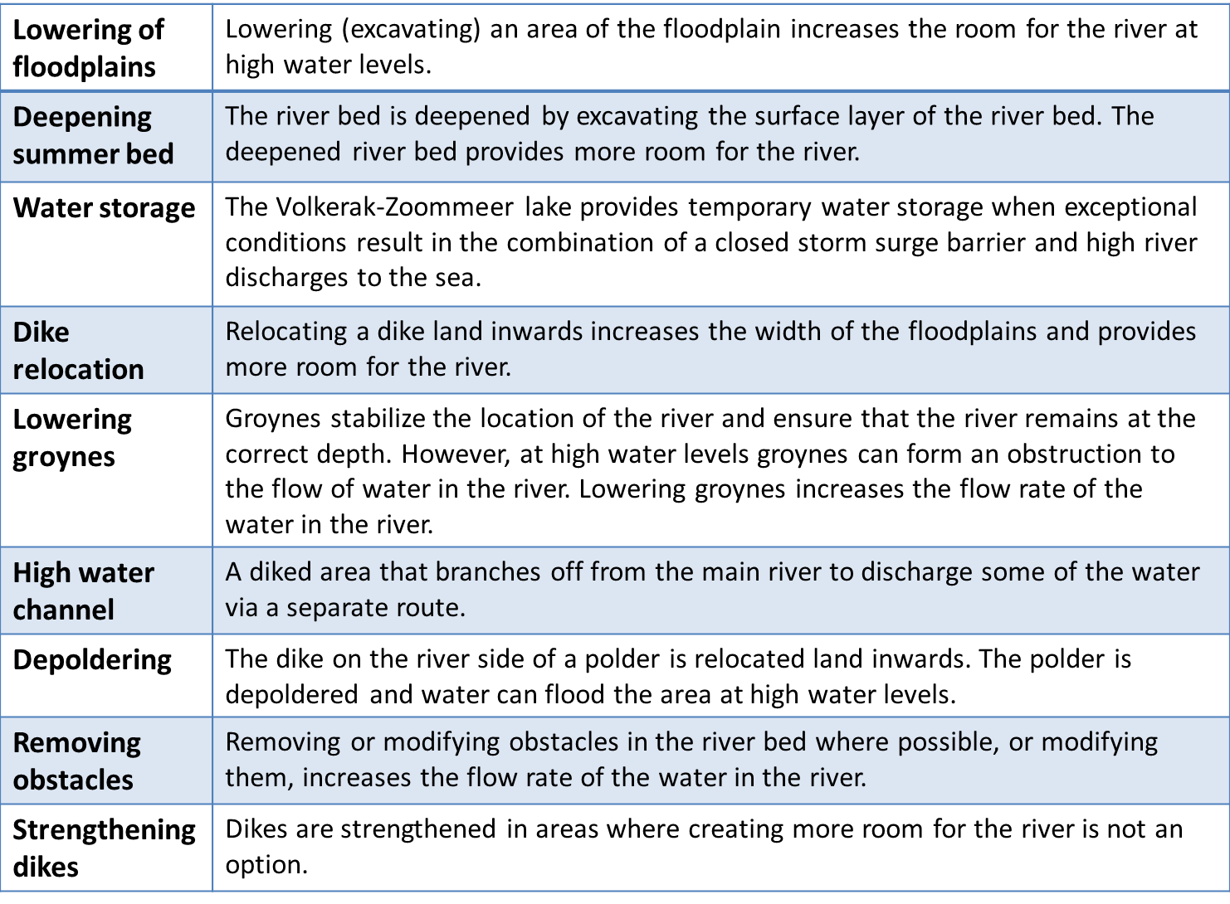
Schematic diagrams of above available from http://www.ruimtevoorderivier.nl/meta-navigatie/english/types-of-measures/

