Name______________________________________ Date _____________

Carbon dioxide (CO₂) is a greenhouse gas that is frequently linked to temperature. Look at the graph of monthly CO₂ data from Mauna Loa, Hawaii. The dashed red line with diamond symbols represents the monthly mean values, centered on the middle of each month. The black line with the square symbols represents the same, after a statistical correction for the average seasonal cycle. The latter is determined as a moving average of seven adjacent seasonal cycles centered on the month to be corrected.
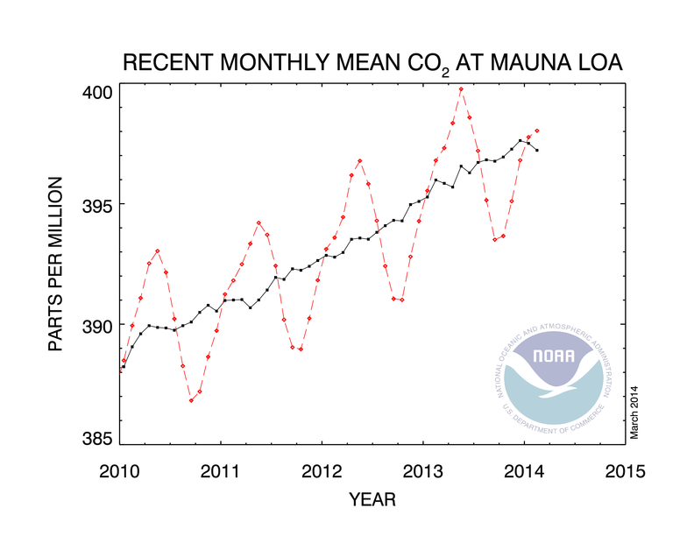

- What variable is plotted on the x-axis? Y-axis?

- In your own words, what does the red line represent? What does the black line represent?

- Does this graph show changes in CO₂ over time? Does one line (red or black) represent that change better than another?

- If CO₂ does change over time, what do you think contributes to the variation in CO₂?

Now look at the graph below and answer the questions. The red line is monthly carbon dioxide data and the black curve represents the seasonally-corrected data.
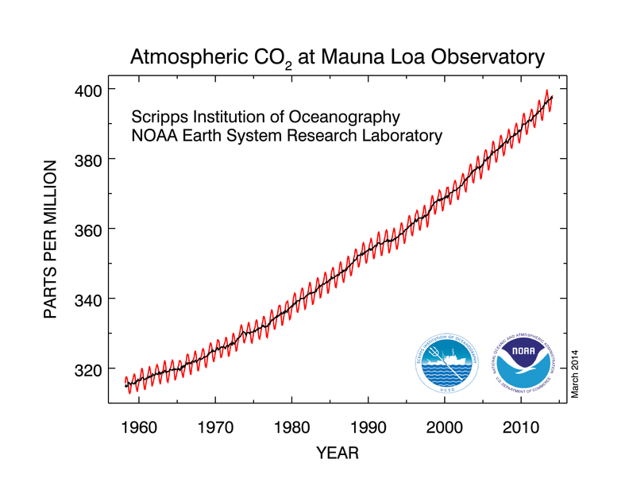

- Is this graph plotting the same data on the x and y axes (as the first graph)? How do the range of data on the axes differ from the first graph?

- Does CO₂ change over time? Does one line (red or black) represent that change better than another?

- If CO₂ does change over time, what do you think contributes to the variation in CO₂?

- Does a longer data set (50 years of data) change the contributing factors or how you interpret the graph?

