Climate of Change InTeGrate Module Case study 5.1

Interactions:
Name:

Climate’s Tangled Web

Intimate interplay of the atmosphere, hydrosphere, cryosphere, biosphere, pedosphere, and lithosphere comprise our climate system. Like a food web the system involves mechanisms from each of Earth's spheres at varying scales, resulting in the temporal and spatial variation we experience in Earth's environments.
Some climate system interactions are direct cause-­‐and-­‐effect relationships that are easy to understand. Other relationships are indirect, increasing the system's complexity. Climate scientists work to understand these relationships, and in so doing, demystify climate function. Our climate system owes much of its complexity to thresholds and feedbacks.
The terms for cause and effect in the climate system are forcing mechanism and climate change. Sometimes the relationship between forcing and change is regular: forcing occurs and change occurs. Sometimes, however, forcing must occur multiple times or for an extended period of time before the change occurs, just like how you can continue to squeeze a balloon until it pops. The pressure required to cause popping is a threshold. The point at which enough climate forcing has occurred and climate change begins is a climate threshold.
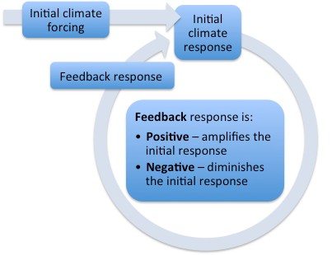A climate feedback is a specific set of interactions, the result of which impacts the initial climate change. As you can see in the diagrams on the left, this process can either lessen or intensify the initial climate change. If a change in climate sets into motion a series of events that causes the initial change to intensify, the feedback in positive. A negative feedback results when a change in climate forces other changes that lessen that initial change.
Climate modeling gives us the ability to watch the climate relationships we currently understand play out in the world of computer simulation. We enter each climate attribute and the way it
interacts with all the others into the model. Then we get to ask the model questions and see what our future would look like depending on changes that occur today or choices the world may make.
Through the course of this activity, you will:
! Experience the varied responses of climate system components to forcing mechanisms,
! Model future climate manually using climate system relationships, and
! Evaluate your climate model and its output.

- Create a climate model group with one member from each role. Fill in the names of your climate players and the number of your future climate scenario here:

Climate Model

Greenhouse Gases
Temperature

Oceans |  |  |  | Human Population

Precipitation

Future
Tectonics
Glaciers
# ___

The background image above is from Josth, R. (2005). Real-­‐Time Atmosphere Rendering for the Space Simulators. http://www.cescg.org/CESCG-­‐2005, last accessed 24 July 2012.

- List the primary forcing mechanism(s) in the scenario you’ve been given.

- What outcome do you predict for your model? How (qualitatively) certain are you of your prediction?

- Run your model! For every round of play, you have a turn to react to climate changes. Use your climate response guide as a resource. As each person takes a turn, fill in your scenario sheet.

- How did your future develop? Describe and diagram your climate story here:

- What is your model's output -­‐ how is Earth a different place in your future (after the last round of play)?

- Evaluate your original hypothesis. Did running the model prove it correct, incorrect, or something between? How was your output different from your hypothesis and why?

- How realistic are your model and its output? Explain. If you could run your climate model again, what would you change?

