Diagram 1. Changes in CO₂ over 1 month.

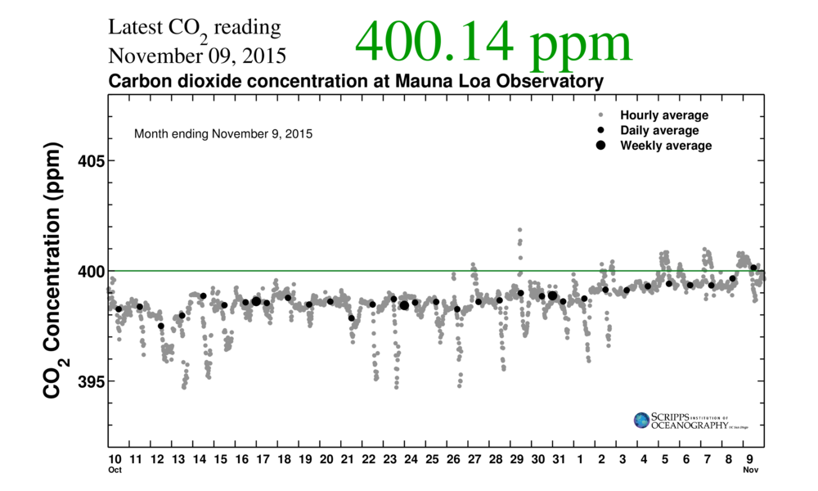

Questions for Diagram 1, Changes in CO₂ over 1 month:

- Describe the changes in CO₂.
- When is average CO₂ highest?
- When is average CO₂ lowest?
- What do you think is causing this pattern?

Diagram 2. Changes in CO₂ over 6 months (Fall to Spring).

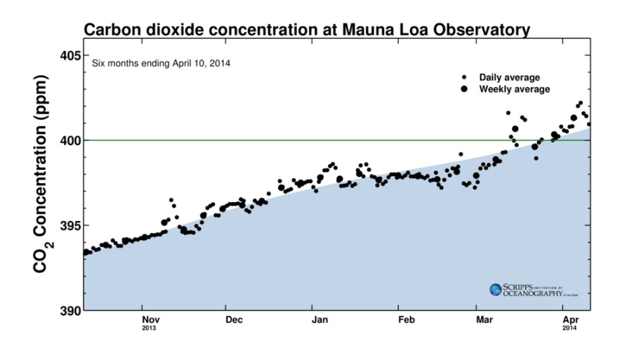

Questions for Diagram 2, Changes in CO₂ over 6 months (Fall to Spring):

- Describe the changes in CO₂.

- When is CO₂ highest? When is CO₂ lowest?
- What do you think is causing this pattern?

Diagram 3. Changes in CO₂ over 6 months (Spring to Fall).
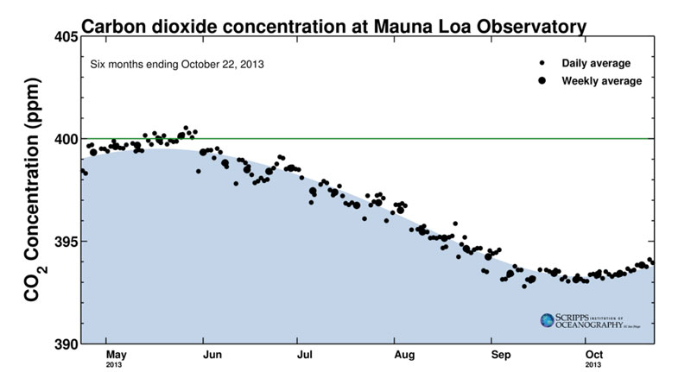

Questions for Diagram 3, Changes in CO₂ over 6 months (Spring to Fall):

- Describe the changes in CO₂.
- When is CO₂ highest? When is CO₂ lowest?
- What was the highest CO₂? What was the lowest?

- What do you think is causing this pattern?

Diagram 4. Changes in CO₂ over 1 year.

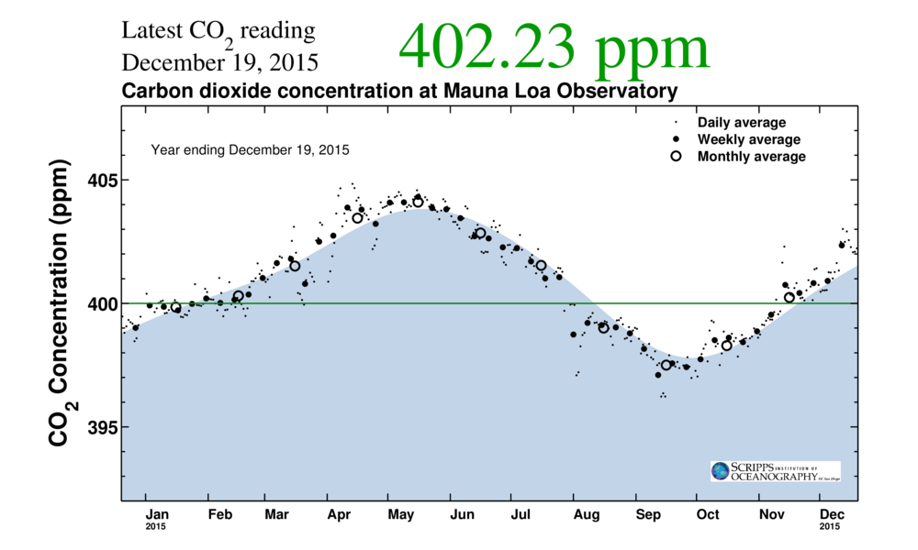

Questions for Diagram 4, Changes in CO₂ over 1 year:

- Describe the changes in CO₂.
- When is CO₂ highest? When is CO₂ lowest?
- What was the highest CO₂ concentration? What was the lowest CO₂ concentration?
- Why does it increase? Why does it decrease?

Diagram 5. Changes in CO₂ over 2 years.

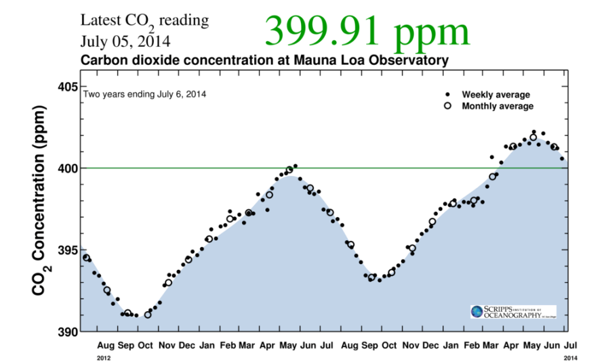

Questions for Diagram 5, Changes in CO₂ over 2 years:

- Are the CO₂ levels the same as they were in the previous year?
- Are the highs at the same level? How do they differ?
- Are the lows at the same level? How do they differ?
- What do you think caused CO₂ levels to change?

Diagram 6. Changes in CO₂ from 1958 to Present.
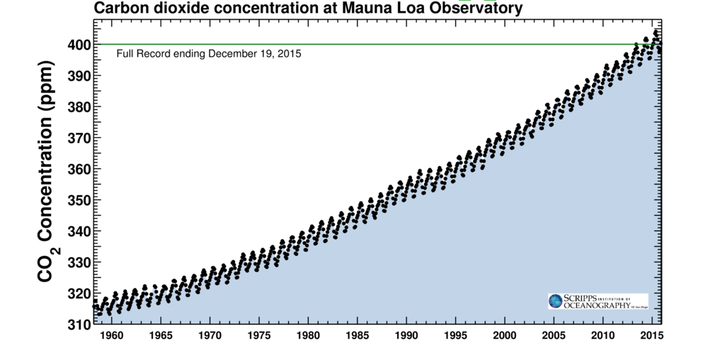

Questions for Diagram 6, Changes in CO₂ from 1958 to Present:

- How do you explain the cyclic, zigzag pattern?
- If there were no people, would it still rise and fall in this cycle?
- How has the level of CO₂ changed over the past 50+ years?
- Why does the line continue to go up? What is causing CO₂ to increase?
- What could people do to make it stop increasing?

Diagram 7. Ice core data extend the record back to 1700.

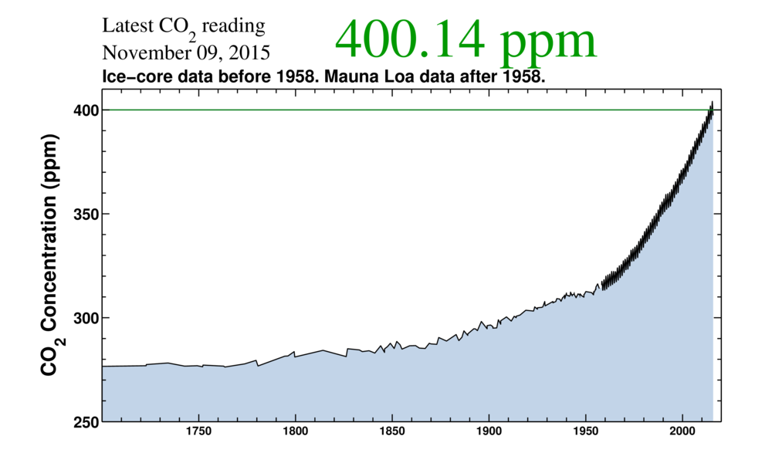

Questions for Diagram 7, Ice core data extend the record back to 1700:

- When did CO₂ rise above about 280 ppm?
- What events in history occurred about this time?
- When did CO₂ concentrations in the atmosphere begin to rise rapidly?
- Why did CO₂ in the atmosphere increase so rapidly?

Diagram 8. Ice core data over the past 800,000 years.

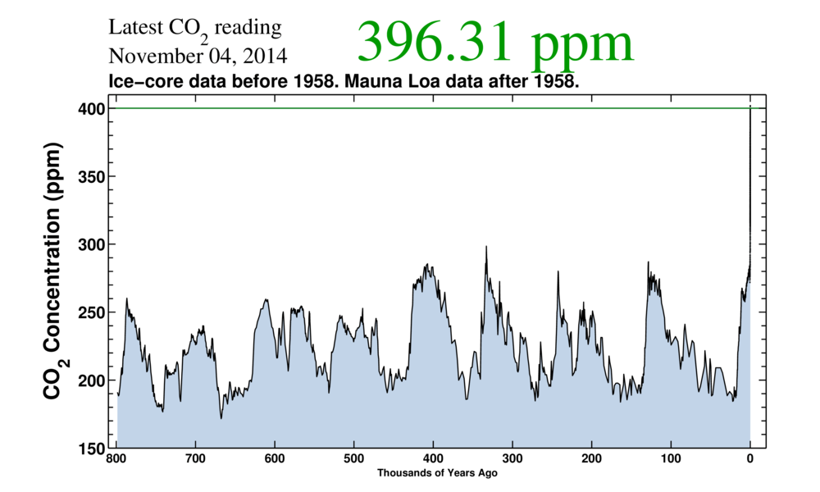

Questions for Diagram 8, Ice core data over the past 800,000 years:

Describe how CO₂ changed over the past 800,000 years.

How high was the maximum CO₂?

How low was the minimum CO₂?

How long were the cycles?
- What do you think caused this pattern?

Diagram 9. Relationship between CO₂ and global temperature.
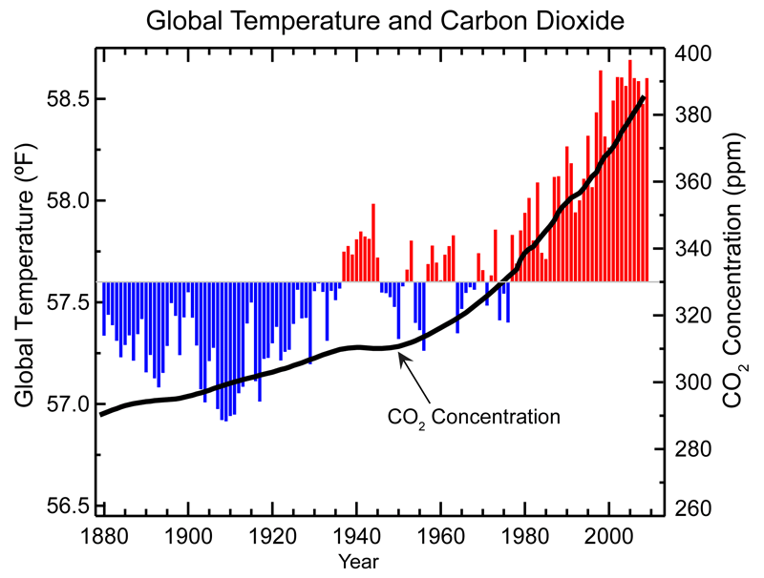

Questions for Diagram 9, Relationship between CO₂ and global temperature:

- What do the blue lines represent?
- What do the red lines represent?
- What does the black line represent?
- Is there a relationship between CO₂ and global temperature? If so, what is it?
- What are some of the consequences of increasing global temperatures?

Diagram 10. Ocean/atmosphere CO₂ exchange.

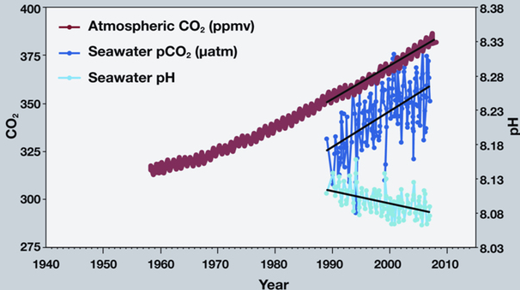

Questions for Diagram 10, Ocean/atmosphere CO₂ exchange:

- How does the amount of CO₂ in seawater change as atmospheric CO₂ increases?
- How did the pH of seawater change between 1990 and 2007?
- Is the acidity of seawater increasing or decreasing?
- What are the consequences of increasing ocean acidity?

- How might this affect marine life?
- How might this affect people?

