Carbon cycle reservoirs and fluxes
Learning objective: Students will quantify and compare the size of various carbon reservoirs (sinks) and fluxes (transfers between reservoirs).
Materials needed:
- large sheets of paper (at least 2 m in diameter)
- pencils or markers, metric ruler (meter stick with mm scale gradations)
- string
- thumbtack (or a finger)
Background information for Part I: We are going to make a graphic representation of the size of the different carbon reservoirs (sometimes called “sinks”) on Earth. The estimated size of each reservoir is given in gigatonnes (billions of metric tons) of carbon (a metric ton is 1000 kilograms). We will represent the different reservoirs with circles of different sizes. We want the area of the circle to correspond to the amount of carbon in the different reservoirs in the Earth system, so we calculate the radius of the circle by reconfiguring the formula:
A = πr²
Where A is the area of the circle and r is the radius of the circle. π is the constant 3.14159 . . .
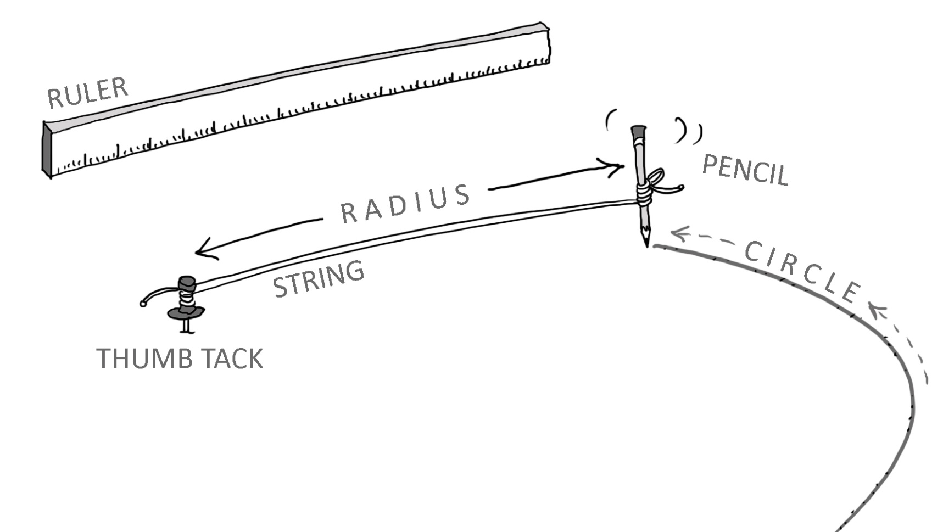
In this activity, we are starting with the circle’s area (equivalent to the carbon “load” of that reservoir, in gigatonnes), and we want to figure out how to draw a circle of the appropriate size. To find the radius, we take the square root of the product of the area (total gigatonnes of carbon) and π. Once the radius has been determined, we can measure off that distance on a string with a pencil or marker at the end. We pin or hold one end of the string down (at our circle’s center), and then use the string’s full length to trace out the circumference of the circle, like this:

Reservoir | Area of circle (each mm² equivalent to 2 gigatonnes of carbon) | Radius of circle (mm)
Atmosphere | 426 | 11.6
Vegetation + soils | 1,900 | 24.6
Fossil fuels still unburned | 2,150 | 26.2
Oceans | 19,000 | 77.8
Crust | 2,850,000 | 952.5
Mantle | 5,000,000 | 1261.6
(Data source: Ralph Keeling, Scripps Institution of Oceanography)
Converting metric distances: 1000 mm = 100 cm = 1 m
Using the materials in your classroom, you should create six circles, one for each of the major reservoirs of carbon. Each circle should have a radius matching the number in the final column above. Label each circle with the name of the reservoir it represents.
Discussion:
- Which of Earth’s carbon reservoirs is the smallest? Does this “smallest” rank indicate it is therefore unimportant? Explain.

- How much larger would the “atmosphere” carbon reservoir grow if the entire “fossil fuel” reservoir were mined and then burned?

Proceed to part II, next page.
Part II: Carbon does not just sit still in a given reservoir. Certain transfers (called “fluxes”) move carbon from one reservoir to another. For instance, when plants engage in photosynthesis, they pull carbon dioxide from the atmosphere and lock it up in the vegetation + soils reservoir. When animals eat plants and then metabolize the carbon in their food, they exhale carbon dioxide, a flux that returns the carbon to the atmosphere again.
The following table lists some of the natural fluxes between carbon reservoirs, in gigatonnes of carbon per year, with human-induced changes shown in bold type:
 | How much carbon is removed  from the atmosphere? | How much carbon is put out  into the atmosphere?
Fossil fuel burning by people | (none) | ↑ 9 gtC/yr
Photosynthesis | ↓ 120 gtC/yr natural  and another 3 gtC/yr from  people burning fossil fuels | (none)
Plant respiration | (none) | ↑ 60 gtC/yr
Microbial and fungal respiration in soil | (none) | ↑ 60 gtC/yr
Absorption into the oceans across the ocean/atmosphere interface | ↓ 90 gtC/yr natural  and another 2 gtC/yr from  people burning fossil fuels | (none)
Degassing from oceans across the ocean/atmosphere interface | (none) | ↑ 90 gtC/yr
Volcanic eruptions | (none) | ↑ 0.15 gtC/yr
Weathering of continental crust | ↓ 0.15 gtC/yr | (none)
(Data source: NASA)
Discussion:
- Over the course of a year, which reservoirs are least affected by carbon fluxes? You can evaluate the answer to this question by calculating what percentage “turns over” each year. (To answer this question, divide each reservoir’s annual flux by the size of the total reservoir. Which one has the smallest number?)
- Over the course of a year, which reservoirs are most affected by carbon fluxes? As with the previous question, you can evaluate the answer to this question by calculating what percentage “turns over” each year. (To answer this question, divide each reservoir’s annual flux by the size of the total reservoir. Which one has the biggest number?)
- Now that humans are burning fossil fuels, what is the net change in the size of the atmospheric reservoir from one year to the next? (Express your answer in gigatonnes.)

- Each gigaton of carbon that ends up being shifted from the “fossil fuel” reservoir into the atmosphere increases the proportion of the atmosphere that is carbon dioxide. Typically, we measure the CO₂ proportion of the atmosphere in parts per million by volume (ppm). Each ppm is equivalent to about 2 gigatonnes of carbon. Based on this conversion factor, by how many ppm would you expect the atmospheric concentration of CO₂ to increase each year?

- Look up the current concentration of CO₂ in the atmosphere at this website: http://www.esrl.noaa.gov/gmd/ccgg/trends/
If your answer to #6 above is accurate and continues unchanged into the future, what would you expect the concentration of CO₂ to be in Earth’s atmosphere 10 years from now?

… 100 years from now?

… 1000 years from now?

- What percentage change in the overall “carbon load” of the atmospheric reservoir does this represent, as compared to pre-Industrial Revolution levels of ~280 ppm?
…Today’s concentration? _____________________________
…your projection for 10 years from now? ____________________________
… your projection for 100 years from now? ___________________________
… your projection for 1000 years from now? ___________________________

- This simple linear prediction is unlikely to come true, however. What complications make it difficult to accurately predict the future size of the “atmosphere” reservoir?

