Pre-activity instruction for the carbon cycle game
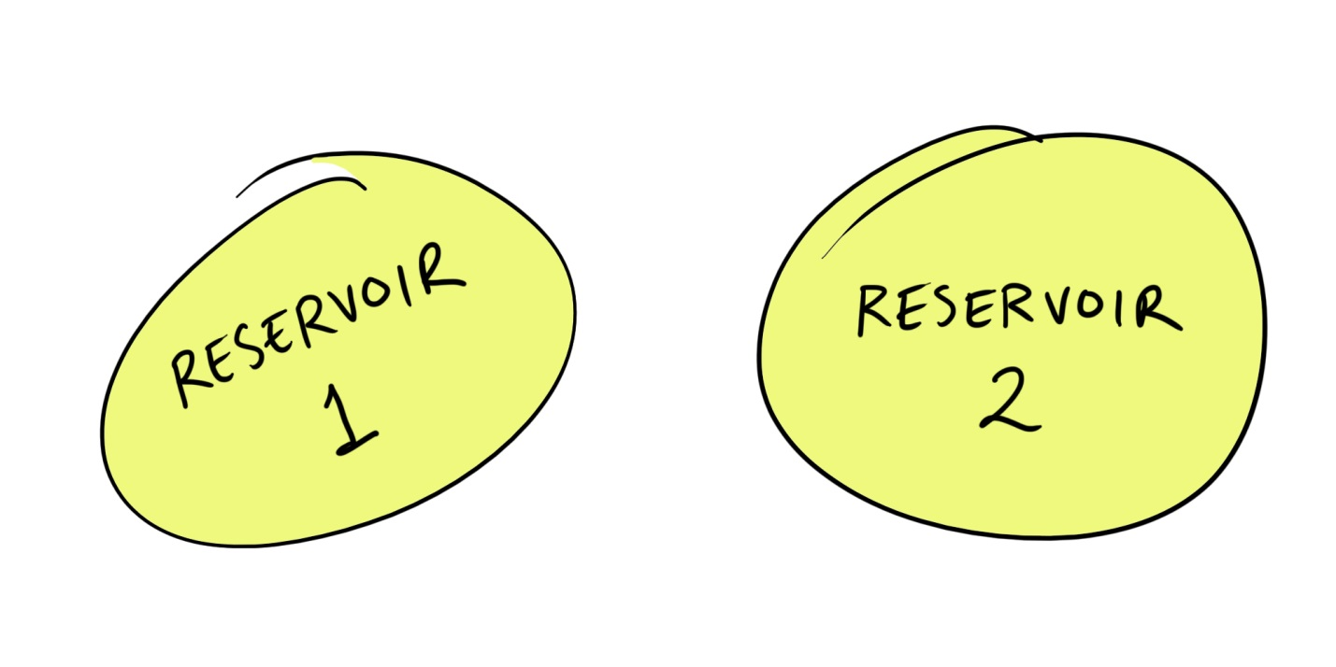
This information is what instructors should cover before students play the dice-rolling carbon cycle game. The point of this pre-activity teaching is to definitively establish the basic ideas of carbon reservoirs and fluxes (movements of carbon between reservoirs).
Teachers should sketch something like this on the board:

They should then say something like, “Reservoirs are places where carbon can be found in the Earth system. Examples of carbon reservoirs include the ocean, the atmosphere, and vegetation, as well as the crust, the mantle, and fossil fuels.” [Optional: “Synonyms would include ‘sinks’ and ‘pools.’”]
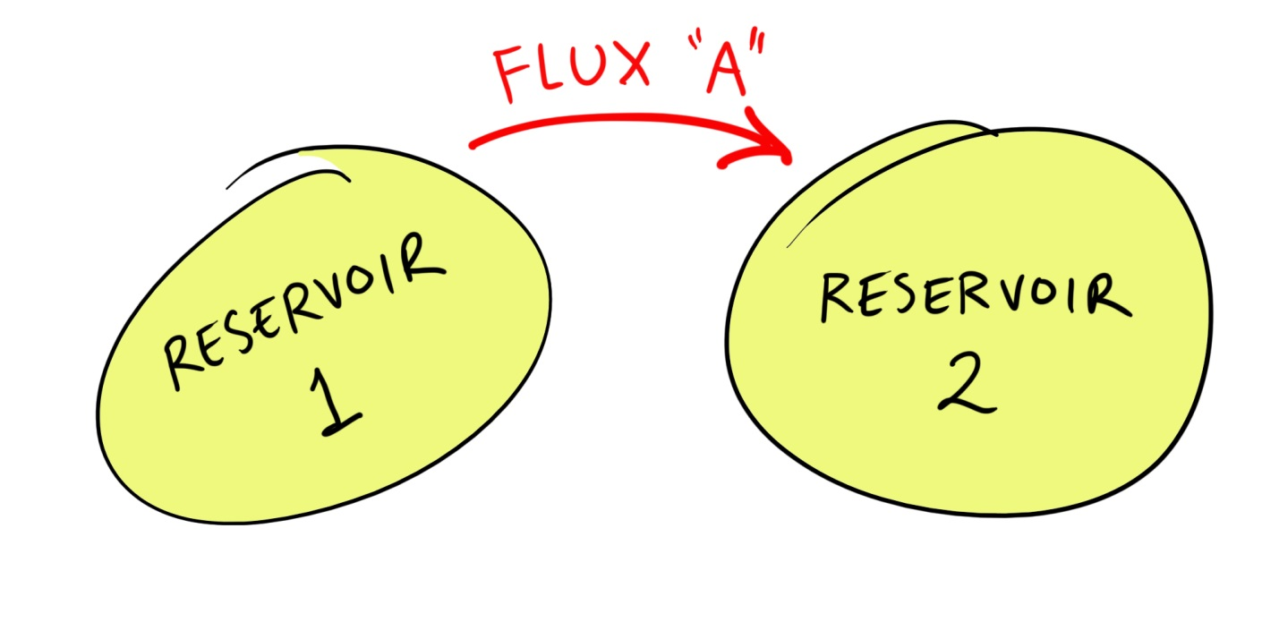
“Fluxes are movements of carbon between different reservoirs.”

“Each flux is a chemical reaction, or a physical process. Each flux will take carbon out of one reservoir and put it in another. Here, Flux A removes carbon from Reservoir 1 and puts it into Reservoir 2. Examples of fluxes include photosynthesis, which pulls carbon from the atmosphere and puts it into vegetation, or diffusion of carbon dioxide from the atmosphere into the water of the ocean. Another example is when the burial of plants under layers of sediments turns vegetation into fossil fuels.”
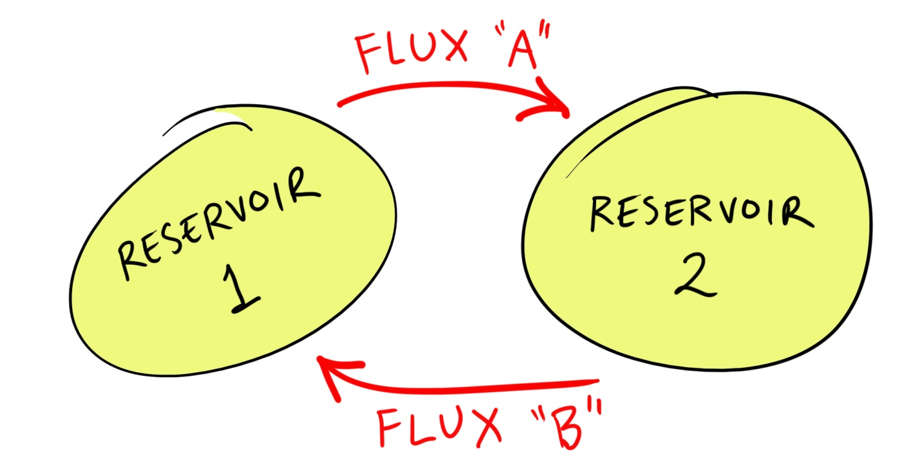
“Balance between reservoirs is achieved when ‘input’ fluxes are equal to ‘output’ fluxes. Let us add another flux to our diagram…”

“If Flux B is a process that moves the same amount of carbon as Flux A, Reservoir 1 is always giving up the same amount of carbon through Flux A that it is getting from Flux B. Reservoir 1 would stay the same size if A and B are equal, and so of course would Reservoir 2. This system is in balance.”
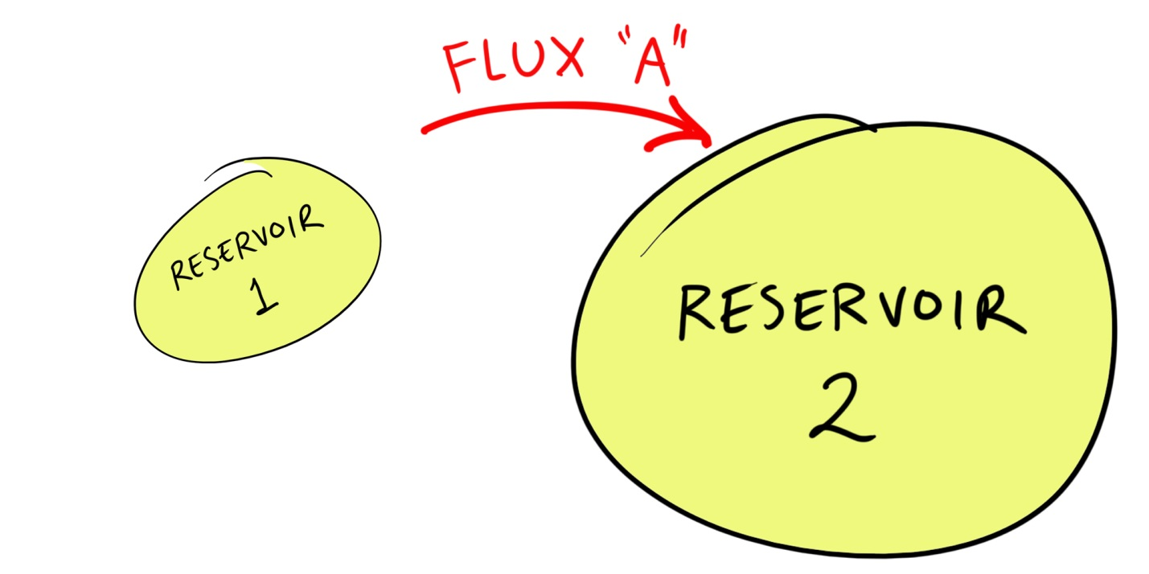
“On the other hand, if something diminished Flux B, or stopped it altogether, then Flux A would gradually transfer more and more carbon out of Reservoir 1 into Reservoir 2. Reservoir 1 would shrink, and Reservoir 2 would grow…”

“This system is out of balance, or ‘perturbed.’”
“Okay, let’s see how this works …” (conclude instruction)
Armed with an understanding of the definitions of “reservoir” and “flux,” students are now ready to start rolling dice in the carbon cycle game.

