Unit 4. Fossil Fuel Formation
Activity 4 — Online research assignments
Student Worksheet
Part 1 — Where are our energy resources and facilities?
1. Are there any energy resources and facilities near you?
Go to the following web page: U.S Energy Information Administration – U.S. States
http://www.eia.gov/state/seds/ and select your state using the blue "Change State/Territory" button near the top of the page.
Click on the OVERVIEW tab to see a map of your state with the locations of energy facilities.
Use the “Layers/Legend” pull-down menu on the upper right side of the map to identify the energy facilities near you — coal mines, power plants, refineries, pipelines, etc. Check and uncheck the boxes to see the locations of specific types of facilities. You will need to scroll down. Pick your item of interest and then click the triangle to the left of the words “Layers/Legend” to hide the list and see the map. Use the Basemaps link to find the type of map you want to see (satellite view, street map, topographical map, etc.). Zoom out to see neighboring states or the United States as a whole.
Use the online interactive map tool to locate areas of fossil fuel resources in the United States. Click on Layers/Legend and “Remove all Layers” using the link at the top. Then scroll down to “Oil and gas wells” and “Fossil Resources.” Click the + sign to the left of the words to open a list. You can examine the following fossil fuel resources: Coal Field, Shale Basin, Shale Play, Tight Gas Basin, and Tight Gas Play.
Part 2 — Petroleum Imports
Use this reference to answer the questions below.
U.S Energy Information Administration – Petroleum and Other Liquids – Company Level Imports
http://www.eia.gov/petroleum/imports/companylevel/
Look for the Excel file link near the top of the web page, in the line below the words "Company Level Imports.” It is on the right side. Look for the letters XLS and the Excel symbol. Click to open the file.
This Excel file shows, for a recent month, the following information: company names (column B), the products they import, for example, asphalt, propane, crude oil, lubricants, etc. (column E), the city and state of the port where the petroleum enters the United States (columns G and H), the country from which the petroleum is imported (column K), along with the quantity imported, sulfur content, and other information.
1. Looking at column K, country name, which companies import petroleum from the Middle Eastern countries in the Arabian Gulf area (Bahrain, Iran, Iraq, Kuwait, Qatar, Saudi Arabia, and United Arab Emirates)?
___________________________________________________________
2. From which countries do some familiar companies get their petroleum? Look at column B (company name) and then check column K (country name). Pick 3 companies that you recognize (such as local gas stations), and list all of the countries from which they import. Put your findings in the table below.
Company Name (from column B) | Countries from which they import oil  (from column K)
3. Through which port cities NEAREST YOU does oil enter the United States? (check columns G and H).
____________________________________________________________________________
Part 3 — Electricity generation
1. Examine the diagram of sources of U.S. electricity generation, below. 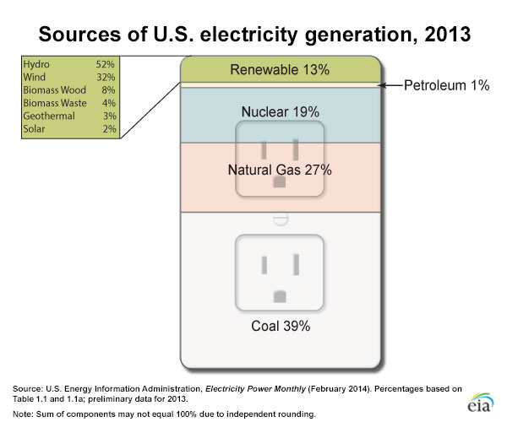
Source: U.S. Energy Information Administration, Electricity Power Monthly (February 2014).
In the table below, list the sources used to generate electricity, along with the percentage of electricity generated by each, and check whether they are fossil fuels or renewable energy sources. For the renewable, you will need to calculate the percentage of energy used, as they are listed as a percentage of 13%.
Source of electricity | Percentage of electricity generated | Fossil fuel? | Renewable?

