Unit 2 Instructor Sheet for the Black and White Jar Demonstration

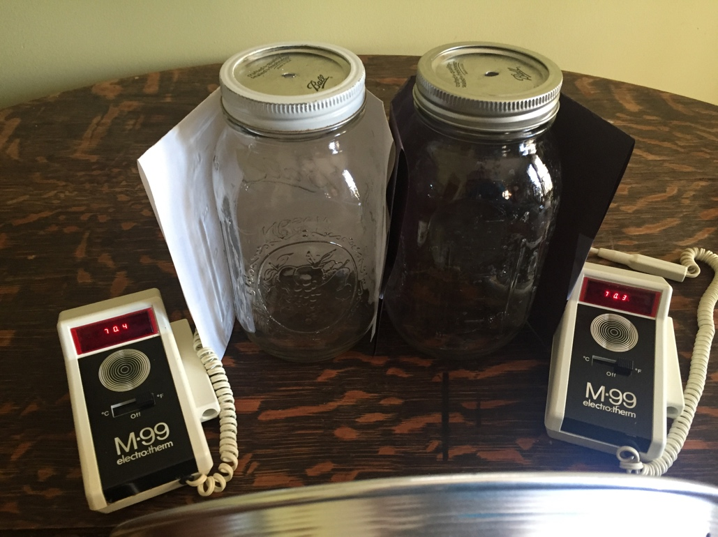

Materials needed:
- Two identical mason jars with lids. You should drill a hole in the top of each lid that is large enough for your thermometer to fit through.
- Two identical demonstration thermometers. Digital thermometers that can be connected to a computer and displayed on a projector are ideal, but any thermometer that fits into the jar will do.
- Two identical lamps are ideal. If you only have one lamp, you need to be very careful that both lamps are shining on the jars equally.
- Two pieces of construction paper: one black, one white.
- (Optional, large classes only) video camera to display the demonstration.

To prepare: Assemble the materials together as shown in the photo above. Be careful that the lamps are shining equally brightly on each of the mason jars so that both mason jars receive the same amount of light. It is important that you test this before class! If the black jar is receiving less light than the white jar, then the experiment WILL NOT WORK.

In-class:
1. Begin with the demo setup and both lamps off. Have a student or two read off temperature readings to confirm that the air inside both jars is the same temperature. Ask your students to write down a prediction about which jar will get hotter: one with black paper or one with white? Then turn on the lights.
2. While you are waiting for the temperature to rise in the mason jars, proceed with the Forcings and Feedbacks lecture by following the Unit 2 lecture notes and PowerPoint slides.
3. Look to see that the black mason jar has stopped heating up (there prompts to return to the demo in PowerPoint). The two jars have established new equilibria: both jars have warmed, and the black jar is warmer than the white jar because black absorbs while white reflects. The outcome of turning on the light differed because of the albedo of the surface. Connect this to the concept of “climate sensitivity” (the amount of warming that occurs for a doubling of carbon dioxide – it is difficult to determine precisely because of the many feedbacks in the climate system).

Note on demo timing: Depending on your set-up, this experiment may take more time to reach full equilibrium then you are wiling to give it in class. The experimental set-up above with 2 1-quart mason jars and a single 100W light bulb just a few inches from the jars took almost an hour to come to equilibrium (the final temperatures were 102 degrees Fahrenheit and 113 degrees Fahrenheit in the two jars). If you do not wait for a full equilibrium, this is ok. Students will be comfortable with your statement that the temperature won’t rise indefinitely (because equilibrium will eventually be reached), and that is the main take-home point. You can even make this a learning opportunity—it takes the climate system CENTURIES to fully reach equilibrium, meaning that the impacts of what we are doing now are long-term.

