Deuce Energy Handout

The Setting
Your company, Deuce Energy, and your rival, Ace Energy, are the two utilities operating in an economy, which has no regulations on carbon emissions at the present time. Each utility has been emitting 15 million tons of carbon each year in the past, but recently Congress has decided that the combined annual emissions of 30 million tons is harmful for human health. Consequently, Congress has passed a new regulation that limits emissions to 10 million tons total.

In order to comply with the new regulation, you have access to the following technologies: instituting demand-side management (DSM) options, concentrated solar power (CSP), and retrofitting coal-fired power plants (RCP). Your abatement costs, shown below, are private information and neither of the other players knows what they are.

Table 1: Deuce’s abatement options and their associated costs
Technology | Abatement potential  (millions of tons) | Total abatement costs (millions of dollars) | Marginal Abatement Cost  (dollars per ton)
DSM | 3 | 90 | 30
LFG | 8 | 1600 | 200
RCP | 15 | 6000 | 400

Your goal is to minimize the cost spent on complying with the law. Compliance costs have two components. You might decide to abate some of your emissions and pay taxes (or buy permits) for the amount you emit. You must account for both costs and must strive to minimize your overall compliance cost, which is the sum of your abatement cost and the tax liability/expenditure on permits.

Command and control (CAC)
CAC policies, such as Best Available Technology (BAT), typically ignore the cost to firms.

In the first round of the game, the regulator will choose a best-available technology, and mandate you and the other firm must employ it to abate 10 million tons each. You must calculate the cost of abating 10 million tons using the BAT and report it to the instructor.

Carbon taxes
In the second round of the game, the regulators will probe you to estimate your abatement cost curve. Here are some sample questions you may be asked:

- What is your total cost of reducing pollution by 5 million tons?
- What is the additional abatement cost of the 9 millionth ton?
- How many tons can you abate using DSM?
- What is the cost per ton of abating carbon if you use RCP?

Legally, you are not obligated to reveal your true costs and can misrepresent them in any way you deem fit if you think you will be able to reduce your compliance costs by doing so. Once you have answered the regulator’s questions, the regulator will announce a certain amount of carbon tax to be levied on each ton of your emissions. Based on the tax, you must calculate your optimal abatement strategy. This is done by considering the cost of abating versus the cost of emitting (which equals the tax). You should choose only those abatement options that are cheaper or as just as expensive as the tax.

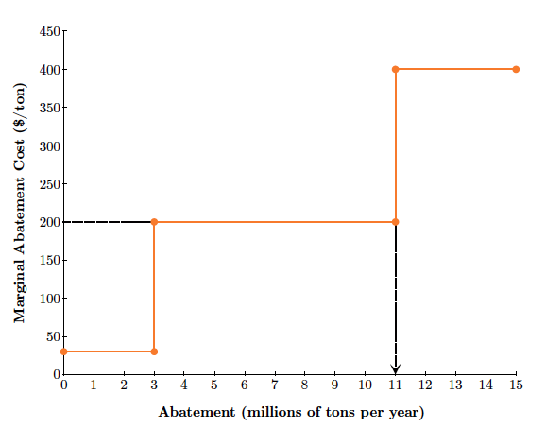

For example, if the regulator announces a tax of $200 per ton, you must choose only the DSM and LFG options; at $400 per ton, the RCP is much more expensive than simply emitting and paying a tax of $200 per ton (see figure). The figure shows that if the tax is set at $200 per ton, you will abate 11 million tons per year by deploying DSM and LFG, which will cost a total of $1.69 billion. On the remaining 4 million tons, you will pay the tax of $200 per ton, making your total tax liability $800 million. Thus, the overall cost of compliance for you will be $2.49 billion.

Calculate and report both these costs to the instructor after you have calculated your optimal abatement strategy.

Emissions trading
In this round of the game, the regulator will impose a direct emissions cap on you and your rival by allocating a specific amount of emissions permits. Since Congress has set a cap of 10 million tons annual, the regulator will release 10 permits, each of which allows its holder to emit 1 million tons per year.

The regulator may choose to either give away permits based on historical emissions, a practice known as grandfathering, or auction them off.
- If the permits are grandfathered, you and your rival will each get 5 permits.
- If the permits are auctioned, assign one member of your team to bid in the auction. This member should make sure they understand the rules of the auction and should try to procure the most number of permits at the lowest price. But, of course, your rival will be doing the same, so your representative will need to be smart and strategic, taking into account the firm’s abatement costs.

Once the permits have been distributed, you will need to decide if you want to trade any permits with your rival or not.
- If you decide not to trade any permits, calculate how many tons of emissions you need to abate, calculate your abatement and tax liability as before and report it to the instructor
- If you decide to trade some permits,
  - Calculate the cost of abatement for the last millionth ton abated
  - Calculates the cost of abating an additional million tons
  - Appoint a member of your team to negotiate the sale or purchase of a permit with the other team’s representative that make sense given these marginal costs.

When you and your rival are both ready, the instructor will open up the permit market and your negotiator should assess if you should buy or sell the other utility a permit. The point of this exercise is for a high-cost abater to buy a permit at a lower cost from the other firm and the low-cost abater to abate an additional million tons for profit. Your representative may ask the other utility’s representative questions like the following.
- What is the lowest price you would be willing to sell one permit for?
- What is the highest price you would be willing to pay for a permit?

Your negotiator should feel free to respond to any questions asked of them strategically, gradually evolving to an agreement. In the interest of time, the instructor may wish to limit these negotiations to five minutes. After you have struck a deal, calculate your abatement costs and the cost of buying permits (or the profits from selling permits), and report these to the instructor.

