Case Study: Climate, Biomes, and Equidae
In this activity, you will explore how environmental changes can shape life on Earth, using Equidae as a case study. By the end of the activity, you should be able to:
- Describe how biodiversity increases with the evolution of new species and is decreased by extinction;
- Evaluate evidence and propose ideas about why changing climatic conditions and an increase in grassland environments led to changes in horse morphology and diversity; and
- Recognize that scientific ideas are subject to change based on new evidence.

We will explore some patterns using the following diagrams. We will focus on the taxa shown with arrows below:
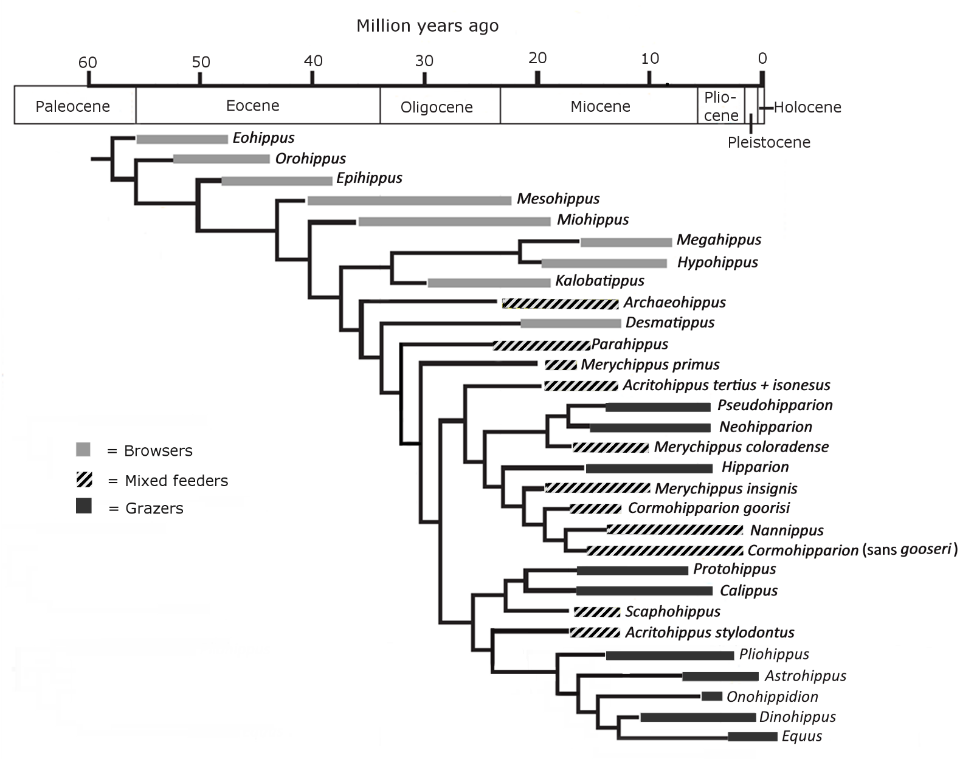

Figure 1. Family Tree of North American Equidae. Family tree after Mihlbacher et al., 2011. Information on diets from MacFadden, 2005 and the Paleobiology Database (paleobiodb.org).

Part 1: Climate, Grass, and Equidae
Take a look at Figure 2 below and answer the following questions.
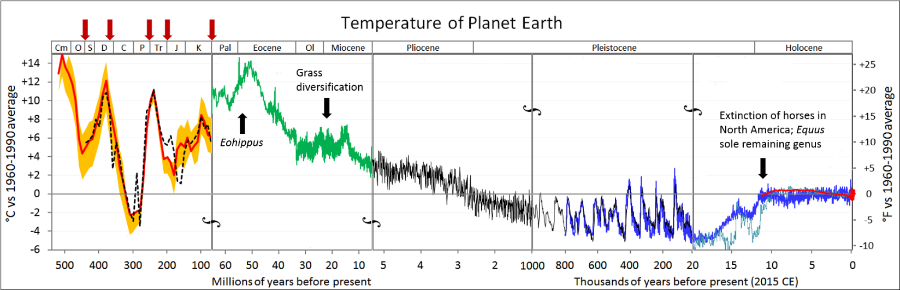
Figure 2. Temperature of Planet Earth. Temperature is shown as anomalies (differences) from the 1960–1990 average, so temperatures above the horizontal line are warmer than the 1960–1990 average and temperatures below the line are colder. Various colored lines indicate different data sets used to reconstruct temperatures (see original file for details). Red arrows show mass extinctions. Note changes in time scale at vertical breaks. Image modified from Glen Fergus, http://en.wikipedia.org/wiki/Paleoclimatology#/media/File:All_palaeotemps.png. Reuse is permitted under a Creative Commons Attribution-Share Alike 3.0 Unported license.
- Eohippus, also known by the name Hyracotherium, means Dawn Horse and is the earliest known horse genus. Eohippus was small, about the size of a small dog, and stood approximately 1-1.5 feet tall at the shoulder—tiny compared to modern horses! It appeared during the early Eocene and lived in forests.

What was the temperature of Earth like during the early Eocene? I.e., how would it compare to today?

- Fossil pollen tells us that the first grasses appeared as early as 80 MYA. It is thought that as they developed drought tolerance, grasses spread from forest margins into dry, open habitats. The grass family went through a major period of diversification and now includes over 10,000 species.

  - According to the graph above, when was the major period of grass diversification?

  - What was the general temperature trend during this time—warming or cooling?

- This period of grass diversification corresponded with an expansion in the areal extent of grass-dominated biomes (grasslands, savannas, and steppes) and a reduction in forested habitats. What happens to Equidae diversity shortly after this time? (Hint: examine the number of genera in Figure 1).

Part 2 – Equidae Tooth Morphology
In mammals, molars come in a variety of different shapes.
Brachydont teeth have short, low crowns covered in a cap of enamel (the hardest substance of which teeth are composed) that extends down to the gum line, and one or more well-developed roots. The chewing surfaces are usually pointed and tend to be good for tearing or shredding. Humans have brachydont teeth.
Hypsodont teeth have high crowns that extend far above the gum line, with enamel extending below the gum line. They are also have a hard protective coating of cementum. This arrangement provides extra material for wear and is common in mammals that eat food that is hard and abrasive. They tend to have flat chewing surfaces that are good for crushing and grinding.
Take a look at the illustration of Equidae teeth in Figure 3 below. You will want to match them to the animals in Figure 1 (where they are marked by the large arrows) to be sure you understand when they lived. The more square views below show the chewing surface of the tooth. The other views show the teeth from the side.
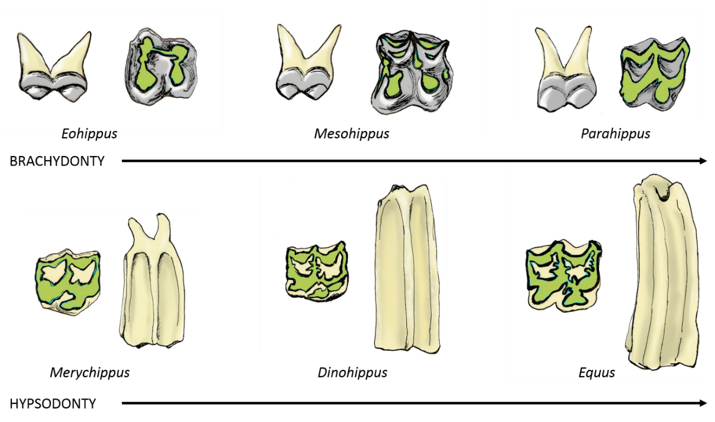
Figure 3. Equidae Teeth. Molars shown from the side and chewing surface. Gray = enamel, green = dentine, beige = cementum. Sizes not to scale to make details visible. Illustrations by Michelle Tribble, https://tribbill.wordpress.com/. Reuse is permitted under a Creative Commons Attribution-Non-Commercial-Share Alike 3.0 license.
- Describe the general changes in Equidae tooth morphology shown in the six taxa in Figure 3.

- How does the timing of these changes in tooth morphology relate to the timing of the expansion of grasslands? I.e., which type of teeth are more common in the early history of Equidae and which are more common after the diversification and expansion of grasses?

- Eohippus and Mesohippus were browsers, meaning they ate softer leaves, shoots, buds, and fruits. Parahippus was mostly a browser, but may have also eaten some grasses, which contain high levels of abrasive silica in their epidermal cell walls. Merychippus had some species that were mixed feeders, and others that were primarily grazers, meaning they ate grasses. Dinohippus and Equus were grazers. What might be some reason for the changes in teeth that you described above?

Part 3 – Equidae Foot Morphology

Examine the illustration of Equidae foot morphology in Figure 4 below. Again, you will want to match them to the animals in Figure 1 (where they are marked by large arrows) to be sure you understand when they lived.
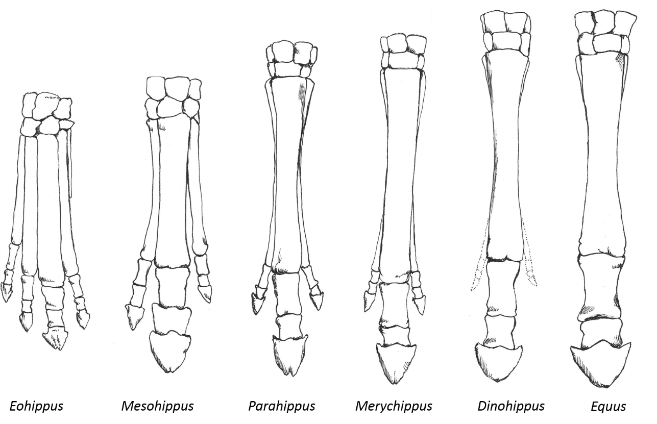
Figure 4. Equidae foot morphology. Sizes not to scale to make details visible. Illustrations by Michelle Tribble, https://tribbill.wordpress.com/. Reuse is permitted under a Creative Commons Attribution-Non-Commercial-Share Alike 3.0 license.

- Take a look at the foot of Eohippus in Figure 4 above. Unlike modern horses, which have bony hooves, its toes had fleshy pads. How many toes did it have on its front feet?

- What happened to the feet of the Equidae shown over time in terms of:

  - Toe number

  - Relative sizes of the individual toes

  - Length of feet

How might a drier climate and change from forests to grasslands have selected for these changes? The photos on the PowerPoint slide may help you to visualize the two different environments.

- Why might fleshy toe pads be advantageous in the forested environments early Equidae like Eohippus and Mesohippus lived in, but bony hooves be better suited to grasslands? (Hint: what is the ground like in forests vs. grasslands? Moist and spongy or dry and firmer?)

- Why might the expansion of grasslands have led to longer feet/legs in grassland environments? (Hint: think about how horses would escape predators in each environment and the need to cover distance).

Part 4 - Changing Ideas about Horse Evolution
We have explored some of the changes in horses including body size, diet, tooth characteristics, and foot/leg morphology. In the past, horse evolution was thought to have been a fairly linear process, with these changes happening in a single direction, for example from smaller to larger body size. With only a small set of fossils, this might appear to be the case, as in the set of species shown in Figure 5 below.
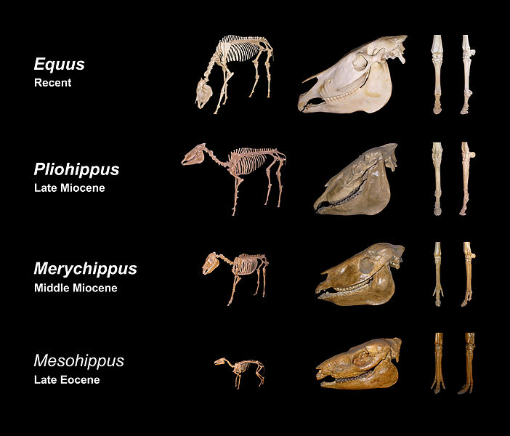
Figure 5. Equidae fossils from the State Museum of Natural History Karlsruhe, Germany. Image by H. Zell, http://commons.wikimedia.org/wiki/File:Equine_evolution.jpg. Reuse permitted under a Creative Commons Attribution-Share Alike 3.0 Unported license.

The Equidae skeletons in Figure 5 show a progressive increase in body size through time. Over time, more and more fossil horse taxa have been discovered. What happens when we look at a more complete set of Equidae sizes? Consider Figure 6 below.
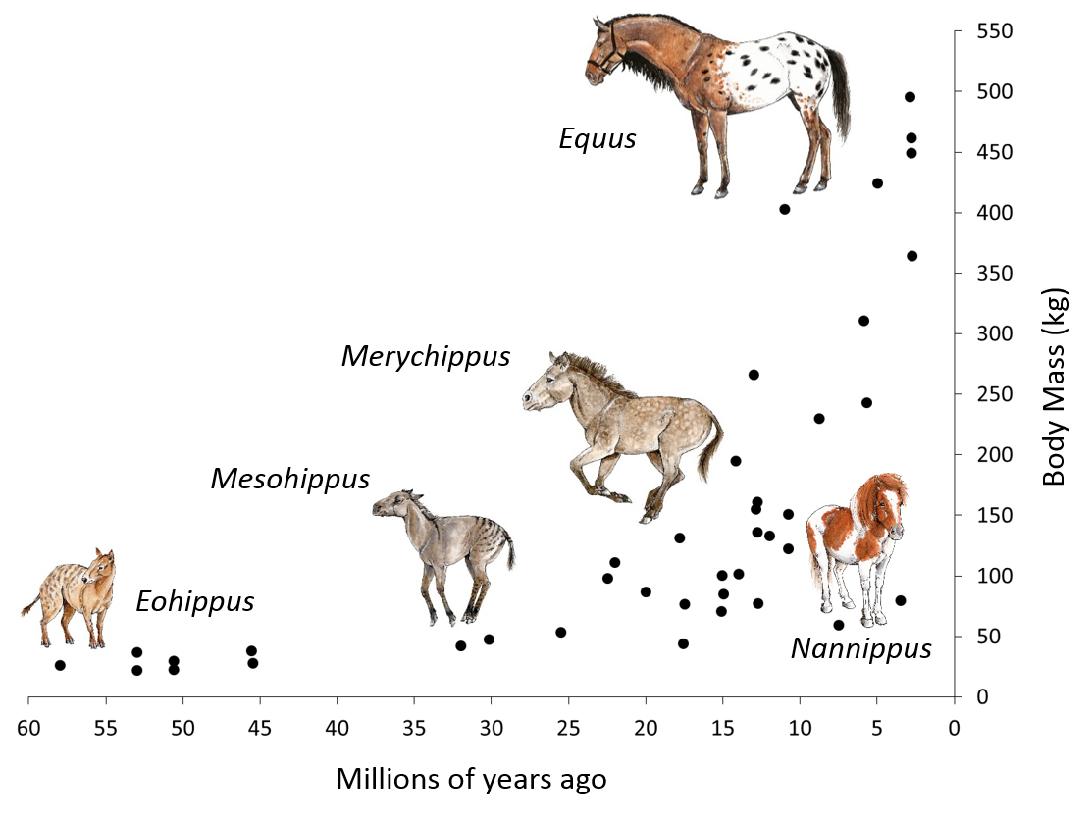
Figure 6. Body size of horses. Figure redrawn from data from MacFaddan (1986). Horse illustrations by Michelle Tribble, https://tribbill.wordpress.com/. Reuse is permitted under a Creative Commons Attribution-Non-Commercial-Share Alike 3.0 license.

- Does Figure 6 suggest a completely linear trend to increasing body size? Explain.

Figure 5, and many like it in older textbooks and museum displays, appears to show one taxa turning into another in a linear pattern. Indeed, horse evolution was previously thought to have been essentially unidirectional, with changes progressing in a straight line from Eohippus to the modern horse Equus.
- Compare and contrast Figure 5 and Figure 1. Does Figure 1 suggest evolution progressed linearly from Eohippus to Equus?? Why or why not? (Hint: does the Equidae family tree in Figure 1 look like a tree trunk that follows a straight line like the one shown by arrows in Figure 5? Or does it look more like a bush with lots of branches?)

So, although we do see overall trends in Equidae adaptations through time that can be correlated with changing global climates and habitats, with the discovery of more fossil horse taxa scientists now know that changes have not been unidirectional through time. For example, even though increases in size were common in most Equidae groups, decreases in size occurred in others such as Nannippus. We also see that the Equidae family tree is not straight, but has many branches. A key point is that scientific ideas are not fixed, but can and do change as new evidence is discovered.
Part 5 – A Brief History of Equus (modern horses)
One reason scientists previously thought horse evolution was fairly linear was the limited diversity of living Equidae today. How did this come to be?
- What happens to the number of horse genera from the late Miocene through the present day in North America? (Hint: refer to from Figure 1)

- While much of the evolutionary history of horses took place in North America, horses went extinct here and in South America, leaving Equus in Eurasia as the last surviving genus Equidae. According to Figure 1, approximately when does this occur?

This timing corresponds to the retreat of the most recent glacial advance as well as the arrival in North American of humans. The glacial-interglacial cycles can be seen in the saw-tooth temperature pattern in Figure 2. Equidae persisted throughout many previous glacial-interglacial cycles, so although it may have played a role, climate alone is unlikely to have caused the extinction without the new player in the game—human hunters. Overhunting by humans is thought to have played a key role in this extinction, which included 73% of megafauna in North America. It was not until Columbus that horses were reintroduced to North America from surviving Equus in Eurasia.
The fact that horses went extinct in North and South America and were absent until reintroduced by Spanish explorers is important because wild horses, which descended from these reintroduced domestic horses, are generally considered non-native by most state and federal wildlife agencies in the United States. Today there are more than 40,000 wild horses on public lands in the western United States. Because they are not considered “native,” they are not protected in the same way as native species and are subject to roundups and removal.
The Bureau of Land Management argues that there are more horses on rangelands than the land can support, while animal rights activists argue they should be protected like native species. What do you think?

Reflection (to be done individually)
- List five things you learned about horses today.

