**The Carbon Cycle and Intro to Feedback Loops**

This introductory reading is designed to provide you with some background information about the carbon cycle, permafrost, and the Arctic tundra that we will use to build **systems diagrams**. The reading also introduces modeling terminology (bolded terms defined in the glossary).

**Introductory video**

Watch the seven-minute video report, “Thawing Permafrost—Changing Planet” (<https://www.youtube.com/watch?v=yN4OdKPy9rM> or <https://science360.gov/obj/video/d8fe889b-8741-4a25-a68d-9541f1562b9b/thawing-permafrost>) for an introduction to the potential impacts of melting permafrost.

**Photosynthesis and stored carbon**

Plants and other photosynthetic organisms use energy from the sun to build high-energy carbon compounds from carbon dioxide that they take up from the atmosphere. Normally, these high-energy carbon compounds are only a temporary storage form of the carbon and energy they contain. Plants, animals, and decomposers will “burn” the organic carbon compounds in a process called respiration, using the energy and releasing the carbon dioxide back into the atmosphere. This **flux**, or movement of carbon between the atmosphere and biosphere, is an important part of the global carbon cycle. Fossil fuels— including coal, natural gas, and crude oil—contain carbon compounds that came from plants living hundreds of millions of years ago. The formation of large organic carbon **reservoirs** like those that produced fossil fuels removed some of the carbon from the atmosphere and stored it in Earth’s crust. When the net movement of a material is adding to a reservoir, we call it a **sink**. The swamps of the Carboniferous Period accumulated high- energy carbon compounds before they could be decomposed, thus removing carbon from the rest of the system. Now that we are mining and burning that stored energy and releasing carbon dioxide back into the atmosphere, the fossil fuel reservoir is acting as a **source**, and carbon is being added to the rest of the system.

Scientists are concerned about another large carbon reservoir that may begin to release stored carbon into the atmosphere. Permafrost—soils and sediments in the tundra that are perennially frozen—contains the remnants of plants and animals that have accumulated over thousands of years. Similar to the origins of fossil fuels, the high-energy carbon compounds stored in permafrost have accumulated for thousands of years without decomposing and act as a carbon sink.

**Major carbon reservoirs**

On Earth, there are four major reservoirs of carbon. They are 1) the oceans; 2) the atmosphere; 3) geosphere (including fossil fuels); and 4) the terrestrial biosphere (including plants, animals, and soils). Permafrost, part of the terrestrial biosphere carbon reservoir, holds half of the global terrestrial soil carbon and more than twice the carbon present in the atmosphere (Schuur, et al., 2015). Because permafrost currently stores more carbon than it releases, it acts as a carbon sink (Schaefer, et al., 2011). When permafrost melts, it releases carbon. In class, we will use systems diagrams to explore some of the changes caused by melting permafrost and how it might influence carbon movement between reservoirs.

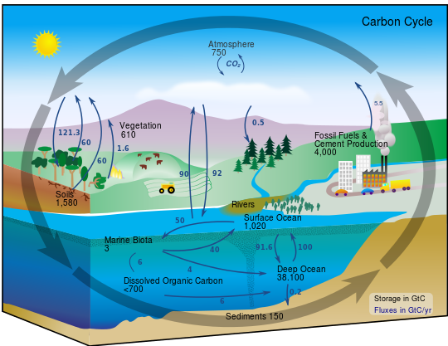

http://earthobservatory.nasa.gov/Library/CarbonCycle/carbon_cycle4.html

Figure 1: Carbon reservoirs.

**Feedback loops**

A feedback loop occurs when changes in one part of a system impact other parts of the system (cause and effect). Positive feedback occurs when an increase in one system component causes an increase in another part of the system. An example of a positive feedback loop is the influence of an increase in birth rate on population growth (Figure 2). Negative feedback occurs when a change in one system component causes a decrease in another part of a system. Temperature regulation by your body is an example of negative feedback (Figure 2). If your body temperature becomes too high, your brain activates sweating. When you sweat, you cool down. Positive feedback tends to promote growth of a trend while negative feedback tends to move a system toward equilibrium.

Figure 2: Positive (left) and negative (right) feedback loop examples

**Glossary of Systems Thinking Terms**

**Flux** – the movement of materials between different reservoirs. For example, photosynthesis and respiration play important roles in the annual carbon flux between the atmosphere and the biosphere.

**Reservoir** – places where materials collect and are stored. For example, about twice as much carbon is stored in the permafrost reservoir than exists in the atmosphere.

**Sink** – a reservoir that is accumulating material. For example, the permafrost is currently storing more carbon than it is releasing, so it is acting as a carbon sink.

**Source** – a reservoir that is releasing material. For example, burning fossil fuels contributes carbon to other parts of the system, so it is acting as a carbon source.

**Systems thinking** – studying the relationships and interactions among the components of a complex system. For example, understanding how carbon dioxide levels in the atmosphere are changing involves understanding how carbon moves between plants, permafrost, and the atmosphere.

**Systems diagrams** – representations of systems that provide information about the interactions between the components and allow us to explore how the systems will change over time. These will be introduced in more detail during class.

**References**

Schaefer, K., Zhang, T., Bruhwiler, L., & Barrett, A. P. (2011). “Amount and timing of permafrost carbon release in response to climate warming.” *Tellus B, 63*(2), 165-180.

Schuur, E. A. G., McGuire, A. D., Schädel, C., Grosse, G., Harden, J. W., Hayes, D. J., ... & Vonk, J. E. (2015). “Climate change and the permafrost carbon feedback.”

*Nature*, *520*(7546), 171-179.

Thompson, A. (Reporter). 2011, March 25. Thawing Permafrost. [Television series episode]. NBC Learn. Retrieved from https://www.youtube.com/watch?v=yN4OdKPy9rM  
A transcript of the video is available - https://nbclearn.com/files/nbcarchives/site/pdf/52627.pdf

Please complete this reading guide and bring it to class.

1. What is the main idea of the video?
2. What are the large carbon reservoirs on Earth?

1. Indicate if the following carbon reservoirs are currently acting as carbon source or sink.
   1. Fossil fuels

* 1. Permafrost

1. What will happen to the amount of carbon in the atmosphere if a significant volume of permafrost melts?
2. What will happen to Earth’s temperature if the amount of carbon in the atmosphere increases?
3. Describe an example of a positive feedback loop other than birth rate.
4. Describe an example of a negative feedback loop other than body temperature.