Spring 2015 InTeGrate Exercise on Climate Departure for Biology Students
Reading Assignment:
- Airplane Engine Dilemma Handout (Read and answer all questions; be prepared to discuss)
- MinnPost Article on Climate Departure (Read and be prepared to discuss)
  - http://www.minnpost.com/earth-journal/2013/10/new-look-climate-tipping-points-where-familiar-patterns-vanish-forever
- Briefly scan the Nature Article on Climate Departure (Mora et al., 2013)
  - http://www.soc.hawaii.edu/mora/PublicationsCopyRighted/Paper.html or
  - http://www.nature.com/nature/journal/v502/n7470/full/nature12540.html
- Group discussion questions below (Look over prior to class)
GROUP DISCUSSION QUESTIONS RELATED TO NATURE ARTICLE ON CLIMATE DEPARTURE
Nature magazine (C. Mora et al, Nature, Oct 10, 2013, Vol 502, pg. 183). We don't expect you to read the entire article from Nature (however, you are probably in a position to read this), please answer the following:
1. Read through and discuss the grey abstract (1st page) and first two paragraphs. What is the goal of this research paper?

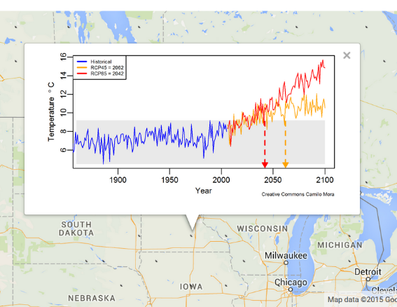
2. Carefully read the text and figure captions for Figure 1 (especially Figure 1a). How would you describe what is meant by Figure 1a in a slightly less “scientific” form that might be better understood by your friends, relatives or parents. In particular, what is plotted in the grey box? What does the red-line and red arrow on the graph mean? Attached is a climate departure plot for southern Minnesota. How would you describe this rather shocking result to another student at Gustavus?

3. Read the first paragraph of the "The Timing of Climate Departure" section on bottom of Page 2 and top of Page 3. How would you restate their results?
4. The Extended Data Table 1 on page 13 outlines all of the computer simulations used. What do you notice about the range of countries where these models have been developed? Do you think that it is possible that researchers from these countries could somehow conspire to obtain funding that produced similar results?

5. Read the caption for Figure 2a. What is shown in this figure?

6. Shifting to biology, look at Figure 3. In what year, on average, does climate departure take place for Coral Reefs and Mangroves if we follow “business as usual” path RCP85? What about terrestrial mammals, and terrestrial or marine birds? How much do these change if we aggressively cut carbon emissions to get to the RCP45 scenario?
7. To understand how they arrived at Figure 3, first look at Extended Data Figure 5 (Page 11) and describe what is shown in the many illustrations. What do they mean by biodiversity hot spots? Where are biodiversity hot spots for Coral Reefs and Mangroves compared to terrestrial mammals, and terrestrial or marine birds?
8. Now compare the diagrams shown in Figure 2a, Figure 3, and Extended Data Figure 5 (Page 11). Based on these figures, why are Coral Reefs impacted by climate change much sooner than terrestrial or marine birds?
9. Choose a biological species that you are interested in, and determine the approximate geographic region of its habitat. The group that published this Nature article has a website where you can select a location on earth and it will show the results of one of their 39 climate departure simulations (the results in the paper are the average of all of the extensive models that they ran).
http://www.soc.hawaii.edu/mora/PublicationsCopyRighted/Data.html
Using the link above, choose locations in the world map that correspond to your species’ habitat. Roughly when does climate departure occur for this species?

Tom Huber
Physics Department
Gustavus Adolphus College
huber@gustavus.edu
April 26, 2015

