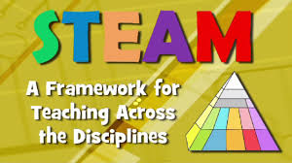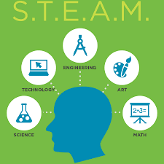
STEAM Professional Development
Agenda for May 3, 2016
9:00 am – 12:30 pm

Event | Elementary, Middle, High |  | When
REGISTRATION AND INTRODUCTION | Getting to know you |  | 9:00 – 9:30  Room BE012
STEAM PD Sessions | Three Sessions (Rotate every 45 minutes)  - H-App-y Hour: Free Educational Apps for the iPad  with Dr. Jabari Cain  - How Strong is a Worm? A Gummy Worm That Is  with Dr. Clemmie Whatley  - InTeGrate: Soils, Systems, and Society: An inquiry-based learning module for K-12 teachers featuring the images from Lexicon of Sustainability  with Dr. Colleen Stapleton  and dr. deb rosenstein |  | 9:30 – 11:55  Small Group  Rotation
WRAP UP Reflection, feedback and closure 12:00 – 12:30 BE 012
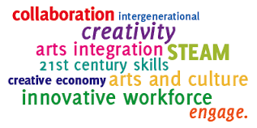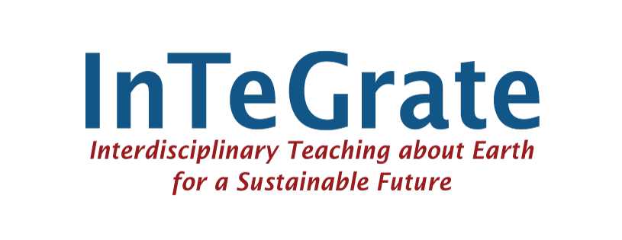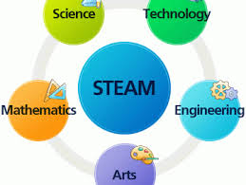

Orange Group

9:30 – 10:15
H-App-y Hour: Free Educational Apps for the iPad
with Dr. Jabari Cain in BE004

10:20 – 11:05
How Strong is a Worm? A Gummy Worm That Is
with Dr. Clemmie Whatley in BE005

11:10 – 11:55
InTeGrate: Soils, Systems, and Society: An inquiry-based learning module for K-12 teachers featuring the images from Lexicon of Sustainability
with Dr. Colleen Stapleton and dr. deb rosenstein in BE115

Red Group

9:30 – 10:15
How Strong is a Worm? A Gummy Worm That Is
with Dr. Clemmie Whatley in BE005

10:20 – 11:05
InTeGrate: Soils, Systems, and Society: An inquiry-based learning module for K-12 teachers featuring the images from Lexicon of Sustainability
with Dr. Colleen Stapleton and dr. deb rosenstein in BE115

11:10 – 11:55
H-App-y Hour: Free Educational Apps for the iPad
with Dr. Jabari Cain in BE004

Green Group

9:30 – 10:15
InTeGrate: Soils, Systems, and Society: An inquiry-based learning module for K-12 teachers featuring the images from Lexicon of Sustainability
with Dr. Colleen Stapleton and dr. deb rosenstein BE115

10:20 – 11:05
H-App-y Hour: Free Educational Apps for the iPad
with Dr. Jabari Cain in BE 004

11:10 – 11:55
How Strong is a Worm? A Gummy Worm That Is
with Dr. Clemmie Whatley in BE005

