Department of Mathematics, Science, and Informatics
ENVS 210 Physical Aspects of the Environment
HYBRID (some class meetings will be carried out online)

Fall 2016, 1st session, Atlanta, Thursday, 6 pm – 10:45 pm and modified. See schedule for details.
Instructor: Dr. Colleen P. Stapleton
Office and phone: Atlanta Campus, Rm 412, 678-547-6565
Atlanta general: 678-547-6411, fax: 678-547-6575
E-mail: stapleton_c@mercer.edu
Office hours: Mon., Wed., Thurs., 2-6 pm, AACC 412; and by appt.

Of all the paths you take in life, make sure a few of them are dirt. – John Muir

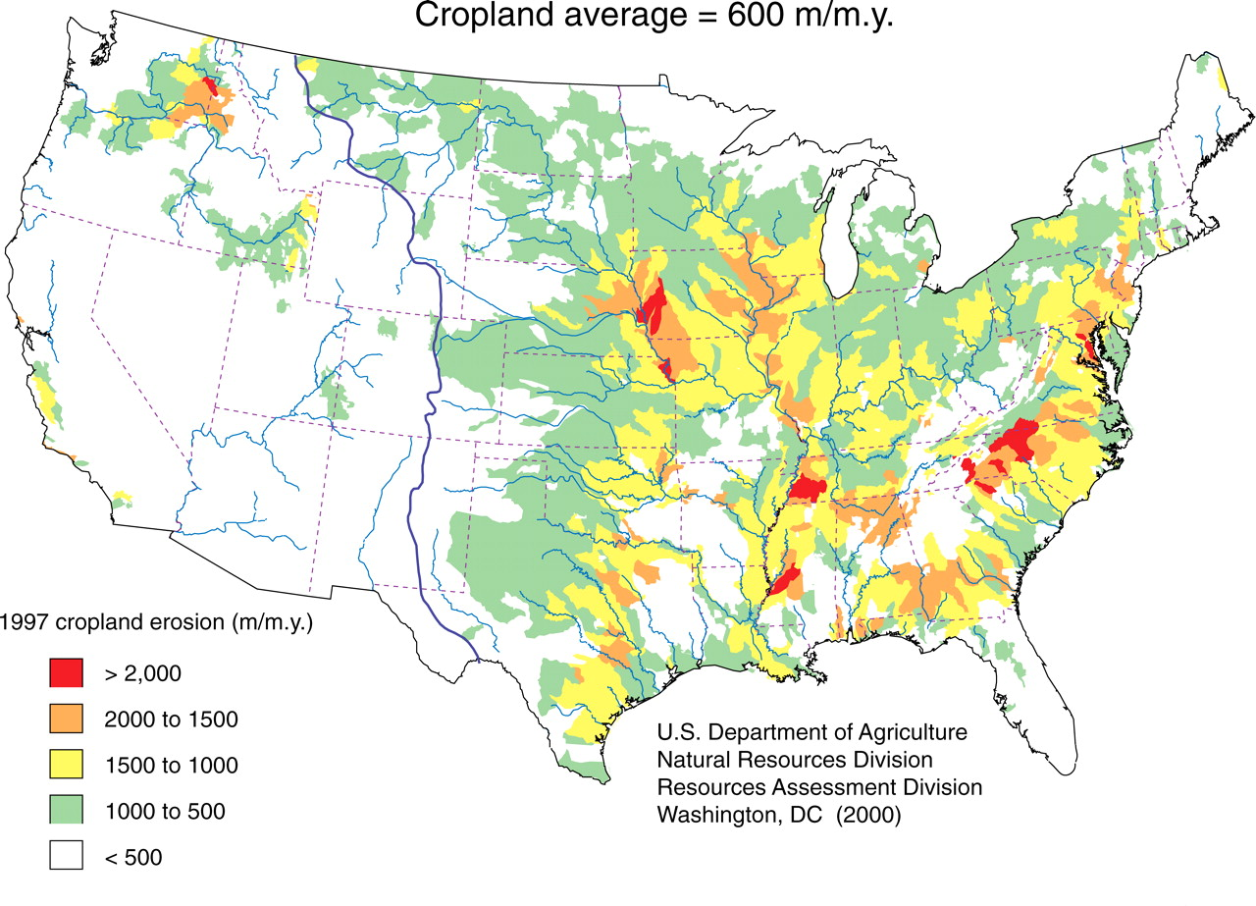
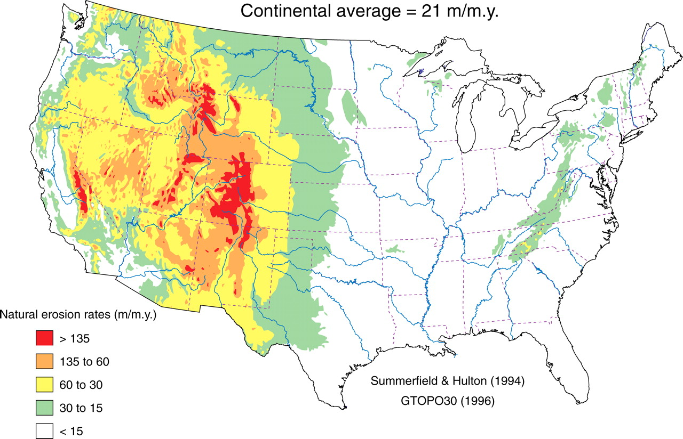
Figure 1 From Wilkinson & McElroy, 2007 GSA Bulletin Jan/Feb, 207 vol. 119 no. 1-2, 140-156.

Course Description
Prerequisite: SCIE 100.
Natural and human-induced changes in Earth’s atmosphere, hydrosphere and geosphere will be studied through lab experiments, field observations, and/or scientific analyses of physical and chemical parameters of these systems. Students will interpret data to determine how changes may be produced by natural events, such as earthquakes or floods, and human activity, such as mining or farming, and how changes may be mitigated or resources sustained. Integrated lecture/laboratory.

Course Objectives
By the end of this course, students should be able to:
1. Analyze and interpret environmental science data to assess the quality of an environment;
2. Synthesize scientific data to assess potential environmental problems in the hydrosphere, geosphere, or atmosphere of an area;
3. Develop possible mitigation for an environmental hazard in the hydrosphere, geosphere, or atmosphere, or possible steps for sustaining a natural inorganic resource;
4. Evaluate the current and future effects of human activity on the physical and chemical characteristics in the hydrosphere, geosphere, or atmosphere;
5. Critically assess interpretations and conclusions based on environmental science data.
6. Interpret causes of and evaluate (possible) mitigation of land and coast erosion, and water and air quality changes; assess sustainability of resources used in energy, mining, and waste management.

Mandatory Course Resources
Access to internet-connected computer with speakers. Computers are available at Mercer’s computer labs: http://it.mercer.edu/student/academic_technology/computer_labs.htm

Online resource A Growing Concern
http://serc.carleton.edu/s/integrate/sustain_agriculture/index.html

Online resource Map Your Hazards: http://serc.carleton.edu/s/integrate/map_hazards/index.html

Blackboard Our course “website” is Blackboard, which contains course materials including class and homework instructions, links to our online resources.

To find and login to our Blackboard:
1) Go to: https://bb-mercer.blackboard.com
2) Username: Mercer ID Number (MUID)
3) Password: six-digit birth date in YYMMDD

Some VERY USEFUL Blackboard tutorials including how to log in and upload assignments:
http://it.mercer.edu/student/academic_technology/tutorials.htm
http://ondemand.blackboard.com/students.htm

For technical help with Blackboard, including logging in, please contact Mercer IT for help:
Phone (Atlanta): (678) 547-8989
Email: helpdesk@mercer.edu
Walk-in: Swilley Library, 108: M–F, 8 am – 5 pm. General:http://it.mercer.edu/student/academic_technology/blackboard.htm

SafeAssign, in Blackboard We will use this as a tool to learn how to give proper credit to others when it is due. Please follow directions for each assignment--some assignments will not require SafeAssign.

Supplementary and Recommended Course Resources: Mercer's Writing Lab, Online Resources
Mercer's Writing Lab You can send written work for evaluation to Mercer's Online Writing Lab (OWL) or go to the walk-in writing lab.
On-line Tutoring Lab (OWL):
http://www.mercer.edu/arc/OWL/index.html
Writing lab walk-in schedule:
http://www.mercer.edu/arc/Tutoring/index.html

Earth Revealed online on-demand videos: http://www.learner.org/resources/series78.html

The Habitable Planet online text, on-demand videos: http://www.learner.org/courses/envsci/index.html
This resource contains online text chapters, videos, animations, and other activities.

Course Delivery Method
This course is a hybrid course. A hybrid course combines face-to-face classroom instruction with online learning. A pre-determined amount of the learning activities will take place online and in a traditional classroom. The online activities will be asynchronous. Asynchronous activities will require students to participate in online learning activities; however, these activities are not real-time and do not require you to be online on a certain day/time. Asynchronous activities can include discussion forums, blogs, journals, wikis, etc.

A hybrid course provides students with flexibility by replacing a number of face-to-face traditional classes with engaging online instructional activities. A hybrid course requires that you work on your own or as part of a virtual group at a computer in addition to scheduled regular classroom meetings. In order to be successful in a hybrid course, you must:
• Manage your time effectively and efficiently;
• Take increased responsibility of your learning;
• Fully engage in learning activities (online and face-to-face);
• Be self-motivated;
• Be willing to learn independently.

While participating in an online communication, it is important to remember that you are engaged in an academic learning activity. This differs greatly from an online social environment with people you know very well. Do not assume that everyone is familiar with acronyms, abbreviations and emoticons used in electronic communication. Here is a link to a source for generally accepted behavior in an online academic environment: http://www.albion.com/netiquette/corerules.html.

Classroom and Attendance Policy
1. Students are responsible for keeping all graded coursework until the grade appeal period is over.
2. The class schedule handed out on the first day of class is a tentative schedule.
3. Students are responsible for information in all assigned readings, handouts, labs, videos, lectures, and other materials assigned by the instructor.
4. Attendance is mandatory for all classes. Student attendance will be noted for each class meeting. Missing a class, arriving late to class, or leaving class early can result in a grade of “0” for that day and for any work scheduled or due. Exceptions will be made in the event of emergencies or medical reasons. Acceptable reasons for absences will be determined by the instructor on a case-by-case basis.
5. Late assignments will not be accepted. Work is due as scheduled. Computer problems are not acceptable excuses for not turning in work. Missing a class is not an acceptable excuse for not turning in work. Even if you miss a class, any work due must be handed in by the deadline. If you miss a class, check the syllabus, Blackboard, your class colleagues to find out what is due in the following week.
6. Make your own arrangements to get class notes and handouts if you miss class. You are responsible for obtaining handouts, notes, and information that you miss.
7. You must attend the whole last class in order to get credit for your final assignments. No exceptions.
8. Students are expected to be courteous to their colleagues and instructor.
9. Academic honesty and integrity, as specified in the Honor Code of Penfield College and the Regional Academic Centers, are required and expected of each student. Violation of this code, including plagiarism, on any work I assign in this class may result in a grade of "F" assigned for the assignment or the entire course. Because this class uses cooperative discovery as one of its primary teaching and learning tools, students must respect each other, contribute mutually to class activities, give proper credit to others when it is due, and take responsibility for their own actions. In preparing any assignments, students may draw upon any legally available resources for research and preparation. However, submitted materials must represent student work and contain proper attribution and citation for the work of others. Institutional procedures relevant to the Honor System and Academic Integrity can be found on the Provost website at http://provost.mercer.edu/handbooks
10. Students requiring accommodations for a disability should inform the instructor as early in their matriculation as possible or by the close of the first class meeting. The instructor will refer you to the Disability Support Services Coordinator to document your disability and determine eligibility for accommodations under the ADAAA/Section 504. In order to receive accommodations in a class, students with sensory, learning, psychological, physical or medical disabilities must provide their instructor with a “Faculty Accommodation Form” from Disability Support Services. Students must return the completed and signed form to the ACCESS Coordinator (208 Sheffield Center). A new form must be requested each semester. Students with a history of a disability, perceived as having a disability or with a current disability who does not wish to use academic accommodations are also strongly encouraged to register with the ACCESS and Accommodation Office and request a Faculty Accommodation form each semester. For convenience, anyone can send this information through Campus Mail; fax the form to (678) 547-6373 or e-mail the form as an attachment to stilley_r@mercer.edu.
Even students with a documented disability who do not wish to use academic accommodations are strongly encouraged to register with Disability Support Services and complete a Faculty Accommodation Form each semester. For further information, please contact: For Atlanta, Douglas, Henry, and Newnan: Richard Stilley, ACCESS and Accommodation Coordinator / Assistant Dean for Campus Life, at (678) 547-6823, by email at Stilley_R@Mercer.edu, or visit the website at http://atlstuaffairs.mercer.edu/disability-servicescfm
Also see ACCESS website http://www.mercer.edu/disabilityservices .

Grading policy
A – Thorough, creative, connects assignment/course subjects to topics from outside of course. Awarded for work which far exceeds the minimum expectations for assignment/course, not only by doing all that is asked, but by demonstrating superior skill, thoroughness, independence of thought, and creativity. Work is free of errors including spelling, grammar, and scientific errors, looks neat, and contains relevant references.
B – Disciplined work with very minor errors, some creativity, exceeds expectations met. Above average grasp and mastery of subject matter, evidenced not only by meeting the basic objectives but also by showing some initiative in pursuing lines of inquiry and some creativity in the use of new understandings outside of classroom experience.
C – Satisfactory work, expectations met. Basic objectives of the assignment/course have been achieved. Student has demonstrated satisfactory mastery of the material. This grade level indicates that the minimum expectations have been met. This is a very respectable grade. In an assignment, there may be a few errors.
D – Below expectations for college-level work. Work is passing but below average competency for college students. Student receiving this grade has not exerted a level of effort or expertise which is expected of the average college student. This level of work is often largely incorrect, minimally thought-out, or incomplete. In a course, not all work has been handed into the instructor on time.
F – Lack of command over assignment/course. This work does not meet the minimum expectations of the assignment/course, demonstrates an unjustifiable lack of command over material, and a significant absence of effort on the part of the student. In a course, not all work has been handed into the instructor on time.

Grade % Score
A 91-100
B+ 86-90
B 81-85
C+ 76-80
C 70-75
D 60-69
F <60

Grading formula
Course component % of Total Grade
Growing Concern Unit 2 Homework 5
Growing Concern Unit 3 Homework 5
Growing Concern Unit 4 Whole Unit 10
Growing Concern Unit 5 Pre-work 5
Growing Concern Unit 5 Homework 5
Growing Concern Unit 6 Homework 5
Map Your Hazards Unit 1: Part A,1/2 B 5
Map Your Hazards Unit 1: Completed 5
Map Your Hazards Unit 2: In class 10
Map Your Hazards Unit 2 Completed 10
Map Your Hazards Unit 3: Slides 5
Map Your Hazards Unit 3: Presentation InClass 5
Field Trip 5
Growing Concern Unit 6: FINAL version 20

Attendance: Weeks 1, 3, 5 in class, Week 7 at field site; Weeks 2, 4, 6, and 8 online.
You will need to do the activities in our face-to-face meetings in order to complete other course assignments. Please see “Classroom and Attendance Policy” above to find out how I work with absences.

Instructional Activities
1. Growing Concern
We will study soil as a natural resource through class discussions, lab activities and group activities. Detailed instructions will be handed out in class and online. See our course Blackboard site for details. Some student materials are here: http://serc.carleton.edu/s/integrate/sustain_agriculture/index.html
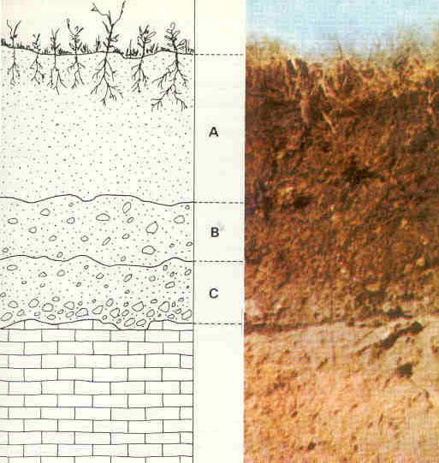
http://serc.carleton.edu/download/images/48217/soil_horizons_identified_trans.jpg
Accessed 25 August 2016 13:40.

2. Map Your Hazards
We will study the risks of environmental problems and vulnerabilities of people in our own communities to those problems. Detailed instructions will be handed out in class and online. See our course Blackboard site for details. Some student materials are here: http://serc.carleton.edu/s/integrate/map_hazards/index.html
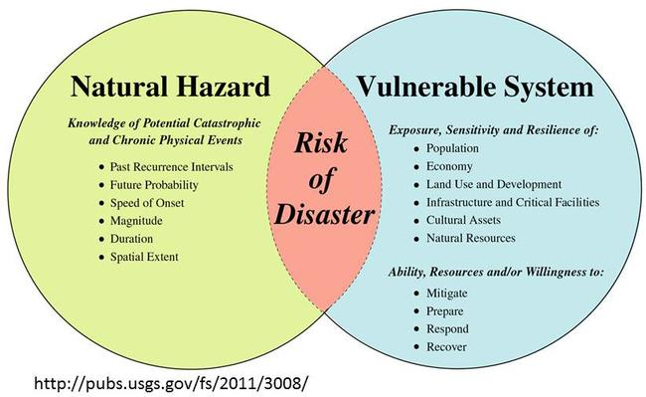
Recreated by Brittany Brand from Wood, Nathan, 2011, Understanding risk and resilience to natural hazards: U.S. Geological Survey Fact Sheet 2011-3008, 2 p.

Direct Instruction
Mercer University requires 2250 minutes of direct classroom instruction (the equivalent of 4 ¾ hours per 8 week class and 750 minutes of direct instruction per credit hour) and 4500 minutes of out-of-class student work for each 3 credit hour course. Faculty members are required to include on the syllabus the amount of out-of-class direct instructional minutes per experience/activity (over and above the 4500 min of out-of-class student work for each 3 credit hr course).
Direct instructional activities for this course:
1125 min Group work
562 min Online data collection/analysis
563 min Case studies

PLAGIARISM -- Rules for all work you turn in:
Do not copy other people's sentences or phrases without giving them credit. This includes sentences where you change a few words and then include the slightly modified sentence in your paper.

If you use information from sources other than your own brain, you must make a reference to the source. Nobody is born with knowledge of everything, so I expect to see references in your homework. I expect you to include references and citations in your main class projects. See Blackboard for information for specific assignments.

If an assignment contains plagiarized material, the assignment may receive a grade of zero (0) and you may receive a course grade of "F". This includes text, tables, data, and images.

If a lot of an assignment consists of quotes from other people's work, then your paper will receive a D, even if the quotes are referenced. If the majority of your paper consists of other people's work and also cite the work (i.e., identify where that quote is from), this will be given a grade of zero (0).

We will use SafeAssign in Blackboard for certain work. Instructions on how to use this are in Blackboard.

Course Outline

Numbers in front of a line are the points available for that activity.

Week Topic
Week 1 Sustaining a Natural Resource IN CLASS Aug. 25
In-class pre-survey
InTeGrate: A Growing Concern
Unit 1: Impacts of Land Use
Unit 2: Soil Characteristics and Their Relationship to Land Use Practices
Unit 3: Natural and Agricultural Erosion Rates

Week 2 Sustaining a Natural Resource ONLINE Sept. 1
InTeGrate: A Growing Concern
Unit 4: Using SoilWeb to Investigate the Soil Beneath You

Work due
DUE: Sunday, Sept. 4, midnight
5, Growing Concern Unit 2 Homework: Soil Compaction and NebGuide. Instructions in Blackboard.
5, Growing Concern Unit 3 Homework: Instructions in Blackboard.
10, Growing Concern Unit 4: Using SoilWeb. Instructions in Blackboard.

DUE: Wednesday, Sept. 7, midnight
5, Growing Concern Unit 5 Pre-work: RUSLE Factors. Instructions in Blackboard.

Week 3 Sustaining a Natural Resource IN CLASS Sept. 8
5, Atlanta Campus Field Trip. Assuming weather is good. Meet in classroom and we will go from there.
InTeGrate: A Growing Concern
Unit 5: Predicting the Effects of Climate Change on Soil Loss
Unit 6: Creating an Agricultural Fact Sheet
Virtual Field Trip: Providence Canyon, GA

Work due
DUE: Sunday, Sept. 11, midnight.
5, Growing Concern Unit 5 Homework: Soil Erosion, Climate, and Humans. See Blackboard.
5, Growing Concern Unit 6 Homework: Draft Agricultural Fact Sheet. Instructions in Blackboard.
Heads-up: A final version of the Fact Sheet is due on the last day of class.

Week 4 Locating and Mapping Environmental Hazards ONLINE Sept. 15
InTeGrate: Map Your Hazards
Unit 1: Hazards, Vulnerability and Risk

Work due
DUE: Sunday, Sept. 18, midnight
5, Map Your Hazards Unit 1: Complete Part A and at least half of Part B.1. See Blackboard.

DUE: Wednesday, Sept. 21, midnight
5, Map Your Hazards Unit 1: All of Unit 1 completed. Instructions in Blackboard.

Week 5 Understanding Hazards, Vulnerability and Risk Data IN CLASS Sept. 22
5, Possible alternative day: Atlanta Campus Field Trip.
InTeGrate: Map Your Hazards
10, Unit 2: Perception of Hazards, Vulnerability and Risk

Week 6 Analyzing Vulnerability and Risk Data ONLINE Sept. 29
InTeGrate: Map Your Hazards
Unit 2: Perception of Hazards, Vulnerability and Risk
Unit 3: Translate the Message

Work due
DUE: Sunday, Oct. 2, midnight
10, Map Your Hazards Unit 2 Homework: Complete data analysis. Instructions in Blackboard.

DUE: Wednesday, Oct. 5, midnight
5, Map Your Hazards Unit 3: Translate the Message. Slides due. Instructions in Blackboard.

Week 7 Informing Stakeholders of Environmental Hazards IN CLASS and FIELD TRIP Oct. 6
5, Possible alternative day: Atlanta Campus Field Trip.
InTeGrate: Map Your Hazards
5, Map Your Hazards Unit 3: Translate the Message. Group Oral Presentation. Instructions in Blackboard.
In-class post-survey.
Reflection.

Work due
DUE: Thursday, Oct. 13, midnight
20, Growing Concern Unit 6: FINAL version of Agricultural Fact Sheet. Instructions in Blackboard.
Post-instruction surveys. Instructions in Blackboard.

Week 8 Analyzing and Interpreting Community Preparedness ONLINE Oct. 13
Growing Concern Fact Sheet
Providence Canyon, GA

REPEAT Work due
DUE: Thursday, Oct. 13, midnight
20, Growing Concern Unit 6: FINAL version of Agricultural Fact Sheet. Instructions in Blackboard.
Post-instruction surveys. Instructions in Blackboard.

