Department of Mathematics, Science, and Informatics
PHYS 106 Earth Systems Science Syllabus
HYBRID course (some class meetings will be carried out online)

Session: Spring 2016, 1st session
Meeting time: Mon., 5:30-10:15 pm and online
Location: AACC room 165
Instructor: Dr. Colleen P. Stapleton,
Office: Atlanta Campus, AACC Rm 412
Office and phone: 678-547-6565
E-mail: stapleton_c@mercer.edu
Office hours: W/Th, 1-6 pm, ATL/AACC 412; M 4:30-5:30, Douglas RAC; and by appointment.

Course Description
Prerequisite: SCIE100.
Students will examine how natural processes of Earth's geosphere, hydrosphere, and atmosphere interact. Interactions that change the chemical compositions and physical features of those systems, shape the planet's surface, and affect weather and climate will be investigated. Students will engage in experiments and field work to collect and analyze scientific data to model Earth's systems and their interactions. Students will also interpret scientific data to explain changes in Earth's geosphere, hydrosphere, and atmosphere through time. Integrated lecture/laboratory course. Laboratory fee.

Course Objectives and Student Learning Outcomes
The Earth can considered a system that is composed of a number of sub-systems that interact with each other, hence our course title: Earth Systems Science. The solid part of the Earth is called the geosphere. The rivers, lakes, and oceans compose most of the hydrosphere. The large reservoir of gases that float above our lithosphere (and only stick around because of the pull of Earth's gravity) is called the atmosphere. In this class, we will examine how all of these parts interact with each other. By the end of this course, students will be able to:
1. describe how processes such as earthquakes, volcanoes, and mountain building act in the solid Earth; explain how they relate to plate tectonics
2. describe how water changes phase as it cycles through Earth’s systems; interpret how water changes these systems
3. describe chemical and physical properties of Earth's oceans; explain how these influence weather, climate, and landscapes
4. describe structure and composition of Earth's atmosphere; explain how it has changed through time by interaction with the Earth’s systems
5. state the age of Earth and describe how this is determined
6. describe Earth's geologic history
7. use scientific methods to identify minerals, rocks, sediments, and fossils
8. interpret Earth science data, including geologic maps, satellite images, and climate variables.
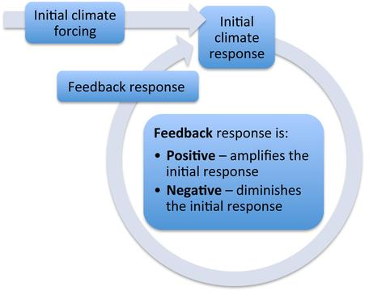
Mandatory Course Resources: Blackboard, Additional Readings
Blackboard Our course “website” is Blackboard. It contains course materials including class and homework instructions, study guides, links to some text resources, and online visual materials and videos. To find and login to our Blackboard:
1) Go to: https://bb-mercer.blackboard.com
2) Username: Mercer ID Number (MUID)
3) Password: six-digit birth date in YYMMDD

Some VERY USEFUL Blackboard tutorials including how to log in and upload assignments:
http://it.mercer.edu/student/academic_technology/tutorials.htm
http://ondemand.blackboard.com/students.htm
For technical help with Blackboard, including logging in, please contact Mercer IT for help:
Phone (Atlanta): (678) 547-8989
Email: helpdesk@mercer.edu
Walk-in: Swilley Library, Ste 108: M-F, 8 am-5 pm
http://it.mercer.edu/student/academic_technology/blackboard.htm

Online Readings and Resources
“Climate of Change” located here:
http://serc.carleton.edu/s/integrate/climate_change/index.html
“Humans’ Dependence on Mineral Resources” located here:
http://serc.carleton.edu/s/integrate/mineral_resources/index.html

Supplementary and Recommended Resources: Mercer's Writing Lab, Online Resources
Mercer's Writing Lab You can send written work for evaluation to Mercer's Online Writing Lab (OWL) or go to the walk-in writing lab.
On-line Tutoring Lab (OWL):
http://www.mercer.edu/arc/OWL/index.html
Writing lab walk-in schedule:
http://www.mercer.edu/arc/Tutoring/index.html
Earth Revealed online on-demand videos: http://www.learner.org/resources/series78.html
The Habitable Planet online text, online videos: http://www.learner.org/courses/envsci/index.html
This resource contains online text chapters, videos, animations, and other activities. We will mainly use the chapters and videos, which contain the same information.

Classroom and Attendance Policy
1. Students are responsible for keeping all graded coursework until the grade appeal period is over.
2. The class schedule handed out on the first day of class is a tentative schedule.
3. Students are responsible for information in all assignments given by the instructor.
4. Attendance is mandatory for all face-to-face class meetings. Student attendance is noted for each class meeting. Missing a class, arriving late to class, or leaving class early can result in a grade of “0” for that day and for any work scheduled or due. Exceptions will be made in the event of emergencies or medical reasons. Acceptable reasons for absences will be determined by the instructor on a case-by-case basis.
5. For the weeks in which we are online, you must check in to our Blackboard site at least once in order to be counted as “attending”. This is easy because you have to turn work into Blackboard in those weeks.
6. Late assignments will not be accepted. Work is due as scheduled. Computer problems or missing a class are not acceptable excuses for not turning in work. Even if you miss a class, any work due must be handed in by the deadline. If you miss a class, check the syllabus and Blackboard and your class colleagues to find out what is due for the following week.
7. Make your own arrangements to get class notes and handouts if you miss class. You are responsible for obtaining handouts, notes, and information that you miss.
8. Students are expected to be courteous to their colleagues and instructor. 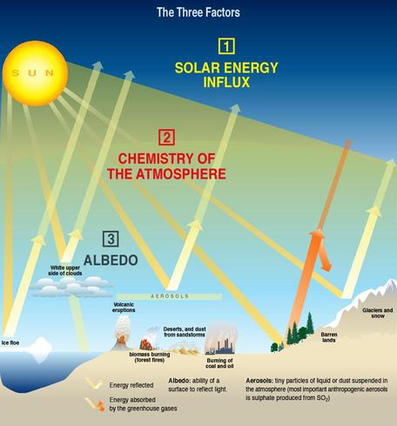
9. Academic honesty and integrity, as specified in the Honor Code of Penfield College and the Regional Academic Centers, are required and expected of each student. Violation of this code, including plagiarism, on any work I assign in this class may result in a grade of "F" assigned for the assignment or the entire course. Because this class uses cooperative discovery as one of its primary teaching and learning tools, students must respect each other, contribute mutually to class activities, give proper credit to others when it is due, and take responsibility for their own actions. In preparing any assignments, students may draw upon any legally available resources for research and preparation. However, submitted materials must represent student work and contain proper attribution and citation for the work of others.
Institutional procedures relevant to the Honor System and Academic Integrity can be found on the Provost website at http://provost.mercer.edu/handbooks
10. Students requiring accommodations for a disability should inform the instructor as early in their matriculation as possible or by the close of the first class meeting. The instructor will refer you to the Disability Support Services Coordinator to document your disability and determine eligibility for accommodations under the ADAAA/Section 504. In order to receive accommodations in a class, students with sensory, learning, psychological, physical or medical disabilities must provide their instructor with a “Faculty Accommodation Form” from Disability Support Services. Students must return the completed and signed form to the ACCESS Coordinator (208 Sheffield Center). A new form must be requested each semester. Students with a history of a disability, perceived as having a disability or with a current disability who does not wish to use academic accommodations are also strongly encouraged to register with the ACCESS and Accommodation Office and request a Faculty Accommodation form each semester. For convenience, anyone can send this information through Campus Mail; fax the form to (678) 547-6373 or e-mail the form as an attachment to stilley_r@mercer.edu.
Even students with a documented disability who do not wish to use academic accommodations are strongly encouraged to register with Disability Support Services and complete a Faculty Accommodation Form each semester. For further information, please contact: For Atlanta, Douglas, Henry, and Newnan: Richard Stilley, ACCESS and Accommodation Coordinator / Assistant Dean for Campus Life, at (678) 547-6823, by email at Stilley_R@Mercer.edu, or visit the website at http://atlstuaffairs.mercer.edu/disability-servicescfm
Also see ACCESS website http://www.mercer.edu/disabilityservices.
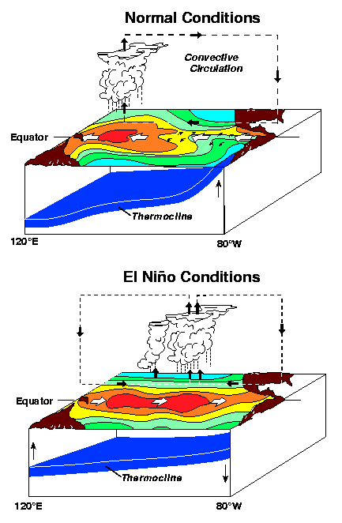
Grading Policy
A– Thorough, creative, connects assignment and course subjects to topics from outside of course. Awarded for work which far exceeds the minimum expectations for assignment/course, not only by doing all asked, but by demonstrating superior skill, thoroughness, independence of thought, and creativity. Work is free of errors including spelling, grammar, and scientific errors, looks neat, and contains relevant references.
B– Disciplined work with very minor errors, some creativity, exceeds expectations met. Above average grasp and mastery of subject matter, evidenced not only by meeting the basic objectives but also by showing some initiative in pursuing lines of inquiry and some creativity in the use of new understandings outside of classroom experience.
C– Satisfactory work, expectations met. Basic objectives of the assignment/course have been achieved. Student has demonstrated satisfactory mastery of the material. This grade level indicates that the minimum expectations have been met. This is a very respectable grade. In an assignment, there may be a few errors.
D– Below expectations for college-level work. Work is passing but below average competency for college students. Student receiving this grade has not exerted a level of effort or expertise which is expected of the average college student. This level of work is often largely incorrect or minimally thought out. In a course, not all work has been handed in to the instructor.
F– Lack of command over assignment/course. This work does not meet the minimum expectations of the assignment/course, demonstrates an unjustifiable lack of command over material, and a significant absence of effort on the part of the student. In a course, not all work has been handed in to the instructor.
Grade Score (%)
A 91-100
B+ 86-90
B 81-85
C+ 76-80
C 70-75
D 60-69
F <60

Grading Formula
Course component % of Total Grade
All work must be handed in through Blackboard, except where noted in assignment directions.
Total possible points in this course is 100.
Climate of Change Case Study Unit 3.2 ENSO... 5
Earth’s Geosphere 10
Slow and Steady? Climate of Change Unit 4 10
Climate of Change Unit 5 pre-class work 2
Climate of Change Unit 6 pre-class work 2
Climate of Change Summative Assessment 15
Earth’s History: Grand Canyon 10
Humans’ Dependence on Minerals...Unit 1 pre-class 2
Humans’ Dependence on Minerals...Unit 2 pre-class 2
Digital Field Trip: Arabia Mountain 5
Humans’ Dependence/Minerals Summative Assess 15
Carbon Cycle pre-class work 2
Final Assessment 20

Climate of Change We will use the online material called "Climate of Change" to study the climate system of Earth. You will be assigned readings, self-assessments, and case studies to demonstrate your understanding of climate systems. To reach this material, go to our Blackboard site weekly folders and follow the instructions. Readings and self-assessments will be graded on being fully completed (following all instructions). Online case studies and in-class group activities will be graded on completion according to instructions.

Humans' Dependence on Earth Resources We will use the online material called "Humans' Dependence on Earth Resources" to study rocks, minerals, and rock-forming processes. You will be assigned readings, self-assessments, and concept maps and/or case studies to demonstrate your understanding of these topics. To reach this material, go to our Blackboard site weekly folders and follow the instructions. Online modules and in-class group activities will be graded on completion according to instructions.

Earth's Geosphere, Grand Canyon,Digital Field Trip You will be assigned online modules, self-assessments, Google Earth exercise(s), webquests, and/or quizzes to demonstrate your understanding of the lithosphere and geologic time. To reach this material, go to our Blackboard site weekly folders and follow the instructions. This work will be graded on completion according to instructions.

Final Assessment This assessment will consist of short answer questions and a diagram showing how concepts we have studied are related to each other (“concept map”).

Direct Instruction
Mercer University requires 2250 minutes of direct classroom instruction (the equivalent of 4 ¾ hours per 8 week class and 750 minutes of direct instruction per credit hour) and 4500 minutes of out-of-class student work for each 3 credit hour course. Faculty members who wish to move 30 minutes of each 8 week class or 240 minutes total of the required direct instructional time to a web-based environment or to another out-of-class experience for pedagogical reasons are required to delineate in the syllabus the additional out-of-class direct instructional experiences/activities that will substitute for in-class direct instruction. Faculty members are required to include on the syllabus the amount of out-of-class direct instructional minutes per experience/activity (over and above the 4500 minutes of out-of-class student work for each 3 credit hour course).
Direct instructional activities for this course:
1020 min Online modules
900 min Group in-class activities
330 min Online assessment

PLAGIARISM -- Rules for all work you turn in: Do not copy other people's sentences or phrases without giving them credit. This includes sentences where you change a few words and then include the slightly modified sentence in your paper. If you use information from sources other than your own brain, you MUST make a reference to the source. Any work that contains plagiarized material will be given a grade of zero.

CITING and QUOTING SOURCES -- Rules for all work you turn in: If you copy any text, please put quotation marks around the copied phrase or sentence, “like this” and include the author name and publication year like this: (Author, 2013). If you copy images, graphs, or any other non-text material, please cite and reference it. If most of your work consists of material copied from other people's work, then your assignment will receive a D, even if the work is cited and referenced. If the majority of your work consists of other people's work, this will be given a grade of zero (0), even if you have cited and referenced the work. I use this grading because I want to know what you know, what you understand and how you understand it.
We will use SafeAssign in Blackboard to help us avoid plagiarism.

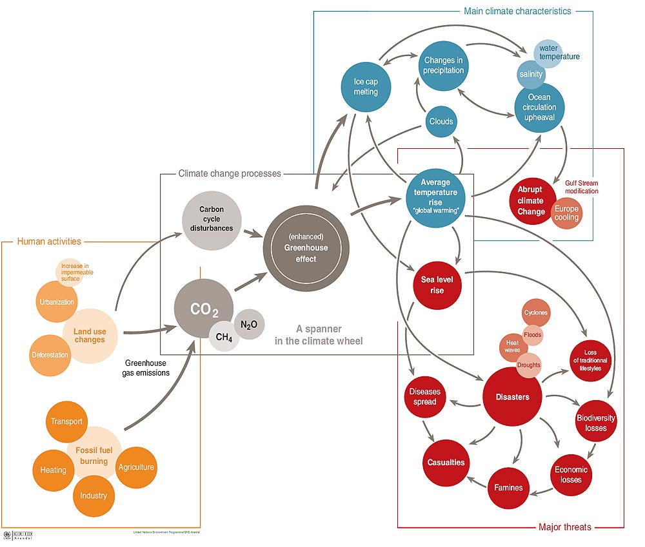

Course Outline
Week Study before coming to class
Week 1 Meet in classroom. Oct. 24
Oceans and Atmosphere Interacting to Make Climate

Examples: El Niño, ENSO
Chemistry and Structure (Layers) of Earth’s Oceans and Atmosphere
Lab: Ocean Circulation.
Forecasting Climate Variability and Change Climate of Change, Unit 1
Deciphering Short-Term Climate Variability Climate of Change, Unit 2
Anomalous Behavior (El Niño) Climate of Change, Unit 3

Assignments
DUE Sunday Oct. 30, midnight:
- 5-Case Study 3.2 ENSO on the Global Stage. See Blackboard for instructions.

Week 2 Online. Oct. 31
Building Earth’s Surface: The Geosphere

Examples: Volcanoes, Earthquakes, Mountain Building, Plate Tectonics and Earth’s Interior
Assignments
DUE Monday Oct. 31, midnight:
- 10-Earth’s Geosphere. See Blackboard for instructions.

Cryosphere: A Result of the Hydrosphere, Atmosphere, and Geosphere Interacting
Getting to Know the Cryosphere http://serc.carleton.edu/eslabs/cryosphere/1c.html
Slow and Steady? Climate of Change, Unit 4
CO₂ in the Ice Core http://earththeoperatorsmanual.com/segment/5

Assignments
DUE Sunday Nov. 6, midnight:
- 10-Unit 4: Slow and Steady? See Blackboard for instructions.
- 2-Unit 5: Pre-class work. See Blackboard for instructions.
- 2-Unit 6: Pre-class work. See Blackboard for instructions.

Week 3 Meet in classroom. Nov. 7
Modeling Climate Change

Lab: Mt. Rainier, WA glaciers, topographic maps
systems@play Climate of Change, Unit 5

Assignments
DUE Sunday Nov. 13, midnight:
- 15-Climate of Change summative assignment. See Blackboard for instructions.

Election Day, Tuesday, November 8

Week 4 Online. Nov. 14
Earth History: The Grand Canyon. What Systems Made the Grand Canyon and its Rocks?

Assignments
DUE Monday Nov. 14, midnight:
- 10-Earth’s History: The Grand Canyon. See Blackboard for instructions.
DUE Sunday Nov. 20, midnight:
- 2-Unit 1: Humans’ Dependence on Mineral Resources. Pre-class work. See Blackboard.
- 2-Unit 2: Humans’ Dependence on Mineral Resources: Pre-class work. See Blackboard.

Week 5 Meet in class. Nov. 21
People, Rocks, and Economics
We will not read everything in these units. See Blackboard for specific parts to read and study.
Boom and Bust: How Econ101 Relates to Rocks Humans’ Dependence on Mineral Resources, Unit 2
Lab: Rocks, Minerals and Resources
Mining and Mining Impacts Humans’ Dependence on Mineral Resources, Unit 3
Thanksgiving Holiday (Mercer), November 22—26

Week 6 Online. Nov. 28
Digital field trip: Arabia Mountain, Georgia
Igneous and Metamorphic Rocks Humans’ Dependence on Mineral Resources, Unit 5
We will not read everything in this unit. See Blackboard for specific parts to read and study.

Assignments
DUE Monday, Nov. 28, midnight:
- 5-Digital field trip: Arabia Mountain, Georgia. See Blackboard for instructions.
DUE Sunday, Dec. 4, midnight:
- 15-Humans’ Dependence on Mineral Resources, summative assignment. See Blackboard for instructions.
- 2-Carbon Cycle: Pre-class work. See Blackboard for instructions. http://serc.carleton.edu/integrate/teaching_materials/change_inthe_air/activity2.html

Week 7 Meet in class. Dec. 5
Carbon, Climate, and Our Planet’s History
The Carbon Cycle Carbon, Climate, and Energy Resources, Unit 2 The Carbon Cycle http://serc.carleton.edu/integrate/teaching_materials/change_inthe_air/activity2.html
http://earththeoperatorsmanual.com/main-video/earth-the-operators-manual
A Year in the Life of CO2: https://www.youtube.com/watch?v=x1SgmFa0r04
Earth’s History

Assignments
DUE Sunday Dec. 12, midnight:
- 15-Final Assessment: Earth Systems. See Blackboard for instructions.

Week 8 Online. Dec. 12
Adapting to a Changing World
REPEAT Assignments
DUE Monday Dec. 12:
- 15-Final Assessment: Earth Systems. See Blackboard for instructions.

