Stones River Watershed
Water quality circa 2000. Visit http://tdeconline.tn.gov/Stones/ for updates.

Unit 2: Rivers
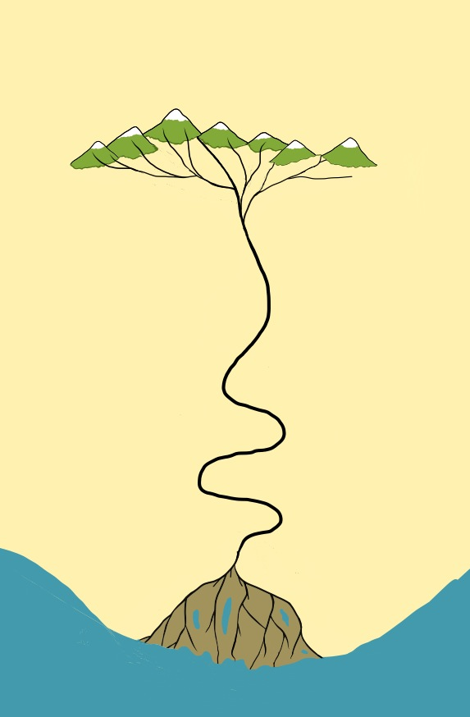
Part 1:
Zone 1
Zone 2
Zone 3
Meanders
Tributaries
Delta
Distributaries
Collecting system
Transporting system
Dispersing system
Sediment source area
Main Trunk
Characteristics of a River System
Background
Fluvial systems are the main factors in shaping the surface of the continents as they drain the water on the continents and move weathered material (gravel, sand, silt, mud) to the ocean basins.
The appearance of rivers and streams is strongly influenced by the climate, geology, and the topography of the region. Although the appearance of rivers may differ from one to the next, all rivers have three subsystems (or zones) that define the entire river system: 1) collecting system, 2) transporting system, and 3) dispersing system.
The diagram to the left is a sketch of a prototypical river system with a dashed line between zones. Although there is typically only a gradual gradation between the subsystems, when you view them at a regional scale, you can recognize patterns characteristic of each subsystem.
Directions: To answer questions 1-1 through 1-3 you will need to examine the map of the Stones River watershed. With the instructor’s help, add the Cumberland River to the map, label Percy Priest Reservoir, and circle or highlight the West and East Forks of the Stones River.
Collecting system (Zone 1)
The collecting system is where the headwaters are located in the region where the river begins. The collecting system is typically a mountainous region containing a network of small tributaries that are created as water and sediment is funneled toward the main stream.
1-1. What is the name of the town, county, or area where the river begins? ______________________________________________________________________________
Transporting system (Zone 2)
This part of the river system consists of the main channel (trunk) and the major tributaries. The transporting system is where water and sediment that has collected in the headwaters is transported downstream to a lake or ocean. This section of the river system will often contain meanders. These are formed by the combination of erosion and deposition of sediment. As the slope (gradient) of the stream channel decreases, so does the velocity.
1-2. What are the names of towns or cities located along the transporting system? _____________________________________________________________________________
Dispersing system (zone 3)
This part of the river system is at the end of the river where the elevation of the river is nearing sea level. Here you can observe a network of distributaries that redistribute the water and sediments into the ocean. The fine-grained sediments (clay, mud) remain suspended in the water and continue to be transported and finally deposited into the bay or ocean. The coarser material is deposited at the shoreline and forms a delta.
1-3. What body of water does the river empty into at the end of the dispersing system?

1-4. In what ways is the “protoypical river” graphic a good representation of the Stones River watershed and in what ways is it not a good representation?

1-5. With the instructor’s help, modify the “prototypical river” graphic to reflect the realities (both natural and human) of the Stones River watershed.

