Module 5: Applications for Tectonic Hazards
  - Student Worksheet

Introduction
As we have learned so far in this lab, the theory of plate tectonics is a global process that operates on long time scales, and accounts for the movements of continents, produces mountain and island chains, and widens ocean basins. In this last module we are going to look at the implications of plate tectonics on human life both past and present.
In Activity 1 of this module you will be doing some detective work to solve the mystery of what plate motion process could have been responsible for historical accounts of the destruction of human settlements in the year 1700. As plates either subduct or grind past each other along a transform boundary, earthquakes occur. Earthquakes that occur along underwater plate boundaries can generate tsunamis that can have devastating impacts on and alter coastal ecosystems and environments, both close by and very distant, and also have far reaching effects on local sea levels.
In Activity 2 we will be looking into the future and considering plate tectonics on other rocky planets and moons by looking at a scenario where you are a planetary geologist designing a study on tectonics for an exoplanet. In the future it is possible that geologists will need to evaluate the tectonic hazards of possible colonization sites on these planets.
This module should take 1 ½ to 2 hours to complete

Learning Objectives
Upon completion of this module you should demonstrate your ability to:
- Relate data of various sources and forms
- Use data to infer past geological events
- Begin the process of designing a research study by setting up a hypothesis and predicting what data might support it

Activity 1: Past Tectonics – Orphan Tsunamis and Ghost Forests
By most accounts, it was a dark and stormy night when Thunderbird and Whale fought their cataclysmic battle. Darkness comes early in the Pacific Northwest in January: the sun had been down for hours, and in the dark and cold, no one could see Thunderbird swoop down. But they felt it when she grabbed Whale in her talons, and rose up with it. Then she dropped Whale from a great height, slamming it into the ground. The land shook, and the waters receded. Some people knew to get into their canoes. Some didn't have time. And then came the great flood, which destroyed whole villages, and left many canoes stranded in the trees.
That's one version of what happened that night.
There are many tales. In some, Thunderbird is the hero: in others, the villain. In some, she (or he) is fighting the virtuous/evil Whale; in others, the Transformer who creates or changes the world is her opponent. The two of them have fought many times. Their stories are told up and down the coast. They have changed the shape of the land. They have created and destroyed. And their most epic battles have shaken the earth, and then caused the ocean to roll over it. People are left floating in the sea in their canoes without a way to get home. Whole villages along the coast are razed. And the ones that survive are those nearer high ground, although some of the stories also tell of how the shaking caused whole mountainsides to come down, sometimes burying villages beneath them. From Vancouver Island to Northern California, variations in the story were told.
And many of them have enough details to be dated. When we do, we discover that they refer to one winter's night in the early 1700s.
But they're just stories. Myths. Right?
-Dana Hunter
Scientific American 2016

Background
In geological science we use data from many different sources. Data can come from geological instruments like seismometers or from datasets published by other earth scientists, and in some cases our data can be derived from oral traditions like myths and folklore as well as historical documents.
In the Pacific Northwest, there are many lines of evidence suggesting there was an enormous earthquake and tsunami in the early 1700s. You will be locating the different pieces of evidence and data, making note of the locations, and generating a list of possible plate margin locations capable of having produced this earthquake and tsunami.

Evidence In North America
Open Google Earth. Load the Plate Tectonics Lab-Lines of Evidence.kmz file. Use the data table below to find approximate locations and place pins at the approximate areas affected by the tsunami generated by the January 1700 earthquake.
Evidence | Location
Thunderbird and Whale Story by the Willapa Tribe | Willapa Bay, WA
Former fire pits | Salmon River, OR (near mouth to Pacific Ocean)
Silt and sand above buried soil (tsunami deposits) | Twentymile River, AK
Ghost forests | Copalis River, WA

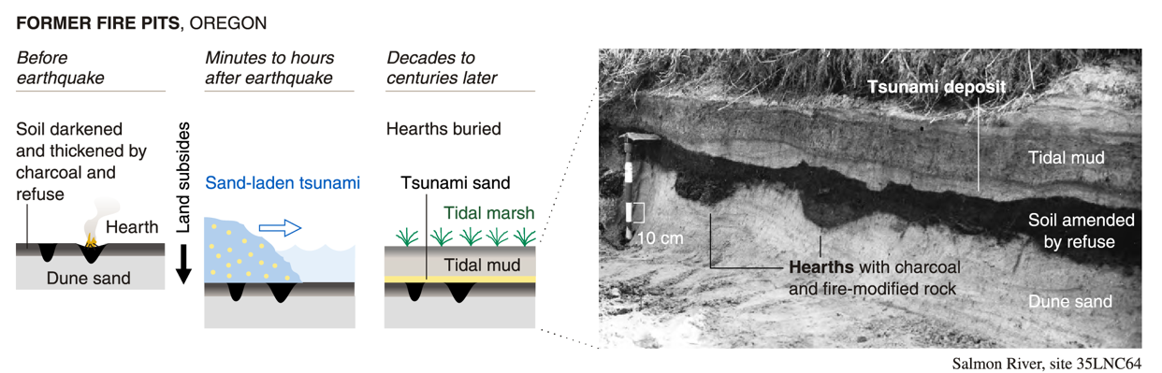
Figure 1 Graphic showing former fire pits in sediment in Oregon. Before the earthquake the soils were darkened and thickened by charcoal and refuse with pits dug and filled in charcoal and fire modified rock and soil material. Minutes to hours after the earthquake, sand-laden tsunami waters arrived and buried the soil and hearths. Decades to centuries later we see layers in the sediment, with the charcoal layer covered with a sand layer, then a mud layer from the tides, topped with the present-day tidal marsh sediment. Sand sheets between marsh or dune soils at the bottom and tidal mud at the top is a good indicator of a tsunami.

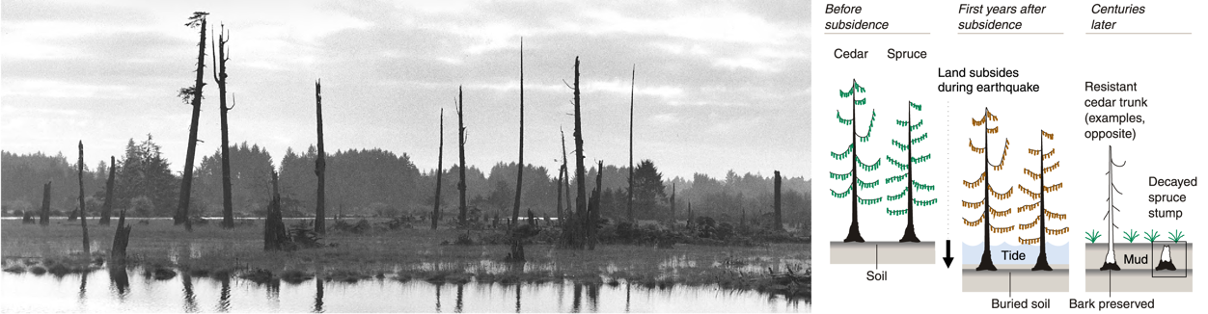
Figure 2 Left: Photograph of a ghost forest along Copalis River, December 1997. Right: Graphic showing how a ghost forest forms when a large enough earthquake changes the ground level to be below tide level. Before the earthquake typical trees grow on ground that is above the level of the highest tides. One response to an earthquake can be a lowering of the ground level (subsidence) as tectonic stresses are released. In the first few years after the change in ground level, the tide drowns the trees and they die. Centuries later, dead cedar trees, which have highly resistant and rigid bark, do not fall over but remain towering over the new marsh landscape. Other less resistant trees do fall, leaving their stumps buried and preserved in the mud, further evidence of the forest that once stood there.

Discussion Questions
- Take a screen capture of the Google Earth portion of your screen showing the pins you’ve placed at the sites in North America listed in the table. Crop out the desktop task bar and paste the screen capture below. Paste Google Image Here

Evidence In Japan
THE YEAR 1700, though almost a century earlier than the first written records from northwestern North America, comes late in the written history of Japan. The year belongs, moreover, to an era of Japanese stability, bureaucracy, and literacy that promoted record-keeping. That era began with national pacification early in the 17th century. By 1700, the country had known almost a century of peace for the first time in 500 years… Reading and writing extended beyond this ruling elite to commoners urban and rural. Booksellers offered poetry, short stories, cookbooks, farm manuals, and children's textbooks. Merchants tracked goods and services in an economy driven by bustling cities. Peasants prepared documents for villages they headed…
… PLACES FLOODED by the 1700 tsunami in Japan include Kuwagasaki, Tsugaruishi, Ötsuchi, Miho, and Tanabe. Some of the accounts mention damage in additional villages. In one account, the tsunami takes the form of rough seas that initiate a nautical accident near Nakaminato
-Excerpt from The Orphan Tsunami of 1700
University of Washington Press
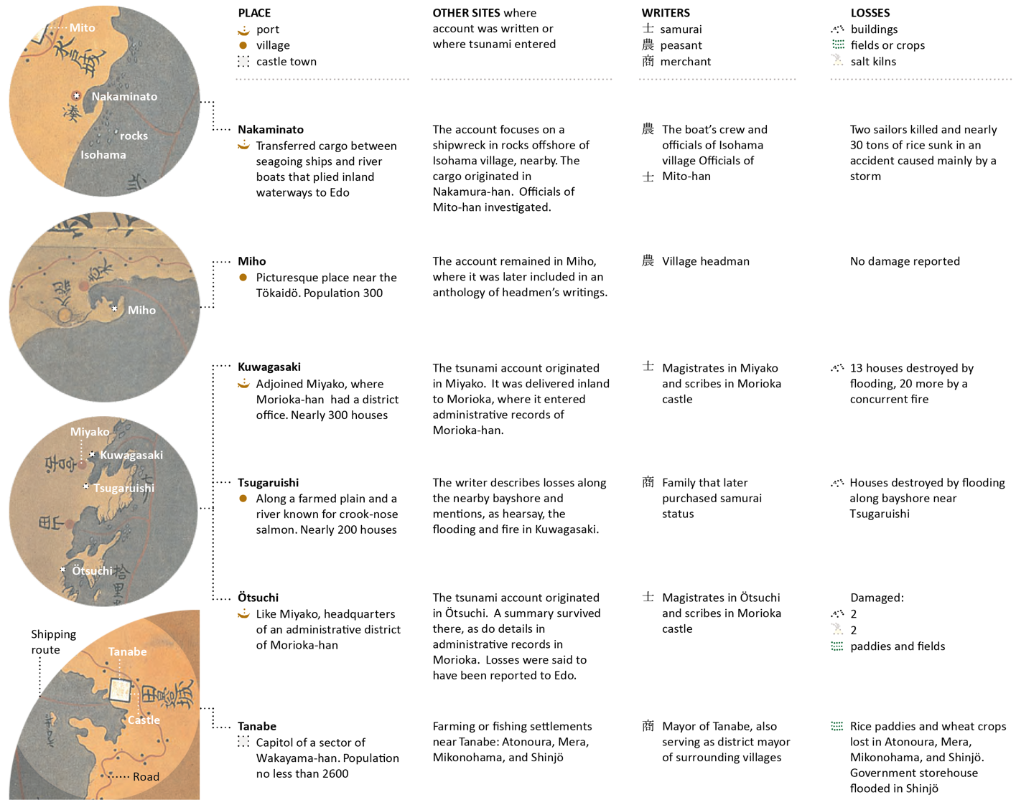
Figure 3 Image showing map locations, places, sites, and losses due to a tsunami in the year 1700 in Japan.

Discussion Questions
- Use the data from the figure above to place pins in approximate locations of areas in Japan that were affected by the Orphan Tsunami of 1700. All locations are from primary sources given in written accounts and maps from Japan. Take a screen capture of the Google Earth portion of your screen showing the pins you’ve placed at the sites in Japan listed in the table. Crop out the desktop task bar, and paste the screen capture below.
Paste Google Image Here

A Look at Modern Data: Locating the Ghost Tsunami
Turn on the Present Plate Boundaries and the Earthquakes layers. Notice which boundaries generate the largest seismic events. In Google Earth, the diameter of the dot shows the magnitude (power) while the color shows the depth. Look for the big circles. This is important to our investigation because large submarine earthquakes generate tsunamis by starting a large wave at the epicenter of the earthquake. See figure below for an example of how a tsunami might start:
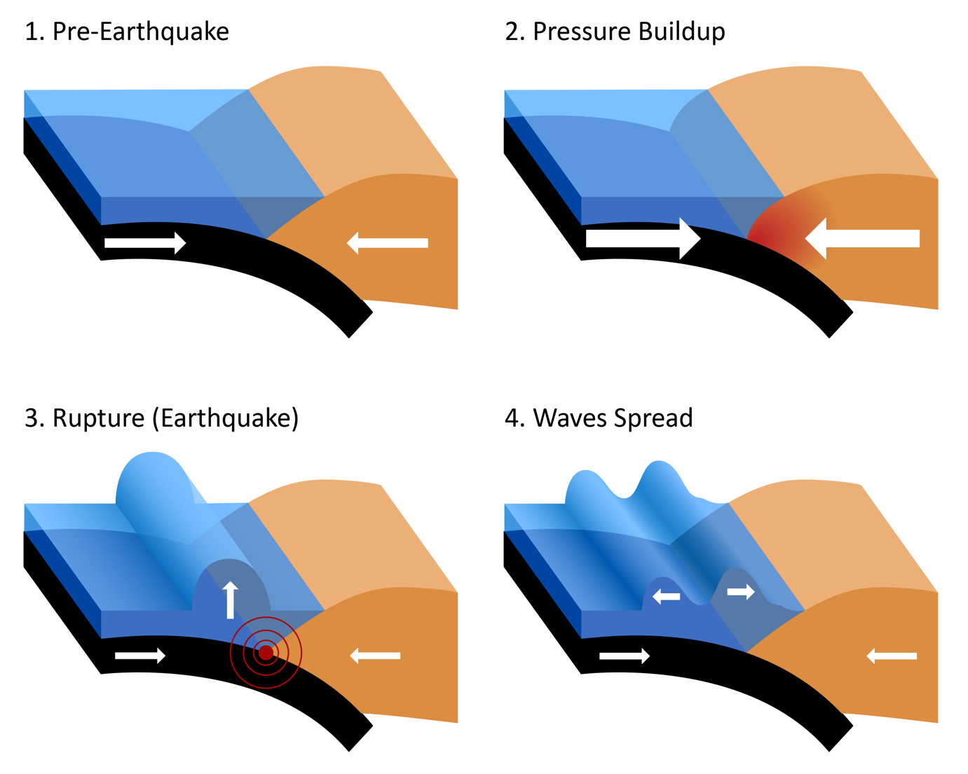
Figure 4 Tsunami formation

Discussion Questions
- Search the Pacific Ocean for the locations of plate boundaries that you think could have triggered the change in ground level, floods, and tsunamis that we have observed. Find and list at least three locations. Write a short explanation for why this plate boundary is a possibility.
Example: The _________ boundary near _________ is a possibility because ____________. I have seen in the lab that ________ generates large earthquakes near the earth’s surface and that could change land elevation and displace large amounts of water.
- Location 1:
Type explanation here:
- Location 2:
Type explanation here:
- Location 3:
Type explanation here:

Designing Scientific Inquiry
Thinking back to what you have learned about the scientific method, what kind of evidence would you need to look for to test the probability of each of the locations on your list of being the site of the 1700 earthquake? How could you find this evidence? NOTE: Think about what you would expect to find in other locations near each of the plate boundaries you identified.
- Choose one of the sites you described in the question above and determine three possible lines of evidence you would need to support your hypothesis of this being the site of the 1700 earthquake. Then briefly (one to two paragraphs) in the table below, describe how you could get that evidence.
  - Which hypothesized site of the January 1700 earthquake did you choose?
Type answer here:
Line of Evidence | How would you get it?

Activity 2: Future Tectonics – Exoplanet Exploration
As of this year we have identified 4197 confirmed exoplanets, or planets outside our solar system, and 1296 are terrestrial. This means that we know of almost 1300 rocky planets that could be colonized in humanity's future. TRAPPIST-1e c is one such rocky planet that is 41 light years from Earth and orbits in the habitable zone of a dim Red Dwarf star. (Nasa Exoplanet Exploration website: https://exoplanets.nasa.gov/ Retrieved 7/27/20.)

Discussion Questions
- Suppose that you are a planetary geologist working for NASA and we have satellites orbiting TRAPPIST-1e and rovers on its surface. Humans plan to colonize the planet and your job is to determine if the planet is tectonically active. What kind of observations or information would you need to be able to evaluate possible sites for seismic or volcanic hazards? What would each specific observation be and what would that evidence mean in terms of plate tectonics? Fill in your answers in the table below.
Observation | Collection Method  (Image, sample, etc) | What does this information indicate about plate tectonics?

