Module 3: Building Context
  - Student Worksheet

Introduction
In Module 3, you will complete 5 Activities using Google Earth to examine Earth’s features in a unique way. Using topographic profiles, which are “side views” of the landscape, you will investigate the depths and elevations in the Atlantic and Pacific Oceans. These profiles cross over plate boundaries that have specific physiographic features such as mid-ocean ridges and deep ocean trenches. You will analyze earthquake depth data to help illustrate plate boundary processes. This should take you 2-3 hours to complete. If you have not already used Google Earth Pro in this course, you should complete the tutorial exercise prior to attempting to complete this module.

Learning Objectives
- As part of Plate Tectonics Theory, describe how certain plate boundaries lead to specific physiographic features (mid-ocean ridges are formed at divergent plate boundaries, and deep ocean trenches are formed at convergent plate boundaries)
- Using topographic profiles with Google Earth visualization software, identify mid-ocean ridges and deep ocean trenches
- Develop a spatial understanding of where ridges and trenches are situated in relation to tectonic boundaries
- Evaluate tectonic processes (earthquakes and volcanoes) at mid-ocean ridges and deep ocean trenches, and how features are produced from plate tectonic motions

Formation of Mid-Ocean Ridges and Deep Ocean Trenches
According to Plate Tectonics Theory, new ocean crust is created at mid-ocean ridges at divergent plate boundaries. Where two plates pull away from each other, magma rises from below. When the magma cools and hardens it forms new ocean crust in the center of the mid-ocean ridge.

Older ocean crust is destroyed along convergent plate boundaries. When a plate of ocean crust collides with another plate, the denser ocean crust is thrust downward into Earth. This collision can occur between two ocean plates or between ocean and continental plates. As the older, denser plate descends, friction causes the plate on top to flex downward, producing linear valleys called deep ocean trenches. The descending plate triggers melting of the mantle above it, and chains of volcanoes form, called volcanic arcs.

Activity 1: Mid-Atlantic Ocean Profile
Open Google Earth with the Plate Tectonics Lab- Lines of Evidence.kmz file loaded. In order for the graph to come up correctly, it is important to open the layers in the following order. Check the box next to the Mid-Atlantic Ocean Profile line under the heading Profile Lines. Then double-click on the text for the Mid-Atlantic Ocean Profile Line. This line crosses the Atlantic Ocean going from North America to Africa. Under the Edit menu and select ‘Show Elevation Profile’. Last, check the box next to Terrain in the preloaded Layers section.

The vertical axis on the profile shows elevations and depths. Negative numbers are below sea-level, so the bigger the negative number, the deeper the depth. The horizontal axis shows the distance along the profile line from where it was started. When the mouse is positioned along the profile line, the specific depth/elevation information is displayed. Use the mouse to pinpoint the location of the North American and African coasts. Notice where the ocean meets the land, the depth is 0 meters – this is sea-level.

Discussion Questions
- In one or two sentences, describe the bathymetry along this profile, where are deep locations, and where are shallow locations?
Type Answer Here:
- When viewed in profile, mid-ocean ridges have an appearance of a “speed-bump” – starting on either continent, the bathymetry goes from sea level to deep to shallow, and then back to deep as you cross the middle of the mid-ocean ridge. Deep ocean trenches, on the other hand, are narrow dropoffs that cut far down into the ocean floor. Does the Mid-Atlantic profile show a mid-ocean ridge or a deep ocean trench?
Type Answer Here:
- Turn on the Present Plate Boundaries layer. Different plate boundaries are shown in different colored lines: Divergent – Red, Convergent – Yellow, Transform – Blue. What type of plate boundary is crossing the middle of the profile?
Type Answer Here:
- Using the Plate Boundary Map from Module 2, name the two plates that meet along the boundary identified in the previous question.
Type Answer Here:
- Turn on the USGS Earthquakes layer – to view the data, be sure to be zoomed in to an Eye Alt of 4000 km or less. Notice the locations of earthquakes. Describe the depth of earthquakes that occur in the vicinity of the plate boundary, are the earthquakes deep (300-800 km), intermediate (70-300 km), and/or shallow (0-70 km)?
Type Answer Here:

Activity 2: East Pacific Ocean Profile
Uncheck all of the boxes. Check the box next to the East Pacific Ocean Profile Line under the heading Profile Lines. Then, double-click on the text for the East Pacific Ocean Profile Line. This line goes from the Pacific Ocean to South America. Under the Edit menu and select ‘Show Elevation Profile’. Last, check the box next to Terrain in the preloaded Layers section.
Position the mouse along the profile and the specific depth/elevation information is displayed. Use the mouse to pinpoint the location of sea-level near the South American coast.

Discussion Questions
- In one or two sentences, describe the bathymetry along this profile, where are deep locations, and where are shallow locations?
Type Answer Here:
- Does the profile show mid-ocean ridges and/or deep ocean trenches?
Type Answer Here:
- Using the colored lines displayed by the Present Plate Boundaries layer, what type of plate boundaries are crossing the profile? NOTE: There are two plate boundaries to identify.
Type Answer Here:
- Using the Plate Boundary Map from Module 2, name the three plates that meet along the boundaries identified in the previous question.
Type Answer Here:
- Turn on the USGS Earthquakes layer – to view the data, be sure to be zoomed in to an Eye Alt of 4000 km or less. Describe the depth of earthquakes that occur in the vicinity of the two plate boundaries, are the earthquakes deep (300-800 km), intermediate (70-300 km), and/or shallow (0-70 km)? Describe if the depths of earthquakes are similar or different for the two plate boundaries.
Type Answer Here:
- Compare the profiles from the Atlantic Ocean and the Pacific Ocean. In two or three sentences, develop a hypothesis to explain why the profiles are different.
Type Answer Here:

Activity 3: Tonga Island, South West Pacific Ocean Profile
Uncheck all of the boxes. Check the box next to Tonga Island Profile Line under the heading Profile Lines. Double-click on the text for the Tonga Island Profile Line. This line goes across a region of the southwest Pacific Ocean, north of New Zealand. Under the Edit menu, select ‘Show Elevation Profile’. Last, check the box next to Terrain in the preloaded Layers section.
The elevation profile shows elevations and depths on the vertical axis, and the distance along the profile line along the horizontal axis. As you slide the mouse along the elevation profile, small maroon-colored boxes appear which give the depth and elevation values, as well as distance for various positions along the profile line.

Discussion Questions
- Find Tonga Island in the profile. How do you know where to find it? How many kilometers is it from the western edge of the profile?
Type Answer Here:
- In one or two sentences, describe the bathymetry along this profile. Where are deep locations, and where are shallow locations?
Type Answer Here:
- Does the profile show a mid-ocean ridge or a deep ocean trench?
Type Answer Here:
- What type of plate boundary is represented by the feature that was identified in the previous question?
Type Answer Here:
- Using the Plate Boundary Map from Module 2, name the two plates that meet along the boundary identified in the previous question.
Type Answer Here:
- Turn on the USGS Earthquakes layer – to view the data, be sure to be zoomed in to an Eye Alt of 4000 km or less. Describe the depth of earthquakes that occur in the vicinity of the plate boundary, are the earthquakes deep (300-800 km), intermediate (70-300 km), and/or shallow (0-70 km)?
Type Answer Here:

Graphing Data
- Earthquake depth and distance
  - Use the graph below to plot earthquake depth data relative to the distance along the profile. Each color represents a range of depths. For simplicity, plot the earthquake along the line representing that range. For example, for an earthquake shown in purple, the depth range is 300-500 km and should be plotted on the horizontal line labeled 300-500. There may be several earthquakes at each depth.
  - On the horizontal axis, label the location of the trench.
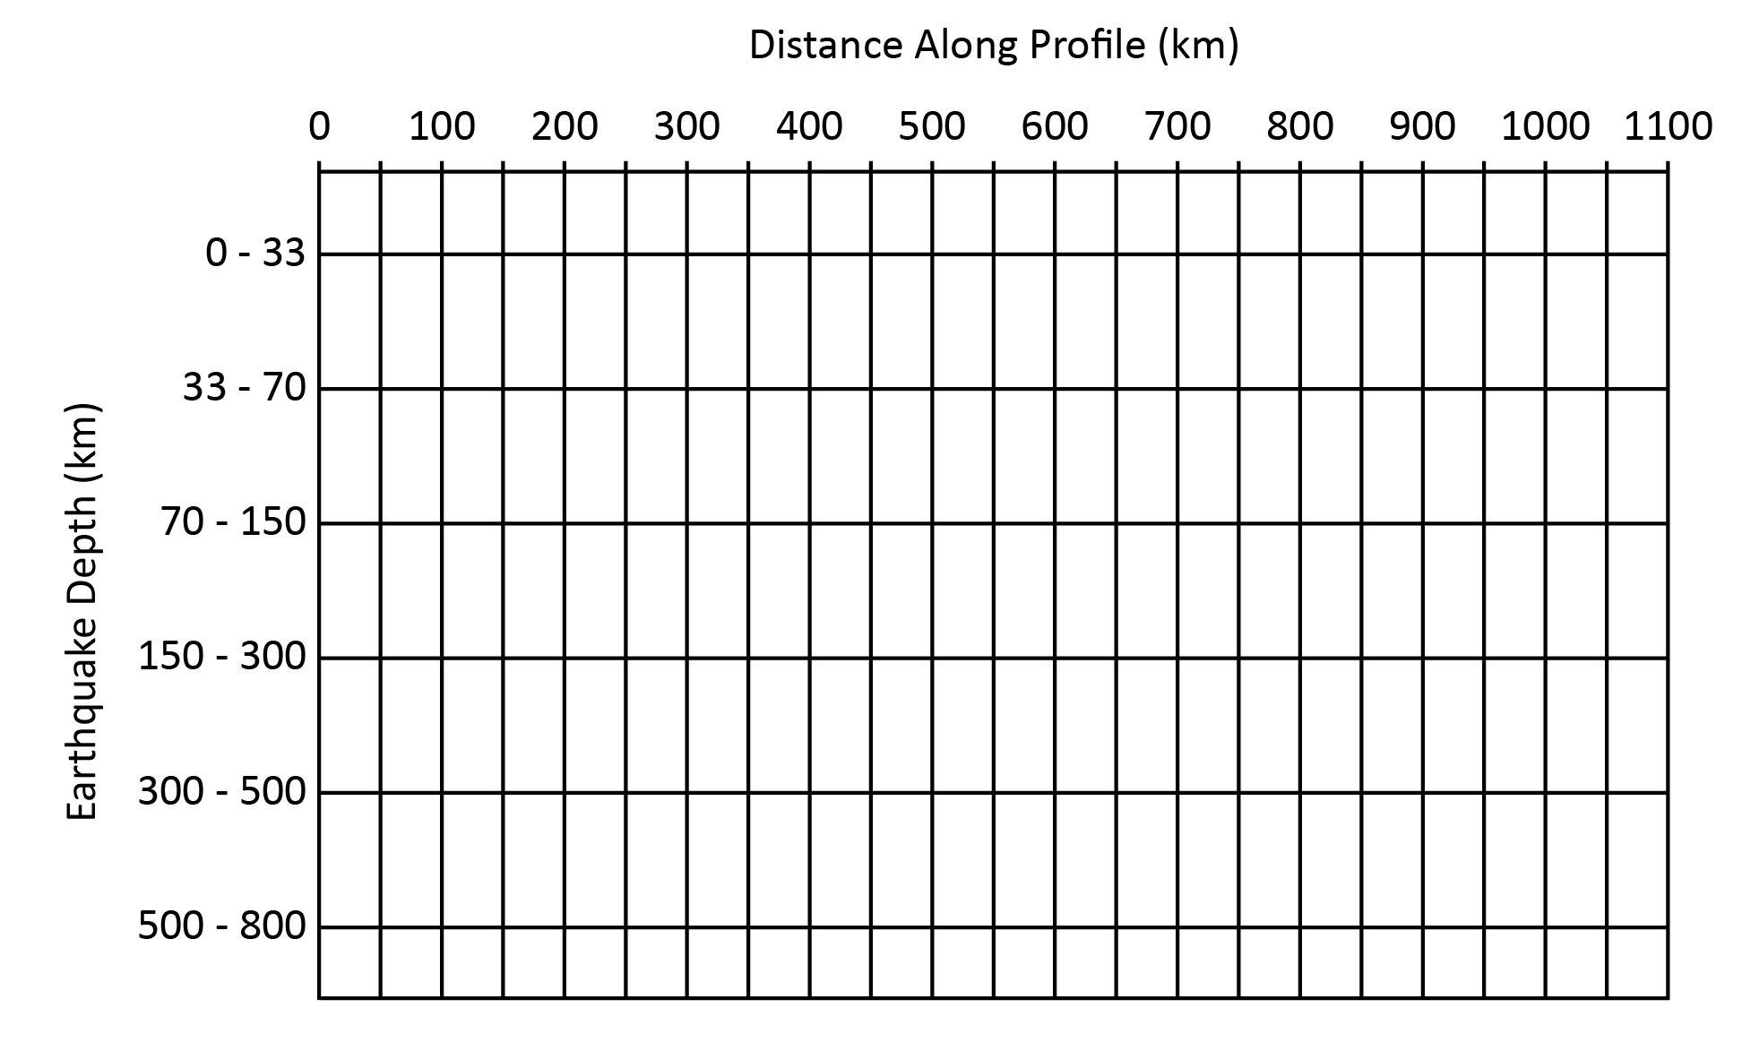
- Describe the distribution of earthquakes relative to the position of the trench. Do the depths of earthquakes remain the same, get shallower or deeper?
Type Answer Here:
- Why do you think earthquakes happen at these locations and depths? What does the earthquake depth data indicate about the position of the subducting plate?
Type Answer Here:
- Turn off the USGS Earthquakes layer and turn on the Volcanoes layer. Describe the distribution of volcanoes relative to the position of the plate boundary and trench.
Type Answer Here:

Activity 4: Northeast Pacific Ocean
Topographic Profile produced using Google Earth of the seafloor in the northeast Pacific Ocean

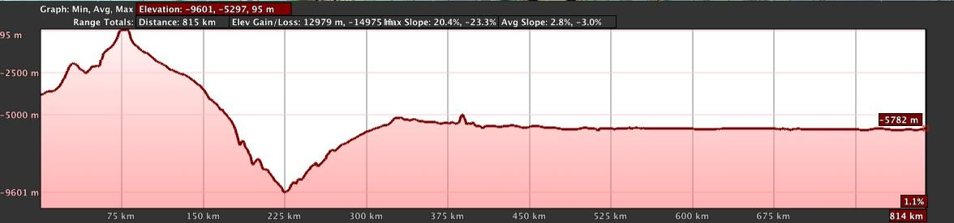
- Examine the profile above.
  - Is the seafloor being created or destroyed at this plate boundary?
Type Answer Here:
  - What sort of tectonic processes are occurring to produce the feature in this profile?
Type Answer Here:
  - Drawing the cross section
    - Beneath the profile, extend the cross section deeper into the Earth by sketching what the plates and the plate boundary look like beneath the surface to produce this feature.
    - On the sketch, draw several stars showing where earthquakes would occur.
    - Draw several triangles showing where volcanoes would occur.

Activity 5: From Africa to Antarctica

This is a topographic profile which shows the bathymetry of the seafloor from the coast of Africa to the coast of Antarctica.

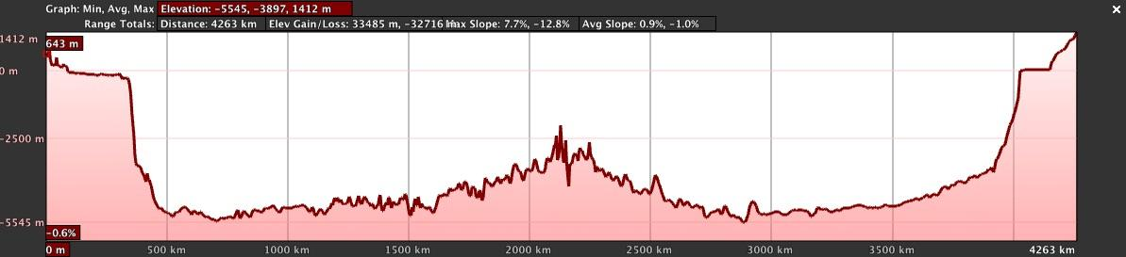
- Examine the profile above.
  - Is the seafloor being created or destroyed at this plate boundary?
Type Answer Here:
  - What sort of tectonic processes are occurring to produce the feature in this profile?
Type Answer Here:
  - Drawing the cross section
    - Beneath the profile, extend the cross section deeper into the Earth by sketching what the plates and the plate boundary look like beneath the surface to produce this feature.
    - On the sketch, draw several stars showing where earthquakes would occur.
    - Draw several triangles showing where volcanoes would occur.
- Develop a hypothesis to explain how bathymetry AND earthquake data can be used to determine the location and type of plate boundary.
Type Answer Here:

