Introduction to Plate Tectonics
  - Pre-Lab Reading

References
The text below is adapted from the following two sources:
Deline, Bradley; Harris, Randa; and Tefend, Karen, "Laboratory Manual for Introductory Geology" (2015). Geological Sciences and Geography Open Textbooks. 1.
https://oer.galileo.usg.edu/geo-textbooks/1
Earle, S. (2019). Physical Geology – 2nd Edition. Victoria, B.C.: BCcampus. Retrieved from https://opentextbc.ca/physicalgeology2ed/

Introduction
According to the scientific method, a theory is a well-supported explanation for a natural phenomenon that still cannot be completely proven. A Grand Unifying Theory is a set of ideas that is central and essential to a field of study such as the theory of gravity in physics or the theory of evolution in biology. The Grand Unifying Theory of geology is the theory of Plate Tectonics, which defines the outer portion of the Earth as a brittle outer layer that is broken into moving pieces called tectonic plates. This theory is supported by many lines of evidence including the shape of the continents, the distribution of fossils and rocks, the distribution of environmental indicators, as well as the location of mountains, volcanoes, trenches, and earthquakes. The movement of plates can be observed on human timescales and easily measured using GPS satellites.
Plate tectonics is integral to the study of geology because it aids in reconstructing Earth’s history. This theory helps to explain how the first continents were built, how oceans formed, and even helps inform hypotheses for the origin of life. The theory also helps explain the geographic distribution of geologic features such as mountains, volcanoes, rift valleys, and trenches. Finally, it helps us assess the potential risks of geologic catastrophes such as earthquakes and volcanoes across the earth. The power of this theory lies in its ability to create testable hypotheses regarding Earth’s history as well as predictions regarding its future.

Layers of the Earth
Key to understanding plate tectonics is an understanding of Earth’s internal structure, which is illustrated in Figure 1. Earth’s core consists mostly of iron. The outer core is hot enough for the iron to be liquid. The inner core—although even hotter—is under so much pressure that it is solid. The mantle is made up of iron and magnesium silicate minerals. The bulk of the mantle surrounding the outer core is solid rock, but it is plastic enough to be able to flow slowly. The outermost part of the mantle and the Earth’s crust are rigid and together, they make up the lithosphere.
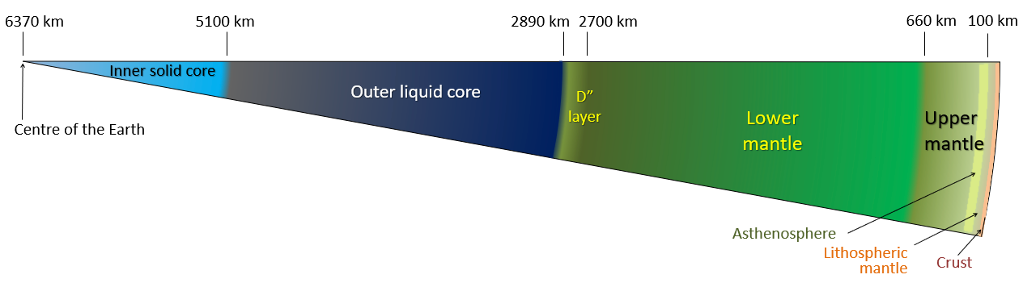
Figure 1 Layers of the Earth. Credit: Steven Earle

The lithosphere is divided into about 20 tectonic plates that move in different directions on Earth’s surface. The rigid lithospheric plates are able to move because they sit on top of a layer of the mantle called the asthenosphere which can flow and convect. Heat is continuously flowing outward from Earth’s interior, and the transfer of heat from the core to the mantle causes convection in the mantle. This convection is the primary driving force for the movement of tectonic plates.
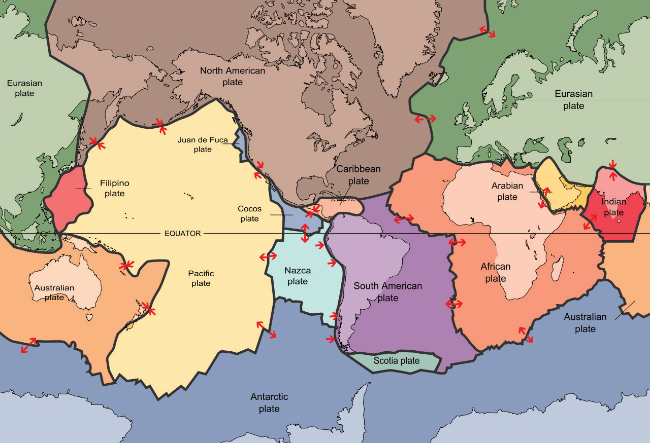
Figure 2 Earth’s major tectonic plates. Credit: USGS

Plate Materials
Tectonic plates are composed of the crust and the uppermost mantle that functions as a brittle solid. These plates can be composed of oceanic crust, continental crust or a mixture of both. The oceanic crust is thinner and normally underlies the world’s oceans, while the continental crust is thicker and like its name consists of the continents. The interaction of these tectonic plates is at the root of many geologic events and features, such that we need to understand the structure of the plates to better understand how they interact.
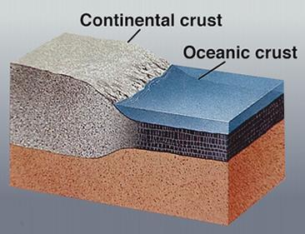
Figure 3. Earth's crust
The interaction of these plates is controlled by the relative motion of two plates (moving together, apart, or sliding past) as well as the composition of the crustal portion of the plate (continental or ocean crust). Continental crust has an overall composition similar to the igneous rock granite, while Oceanic crust is primarily composed of the igneous rock gabbro. The difference in rock composition results in a difference in density with the oceanic crust being much denser than the continental crust.

Plate Boundaries
Tectonic plates can interact in three different ways they can come together, they can pull apart, or they can slide by each other (Figure 4). The other factor that can be important is the composition of the plates (oceanic or continental crust) that are interacting. These three types of motions along with the type of plates on each side of the boundary can produce vastly different structures and geologic events.

Divergent
Two plates that are moving apart from each other are called divergent. Divergent boundaries are important because they are the way that continents split apart and break into separate plates as well as where new ocean crust is formed. If a divergent boundary forms within a continent that area stretches apart. This results in the area becoming thinner creating a topographic low or a valley. This extension is not a smooth process so the area is prone to earthquakes as well as volcanic activity. Eventually, the crust gets so thin it will rupture, forming a gap between the plates, which will be filled with molten rock, forming new oceanic crust. A thin and dense plate will be topographically low and will be covered in water forming a long and narrow sea. As the plates persist in pulling apart new crust is continually being formed at the plate boundary along an elevated crest known as a mid-oceanic ridge.

Convergent
Two plates that are moving together are called convergent. Convergent boundaries are important because they are the way distinctive plates can join (suture) together to form larger plates as well as where ocean crust is destroyed. The resulting structures we see at convergent boundaries depend on the types of tectonic plates. If two thick and lower density continental plates converge we get a large collision which results in mountains. This is a violent process resulting in many earthquakes, deformation (folds and faults) of rock, and the uplift of mountains. The rocks are also under immense pressure and heat and will eventually become stuck together as a single plate.
If a continental plate and an ocean plate converge (continent-ocean convergent plate boundary) there will be subduction, where the oceanic plate sinks downward underneath the continental plate. This will result in several features including a deep trench near the subducting plate, abundant earthquakes, and the formation of magma which results in a line of volcanoes along the coast. Associated with this type of plate boundary is the Wadati-Benioff zone, a zone where earthquakes are produced; this zone ranges in depth from shallow (at the trench) to deep (~600km), indicating that the oceanic plate is sinking into the mantle. If two oceanic plates converge it will also result in subduction with similar features as were just discussed. The only exception will be that the volcanoes will appear on an oceanic plate and will eventually form islands along the tectonic boundary.

Transform
When the two plates slide past each other it is called a transform boundary. This type of boundary differs from the previous two in that no new crust is being formed and no old crust is being destroyed. Therefore, there won’t be as many striking geologic features. Transform boundaries are often marked by abundant earthquakes that can be close to the surface as well as distinctive patterns of rivers that become offset as the land is moving underneath them. Transform boundaries are also often associated with mid-oceanic ridges. If the ridge has a jagged or stair-stepped edge the pulling apart of the two tectonic plates will also result in transform motion as you can see in Figure 4.
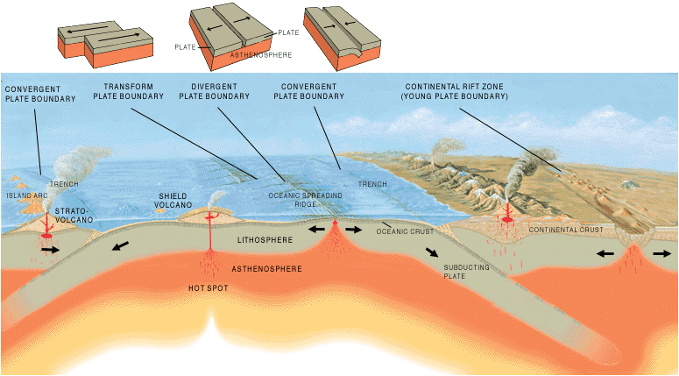
Figure 4. Figure showing multiple plate boundaries and the features associated with them. Credit: USGS

