Online Minerals Inquiry Lab Student Lab Report

In Development from EER2020 “Creating Inquiry Labs” Workshop, August 2020.
Authors: Christopher Berg, Becky Jirón, Alexandra Priewisch, Katryn Wiese

Student Preparation:
Prior to completing this lab, be sure you have:
- Covered mineral concepts in lecture (including textbook material and other references)
- Access to Moh’s hardness scale, mineral ID chart, and other references (typically from lecture) -- example review document for a class
- Gathered five objects from around their house of roughly similar volume, but made of very different material AND ALSO OKAY TO SCRATCH THE SURFACE OF (so avoid anything precious). Examples: old plastic bottle, glass bottle, penny, iron nail, soap

At Home Materials -- Hardness (~10-15 minutes)
- Set your 5 samples down alongside each other on a table and order them from softest to hardest -- remember hardness scale and what it means when one object scratches another.
- Record results below and reflect and write a paragraph describing how accurate you think your results were and why. What methods did you use to assess hardness? What was useful? What wasn’t?
Materials listed in order from softest to hardest:  - Softest  2.  3.  4.  5. Hardest | Reflection on accuracy. What methods did you use to assess hardness? What was useful? What wasn’t?

- Watch the instructor’s video of completing the same procedure:
Example: Hardness -- Becky Jirón.
After reviewing the video, what additional information/insights do you have?

At Home Materials -- Density (~10-15 minutes)
- Using the same five samples, order them from least dense to most dense.
- Record results below and reflect and write a paragraph describing how accurate you think your results were and why. What methods did you use to assess density? What was useful? What wasn’t? How well were you able to distinguish between density and mass?
Materials listed in order from least dense to most dense:  - Least dense  2.  3.  4.  5. Most dense | Reflection on accuracy. What was useful? What worked well? What was most challenging? How well were you able to distinguish between density and mass?

- Watch the instructor’s video of completing the same procedure:
Examples: Density -- Katryn Wiese, Density -- Chris Berg
After reviewing the video, what additional information/insights do you have?

At Home Materials -- Material Properties (~5 minutes)
What other properties can you observe for each sample? Which properties might be useful for identifying each of these materials in a different sample and why? For example,does the shape of the object reflect something about the material itself? Record notes below:

Properties of Minerals: Hardness (10-15 minutes)
For Box A (see photo gallery), use the box of materials to determine the hardness of each sample.
Apply hardness tests and give results as limits. Examples: X < 2.5; X > 6.5; 2.5 < X < 3.5. If two or more samples have the same limits, in addition to giving their hardness range as above, ALSO compare them to each other: Examples: A2 < 2.5; A1 < 2.5; A2 < A1. (Remember: X > Y means X is greater than Y.)
**The sample numbers below refer to the following resource collection (substitute as needed):
BOX A: Video *No audio | Photo Album

 | Hardness |  | Hardness |  | Hardness
A1 |  | A2 |  | A3
A4 |  | A5 |  | A6

Properties of Minerals: Cleavage or fracture (10-15 minutes)
For Box B (see photo gallery), describe the type of cleavage or fracture displayed in each sample. (Be sure to describe what you see, not necessarily what the mineral ID chart suggests!)
**The sample numbers below refer to the following resource collection (substitute as needed):
BOX B: Video *No audio | Photo Album
 | Fracture description (if exists – fracture and cleavage can exist in the same sample) | # of cleavage planes | Angle(s) between cleavage planes (circle)
B1 |  |  | 90º >90º <90º n/a
B2 |  |  | 90º >90º <90º n/a
B3 |  |  | 90º >90º <90º n/a
B4 |  |  | 90º >90º <90º n/a
B5 |  |  | 90º >90º <90º n/a
B6 |  |  | 90º >90º <90º n/a

Properties of Minerals: Crystal Form (10-15 minutes)
For Box C (see photo gallery), describe crystal form ONLY of each sample. Use pictures to help. Be specific and detailed. (include number of sides, shape, etc.). (Describe what you see, not what mineral chart suggests!)
**The sample numbers below refer to the following resource collection (substitute as needed):
BOX C: Video *No audio | Photo Album
Crystal form description
C1

C2

C3

C4

Properties of Minerals: Color, Luster, and Optics (10-15 min)
For Box D (see photo gallery), describe the color, luster, & special optical properties of each sample. (Be sure to describe what you see, not necessarily what the mineral ID chart suggests!)
**The sample numbers below refer to the following resource collection (substitute as needed):
BOX D: Video *No audio | Photo Album
 | Luster (and any special opt. props.) | Color | Optical clarity (circle)
D1 |  |  | Opaque  Translucent  Transparent
D2 |  |  | Opaque  Translucent  Transparent
D3 |  |  | Opaque  Translucent  Transparent
D4 |  |  | Opaque  Translucent  Transparent
D5 |  |  | Opaque  Translucent  Transparent
D6 |  |  | Opaque  Translucent  Transparent

Mineral Identification (2-3 minutes per sample)
For Box E (see photo gallery), correctly identify each sample. Describe the diagnostic characteristics of that mineral (include only those that are true for the sample that you are observing, and include enough to distinguish that mineral from any other). Make your answers unique!
NOTE: Instead of “very dense or very hard,” use actual hardness and specific gravity numbers from the rock ID table or indicate the relative density and hardness (e.g. denser than any other mineral; harder than glass).
**The sample numbers below refer to the following resource collection (substitute with other samples/photos as needed, and use only the minerals that you think are important for your students):
BOX E: Video *No audio | Photo Gallery
**Samples are in order in photo album, but to check on sample number, click information icon: i
 | Mineral name & formula | Diagnostic characteristics (a description that will be useful to you for identifying this mineral when it appears in the upcoming rocks labs)
1
2
3
4
5
6
7
8
9
10
11
12
13
14
15
16
17
18
19
20
21
22
23
24
25
(**The above 5 sections are from the Minerals Lab created by Katryn Wiese**)

Mineral Descriptions -- how good are yours? (5-10 minutes)
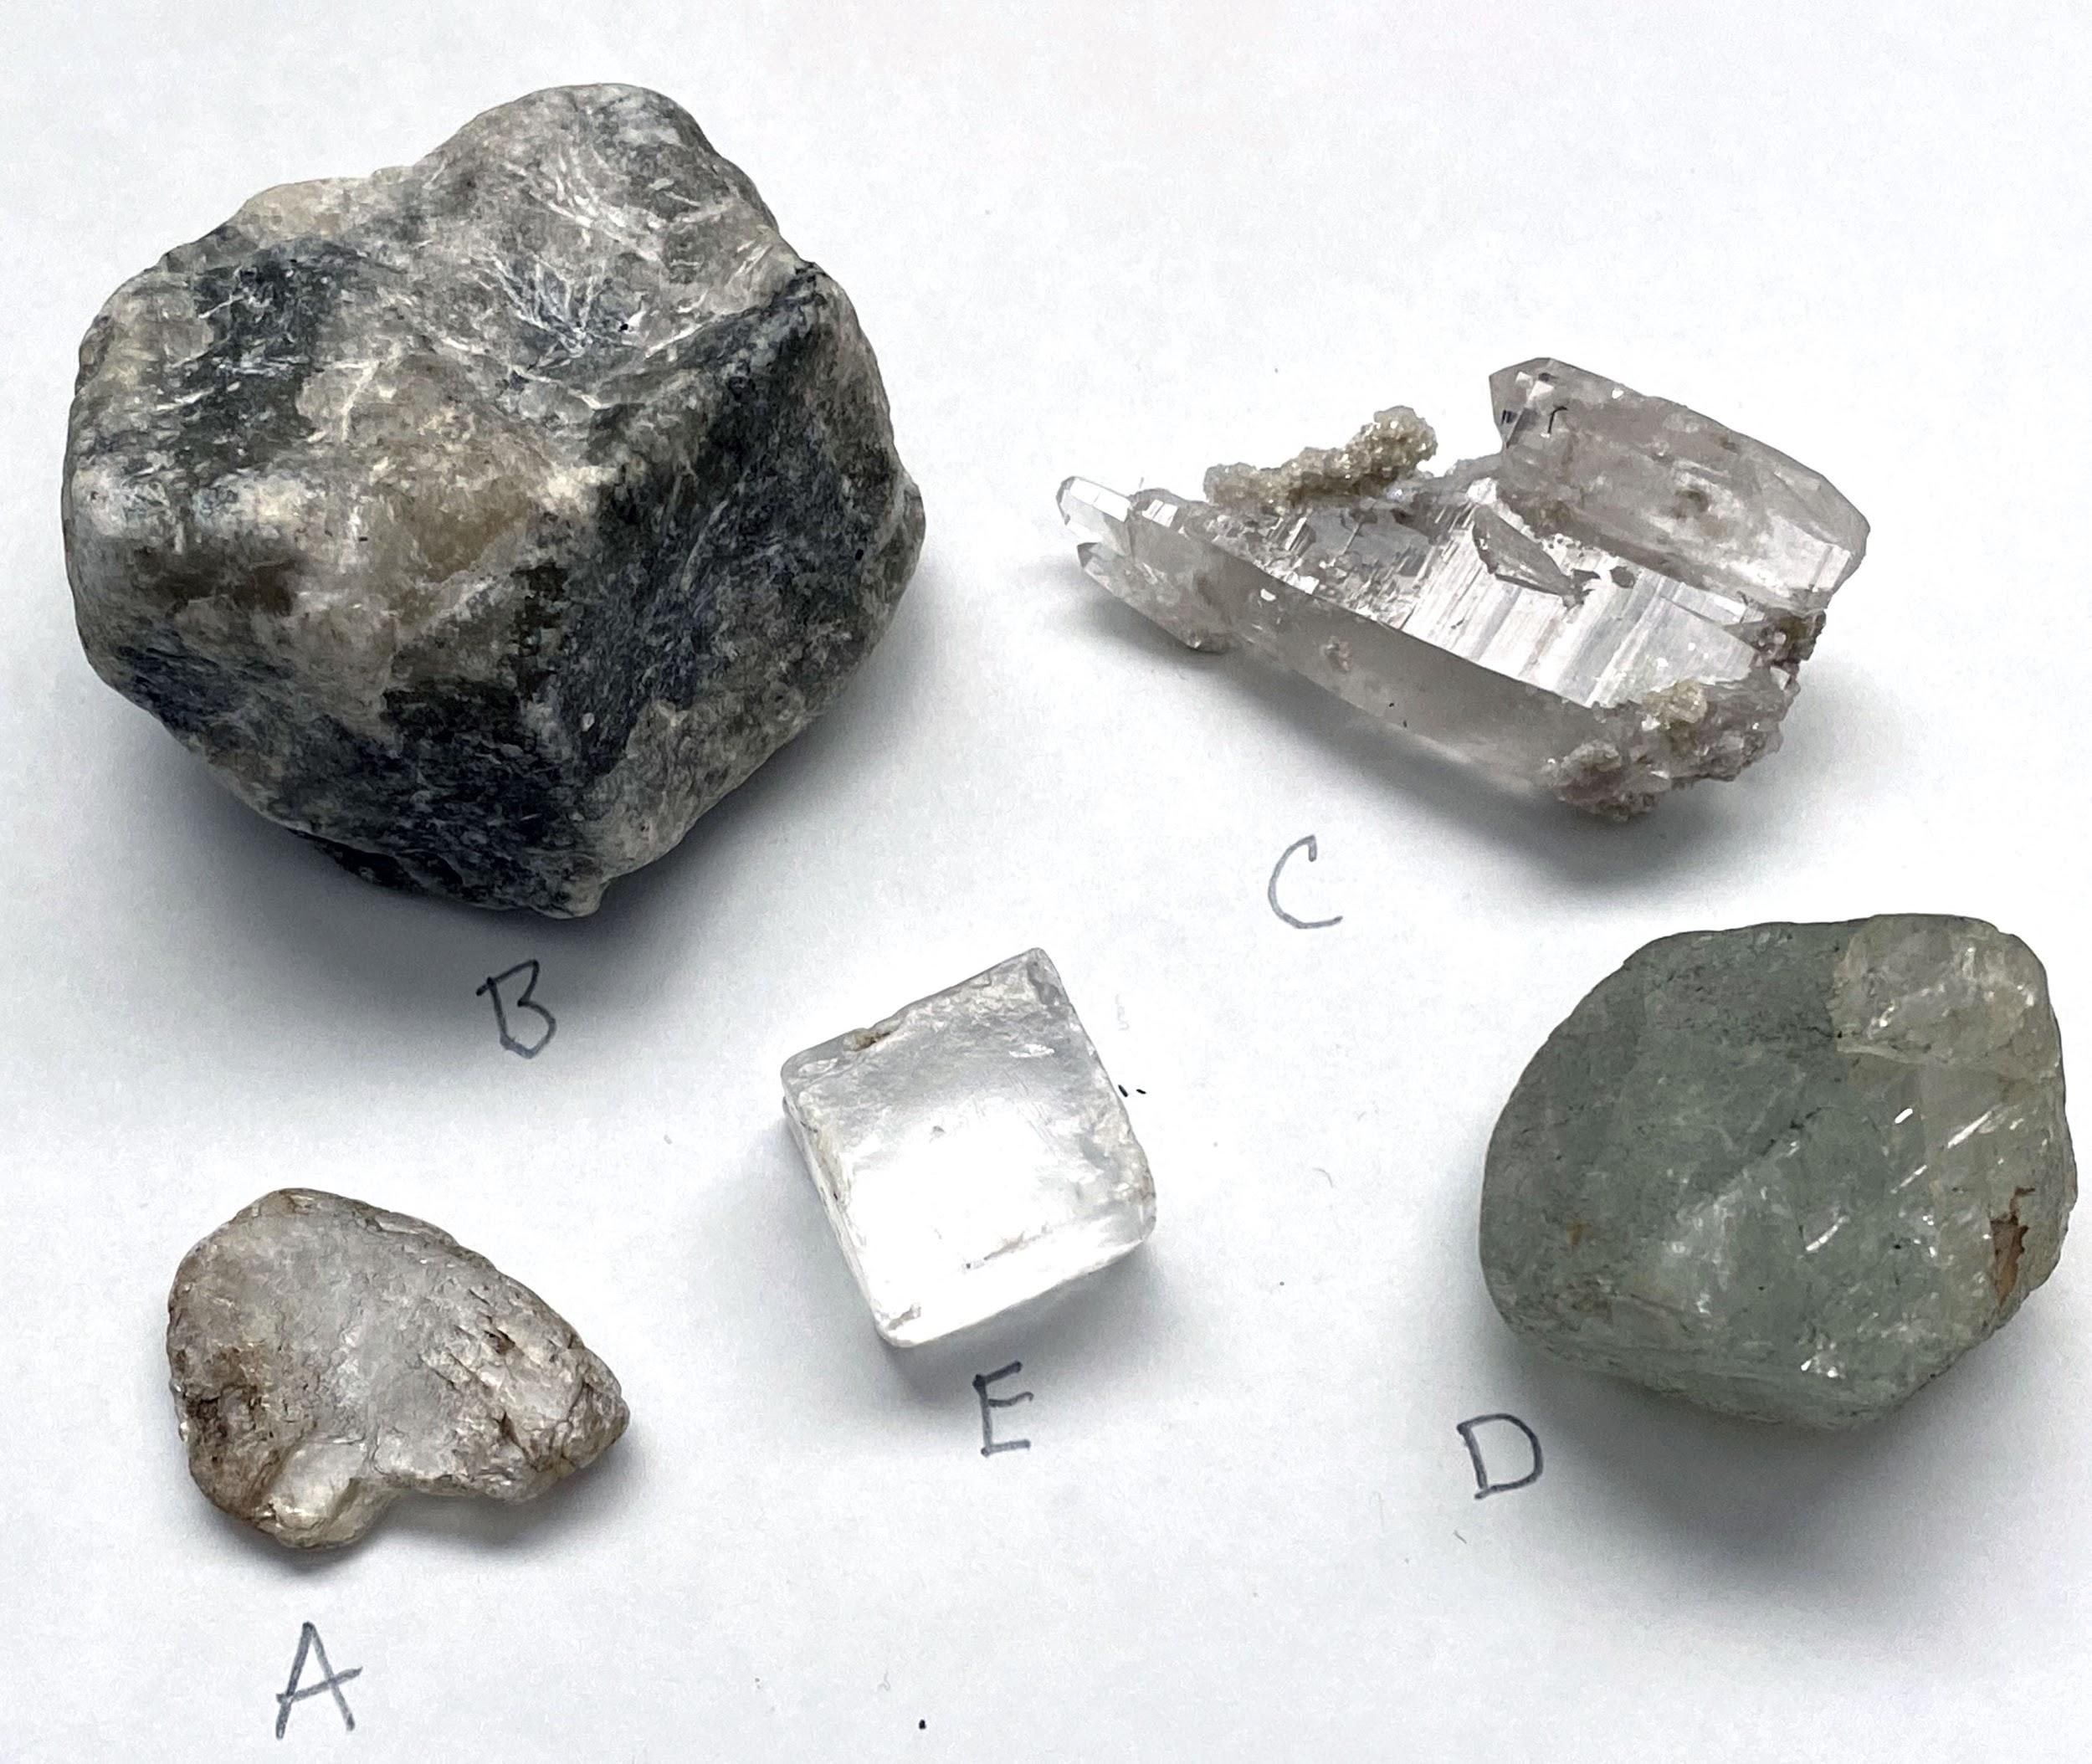
Album of above minerals (3 different views)

Pick one of the above minerals and provide below a description of it that you think others could use to effectively choose this mineral from the pile (and also distinguish it if another sample appeared that didn't look identical to this one).

Matching question: 5 different mineral samples and 5 descriptions of this mineral written by students from previous semesters (for different samples than the ones shown).

- This mineral is kind of greenish and lumpy shaped, some of it is gray and it feels kind of soft. There are white scratches on it, and I can scratch it with my fingernail. It’s the biggest and heaviest one.
CIRCLE GUESS ON SAMPLE: A | B | C | D | E

- This mineral is colorless and translucent. It has one good cleavage.I can scratch it with my fingernail.
CIRCLE GUESS ON SAMPLE: A | B | C | D | E

- This mineral is a translucent purple octahedron (it has 8 triangular faces), but it can be different colors and shapes. It has 4 directions of cleavage. It can be scratched by a steel paperclip, but not by a penny.
CIRCLE GUESS ON SAMPLE: A | B | C | D | E

- This mineral is smooth to the touch, with some scratches and a little black line inside.
CIRCLE GUESS ON SAMPLE: A | B | C | D | E

- The sample is purple, is longish, has six sides with a broken end, and is really hard.
CIRCLE GUESS ON SAMPLE: A | B | C | D | E

Reflect and describe how well did you match these descriptions to the right mineral? What’s helpful and not helpful in a mineral description? Why? Looking back at your own mineral descriptions and knowing you’ll have to identify these same minerals later when we study rocks, what would you change?

FOLLOW-UP (LAB OR LECTURE)
Mineral-Use Activity: Concept Sketch (~1-2 hrs)
Choose your favorite mineral and research it in class materials and online. (Alternatively: choose a mineral that has cultural or personal relevance and be sure to explain that relevance.) What are its most distinguishing properties? How it is used in our society and why? Where is it mined and why there in particular? Use the answers to these questions and your research to draw a concept sketch of the mineral below. Add your name and a bibliography of any sources you used.
1. Upload above to a class discussion board.
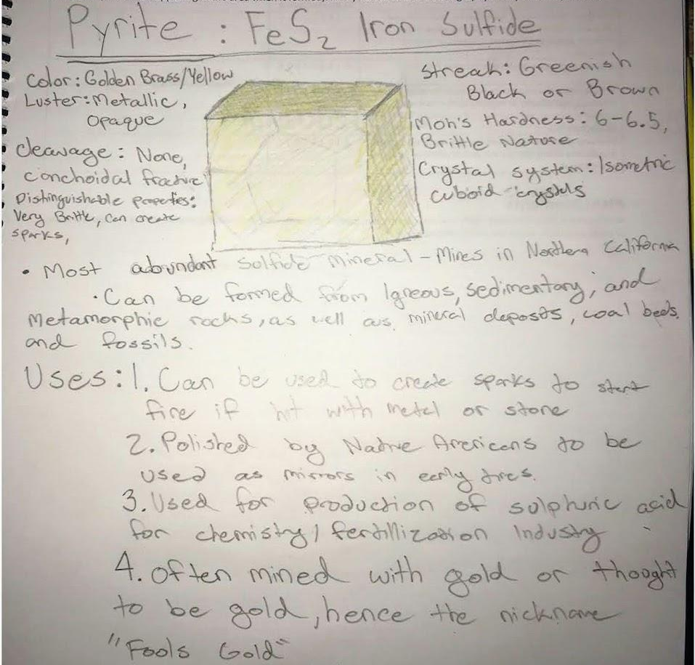
2. Review all the other concept sketches in your group (~5 students per group) and post thoughtful responses to each one.
**What is a concept sketch? See this example of concept sketch (not specifically for this assignment, but similar, from a student at CCSF)

