Metamorphic Rocks Lab
In this lab, you will use observations to compare and contrast metamorphism processes and features to draw conclusions about the geologic history of metamorphic rocks.

Learning Objectives
By the end of this lab, students will be able to:
● Describe the changes that a rock undergoes as it is metamorphosed and the metamorphic rocks they become.
● Rank degree of foliation using observations from hand samples and tectonic setting.
● Correlate agents of metamorphism with metamorphism type, plate boundary and rock type.
● Identify metamorphic rocks based on textural and compositional observations.
- Discuss the economic importance and the human health impact of metamorphic rocks

Materials
- 2-3 color Clay or play dough and assortment of pennies or beans (one set per group)
- Rock samples (or images): shale- schist (garnet –Biotite if possible)- gneiss. Sandstone- quartzite (one set per group)
Set of unknown samples (or images): slate- phyllite- schist-gneiss-marble-quartzite- serpentinite (optional)- 1 set per group. or:
Link to high resolution images:
Scott Brande’s page: https://omg.georockme.com/home and/or https://meg.georockme.com/
Virtual Samples sets: select Metamorphic Rocks
http://gigapan.com/
Icebreaker: What do crayons-asbestos and cancer have in common? Watch/ read the following news report. What is asbestos? How could they be related to today’s lab?
https://time.com/3948342/asbestos-crayons/
Asbestos in crayons? Group finds toxins in popular school supplies

Activity 1: Deformation Demonstration
Work in assigned groups (or observe instructor demo).

- With the material provided create two rocks: use clay and pennies for an igneous rock of your choice and use the remaining of the clay to make a sedimentary rock. Name both rocks.
- Sketch and label each rock in the space below under “Before”.
- Discuss different ways to “change “ the look of your rocks and proceed.
- Sketch and label each rock after deformation. What changes did you observe and what caused these changes? Discuss possible scenarios where these changes could occur to a rock in/on earth. Walk around and observe other groups' processes.
Pennyite
Before | After

Clayorite
Before | After

Write your group observations:

Activity 2: Metamorphism: How did it happen?
In this activity, you will observe two sets of rocks. Each set of rocks includes one or more unknown samples of metamorphic rocks and the sedimentary parent rock. A parent rock (or protolith) is the original rock from which a metamorphic rock was formed. A parent rock can be an igneous, sedimentary, or metamorphic rock.

- Sample A is a sedimentary rock (mudstone or shale) and is the parent rock (protholith) of samples B, C, and D (all metamorphic). With your lab group, observe and discuss the changes that took place when Sample A underwent metamorphism into Samples B, C, and D. Additionally, hypothesize what caused these changes to occur. Provide your observations and hypothesis below.

- Sample E is a sedimentary rock (sandstone) and is the parent rock (protholith) of Sample F, a metamorphic rock. With your lab group, observe and discuss the changes that took place when Sample E underwent metamorphism into Sample F. Additionally, hypothesize what caused these changes to occur. Provide your observations and hypothesis below.

- Compare and contrast how this activity relates to what you observed in Activity 1?

Background Information
Metamorphism relates to changes in mineral composition and/or texture that occur in rocks as a result of increasing pressure and/or temperature and reactions with hot, mineral-rich fluids. These agents of metamorphism will result in three possible changes in the rocks:
• Mineralogical: some minerals recrystallize to larger grains; some convert to more stable minerals.
• Physical: high pressures can result in bent or folded rocks and distorted mineral grains.
• Fluids: new minerals may precipitate from hot fluids to fill rock fractures and form veins.

There are two main types of metamorphism:
1) Contact: when rocks undergo metamorphism because they come in contact with a heat source (usually a magma body). The composition does not change but the texture does. Marble forms when limestone is metamorphosed. Marble and limestone have the same composition, but marble has larger grains.
2) Regional: when rocks undergo metamorphism over a large area due to high pressure and temperature, usually associated with mountain building. In these areas, rocks may be buried to great depths. Added pressure causes sheet-like minerals (mica) in the rock to rotate or grow in a preferred alignment. Those minerals are layered parallel to each other (like a stack of papers on a table) and perpendicular to the direction of pressure (pressing down on the stack of papers). This alignment of minerals into sheets is termed a foliation. Slate, schist and gneiss are examples of foliated metamorphic rocks.
Rocks that lack sheet-like minerals will not create a foliation. Sandstone, composed mainly of quartz, is converted to quartzite; limestone to marble. Neither contains foliations.

Activity 3: Classification and Identification of Metamorphic Rocks
You will use the observation of texture and composition of common metamorphic rocks to determine their name, probable parent rock and metamorphic conditions.

- With your lab group, design a simple flow chart that could lead to the classification of metamorphic rocks. Within the chart try to have one single rock at each end. Show to your instructor to make adjustments before doing the final identification of your samples (names).

Metamorphic Rocks Identification Flowchart (your group work)

- With your lab group, observe each metamorphic rock’s texture and composition to determine its type of metamorphism and parent rock (use your own classification or the one provided by the instructor).

Sample # | Foliation (Y/N) | Grain Size (Coarse/Fine) | Mineralogy  (if visible) | Rock Name | Parent Rock

Activity 4: Agents of Metamorphism and Metamorphism Type and Setting
The cross section below shows the two most common plate tectonic settings where metamorphic conditions exist.

- Identify the type/s of plate boundaries shown in the cross section. Briefly explain how do you know:

- Match each labeled “spot” (A, B, C, D and E) with the type of metamorphism and the P-T conditions most likely to occur at each location. Discuss with your group where metamorphic rocks from Activity 1 are most likely to occur in this context.

Location | Plate Boundary Type | High or low pressure? | High or low temperature? | Type of metamorphism
A
B
C
D
E

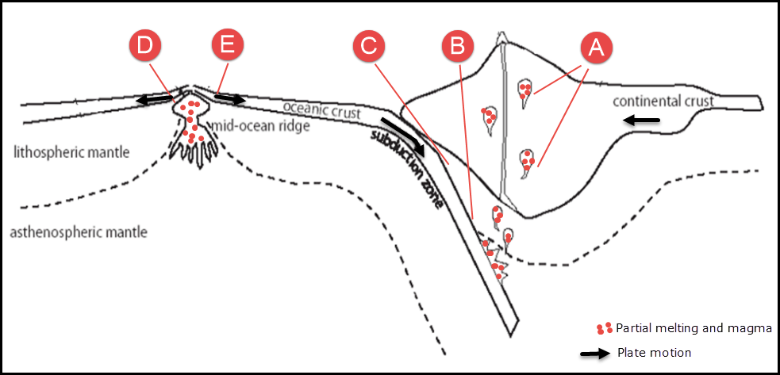
Figure 1: Cross section of a plate tectonic model (Modified from NC State MEAS 101 Lab)

Activity #5: Correlating Metamorphic Rocks with their formation
- Rank the samples exhibiting foliation from low degree of foliation to high degree of foliation.

Low Degree of Foliation → High Degree of Foliation
Rock Name

- Use Figure 3 to correlate each metamorphic rock with the P/T conditions and area of formation by completing the table below.

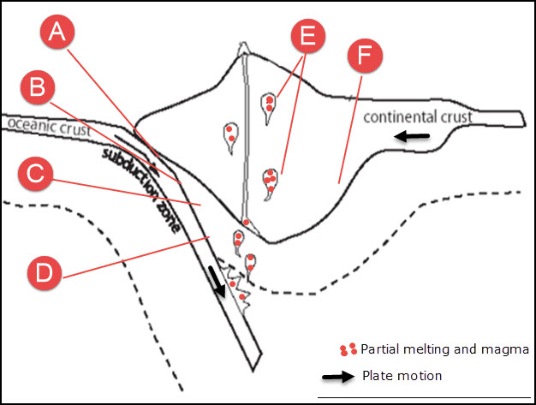
Figure 3: Cross section of a plate tectonic model (Modified from NC State MEAS 101 Lab)

Sample # | Rock Name (Activity #4) | Primary Agent of Metamorphism | Type of Metamorphism | Area of Formation  (Figure 3)

Activity #6: Metamorphic Rocks and the Real World
Metamorphic rocks and the minerals they are composed of are invaluable to our society. They show up everywhere from our kitchens to yours ! In this portion of the lab you will research the uses of common minerals found in metamorphic rocks and present your findings in a digital gallery walk.

- Your instructor will assign your group a metamorphic rock, or if you are partial to one, request it (recall the icebreaker theme at the beginning of the unit?).

- Research which types of minerals can be found in your assigned rock and the variety of uses for these minerals. There are all sorts of resources you can use, so don’t get bogged down with just one reference. Look for all types of reference materials, but remember that not every resource is of equal quality.

- Once you are satisfied that you have fully researched the uses of your rock you will create a product to share in the Gallery Walk of Metamorphic Rock Mineral Uses (your instructor will provide you with a link to the Gallery Walk via Google Slides). Remember to be creative! Make a collage, write a story, or make a fun video! Then upload/place your product in the appropriate slide in Gallery Walk.

- Once everyone from the lab has posted their materials in the Gallery Walk, return to it and read/watch what has been added and answer the following questions:

- Which metamorphic mineral uses most surprised you and why?

- Which metamorphic mineral uses did you already know about? How did you learn about those minerals?

- Which formats of presentation (e.g., video, drawing, stories, etc.) did you find most enjoyable and why?

