Igneous Rock Lab (Student Packet)
Rocks Tell a Story
Any rock that comes from the cooling and solidification of a melt (either magma or lava) is known as an igneous rock. The term igneous comes from the Latin word for fire: ignis. The resulting rocks are aggregates or mixtures, mostly made up of intergrown minerals that crystallize during the cooling and solidification process. The cooling rate of the magma controls the size of the mineral crystals that form. Since melts cool over a range of temperatures and with different chemistries, different igneous rocks will form. By observing and identifying igneous rocks, we can interpret past conditions or “tell the story” of the rock.
At the beginning of the solar system, the surface of planet Earth was completely molten. As it began to cool, igneous rock was the first type of rock to be formed. Today, igneous rocks can be found just about anywhere since they make up all oceanic crust and much of the continental crust on Earth. The mineral composition of magma may vary significantly from place to place, and the appearance and mineral content of igneous rocks can give us clues about how and where they formed. During this lab exercise, you’ll make observations about a variety of igneous rocks and learn how to group them and name them based on observable characteristics. We’ll conclude by discussing possible useful purposes for igneous rocks as well as what they can tell us about our changing planet.
Learning Objectives
At the end of our investigation, you will be able to:
- Create a detailed sketch of an igneous rock.
- Make observations that enable you to arrange igneous rocks into subcategories.
- Understand terminology that geologists use to describe igneous rocks.
- Use your observations along with a graphic scheme for igneous rock identification to identify samples of common igneous rocks.
- Work collaboratively with classmates to come to consensus on rock identification.
- Create an interpretation of igneous environments and tectonic settings based on sample characteristics.
- Use observational skills to develop explanations of rock “stories.”

Part 1: Mystery Rock Observations & Sketching
Start with the large “Mystery Rock” sample at your table.

Q1: On this page first make a detailed sketch of your Mystery Rock, then make a list of observations about it. Include any questions or things that you wonder about your rock sample. Spend a minimum of 10 minutes on this activity.

Next, you’ll set aside your Mystery Rock (for now) and turn your attention to the other rock samples at your table.
Part 2: Rock Sample Observations
You have before you an array of igneous rocks that are found consistently around the world. Recall what you’ve learned previously about mineral identification. Once again, you will be using your observational skills to identify these rocks. Start by looking for common characteristics.

Q2. Based on your observations, agree on a physical characteristic that multiple rock samples share. Then record your groupings in the table below, identifying the samples by their ID number/letter. Are you left with any “outliers'' that don’t fit?

First Physical Characteristic (i.e., “color”) ________________________
Group 1 characteristic (i.e. “black”): | Group 2 characteristic (i.e. “white”): | Group 3 characteristic OR outliers (optional):
Rock(s): | Rock(s): | Rock(s):

Now bring all of your rock samples back together, and identify another, different physical characteristic you could use to divide your rocks into two or three groups. Fill out the table below:

Second Physical Characteristic: ___________________________________
Group 1 characteristic: | Group 2 characteristic: | Group 3 characteristic Or outliers (optional):
Rock(s): | Rock(s): | Rock(s):

Look again at all of your rock samples and see if you can identify one more physical characteristic you could use to divide your rocks into two or three groups.Fill out the table below:

Third Physical Characteristic: _________________________________
Group 1 characteristic: | Group 2 characteristic: | Group 3 characteristic OR outliers (optional):
Rock(s): | Rock(s): | Rock(s):

Q3. Wrap-up. Each lab group will share with the entire class the physical characteristics you decided to use to put your rocks into categories. What (if any) were your outliers?

Q4. Make a note below of the ways of categorizing that groups had in common. Even if the categories were the same, did each lab group identify the same rock samples in the categories? Did you have common outliers, too?

Q5. Which ways of categorizing samples were different from your group?

Part 3: Group Teach-Out
Igneous petrologists (geoscientists who study igneous rocks) classify igneous rocks by composition and texture. These are generally observable qualities that are easy to define with some practice. Each lab group will do some research on some specific terms used in igneous rock identification, then share what you’ve learned with the rest of the class. (You can use your phone, textbook, laptop to do your research.)

Q6. Each group will be assigned one geologic term to research and report on. You will spend about 10-15 minutes researching the definition of your term, paying attention to how one might identify a rock that fits that definition. What observable characteristics would you see? Which rock samples might be used as an example of the definition. Be ready to share your findings with the rest of the class and include the following:
- What is the key definition?
- How does this characteristic form in igneous settings?
- How is this characteristic recognized in hand samples?
- Provide the ID number(s)/letter(s) of a hand sample that exhibits this characteristic.

Use the tables below to first record your own group’s research, then fill out the remaining tables as other groups share their research with the class.
Term | Phaneritic
Definition
How formed?
How identified in hand sample?
Letter(s) of Example Rock(s)

Term | Porphyritic
Definition
How formed?
How identified in hand sample?
Letter(s) of Example Rock(s)

Term | Aphanitic
Definition
How formed?
How identified in hand sample?
Letter(s) of Example Rock(s)

Term | Vesicular
Definition
How formed?
How identified in hand sample?
Letter(s) of Example Rock(s)

Term | Mafic
Definition
How formed?
Common Mafic Minerals?

How identified in hand sample?
Letter(s) of Example Rock(s)

Term | Felsic
Definition
How formed?
Common Felsic Minerals?
How identified in hand sample?
Letter(s) of Example Rock(s)

Part 4: Now Identify the Rocks!

Q7. Now that you have some terms you can apply to your rock samples, you should be able to start giving them names. Using your observations of each sample and the Scheme for Igneous Rock Identification (following page), discuss with the members of your group the names of your rock samples. Enter them on the table below. (Include the specific characteristics that you observed which assisted in your identification.)

Rock ID = | Rock ID = | Rock ID =
Rock ID = | Rock ID = | Rock ID =
Rock ID = | Rock ID = | Rock ID =

Part 5: Collaborate with Colleagues
Q8. Share your data. Choose a group representative to come to the front of the room, and on the board, write the rock names your group decided on with the corresponding Rock IDs. Is everyone in agreement? If not, discuss with the members of other lab groups how you could come to consensus on an identification. List below some of the observations that helped you make your identifications:

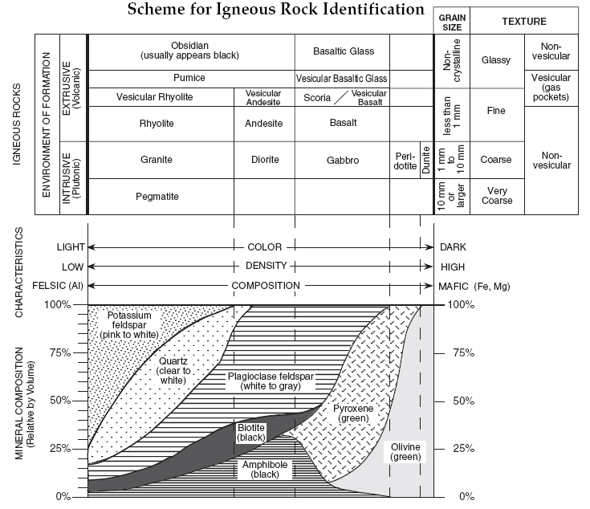

Part 6: Interpret Tectonic Settings of Igneous Rock Formation
Consider various tectonic settings and how you could associate them with various igneous rocks.
You might need to research the definition of intrusive and extrusive igneous rocks. Also consider that magma that comes directly from the mantle is mafic, and that magma that travels through continental crust is generally felsic or intermediate composition.

Q9. What kinds of igneous rocks would you expect at the following tectonic locations? (Would you be able to draw a cross section picture of some of these locations?)

Setting | Intrusive/Extrusive? | Composition? (felsic/intermed/mafic) | Rock Name(s) & ID(s) | Example Location on Earth
1. At a Divergent Boundary
2. Lower Part of Ocean Crust
3. Hot Spot (ocean crust)
4. Hot Spot (continental crust)
5. Volcano at Convergent Boundary
6. Deep In the Crust at Convergent Boundary
7. Continent-Continent Convergent Boundary

Part 7: Circle Back
Go back to your large Mystery Rock that you sketched and observed at the beginning of class. Using your new igneous rock knowledge, and collaborating with the other members of your group, answer the following questions:

Q10: What is the name of your rock?

Q11: List all of the lines of evidence that informed your identification:

Q12: “Tell the story” of your unknown rock sample! How did it form?

Q13: Draw a cross-section of the tectonic setting where it might have formed:

Q14: Where on Earth might your Mystery Rock have been found?

Q15: Why should we care? Discuss with your partners why we might care or want to know about igneous rocks. What are some reasons that we might want to study them and/or understand how they form? What other purpose(s) might we have for igneous rocks?

