Unit 2: What does Ground-Penetrating Radar Data Look Like? Student exercise
Christine Downs and Sarah Kruse (University of South Florida)
Unit 2 will introduce characteristics of the ground that causes transmitted ground-penetrating radar (GPR) waves to reflect back up toward the surface. This unit is also an opportunity to work with real GPR data.
GPR is very similar to ultrasounds in that a signal is transmitted out and a receiver records the part of the wave that reflects. Reflections occur when the wave encounters a change in the ground’s electrical permittivity (sometimes called the dielectric constant). Simply put, permittivity is a measure of how much a molecule will stretch out in an electromagnetic field. Permittivity also controls the velocity of the radar wave as it travels through the ground, but we will get to that later.
Let us take a sandy soil as an example. A dry sandy soil has a different permittivity than a water-saturated sandy soil. So, if a GPR signal travels through the dry sand and encounters the water table as a sharp boundary, some of the energy reflects up.
The GPR system records the amplitude of the reflected signal and the time that passed between the antenna emitting a signal and the reflected signal returning. This is called the two-way travel time (TWTT). The depth that the reflected signal came from is not known because the speed at which the wave was traveling is not known.
Now suppose a pipe is buried in sandy soil. The permittivity of the pipe is different than that of the soil. Imagine a GPR system moving over a buried pipe. The GPR signal travels out in all directions. Even if the pipe is not directly beneath the antenna it will reflect part of the signal back to the receiver. The receiver will record the amplitude and TWTT for all received energy. By convention, when the data are plotted, is will appear as though reflections from the pipe are coming from directly below the antenna. As the antenna gets closer to the object, the reflected signal is received sooner. After the antenna crosses over the pipe and moves away, the reflected signal is received later. In the resulting radargram, the pipe looks like an upside-down ‘u’ or, more precisely, the curve is a hyperbola. This is called a diffraction pattern. (If a buried object is not directly beneath the path of the GPR, it can also produce a diffraction. The location of such an off-line object could be misinterpreted unless multiple lines are collected to form a grid of data.
Diffraction patterns are very useful. Firstly, they are indicative of point-like features. By point-like, we mean objects that are not broad in extent. For example, if a GPR profile crosses perpendicularly over a pipe, the section of the pipe that is directly under the GPR is just a small circular slice, more like a point than a broad extended object or geological layer. A buried cannon-ball at a historical battleground would be a point-like object. Secondly, the hyperbola shape (i.e., how open the hyperbola is) is controlled by the velocity that the wave is traveling. We can use the shape of the diffraction pattern to estimate a ground velocity, and that means we can convert TWTT to depth!
For example, suppose the TWTT at the top of a diffraction is 15 nanoseconds. This is the time it took the radar wave to travel from the transmitter, down to the top of the buried object, and back up to the receiver. In this case a one-wave travel time would be 15/2=7.5 nanoseconds. Now suppose we determined from the diffraction’s shape that the ground velocity is 0.1 meters per nanosecond. Velocity is distance divided by time
v=d/t
so distance is velocity times time
d=v*t.

Our velocity (0.1 m/ns) times the one-way travel time (7.5 ns) is 0.75 meters.
d = v*t = 0.1 m/ns * 7.5 ns = 0.75 meters

The top of the buried object is 0.75 meters below the ground surface.
In this handout 2a, you will answer questions aimed at increasing your understanding of how a GPR wave behaves when transmitted into the ground. It will also help familiarize you with some terminology.
Handout 2b walks you through analysis of an actual GPR data set. Using example data provided to you, and perhaps your own data, you will identify the diffraction patterns in a radargram, estimate the ground velocity, and determine the depth of underground features.
- Causes of radar wave reflections
    - The GPR wave leaves the transmitter and travels into the ground. Portions of the wave will reflect up to the surface when the ground ____________________ changes.
    - From the list below, select possible causes for a GPR wave reflecting.
      - Encountering the water table
      - Flowing water
      - Encountering saline groundwater at the beach
      - Buried storage tank
      - Experiencing an earthquake while collecting GPR field data
      - Gasoline spill beneath an old gas station
    - What is the signal that GPR sends into the ground? ________________________
    - Is it continuous or a pulse? _______________________

- Detecting Point-like Objects
    - When GPR crosses over point-like objects, a _______________ _________________ is recorded.
    - Select from the list possible features that could be detected as point-like objects. (Hint: Remember the orientation that you cross over an object can influence whether it appears as point-like.)
      - clay layer
      - a long pipe
      - tree roots
      - the water table
      - a grave
    - The closer a GPR antenna comes to a buried point-like object, the _________________ reflected wave returns.
    - The ________________ the ground velocity, the wider the upside-down ‘u’ it produces in GPR data.
    - In which example in Figure 1 is the ground wave velocity faster? A or B
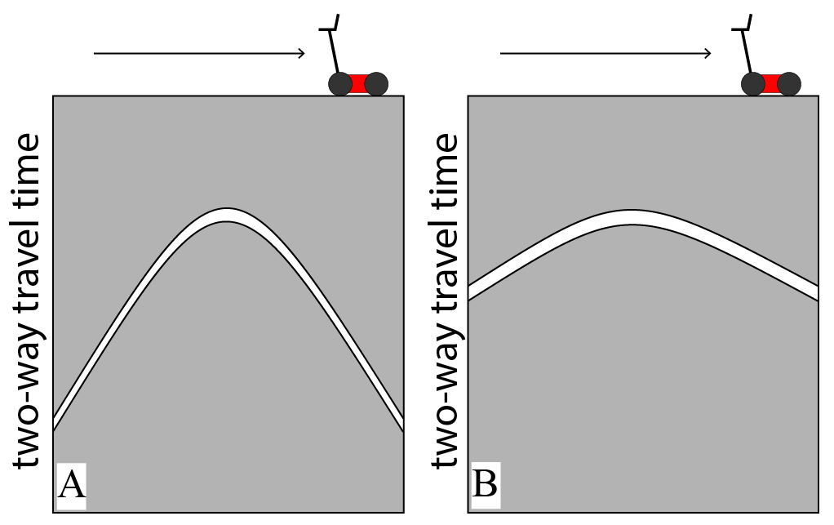
    - In which example in Figure 1 is the ground permittivity larger? A or B
Figure 1 Schematic GPR response from a point-like object under two sets of ground conditions.
    - In which example in Figure 1 is the object deeper? A or B
    - GPR wave velocity is __________________ in water saturated sediments compared to dry sediments.

- Think-Pair-Share
- Why do buried objects produce diffraction patterns in GPR data?
- If diffraction hyperbolas overlap, as in the image below, does that mean that the buried objects overlap each other?
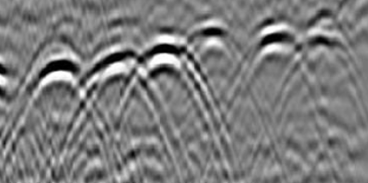
- Pipes and graves are long features rather than points. How is a buried pipe or grave a point-like object?
- Will the diffraction pattern of a buried object be wider or narrower after a heavy rain?
- You have just read a consulting report that presents the findings of a GPR survey in a cemetery. The consultant identified several unmarked graves on the property’s edge, which is lined with oak trees. The graves range in depth from 20-50 cm. What do you make of these interpretations? What information could you look up to help assess the report’s findings?

