CUAHSI Data-Driven Education Workshop

Submarine Groundwater Discharge Estimation

Instructor: Xuan Yu, University of Delaware

The purpose of this exercise is to estimate submarine groundwater discharge at Delaware. This exercise will use WaterML is a technical standard and information model used to represent hydrological time series structures. WaterML is a R Package published by CUAHSI. If you are interested, you can find more information about WaterML on the web at https://cran.r-project.org/web/packages/WaterML/index.html

Introduction
Near the Earth surface, hydrologic flow carries nutrient and other chemical solute and sediment from land to ocean. The flow and transport processes are critical to understand and management environment at rivers, estuaries, and seas. On the surface, we use gauge station to observe overland flow collected at river mouth (Figure 1). Beneath the surface, submarine groundwater discharge (SGD) happens along the coastal, which is difficult to measure (Figure 1). Here we utilize observation data to estimate SGD. The goals of this exercise are:
- To learn WaterML,
- To compare SGD against surface runoff at Delaware,
- To preserve hydrologic dataflow in a reproducible way.
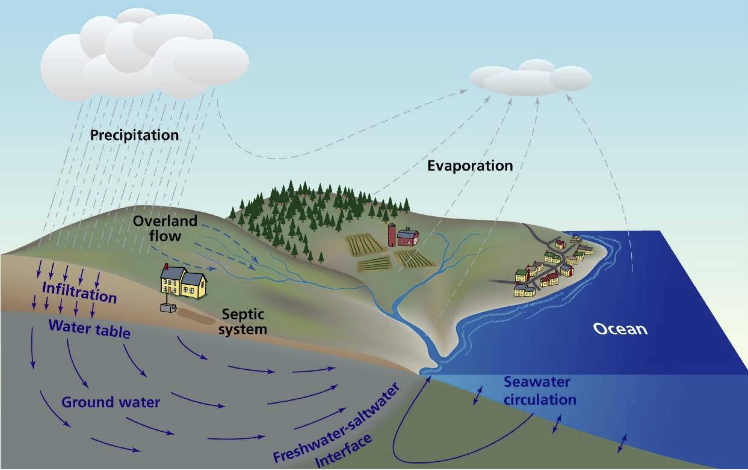
Figure 1. Hydrologic flux between land and ocean (Mulligan and Charette, 2009).

Data processing steps:

- Select following data: groundwater level data, tidal data, and runoff data (Figure 2). The time range is from 2013-12-01 to 2014-4-30.
- Download other hydrologic data from a URL (https://udel.edu/~xuan/CUAHSIworkshop.csv ).
- Calculate SGD.
- Compare SGD against runoff data.
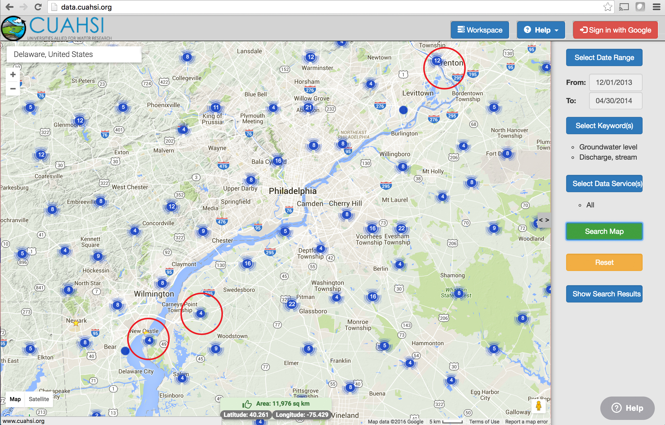
Figure 2. Locations of time series data were highlighted by red circles.

Table 1. Hydrologic characteristic data collected
Variables | Value | Unit | Source
Hydraulic Conductivity | 17.5 | feet/day | Andres, et al., 2015
Aquifer thickness | 15 | feet | Andres, et al., 2015
Bank length | 120 | miles | Google map measurement
Distance between two sites | 2.3 | km | Google map measurement

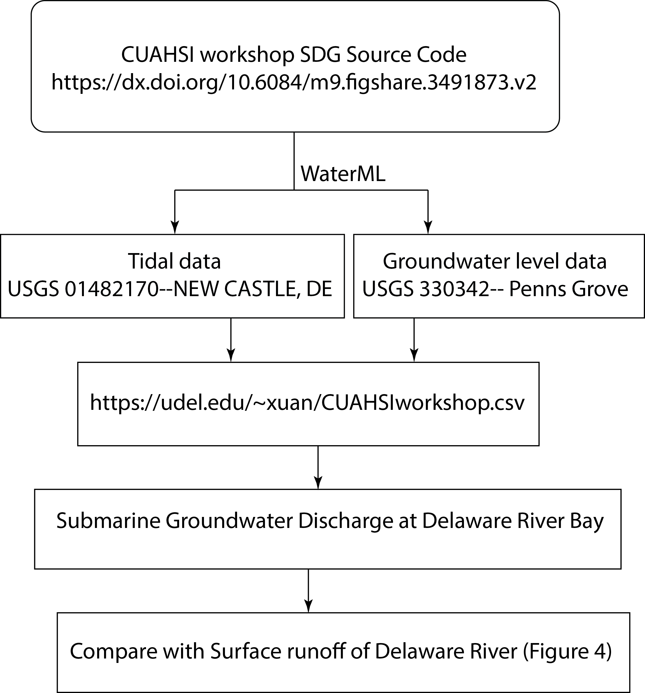
Figure 3. Computational workflow for the exercise.

Results
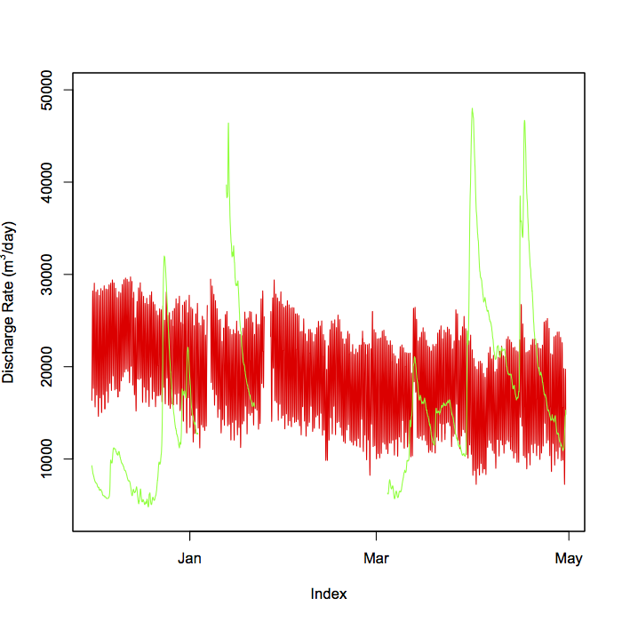
Figure 4. Comparison between SGD (in red) and surface runoff (in green).

Reference:
Andres, A.S., Walther, E.F., Türkmen, M., He, C., 2015, Hydrogeology of a Rapid Infiltration Basin System (RIBS) at Cape Henlopen State Park, Delaware: Delaware Geological Survey Bulletin 1B, 44 pp.
Mulligan, A.E., Charette, M.A., 2009. Groundwater flow to the coastal ocean. In: Steele, J.H., Turekian, K.K., Thorpe, S.A. (Eds.), Encyclopedia of Ocean Sciences, 2nd Ed., pp. 88–97
Yu, Xuan (2016): CUAHSI workshop SDG Source Code. figshare. https://dx.doi.org/10.6084/m9.figshare.3491873.v2

