Name:______________________
Nutrient Loading Module
Student Handout

MODULE DESCRIPTION:

Learning Outcomes:

By the end of this module, you will be able to:
- Evaluate factors related to concentration versus discharge that control the load of nitrogen exported downstream.
- Discuss causes of variability and covariability in nitrate-N and discharge data, and propose a strategy that allows data to be used with a high level of confidence.
- Explore how to look at correlations of two variables
- Understand the effect of sample frequency on developing a robust estimate of a variable

Finding the data-

Part A Assessment of chronic downstream water quality impacts - Loads
Evaluating chronic downstream environmental impacts can be more difficult than evaluating acute local impacts. The concentration of nitrate in stream water determines whether or not there is a local impact. However, for downstream impacts, we are not concerned with concentration but with the mass of nitrate transported downriver. It is the accumulation of nitrate mass at the terminus of the stream or river, such as in a lake or an estuary, that causes eutrophication, hypoxia, and/or algal blooms in these environments.

To manage these risks, management agencies such as the U.S. EPA, use the calculation of “load.” Load is simply the multiplication of discharge (m³/day, L³/Time) by concentration (kg/m³, Mass/L³), and has the units of kg/day (Mass/Time), which is the approximate mass of a substance moving past an observation point on a given day. A total maximum daily load (TMDL) is the cumulative maximum load allowed to flow past a given point on a given day.

Under the Clean Water Act, states are required by the federal government to develop a TMDL for nitrogen, phosphorus, suspended sediment, and other parameters for all rivers listed on the state’s 303D List. The TMDL applies to a specific measurement point in a specific stream, and represents the mass that can be safely assimilated by the river without causing downstream impacts. Rivers that continually exceed their TMDL may be subject to regulatory actions, such as aggressive watershed management planning and restricted activities. State with rivers that fail to meet TMDLs will receive annual fines from the federal government (i.e. EPA). Most states are still in the process of developing TMDLs for their rivers (http://cfpub.epa.gov/wqsits/nnc-development/)
Two challenges are presented when trying to understand and regulate nutrient loads (or other pollutants) in streams. First, what is the relationship between concentration and discharge, and how does their interplay determine the observed load? Second, what processes influence the load of a nutrient to a receiving water body?

Exploring concepts

Think about a river close to campus or to your home town. How does discharge vary over the course of the year? On a separate sheet of paper, draw a sketch of how you expect discharge to vary across a year.

List some potential sources of nitrogen in a watershed. Think about each of the sources you listed; do you expect the amount of nitrogen coming from that source to vary over time? Why or why not? Draw a sketch of how nitrogen input (in units of mass) varies across the year for two of your potential sources.

Compare your discharge and nitrogen input figures. Discharge and input will affect steamwater nitrogen concentration. Given your two figures, show how you expect concentration to vary across the year?

Part B What is the relationship between stream discharge and nitrate concentration?
Option 1
1. Now to graph data from Open the USGS Water Quality Watch web page http://waterwatch.usgs.gov/wqwatch/
- Under the “State” menu, select “Iowa” and allow the map to refresh.
- Under the measurement menu, select “Nitrate.”
- Move your mouse over the available triangles until you find “Cedar River at Blairs Ferry Rd, at Palo, IA.” This triangle is equidistant from the top (North) and the bottom (South) of the map, and about an inch to the left of the right (East) boundary of the state.
- Once you find it, click once on the triangle, and the click again on the eight-digit hydrologic unit code (HUC) number “05464420” which identifies this site.
- Now you are in the official USGS data site for the Cedar River at Blairs Ferry Rd, Palo, IA. Scroll down and explore the plots of the available data. What do you see?
- We would like to see whether nitrate changes as a function of stream discharge during the summer agricultural season. To do this:
  - Scroll back up to the box labelled “Available Parameters.”
  - Uncheck “gage height” and “water temperatures.”
  - Change the starting date to April 1, 2014 and the end date to September 1, 2014. Enter these dates in YEAR-MO-DY format (i.e. 2014-04-01, and 2014-09-01, respectively).
  - The top graph shows discharge in ft3/sec whereas the bottom graph shows nitrate-nitrogen (NO3-N) concentration in mg/L.
- First consider the bottom graph showing nitrate concentrations vs. time. When was the concentration of NO3-N the highest, and when was it the lowest?
- Now consider the top graph showing stream discharge. Does there appear to be a relationship between nitrate concentration and stream discharge? During which months does this relationship appear to be strongest?
- Propose a hydrological process that might be responsible for creating this relationship.
- Do you expect that other dissolved constituents (Calcium, Iron, Phosphate, etc.) would show the same behavior? Why or why not?
- Based on this analysis, predict whether nitrate concentrations in downstream streamwater should be larger or smaller than the concentration observed at Cedar River.

Option 2-
To find the data on HydroClient:
- Enter Date Range (04/01/2014 to 09/01/2014)
- Select Keywords (Discharge and Nitrogen) (You can find nitrogen in the full list of keywords, see screenshot below)
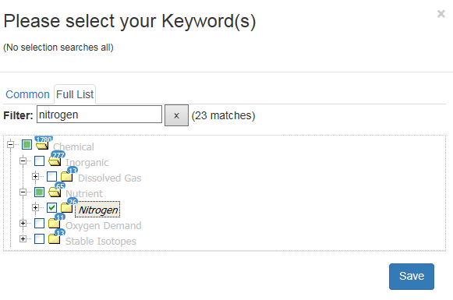
- Click Select Data Service and use the search box to type geological and click to highlight U.S. Geological Survey

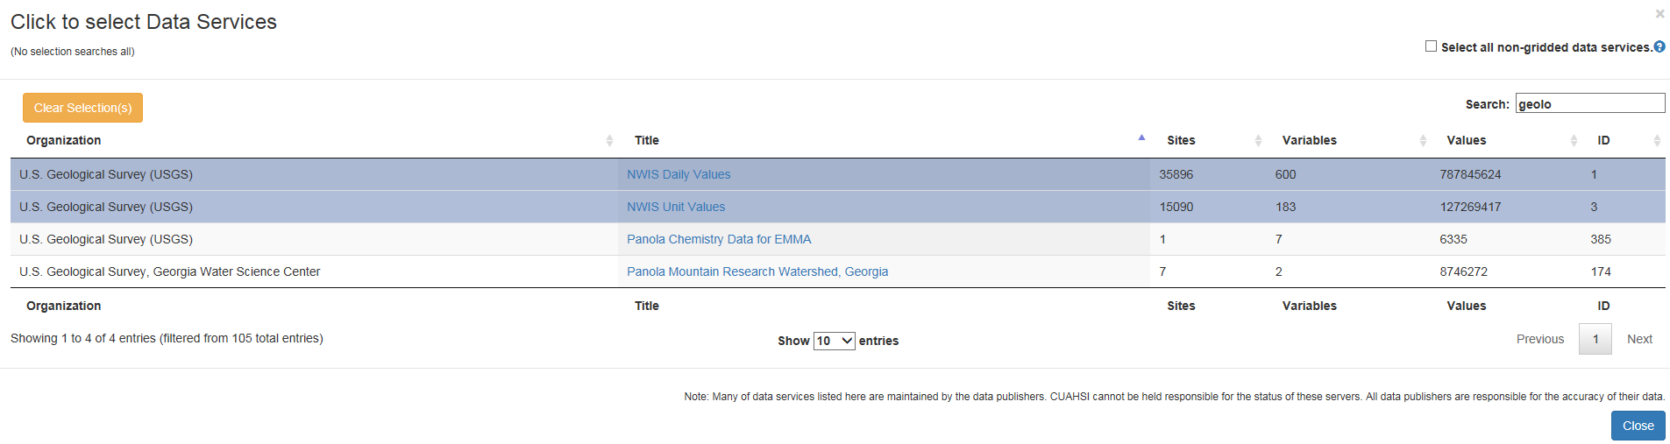
- Click Search Map
- Click Show Search Results
- Use the search box in the list of Search results to type the USGS site number: 05464420
- Exit out of list of Search Results to see filtered sites shown below

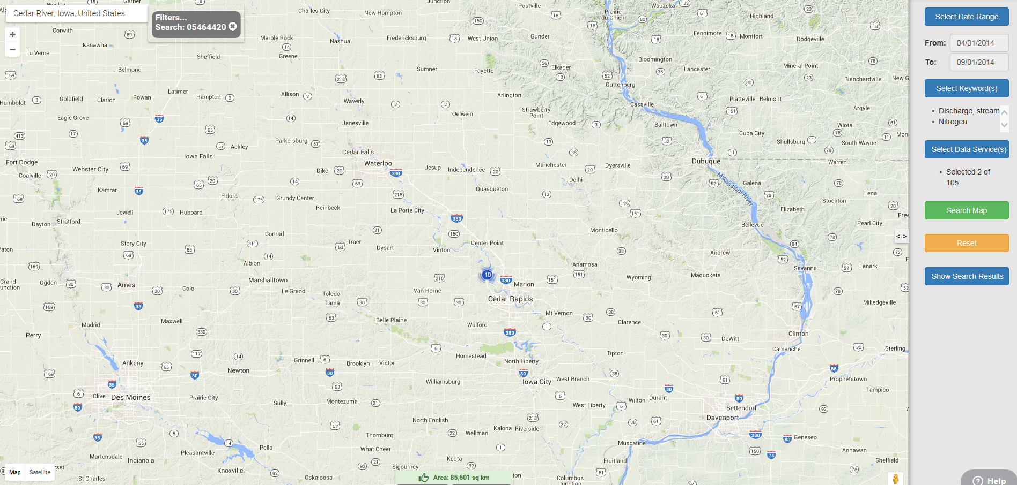
Plot the data using Data Series Viewer in HydroClient:

Click on the data marker shown above, find the data series of interest for discharge and nitrate and highlight each as shown below.
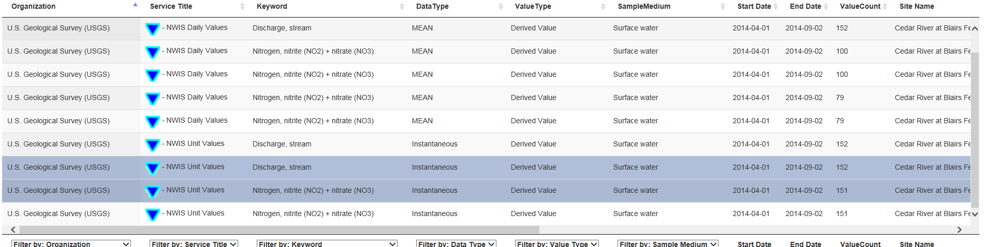
Click Select Action, choose Save 2 Selections to workspace.
Click on the workspace button in the top right
Highlight the two data series
Click Select Tool, choose Data Series Viewer
Click Launch tool.
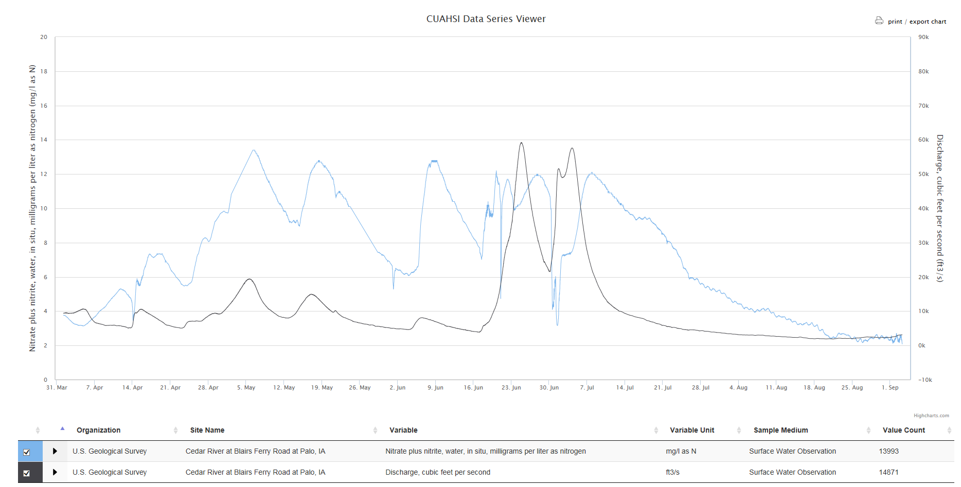

Part C Quantifying Discharge/Concentration relationships
Now let’s attempt to quantify the relationship between discharge and concentration that you observed above by downloading the data and creating your own graphs.
- Under the heading “Output Format,” select the “Tab-separated” circle and click “GO.”
- Copy and paste these data into MS Excel.
- After eliminating unnecessary data, make a plot showing discharge (x-axis) vs. nitrate concentration (y-axis).
- If there is a direct, one-to-one relationships between discharge and concentration, this graph should have a straight line. What do you observe? Is this what you expected? Look at your answer to question Bi.
- What can explain the observed relationship? To answer this question:
    - First, consider whether there is part of the graph that matches your expectations, where discharge and concentration have a linear relationship. Up to what discharge does this linear relationship hold?
    - Now, think about what happens to the concentration of a dissolved solid as we add more water to the stream during a flood event. What effect would large amounts of water have on nitrate? Do you see this in the graph?
    - Okay, now let’s think about where stream water goes during major flood events, apart from flowing downstream. Is there another reservoir that takes on water? What is this reservoir called?
    - What happens to nitrate in stream water as the flood event passes, the river stage drops, and the river goes from losing water to groundwater to gaining water from groundwater?
    - This cyclical process is called “hysteresis,” and is an excellent example of the complexity of factors driving stream concentrations.

Part D Nutrient Loads (Concentration Times Discharge)
1. In this activity, we will compare the daily load in the Cedar River, a tributary of the Mississippi River in Palo, Iowa, to the load in the Mississippi River at Baton Rouge, Louisiana, roughly 940 miles downstream. We will use USGS data from April 1 to September 1, 2014 for this analysis.

- First you should formulate some hypotheses:
  - Which location do you think will have a higher nitrate concentration? Why?
  - Which location do you think will have a higher discharge? Why?
  - Which location do you think will have a higher daily nitrogen load? Why?
  - Which system will show more variability in load over time? Why?
- Calculating loads
  - Copy and past discharge and concentration data from the Cedar River into the spreadsheet provided by your instructor called “Load Calculator.” This spreadsheet automatically converts discharge and concentration data into the correct units for our analysis.
  - Open the USGS Water Quality Watch web page http://waterwatch.usgs.gov/wqwatch/
  - View data for the State of Louisiana.
  - Under “Measurement,” select “Nitrate.”
  - Baton Rouge is the only triangle that appears in this state. Why do you think Iowa has so many more real-time nitrate measurement points than Louisiana?
  - Click on the Baton Rouge triangle and click on the eight digit hydrologic unit code (HUC) for the stream gage.
  - Under the box titled “Available Parameters,” uncheck everything except “Discharge” and “NO3+NO2.” Change the output format to “Graph.” Enter the date range for April 1, 2014 (2014-04-01) to September 1, 2014 (2014-09-01). Click “GO.”
  - Check your first two hypotheses against the graphs provided:
    - Which site had a higher concentration?
    - Which site had a higher discharge?
    - Do you wish to change your load prediction at this point?
  - What are the potential causes of of variations?

2. Formulate a hypothesis: What should the concentration be downstream? How should concentration change over the year?

3. Now data for the Mississippi River at Baton Rouge, LA (USGS site No. 07374000) and compare the Mississippi River to Cedar River. Do the data support your hypothesis? Why? Which has higher concentration? Which has higher discharge? How can we compare the contribution of both sites? Can you develop a common metric?
4. . Which site should have a bigger load and why? How can you test this hypothesis? Calculate daily load across the year for each site.

Part E Sample Frequency

Since the calculation of load requires observations of discharge as well as concentration, our resulting estimates depend on the accuracy, precision and frequency of these observations. More often than not stream discharge is observed at a 15 minute frequency through relatively low cost stage height monitoring equipment. Observing nitrate at a 15 minute interval is significantly more difficult and more expensive than observing discharge so we often have much less frequent data of nitrate concentrations. High frequency nitrate sensors (called ion selective electrodes, or ISE’s) are a relatively new technology and have only been used since ~2010. In this exercise we will investigate the effect of sample frequency on the estimated nitrate load for the Palo Iowa Cedar River USGS station.

1. Your instructor has sheets (cedar_river_palo_iowa_cleaned.xlsx) that sub-sample the nitrate data for 4 times daily (0000, 0600, 1200, 1800), Daily, Weekly (Tuesday’s at 0900) and monthly (the first of the month at 9 AM).
2. These sampling regimes represent typical approaches to sampling when 15 minute sampling is not possible.
3. Calculate nitrogen load as you did before but now only use the 4 times daily, daily, weekly and monthly sampling regime.
4. How much does your estimate of load change?
5. Each time you sample there is a cost associated. Imagine that each sampling round costs the government $1000 for instrument maintenance and staff salary. The benefit of sampling is improved information, and estimates must be weighed against this costs. Which sampling regime would you choose to balance the cost and benefit? Justify your answer.

