Measuring Water Resources Unit 2: Traditional and geodetic methods for monitoring groundwater change—Student Exercise

Eric Small (University of Colorado) and Bruce Douglas (Indiana University)

# Introduction

The water balance of an aquifer can be summarized by the following equation



On the left-hand side, *S* represents the volume of water stored in the aquifer. So, d*S*/dt is the rate of change in volume of water stored (km3 yr-1). The right-hand side represents the fluxes in and out, all with units of km3 yr-1: P = precipitation (which adds water via recharge); ET is evapotranspiration, R is loss to rivers, and *pumping* is water removed from the aquifer. Equation 1 can also be applied on a per-area basis: d*S*/dt and the fluxes all then have units of water depth per time (e.g., m yr-1 or mm yr-1).

Over the past century, humans have removed enormous quantities of water from aquifers for agriculture and domestic uses. There are different ways to document how much water has been removed from aquifers.

**Flux-based estimate**: First, you can measure or estimate each flux in and out of aquifers: *P*, *ET*, *R*, and *pumping—*andthen calculate changes in *S*.

**Volumetric approach using well data**: You can directly measure changes in storage (*S*) as indicated by the height of water in groundwater wells and knowledge of the aquifer’s hydrologic properties. Data from many wells across the aquifer must be included in the analysis to yield accurate results.

**GRACE-based measurements of mass change**: The GRACE satellite system responds to changes in mass beneath its track, which can be recast as gravity anomalies. One type of anomaly is due to variations in the mass of water stored at or beneath the surface of the Earth.

**GPS-based measurements of mass change:** The solid Earth responds elastically to variations in the amount of water stored at or beneath the surface of the Earth. Unit 3 focuses on using GPS records of vertical position to examine fluctuations in groundwater storage. The GPS instruments record the elastic response of the Earth; change in water storage can be estimated by the relative vertical motion of the instrument.

# Part 1. Observations of depth to water table

USGS archives groundwater data from thousands of sites across the United States. We will consider water table level measurements from the western portion of the High Plains Aquifer in Wyoming.

Records of water depth from three groundwater wells are provided in an Excel spreadsheet, and locations are shown in a Google Earth kmz file). Make a graph of depth to groundwater (below land surface) through time. The data are provided by the USGS in feet. From now on, your graphs should be in metric (so in this case, meters). Plot y-values in “reverse order,” so the changes exhibited on the graph correspond to the water table moving up and down.

First analyze the ***seasonal variations*** of groundwater depth. The following questions can be answered by looking at the graphs you have made and at the data in the spreadsheet.

1. What month/s of the year is the water table the lowest (i.e., the depth to the water table is greatest)? What month/s of the year is the water table the highest?

Site 1:

Site 2:

Site 3:

1. What is the ***amplitude*** of the annual cycle in groundwater depth (in m)? Convert this to a change in depth of water stored, using specific yield typical of sandstone (0.2). Repeat the calculation with a specific yield typical for clay (0.02).

Site 1:

Site 2:

Site 3:

1. In terms of the different components of the water balance equation, hypothesize why the level of the water table varies throughout the year? You may access relevant data from the web if you feel this is helpful.
2. Compare the seasonal variations observed at the three wells. What are possible explanations for the differences you observe?

Now analyze with data the change in groundwater depth throughout the interval.

1. Ignoring seasonal variations, does the water table drop continuously at each site over the period of record? For comparison, consider the “High Plains” curve in Figure 1 of Konikow (2011).

Site 1:

Site 2:

Site 3:

1. How much did the water table drop from the first year to the last year of the record? To account for the seasonal variations, you need to make this comparison at the same time of year (choose either late summer or late winter).

Site 1:

Site 2:

Site 3:

1. Convert the water table drop over the period of record to the equivalent change in depth of water stored. First complete the calculation using specific yield of sandstone. Repeat the calculation with a specific yield typical for clay.

Site 1:

Site 2:

Site 3:

1. Consider your answers from question 7 in terms of the water balance equation. Are changes in aquifer water storage large or small compared to the magnitude of the precipitation (or ET) flux? Consult Figure 1 for the mean annual precipitation where the wells are located. Estimate the magnitude of uncertainty in the “flux-based approach” for estimating storage changes, compared to the “volumetric approach”.

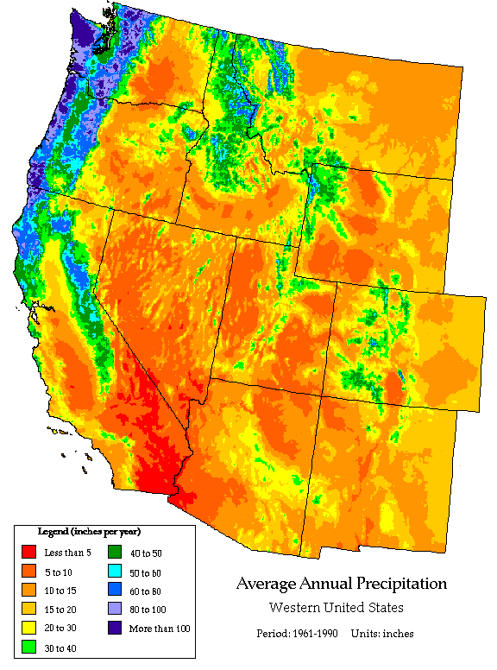

Figure 1. Average annual precipitation in the Western USA. (Map produced by the National Resource Conservation Service (<https://www.nrcs.usda.gov>) and Oregon Climate Service (<http://www.occri.net/projects/oregon-climate-service/>). Map available from

<http://www.wrcc.dri.edu/precip.html>.)

# Part 2. Observations from GRACE satellites

Now consider observations from the GRACE satellites for the entire High Plains Aquifer (see High Plains Google Earth kmz for overview data). These data represent gravity anomalies over a large region (~1000 km x ~1000 km) converted to terrestrial water storage anomalies (TWSa). Using the data in the Excel spreadsheet, make a graph of TWSa through time for the High Plains. The data are in mm of water depth, shown as anomalies (the average value is 0.0). Make sure your graph includes a horizontal line at zero, showing when anomalies are positive or negative.

First analyze the ***seasonal variations*** of terrestrial water storage anomalies in the High Plains region.

1. What month of the year is TWS the lowest? What month of the year is TWS the highest?
2. What is the ***amplitude*** of the seasonal cycle in terrestrial water storage (in mm)?
3. Compare and contrast the seasonal variations in TWS to seasonal variations in groundwater storage based on well observations of depth to water table (part 1, above). Your answer should address both (1) timing of maxima/minima and (2) the magnitude of the seasonal variations.
4. Now look at the Google Earth file. Turn on/off the different layers that show snapshots of the wettest (May 2011), driest (November 2012), and difference between the two over the period of measurement. Describe the spatial variability for each. What region had the biggest difference between the two periods?
5. Explain the similarities and differences you described in question 11 in terms of the water balance equation (eqn 1)? Consider both what the different methods measure (wells data versus GRACE) and the spatial scale they represent.

Now analyze the change in GRACE TWS throughout the period of record (2002–2015).

1. Ignoring seasonal variations, describe the changes in TWS throughout the GRACE period of record. Is there a steady trend in TWS or do other variations dominate?
2. Calculate a change in TWS between the first and last year of the record. Make sure to compare TWS at approximately the same time of year (given the strong seasonal cycle). If the entire change was due to withdrawal of groundwater, how much would water level decrease in wells if the aquifer had a specific yield of sandstone? Of clay?
3. Convert your answer in #15 to trend in mm yr-1 and km3 yr-1 (the latter requires knowing the area of the High Plains Aquifer). There are two ways you can do this. First, you can use your answer from #15 for the magnitude of change in the trend calculation. Second, you can calculate a trend using all the data in the time series—by fitting a straight line in Excel. Compare your results to the trend from Figure 1 of Konikow (2011).

Figure 2. Cumulative net groundwater depletion in major aquifer systems or groups in the United States, 1900–2008. (From Konikow, 2011, Geophysical Research Letters. American Geophysical Union journals allow reproduction of a single figure for educational purposes.)

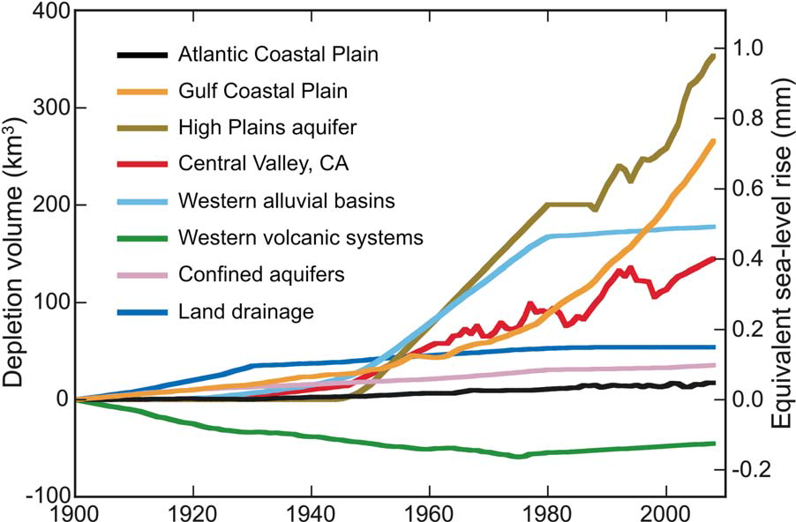

1. Based on your data analysis above, what do you feel are the strengths and weaknesses of GRACE for monitoring trends in groundwater storage? What are the strengths and weaknesses of using well data?

**Part 3. Reflections**

1. Over the course of completing this unit, you have been asked to consider terrestrial water storage using both traditional and nontraditional geodetic data sets. Please reflect on the following:
   1. How familiar were you with regard to the basic concepts of reservoirs and fluxes that address terrestrial water storage?
   2. Were you surprised to learn about new geodetic-based methods of determining the same parameters used in documenting terrestrial water storage?
   3. What value do you see in the incorporation of geodetic based data sets?