Eyes on the Hydrosphere Unit 2.2: Student Exercise – Western Mountain Watershed
Jon Harvey (Fort Lewis College) and Becca Walker (Mt. San Antonio College)
Measuring water in remote mountain watersheds can be challenging! But over three billion people on Earth depend on water that flows down from high mountain areas, so it is also really really important. In this exercise you will investigate in more detail:
- how we measure surface water (snow and water)
- what different methods are better at measuring
- how seasons, drought cycles, climate change, and human use affect surface water
The case study site will be a Western Mountain Watershed in Colorado USA, but the same issues are present in many mountains and the areas downstream of them around the world.
Answer the numbered question. The lettered sub-headings indicate the different sub-topics.

In the provided spreadsheet, you will find hydrologic data for a mountain watershed in southwest Colorado, USA as measured by three difference methods you are already familiar with: SNOTEL, reflection GPS, and stream gaging.
You should see several tabs at the base of the document – each takes you to a difference spreadsheet in this Excel Workbook.

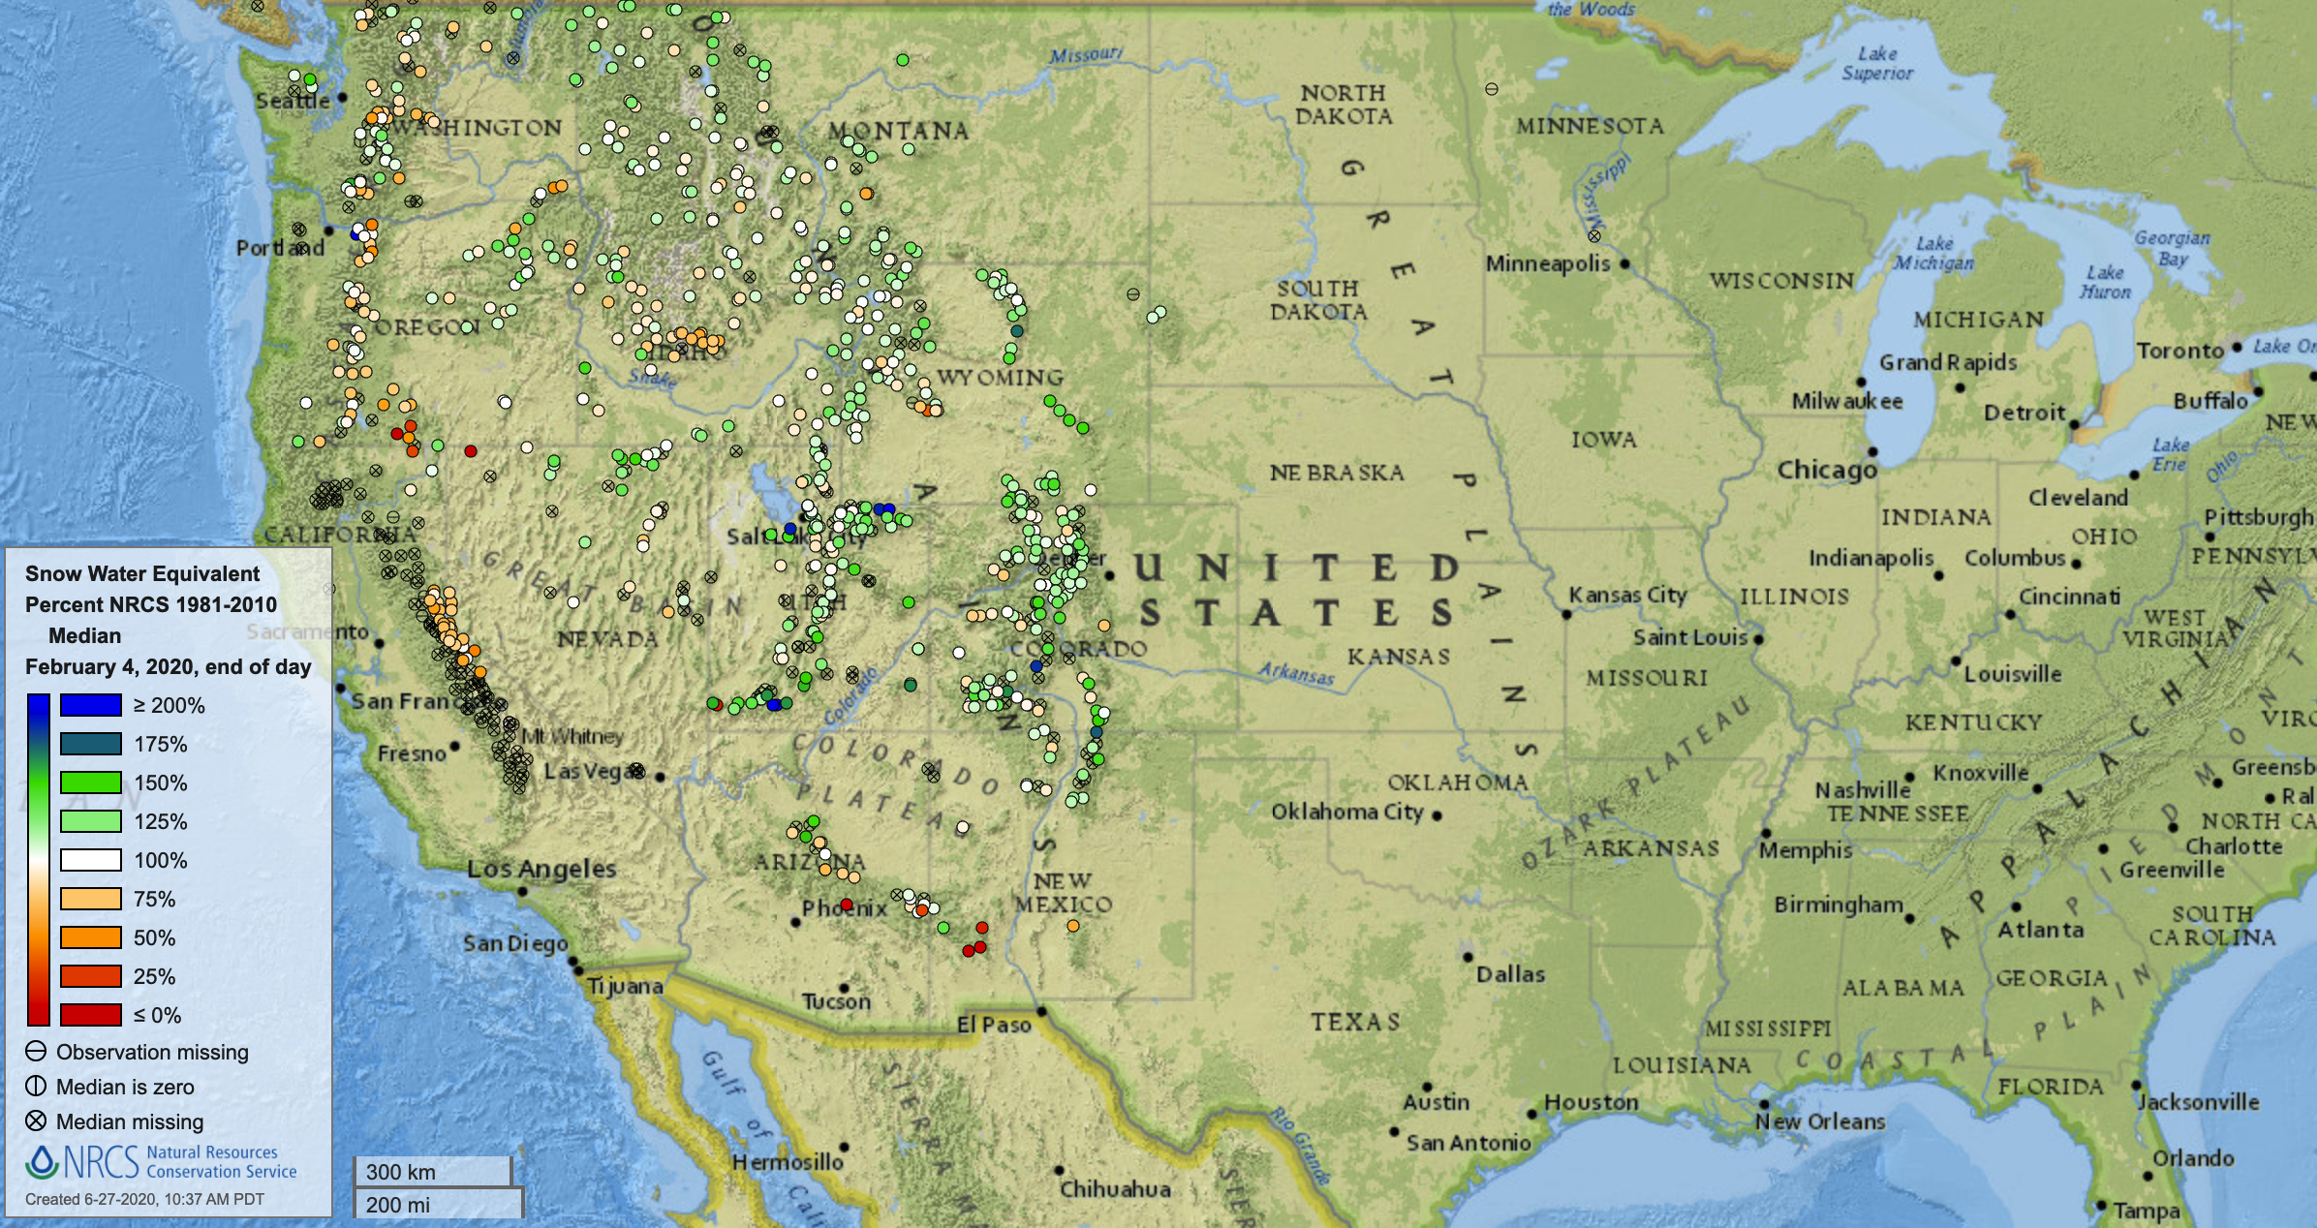
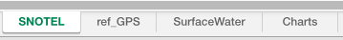
SNOTEL stations – snowpack measurements
Figure 1. Screenshot showing tabs at the base of the workbook.
Figure 2. Map of USDA SNOTEL stations from https://www.nrcs.usda.gov/wps/portal/wcc/home/quicklinks

- Check out the link to the SNOTEL website, showing the map of stations (https://www.wcc.nrcs.usda.gov/snow/snow_map.html - you will need to click on one of the links to bring up the map…try Snow Water Equivalent > Percent of 1981-2010 Median > Stations Only). How would you describe the coverage of that network? Where does it seem most stations are located?
(if you cannot access the website, look at Figure 2 instead)

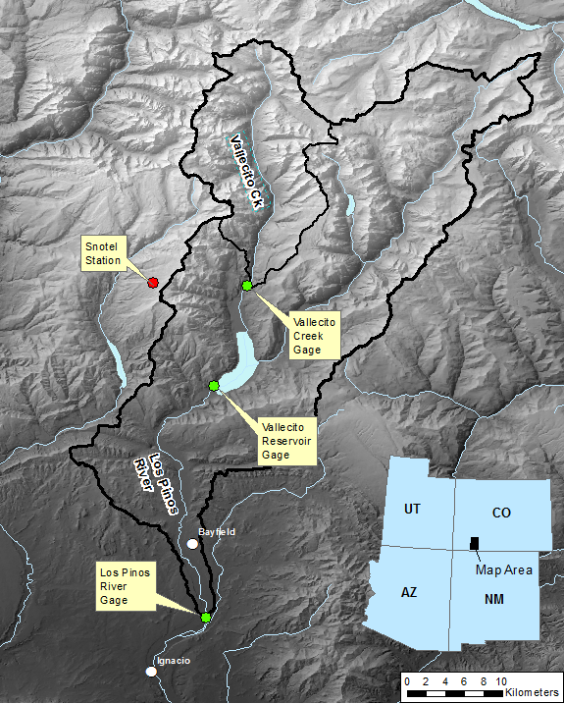
We will go to southwest Colorado, to the watershed of Los Piños River. This is a high-altitude, mountainous setting in the southwestern US. Water users include residents of the towns of Bayfield, Ignacio, the Southern Ute tribe, recreational users of Vallecito Reservoir, and farmers who irrigate the lowlands using water from the Los Piños River (Figure 3).
Figure 3. Map showing location of the Los Piños River and Vallecito Creek watershed divides (black outlines), gaging stations (green circles), and SNOTEL station (red circle) used in the assignment. Also shown are the two nearest towns (white circles).
Precipitation is enhanced by the mountainous terrain, and the higher elevations receive up to 5 times as much precipitation as the lowlands (~50 in/yr in the high country and ~10 in/yr in the low). Most of the high-elevation precipitation falls as snow, which accumulates throughout the winter and melts away in the spring and summer. Rainfall occurs in the warm months too, but only larger storms contribute significantly to river flow. Water from smaller showers is quickly re-evaporated, taken up by plant roots, or otherwise absorbed by parched soils.
We will take a look at the most important water delivery mechanism to this area - snowfall. How do we keep track of that resource? You may recall from Unit 1 that SNOTEL stations track the depth and water content (snow-water equivalent, or SWE) of snowpack at that station throughout the winter accumulation season.

A. How does the snowpack change over the course of a year?
On the ‘SNOTEL’ tab of your spreadsheet, you will find SNOTEL data from the “Stump Lakes” station (location shown in Figure 1) from 2000 to 2019. Open it up and inspect the plot. Note that you can mouse-over the plot to get the date and value at that point on the curve.
- Let’s start by describing the basic patterns present in the data:
  - During which month(s) does snow typically start accumulating in a given year?

  - During which month(s) does it typically reach its annual max?

  - By which month is it typically done melting?

  - Which takes longer to occur - the accumulation or the melting?

B. How does snowpack change from year to year?
- Zoom out and, looking at the whole plot, make a prediction as to which two years in the record had the most problems with water scarcity. What were the highest snow water equivalent (SWE) values measured those years?

Reflection GPS – snowpack measurements
SNOTEL stations are not the only way to measure accumulating snowpack. You may recall from Unit 1 that GPS stations can give us estimates of snow depth at the station by measuring the GPS satellite radio signals reflected off the snow surface. Note that these data do not provide snow-water equivalent values, so we get depth only. Here is a link to a website that shows the network of GPS stations that participate in monitoring snowpack: https://cires1.colorado.edu/portal/

C. How do SNOTEL and GPS snow data compare?
In your spreadsheet, under the ref_GPS tab you will see data from the nearest Reflection GPS station (120 km away in Montrose, CO).
Remember that most SNOTEL stations measure both snow depth and snow water equivalent (SWE; the actual amount of water stored in the snowpack) and Reflection GPS measures only snow depth.
- Compare the Montrose, CO reflection GPS data to the SNOTEL data. How well do the two curves resemble each other (keeping in mind that the station is ~75 mi away)?

- List a few reasons that could explain the differences you observed.

D. What happens as the snow melts?
All of that snow melts as temperatures rise in the spring and summer. Some of it enters the groundwater system, some evaporates or is used by plants, but much of it ends up flowing downhill in rivulets and gullies that enter streams, which join to form larger rivers. This “surface water” transport pathway is important to monitor as it delivers most of the meltwater to its ultimate users. To help keep track of this surface water resource, the USGS maintains a network of river gages across the country. Check out the coverage map here: https://waterdata.usgs.gov/nwis/rt

- List any parts of the country (e.g. state names or regions) that appear to be experiencing high water at the moment (look for stations with dark blue dots). Make a separate list for areas that are dealing with unusually low water (orange and red dots).

Back to our study watershed in southwest Colorado: The first river gage that melting snow in the Los Piños watershed will encounter is the Vallecito Creek gage (See Figure 3 for location). Go to the SurfaceWater tab of your Excel sheet to see data from that gage.

Inspect the plot. The Y-axis is showing the volume of water flowing past the gage in a given time. In this case, it is the number of cubic feet per second (cfs) flowing past the gage. For reference, there are around 7.5 gallons in one cubic foot. So, a flow of 100 cfs = 750 gallons flowing past the gage every second.
- Describe the behavior of the flow in a given calendar year.
  - During what month(s) does the flow start to increase in a given year?

  - By what month does it usually trail back down to background levels?

- Based on that annual cycle, during what months should farmers have access to surface water for irrigation?

E. Do we see correlations between drier snow years and decreased river discharge?
- Thinking back to question #3 about years with low snowpack - How accurate were your predictions about years of water scarcity? In which two years do we see the lowest discharges coming down Vallecito Creek? Write down the years and corresponding peak snowmelt discharges of those years. Are those the same years that you identified in your answer to #3? Explain.

F. What about reservoirs? Do they show similar changes to rivers?
Like so many river systems in the western US, the waters of Vallecito Creek are eventually impounded behind a dam (forming Vallecito Lake) that provides flood control, water storage capacity, and recreation through boating and fishing. The water storage capacity provided by the reservoir serves an important role - it allows farmers to stretch the normal runoff season longer into the growing season. Reservoirs like Vallecito also serve as important benchmarks for water users downstream - in general, they tell us something about how much water is left to send downstream.

On the same sheet in your Excel file, take a look at the plot of lake elevation for Vallecito Reservoir. The following questions are based on that plot (remember that you can get the date and Y-axis value off the chart by mousing over it in you are using Excel):

- During what month(s) does the lake level typically reach its annual peak?

- Based on the chart, what is the maximum elevation of the reservoir? (hint: the water level cannot rise any higher than the maximum)

- During what month(s) do the dam operators tend to release water? (hint: releases send water to downstream users, and are marked by sudden downward trends in the lake elevation).

- During the low-water years you identified in #3 and #9, what happened with the lake elevation?

G. How do dams and diversions impact river flow below them?
Most of the users of the Los Piños River are downstream of Vallecito Reservoir. See Figure 2 for location of the Los Piños river gage. This instrument can tell us how much water is being delivered to downstream users and is important to monitor because hydrographs below dams often look quite different from those upstream of the dam.

- How do flows below the dam (bottom plot) compare to natural flows in Vallecito Creek (top plot)? Do you see any major differences in timing or magnitude of flows? Explain.

- How did the low-water years you identified in the snowpack data (#3) show up downstream of the dam? Speculate on the impact that year would have had on farmers and other users downstream. What options might they have had?

- Based on the above info, what hydrosphere measurement technique(s) would be most appropriate for a farmer in Bayfield, CO (Figure 1) to use to keep track of water resources as they prepare their upcoming farming/irrigation season?

H. Comparing snow and water the data sets and what they imply for society
Most of the charts used in this exercise are compiled in the ‘Charts’ tab. Open that sheet, and take ~5-10 minutes to inspect how water resources move through this mountain watershed. Questions to ponder:
- How does timing of ‘peak water’ change from snowpack to river flow to reservoir level to below-dam river flow?

peak snowpack:
peak streamflow:
peak reservoir levels:
peak below-dam streamflow:

- Where in this system are drought years likely to be felt most strongly?

- Consider 2015. Note from the SNOTEL chart that it was an unimpressive snow year. Speculate on how 2015 could also have produced one of the largest flows on Vallecito Creek and the Los Piños River? (it is OK if you are unsure – there are multiple plausible answers here – just give your ideas).

- Check out the flood on Vallecito Creek in Oct 2006. What was its peak discharge? What does that flood wave look like downstream on the Los Piños gage? Explain.

- Under global climate change, many western mountain watersheds are expected to see more of their winter precipitation fall as rain not snow; and snow that does come is expected to melt earlier.
Sketch what a typical year of SNOTEL data looks like (solid line). (Hint: you can just look at the graph of the SNOTEL station to get the idea for this, but only sketch one “typical” year here.)
Add in a dashed line of what we would expect it to look like with a warmer climate.
Sketch what a typical year of the Vallecito Creek gage looks like (solid line). Add in a dashed line of what we would expect it to look like with a warmer climate.
Jan Mar May Jul Sep Nov
Snow amount
Jan Mar May Jul Sep Nov
River discharge

How might that affect the local cycle of water storage and water availability for users in the area?

- Based on the example of the Los Piños river system, describe one benefit and one drawback to putting dams on rivers in western mountain watersheds.

