Eyes on the Hydrosphere Unit 1.2: Traditional and Geodetic Methods for Measuring Water Resources—Student Prep Exercise
Jon Harvey (Fort Lewis College) and Becca Walker (Mt. San Antonio College)

In preparation for your next class meeting, you will do some reading on a particular method that scientists use to measure different parts of the hydrologic cycle. This preparation may involve answering some questions, looking at figures, and/or watching short video clips about the method that you have been assigned. You will be responsible for teaching your colleagues about the method that you studied. Here is what you should be prepared to discuss with your colleagues before your next class meeting:
1.) What is the name of the method?
2.) What type of equipment is used in conjunction with this method?
3.) How does the method work?
4.) Over what timescale(s) is the method used?
5.) If the data for this method are plotted, what does a time-series look like? (In other words, what is measured on the X-axis, and what is measured on the Y-axis?
6.) What might different patterns in the data indicate about what is going on hydrologically in the area being studied?)
7.) For which reservoir(s) and/or transport pathway(s) of the hydrologic cycle is the method typically used?
8.) You will also receive 1–2 thought questions about your method that you should consider prior to your next class meeting.

Remember, you will be the only person in your group who has read about your particular method. You need to be well prepared to discuss the points above with your colleagues and teach them about this method for measuring water resources.
Which method are you preparing? (Please circle one.)
stream gaging depth to groundwater vertical GPS
GRACE reflection GPS SNOTEL

Reflection GPS
High-precision GPS stations consist of a GPS antenna inside of a dome for protection, the monument securely attached to the ground, a solar panel for power, and an enclosure for the GPS receiver, power/batteries, communications equipment to send data to offsite facilities for analysis, and data storage (Figure 1.) There are GPS networks on every continent. The largest GPS networks in the United States are the Network of the Americas, with more than 1100 stations, and CORS (Continuously Operating Reference Stations), with approximately 2000 stations.

Many scientists study the changes in GPS stations’ positions to measure how the Earth’s crust deforms. However, GPS can also be used to study components of the hydrologic cycle using the fluctuations in signal power from signal reflections. When a GPS signal leaves a satellite, the “reflected” signal bounces off the ground, rather than being received directly by the GPS antenna (Figure 2.) The GPS receiver can then measure the interference between the direct and reflected signals. The reflected signal changes depending on the type of surface that the signal hits, which means that reflection GPS can be used to measure surface characteristics such as vegetation, soil moisture, and snow depth. There are other traditional and geodetic methods for measuring, for example, snow depth, but since reflection GPS measures a wider area than methods that measure single points, it can account for snow-depth variability in a ~50-meter study area. Comparing snow depth data from traditional measurements like photography (Figure 3) reveals a strong match with the snow depth data obtained using reflection GPS.
Figure 1. Network of the Americas GPS station PO37.
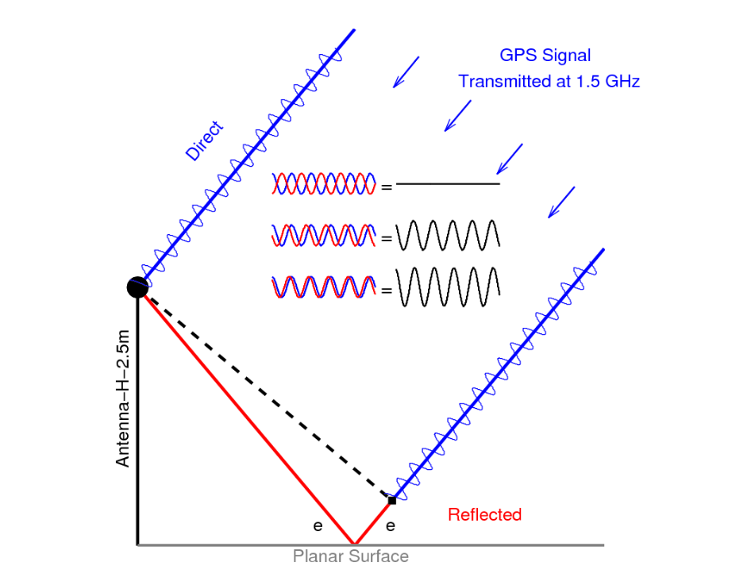
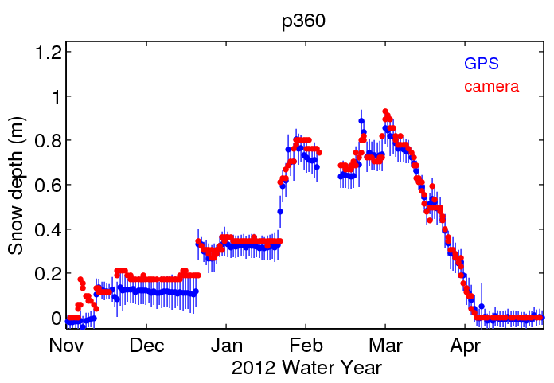
GPS
station
Figure 2. Schematic diagram illustrating the GPS reflection method. The direct GPS signal is shown in blue. The reflected signal is shown in red. From UNAVCO GPS Spotlight.

Figure 3: For snow depth studies using reflection GPS, the data are represented graphically with a plot called a time-series, which illustrates time on the X-axis and snow depth on the Y-axis. Data from Station P360.

Please watch a video from CU Boulder, Univ. of Colorado: Measuring Snow and Soil with GPS, to hear how reflection GPS is useful for meteorologists, water resource managers, climate modelers, and farmers. https://www.youtube.com/watch?v=LWYppZlqTwc
Additional resources:
Throwaway GPS Info Reveals Snow Depth Data: https://www.wired.com/2009/10/gps-measures-snow-depth/
CU-Boulder Group Using GPS to Measure Snow Depth, Water Level: https://www.dailycamera.com/2009/11/20/cu-boulder-group-using-gps-to-measure-snow-depth-water-level/

