Eyes on the Hydrosphere Unit 1.2: Traditional and geodetic methods for measuring water resources – Student Prep Exercise
Jon Harvey (Fort Lewis College) and Becca Walker (Mt. San Antonio College)

In preparation for your next class meeting, you will do some reading on a particular method that scientists use to measure different parts of the hydrologic cycle. This preparation may involve answering some questions, looking at figures, and/or watching short video clips about the method that you have been assigned. You will be responsible for teaching your colleagues about the method that you studied. Here is what you should be prepared to discuss with your colleagues before your next class meeting:
1.) What is the name of the method?
2.) What type of equipment is used in conjunction with this method?
3.) How does the method work?
4.) Over what timescale(s) is the method used?
5.) If the data for this method are plotted, what does a time-series look like? (In other words, what is measured on the X-axis, and what is measured on the Y-axis?
6.) What might different patterns in the data indicate about what is going on hydrologically in the area being studied?)
7.) For which reservoir(s) and/or transport pathway(s) of the hydrologic cycle is the method typically used?
8.) You will also receive a 1-2 thought questions about your method that you should consider prior to your next class meeting.

Remember, you will be the only person in your group who has read about your particular method. You need to be well-prepared to discuss the points above with your colleagues and teach them about this method for measuring water resources.
Which method are you preparing? (Please circle one.)
stream gaging depth to groundwater vertical GPS
GRACE reflection GPS SNOTEL

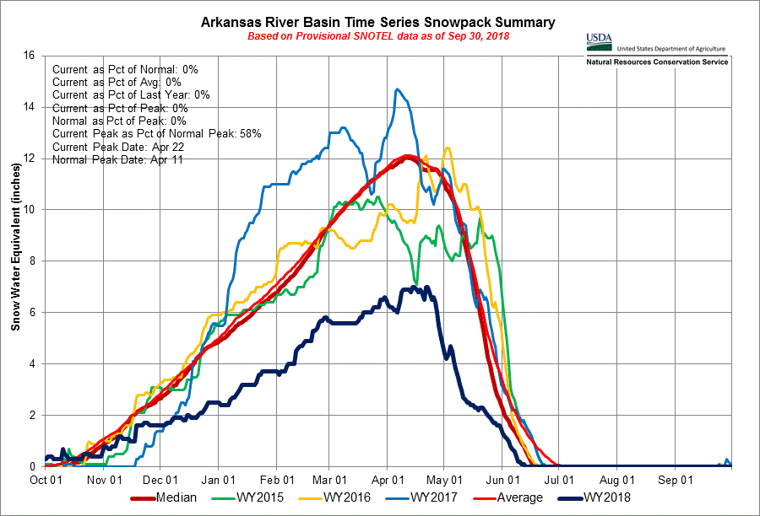
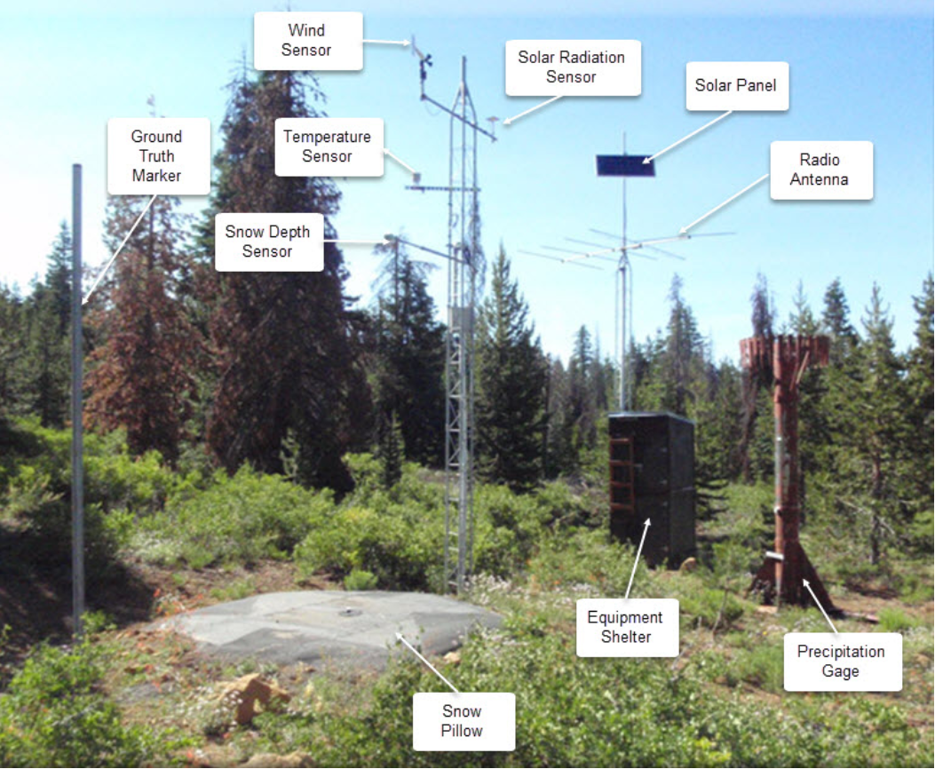
SNOTEL
Snow is an important contributor to water budgets in areas that receive snow seasonally. When making snow measurements, scientists are interested in the snow water equivalent, the amount of water in a given volume of snow, and snow depth. The Snow Telemetry (SNOTEL) network is composed of over 800 data collection sites located in the western US and Alaska. SNOTEL stations are used to monitor snowpack, precipitation, temperature, and other climatic conditions. These field data are transmitted to a database called the Water and Climate Information System. A typical SNOTEL remote site consists of a snow pillow, a precipitation gage, and a temperature sensor (Figure 1). When snow accumulates on the snow pillow, a pressure sensor inside of the pillow measures the snow water equivalent of the snowpack. SNOTEL sites can collect a variety of other hydrologic and meteorologic data as well including snow depth, precipitation, air temperature, soil moisture, and soil temperature, wind, and relative humidity.
Figure 1. Parts of a SNOTEL collection site. From the National Water and Climate Center.
Figure 2. SNOTEL time series for Arkansas River Basin, CO. Different colors show the 30-year average snow water equivalent and data for 2015-2018. The terminology “water year” (WY) refers to the 12-month period starting October1and ending September 30 of the following year. For the 2018 water year is October 1, 2017-September 30, 2018.

Please watch a video from OnTheSnow, Snow Science: Measuring Snowpack and SNOTEL, to see some examples on how SNOTEL stations operate. https://www.youtube.com/watch?v=Ytxj6YhZi-0
Do you have some preliminary thoughts about whether a particular SNOTEL station provides data for a relatively small area OR a larger region? Which hydrosphere reservoirs that you studied during your last class meeting can be impacted by snow?
Additional resources:
NRCS SNOTEL website: https://www.nrcs.usda.gov/wps/portal/wcc/home/snowClimateMonitoring/snowpack
SNOTEL infographic: https://www.nrcs.usda.gov/wps/portal/wcc/home/aboutUs/monitoringPrograms/automatedSnowMonitoring/
Interactive Maps including U.S. SNOTEL Stations from NRCS: https://www.nrcs.usda.gov/wps/portal/wcc/home/

