Eyes on the Hydrosphere Unit 1.2: Traditional and Geodetic Methods for Measuring Water Resources—Student Prep Exercise
Jon Harvey (Fort Lewis College) and Becca Walker (Mt. San Antonio College)

In preparation for your next class meeting, you will do some reading on a particular method that scientists use to measure different parts of the hydrologic cycle. This preparation may involve answering some questions, looking at figures, and/or watching short video clips about the method that you have been assigned. You will be responsible for teaching your colleagues about the method that you studied. Here is what you should be prepared to discuss with your colleagues before your next class meeting:
1.) What is the name of the method?
2.) What type of equipment is used in conjunction with this method?
3.) How does the method work?
4.) Over what timescale(s) is the method used?
5.) If the data for this method are plotted, what does a time-series look like? (In other words, what is measured on the X-axis, and what is measured on the Y-axis?
6.) What might different patterns in the data indicate about what is going on hydrologically in the area being studied?)
7.) For which reservoir(s) and/or transport pathway(s) of the hydrologic cycle is the method typically used?
8.) You will also receive 1–2 thought questions about your method that you should consider prior to your next class meeting.

Remember, you will be the only person in your group who has read about your particular method. You need to be well prepared to discuss the points above with your colleagues and teach them about this method for measuring water resources.
Which method are you preparing? (Please circle one.)
stream gaging depth to groundwater vertical GPS
GRACE reflection GPS SNOTEL

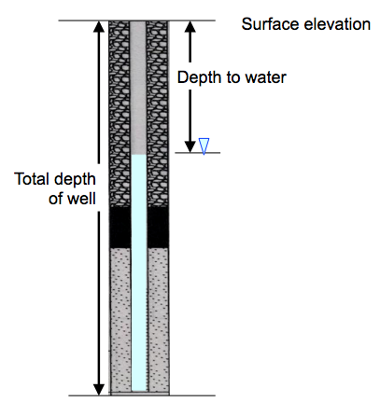
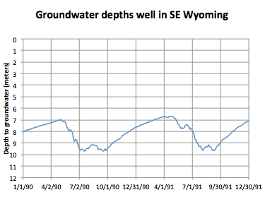
Depth-to-groundwater
A traditional method of measuring groundwater levels is measuring the depth from the Earth’s surface to the water table using wells (Figure 1: pipes in the ground that fill with groundwater and can subsequently bring groundwater to the surface using a pump.) The US Geological Survey monitors more than 1500 wells to measure depth-to-groundwater and how groundwater levels change over time. The greater the distance from the Earth’s surface to the water table, the lower the water table. In contrast, smaller depth-to-groundwater measurements indicate that the water table is closer to the Earth’s surface. Depth-to-groundwater measurements over time can be represented using a plot called a time-series, which illustrates time on the X-axis and the depth to groundwater on the Y-axis (Figure 2.)
Figure 1. Schematic diagram of a well illustrating the elevation of the Earth’s surface, depth to groundwater, groundwater level, and total well depth.
Figure 2. USGS data illustrating depth-to-groundwater for a well site in SE Wyoming for 1990–1991.
Please watch a video clip from the US Geological Survey. When you navigate to the page, please watch GWPD 1 (steel tape methods) and GWPD 4 (electric tape methods).
https://water.usgs.gov/ogw/video/gwpd.html
Do you have some preliminary thoughts about whether data from a well would be most useful to study changes in the hydrosphere over a small area OR a larger region? Which reservoirs that you studied during your last class meeting could cause changes in the depth to groundwater?
Additional resources:
USGS groundwater watch: https://groundwaterwatch.usgs.gov/
American Geosciences Institute depth-to-groundwater page: https://www.americangeosciences.org/critical-issues/faq/how-can-you-find-out-how-deep-water-table-specific-location

