Eyes on the Hydrosphere Unit 1.2: Traditional and geodetic methods for measuring water resources – Student Prep Exercise
Jon Harvey (Fort Lewis College) and Becca Walker (Mt. San Antonio College)

In preparation for your next class meeting, you will do some reading on a particular method that scientists use to measure different parts of the hydrologic cycle. This preparation may involve answering some questions, looking at figures, and/or watching short video clips about the method that you have been assigned. You will be responsible for teaching your colleagues about the method that you studied. Here is what you should be prepared to discuss with your colleagues before your next class meeting:
1.) What is the name of the method?
2.) What type of equipment is used in conjunction with this method?
3.) How does the method work?
4.) Over what timescale(s) is the method used?
5.) If the data for this method are plotted, what does a time-series look like? (In other words, what is measured on the X-axis, and what is measured on the Y-axis?
6.) What might different patterns in the data indicate about what is going on hydrologically in the area being studied?)
7.) For which reservoir(s) and/or transport pathway(s) of the hydrologic cycle is the method typically used?
8.) You will also receive a 1-2 thought questions about your method that you should consider prior to your next class meeting.

Remember, you will be the only person in your group who has read about your particular method. You need to be well-prepared to discuss the points above with your colleagues and teach them about this method for measuring water resources.
Which method are you preparing? (Please circle one.)
stream gaging depth to groundwater vertical GPS
GRACE reflection GPS SNOTEL

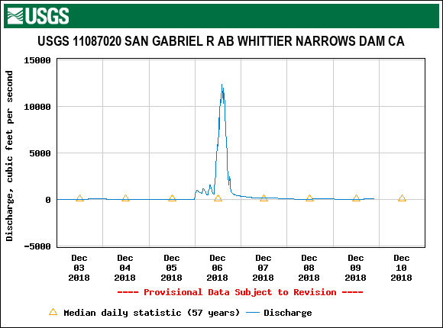
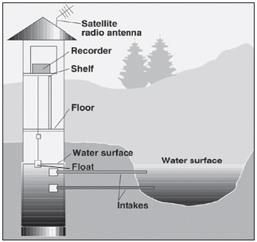
Stream/river gaging stations
Stream gaging is a method that has been used by the US Geological Survey since the late 1800s and today includes a network of over 9000 stream gaging stations in the United States. Stream gages are typically installed adjacent to the channel (Figure 1). The structure contains the instruments that make measurements and store and transmit the data from the gaging station to the facility that analyzes the data. Gaging stations can measure a variety of characteristics about the stream, including stage and discharge. Stage is the height of the water surface at a specific location. One method of measuring stage is the construction of a stilling well that extends from the structure into the channel. Water from the stream comes into the well and exits the well through the pipes, making the elevation of the water surface in the stilling well the same as the elevation of the surface of the stream. Typically, the stage is measured every 15 minutes. Discharge is the volume of water that moves through a stream channel in a given amount of time. To measure stream discharge, the average velocity of the water and the area of the channel must be determined. There are a variety of methods that can be used to measure the discharge of a particular stream, including the use of a current meter (the velocity of the water is measured in subsections across the channel, discharge is calculated for each subsection of the channel, and these discharges are added together to measure the total discharge.) Discharge data over time are depicted using a hydrograph (Figure 2.)
Figure 2 (above): hydrograph for a USGS stream gage station in Los Angeles County for a 7-day period in December 2018. From USGS build-a-time-series, https://waterdata.usgs.gov/ca/nwis/rt

Figure 1: schematic diagram of stream gaging station from USGS.

Please watch a film clip from the US Geological Survey, Streamflow Gaging Station and Measurement on the San Pedro River in Southern Arizona, to see how stage and discharge are measured. https://www.youtube.com/watch?v=uP9QBGWHl_A
Thought questions: Do you have some preliminary thoughts about some of the environmental processes or human actions that could cause discharge to increase? How about decreases?
Additional resources:
USGS Water Science School: https://water.usgs.gov/edu/measureflow.html
Penn State University Water: Science and Society web modules on hydrographs: https://www.e-education.psu.edu/earth111/node/865

