Tracking Water Resources Unit 2.1: Student Preparation Reading and Exercise – High Plains Aquifer
Jon Harvey (Fort Lewis College) and Becca Walker (Mt. San Antonio College)

Now that you are well-versed in the water cycle and the myriad reservoirs and transport pathways it comprises, it is time to look at some real data from real locations with real users and real implications when water supplies are compromised. The case study site will be the High Plains Aquifer in the central USA, but the same issues are present in many aquifers around the world. The reading and questions will help you come to class ready to do the main exercise. You will need to refer to this in class.

Introduction
Let’s start by thinking about groundwater. Groundwater is stored in aquifers, which can be as small as the ribbon of sand and gravel under a creek bed to vast rock formations hundreds of feet thick and hundreds of miles wide. Water is stored in the microscopic pore space of the rock, which, although difficult to see, can store enormous amounts of water beneath our feet.
Aquifers are recharged primarily through precipitation that infiltrates the soil and enters the pore space in the subsurface materials. Additionally, water from streams and rivers can recharge aquifers by sinking into the streambed (more common in drier climates).
Water users around the world rely on aquifers to provide reliable, clean, and abundant water. They access the water either by collecting it from springs (which occur where the aquifer intersects the ground surface) or by drilling wells into the aquifer and pumping the water to the surface. Many important aquifers around the world are facing increasing demand - can the supply keep up with it? For example, in many aquifers in the U.S., demand has outpaced aquifer recharge, causing aquifer depletion that threatens the sustainability of groundwater as a reliable water resource (Figure 1).
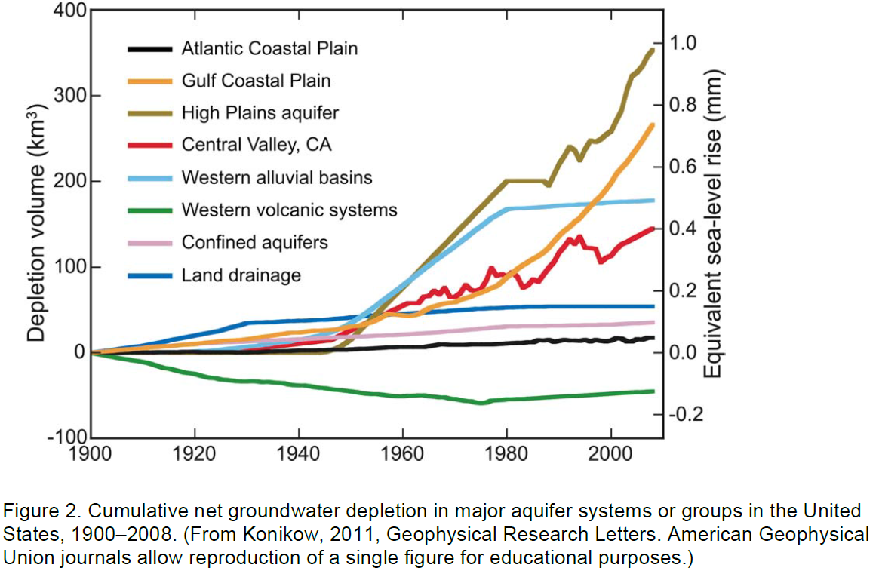
Figure 1. Cumulative loss of water from major aquifer systems or groups in the United States, 1900-2008. (From Konikow, 2011, Geophysical Research Letters, which allows reuse for educational purposes).

We can keep track of how much water is in an aquifer (its water storage), with this equation:
ΔS = P - ET - R - W

Change in water Storage = Precipitation - EvapoTranspiration - Loss to Rivers – Withdrawals

Although the equation is relatively simple, we can only calculate changes to storage if we have accurate estimates for the terms on the right side of the equation:

Precipitation - We can measure this with rain gauges and SNOTEL stations, but it is rather spatially variable, and difficult to accurately capture over a whole watershed.
Evapotranspiration - We can model this using algorithms based on land cover, vegetation type, soil moisture, and weather/climatic conditions experienced at the site, however, there is substantial uncertainty in model predictions, limited by sparse data inputs.

Rivers - The loss/gain of groundwater from/to rivers can be estimated by comparing river discharge measurements in the downstream direction. Only possible on gaged streams.

Withdrawals - Hard to keep track of unless users are voluntarily reporting their withdrawals

With so many unknowns in the equation, changes in the total volume of water in the aquifer can be difficult to predict. That is where some of the measurement techniques you learned about in Unit 1 can fill in the story. These methods attempt to more directly measure the left side of the equation: the underground water storage itself. These methods include:
-Depth to water table in water wells
-GRACE satellite observations
-Vertical GPS measurements

Review
Below are brief synopses of the groundwater measurement techniques that you will be using in this exercise. For more details, see the materials from Unit 1 and the accompanying presentation.

Measuring changes in water storage with depth to water table in wells
The traditional way to track changes in water storage is by directly measuring just how deep the water table is beneath the surface. When the depth to water table decreases (i.e. groundwater table is rising in elevation), the aquifer is refilling. When the depth to water table increases (i.e. groundwater table elevation is falling), the aquifer is losing water. One challenge of this data source is that water table elevations are very sensitive to local withdrawals and recharge, and aquifer complexity may mean that a well in one location could behave very differently than one only a few miles away. In order to track regional water storage changes, one must include data from several wells across a region.

Measuring changes in water storage with GRACE satellite
The GRACE satellite is equipped to measure subtle changes in the strength of gravity across Earth’s surface (spatial patterns) and over time (temporal patterns). Although many factors influence just how hard the tug of gravity is across the surface, one factor exhibiting temporal changes is how much water is stored in the aquifers beneath our feet at a given time. Measurements from GRACE help scientists estimate the change in water storage in large aquifers, including the High Plains Aquifer.
GRACE data is commonly processed to show changing amounts of water storage, in units of Water Equivalent Height. This is the equivalent depth of water that is extra / missing from the crust at that location. For example, A Water Equivalent Height anomaly of -10 cm means that the amount of water missing from the crust at that location is equivalent to removing 10 cm of standing water from everywhere in that location.

Measuring changes in water storage with vertical GPS
Vertical GPS stations tell us about tiny vertical movements of the ground surface. How does that help us with groundwater? In many bedrock aquifers, including the High Plains Aquifer, as water storage increases, the ground surface should sink slightly under all that weight. Conversely, we would expect the surface to rebound slightly as aquifer water storage decreases (need to be careful, though - clay-rich aquifers expand when they gain water and contract as they are pumped out, leading to the opposite effect). Scientists track this vertical motion using networks of permanent GPS stations like the Plate Boundary Observatory. Similar to the depth-to-groundwater data, GPS data is station-based. To study changes in groundwater storage across broad areas, several different GPS stations must be included in the analysis.
Together, these tools help scientists and water managers keep account of water resources and how they are changing through time. Long-term studies of water resources in major aquifers in the US show that many are losing large volumes of water (Figure 1). Among the most depleted is the High Plains Aquifer.

Introduction to the High Plains Aquifer
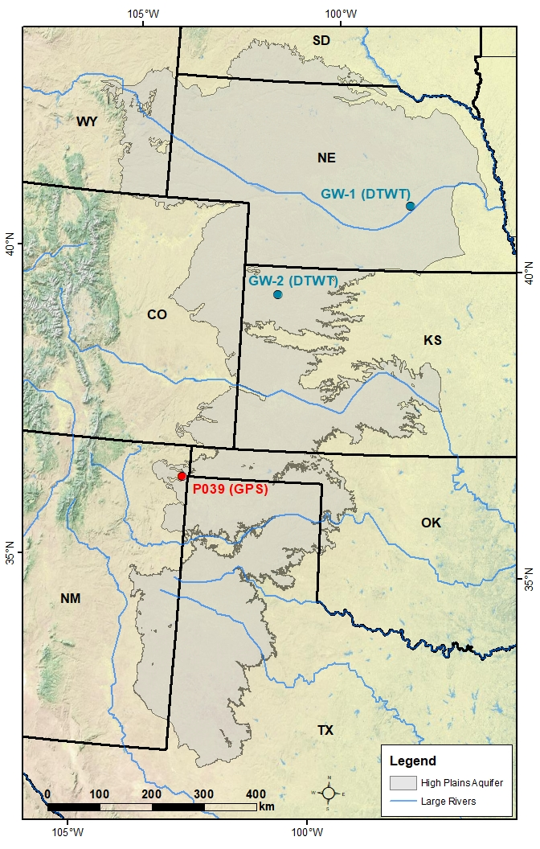
In this unit, you will explore one of the largest and most important aquifers in the United States - the High Plains Aquifer (HPA). Underlying portions of eight states in the central US, the High Plains Aquifer is a shallowly-buried apron of gravel and sand that that was shed off the growing Rocky Mountains (Figure 2). Its water is used to irrigate millions of acres of grain in America’s “Bread Basket” – In fact, nearly a third of the United States’ irrigated crops rely on the High Plains Aquifer. That grain goes on to be processed into food for humans, food for livestock, and ethanol production. In addition, over 80 percent of the residents within the High Plains Aquifer rely on it for their domestic drinking water. Clearly, the High Plains Aquifer is of great importance not only to the residents of the High Plains but for the whole US economy!
Users of High Plains Aquifer water primarily access it by pumping from groundwater wells drilled 10s to 100s of feet into the High Plains Aquifer. Unfortunately, across much of the High Plains Aquifer pumping withdrawals have exceeded natural recharge of the aquifer, so the aquifer is being depleted (water levels are dropping) (Figures 1, 4). Some studies show that much of the water in the High Plains Aquifer entered it during the last Ice Age and can thus be considered ‘fossil water’ (i.e. not being renewed).

Figure 2. Map showing location of High Plains Aquifer in gray. Locations of groundwater stations (blue dots) and GPS station (red dot) used in the assignment are included. Background image from ESRI.

Read more about changes in High Plains Aquifer water storage from a USGS report here (don’t worry, it’s only one page long!): https://ne.water.usgs.gov/ogw/hpwlms/files/HPAq_WLC_pd_2013_SIR_2014_5218_pubs_brief.pdf

- By how much has the water table declined (1950 to 2013) in the most depleted parts of the High Plains Aquifer? (hint: look at the map in the above link)

- What was the volume of water lost from the High Plains Aquifer during that time (pre-development to 2013) measured in acre-feet? (hint: read the bullet-point summary at the top of the report.)

- Your answer to #2 is probably a difficult number to digest…let’s try to visualize it by imagining that we made a swimming pool the size of the state of Kansas (area = ~52 million acres). If we could put the volume of water in your previous answer into that pool, how deep would that water be? (hint: volume = area * depth)

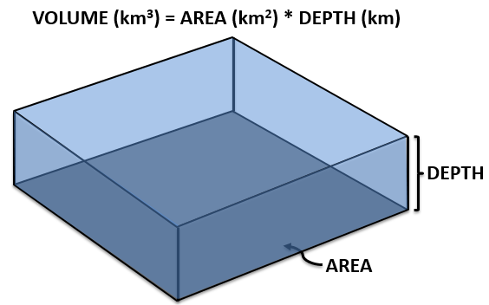

Hopefully that has impressed upon you that we have already pumped an enormous amount of that ‘fossil’ water from the High Plains Aquifer. So water managers are now faced with how to manage a dwindling resource.

Read this article about challenges facing the High Plains Aquifer, and potential solutions: https://www.geosociety.org/gsatoday/archive/27/6/pdf/GSATG318GW.1.pdf

- List three ways that High Plains Aquifer states are trying to curb losses in the aquifer’s water.

