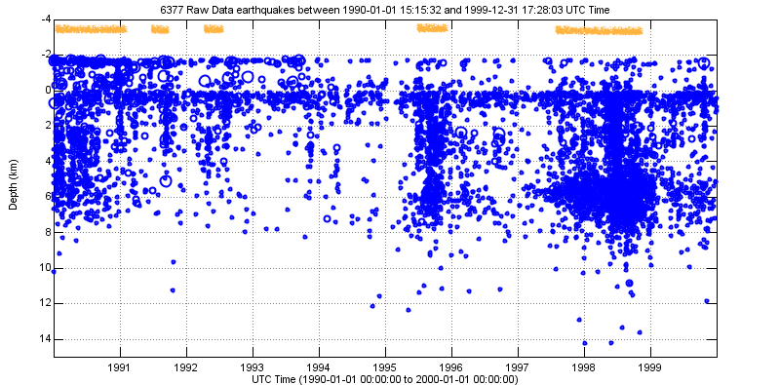
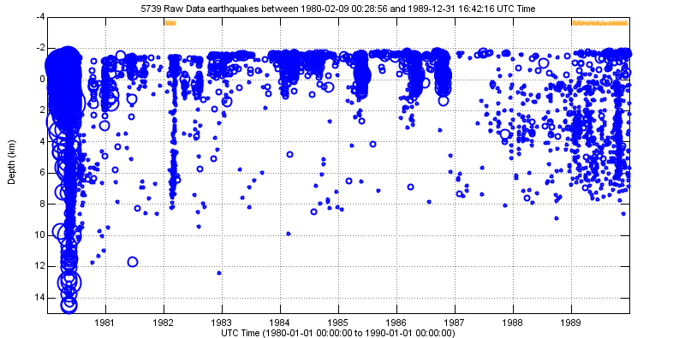
Depth of seismic activity
at Mount St. Helens (all stations)

1980–1989

1990–1999
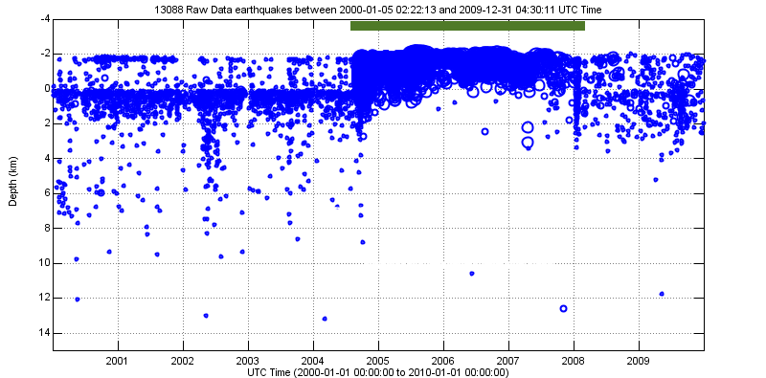
Depth of seismic activity
at Mount St. Helens (all stations)
https://pnsn.org/volcanoes/mount-st-helens#seismicity

2000–2009

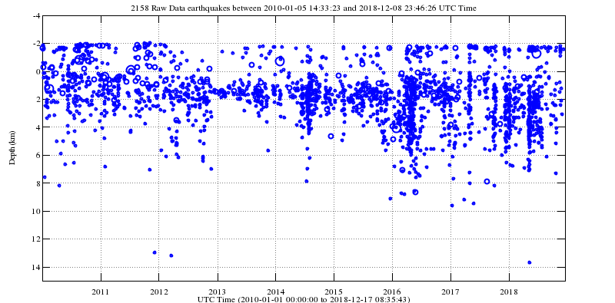

2010–2018

Earthquake per day at Mount St. Helens (note vertical scales change from year to year)

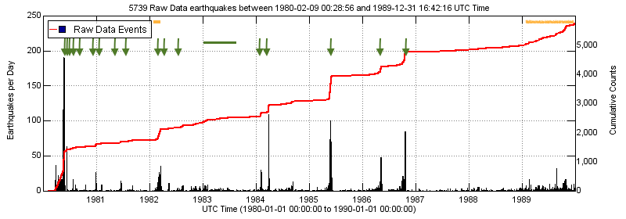
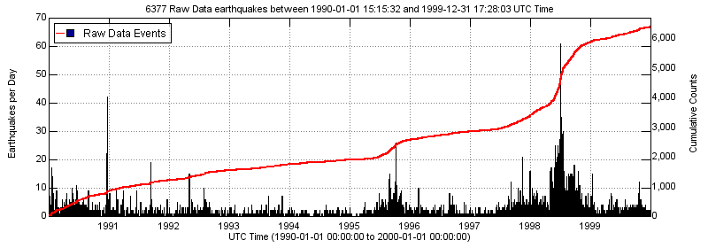

1980.1989

1990-1999
Earthquake per day at Mount St. Helens (note vertical scales change from year to year)

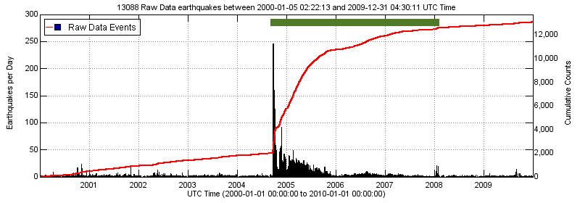

2000–2009

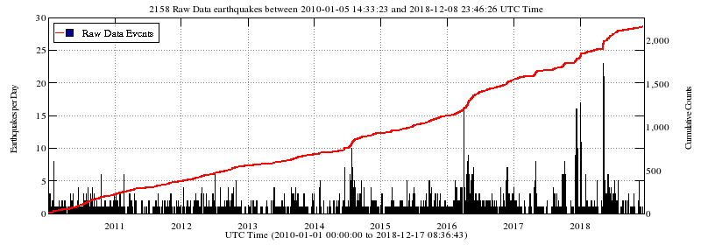

2010-2018

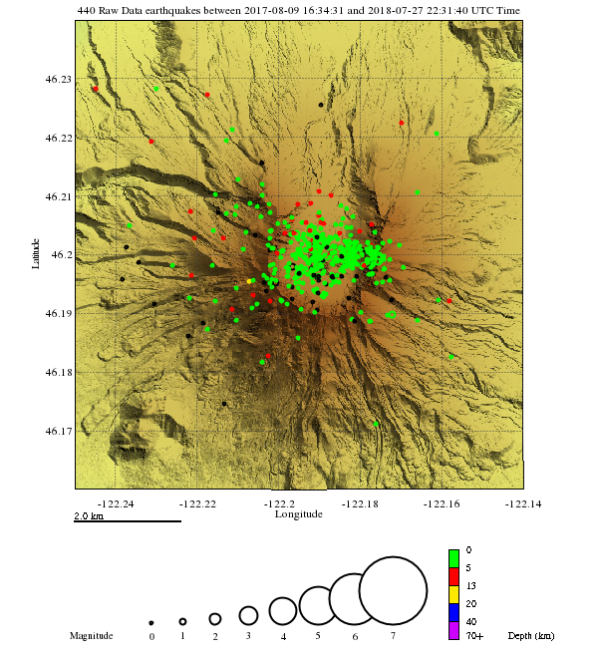
Map of Mount St. Helens shows earthquake epicenter locations from summer 2017-2018. Legend shows that earthquake magnitudes are shown by the size of circles on the map. Colors represent the depth of earthquake foci. Epicenters are not included for all decades because at the normal scale produced they don't show anything of interest.
Map oriented with text oriented north.

