Monitoring Volcanoes: Unit 3: Yellowstone Exercise
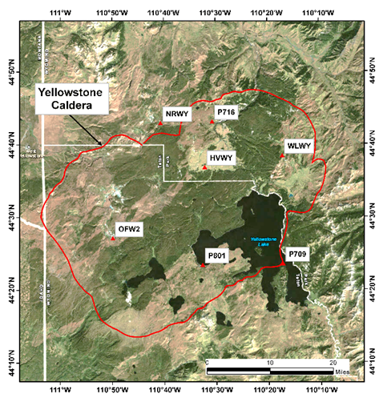
Rachel Teasdale (California State University Chico) and Kaatje van der Hoeven Kraft (Whatcom Community College)
Figure 1 Yellowstone caldera (red line and GPS station locations (red triangles). Map from USGS

Part 1 Seismic data at Yellowstone
Your instructor will assign your group a decade(s) of seismic data to work on for Part I:

- In your groups, develop a definition of a seismic swarm using your own words and record it below. For example, consider the size, duration, and indicator that one has started/stopped.

- Using your working group definition (or based on a class working group definition), indicate when the seismic swarm(s) occurred during your assigned decade.
- Indicate the duration of the swarm(s).
- Indicate the relative number of earthquakes that make this/these a “swarm” (how large of an increase was it relative to the overall decadal trend)?
- Calculate the MRI the full class data set (recall method from pre-work, show calculations here)

- Hypothesis Discussion Notes:

Table 1
Decade | Date(s) of swarms | Duration of swarm(s) | Size of swarms (how many EQ above “background”/cumulative count shift)
1980-1989
1990-1999
2000-2009
2010-2018

Part 2 Assessing the State of Yellowstone
Compare InSAR, GPS and seismic data for the most recent decade (January 2010 to now)

- In the row of Table 2 with the GPS station you were assigned, summarize the GPS activity
- For the InSAR data, including the general location within Yellowstone where the interferogram indicates deformation occurred and if it is inflation, deflation or no change.
- Compare and contrast the location and type of deformation indicated by the combination of all data types (seismic, GPS and InSAR). Are the GPS, InSAR and seismic data are internally consistent? Discuss with your group.
- Write your interpretation of what the combination of all three data types indicate about potential magmatic activity at Yellowstone for each location. Be ready to report your results to the rest of the class.

- What are reasons for EQ swarms without magma movement?

Table 2
GPS Station | Dates of EQ Swarm | #7. GPS Activity | #8. InSAR Activity | #8. Location of InSAR displacement(s) | # 9 & 10. Geologic Interpretation of geodetic activity
NRWY
P709
OFW2
HVWY

