Name: Date:

Unit 3 Pre-Reading Questions & Activities

Your turn
Use the data in Table 1 to determine the MRIs for the following volcanoes.
Volcano Name | Years since oldest known eruption (N) | # of Confirmed Events since oldest known eruption (n) | MRI (T)
Mt. Baker
Lassen Peak

Table 1: Data to calculate MRI. Data is from the Smithsonian Institution’s Global Volcanism Program: https://volcano.si.edu/
Mt. Baker | 1880 | 1870 | 1863 | 1859 | 1858 | 1954 | 1852 | 1843 | 1820
Lassen Volcanic Center | 1914 | 1666 | 980 | 880 | 800

Seismic Swarms
- Describe the axes of this graph and what it illustrates in your own words.
- Circle (or name the date ranges for) the three most important seismic swarm(s) in the year 2017 at Mount St. Helens
- How did you determine what constituted a seismic swarm?
- What information do you have, what information is missing? What information/data would you like to know?
- Did any of this activity result in volcanic eruptive activity? Look on the Mount St. Helens’s Activity Alert page: https://volcanoes.usgs.gov/volcanoes/st_helens/status.html and determine if the seismic swarm resulted in any kind of concern by the scientists at the Cascades Volcano Observatory (USGS).
Note that MRIs for earthquake swarms can also be calculated!

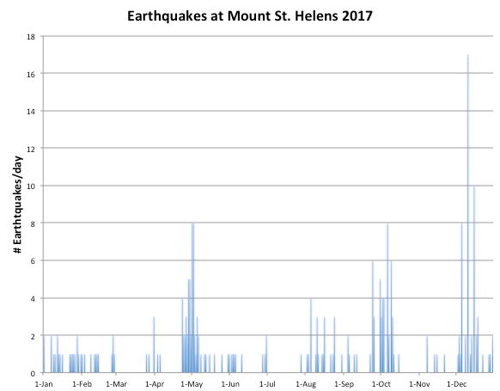
Figure 1: Number of earthquakes per day at Mount St. Helens in 2017. Data from USGS.

