Monitoring Volcanoes & Communicating Risks Unit 3: Yellowstone Pre-Reading & Exercise
Kaatje van der Hoeven Kraft (Whatcom Community College) and Rachel Teasdale (California State University Chico)
Read the following in order to answer the accompanying questions:

Mean Recurrence Interval
Geologic events happen over very long time spans and occur somewhat randomly. While they are based on systems that occur consistently (e.g., slow gradual movement of plates results in a release of that stress as an earthquake), there is not a specific time that it should occur or will occur. In order to better understand this randomness, we determine a recurrence interval (or mean recurrence interval) to represent the average time between events.
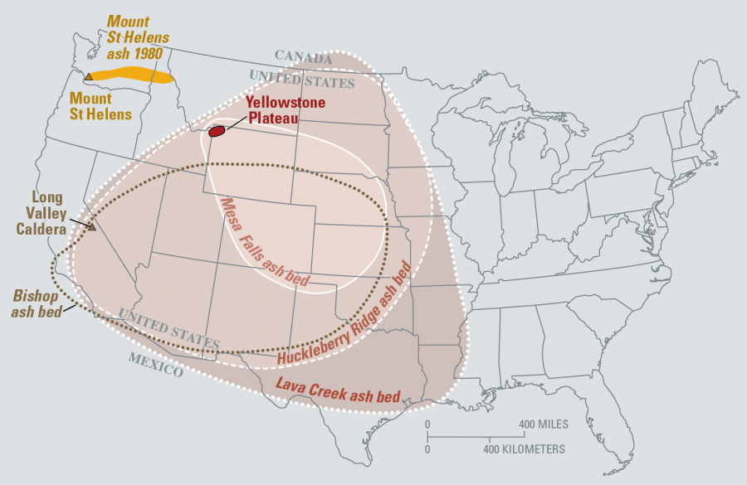
Volcanoes are one geologic event for which determining a mean recurrence interval can be helpful to better understand the range of activity, particularly for volcanoes that erupt very infrequently, like Yellowstone Caldera (Figure 1). Over the last 2.1 million years, there have been three major eruptions at Yellowstone, resulting in a Mean Recurrence Interval (MRI) of 600,00-800,000 years.
Figure 1. The past three eruptions for Yellowstone Caldera occurred 2.1 million, 1.2 and 640,000 years ago. Image Credit: USGS
In order to better understand MRI’s and how they can be useful at a range of time scales for assessing and monitoring volcanic activity, you’ll be calculating MRI’s in class around earthquake activity in Yellowstone. To prepare you, work through the sample problems below.

Calculating Mean Recurrence Intervals
The formula for calculating a very basic recurrence interval is:
T = N/n
Where T is the recurrence interval, N is the number of years on record (how long back do we have information for events occurring in this region), n is the number of events on record.

Example
So with three extremely large explosive eruptions at Yellowstone in the last 2.1 million years, we can calculate:
T = 2.1 million years/3 events = 700,000 years/event
USGS reports that Yellowstone’s MRI is more broadly 600,000-800,000 years. The last large explosive eruption was 640,000 years ago, but smaller eruptions have occurred since then. It should be noted, that just because there was an eruption 50,000 years ago, does not mean that it will be another 650,000 years before the next eruption. Because major eruptions do not occur regularly, we try to understand their frequencies by examining the probabilities of their occurrence.

Your turn
Use the data in Table 1 to determine the MRIs for the following volcanoes.
Volcano Name | Years since oldest known eruption (N) | # of Confirmed Events since oldest known eruption (n) | MRI (T)
Mt. Baker
Lassen Peak

Table 1: Data to calculate MRI. Data is from the Smithsonian Institution’s Global Volcanism Program: https://volcano.si.edu/
Mt. Baker | 1880 | 1870 | 1863 | 1859 | 1858 | 1954 | 1852 | 1843 | 1820
Lassen Volcanic Center | 1914 | 1666 | 980 | 880 | 800

Seismic Swarms
A seismic swarm occurs when there is an unusually large number of minor earthquakes relative to what is considered to be “background” seismic activity. Background seismic activity may be occurring regularly in small amounts. A swarm is distinguished by seeing a large number in these small events in a shortened period of time.
Many active volcanoes have seismic swarms that may or may not be related to eruptive activity. An active volcano is one because magma is moving and generating seismic waves in the process. Movement does not always equate to activity. Use the graph below (Figure 1) to answer the following questions to turn in:
- Describe the axes of this graph and what it illustrates in your own words.
- Circle (or name the date ranges for) the three most important seismic swarm(s) in the year 2017 at Mount St. Helens.
- How did you determine what constituted a seismic swarm?
- What information do you have, what information is missing? What information/data would you like to know?
- Did any of this activity result in volcanic eruptive activity? Look on the Mount St. Helen’s Activity Alert page: https://volcanoes.usgs.gov/volcanoes/st_helens/status.html and determine if the seismic swarm resulted in any kind of concern by the scientists at the Cascades Volcano Observatory (USGS).
Note that MRIs for earthquake swarms can also be calculated!

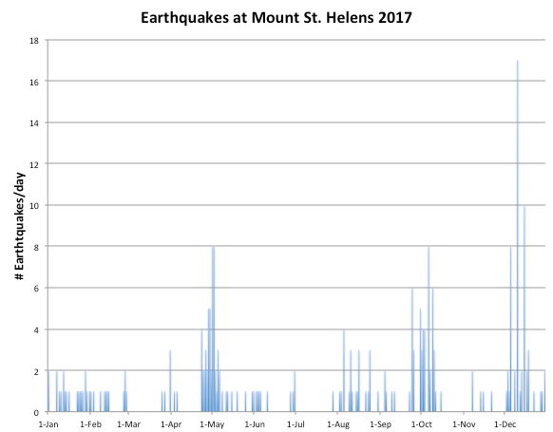
Figure 1: Number of earthquakes per day at Mount St. Helens in 2017. Data from USGS.

