Monitoring Volcanoes Unit 2: Lava Flow Diversion Pre Reading Exercise
Rachel Teasdale (California State University, Chico) and Kaatje van der Hoeven Kraft (Whatcom Community College)
Answer the following questions on Lava Flow Diversion Methods.

Pre-class Questions:
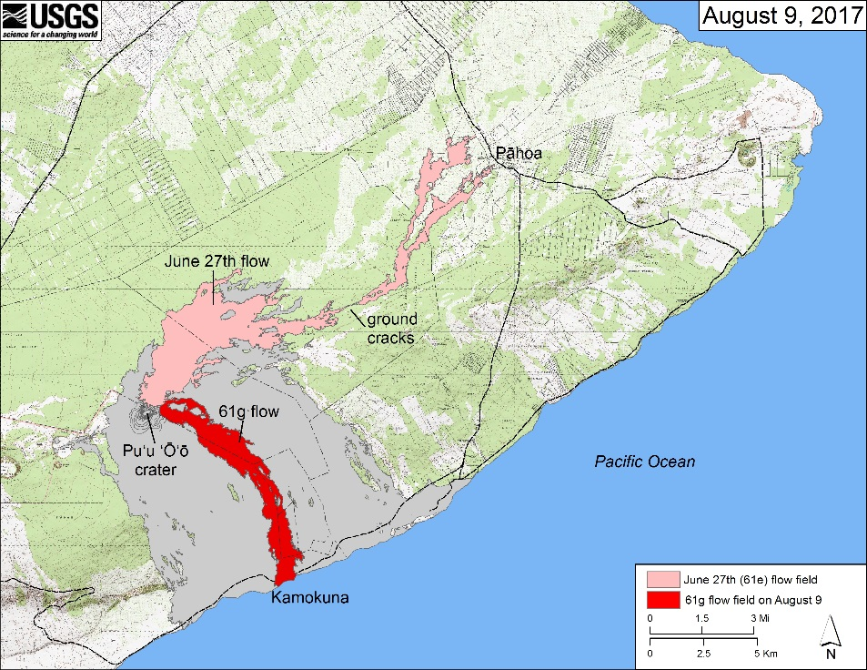
- Given the complexities of lava flow diversion in 1669 at Mt. Etna, what do you expect could be some consequences of diverting lavas in the US, specifically in southeastern Hawaii where Pu’u O’o is located? (the USGS map may be useful).

- What concerns would you expect the following “stake holders” to have with regard to deciding to create a berm to divert lava from the town of Pahoa during an eruption?
  - Resident of Pahoa

  - Resident of neighboring town (name this and label it on map)

  - Civil defense officials

  - Native Hawai'ians, whose cultural heritage is deeply interwoven with the belief that Pele (the goddess of fire and volcanoes) shapes the sacred land of Hawai'i with lava flows.

