Monitoring Volcanoes Unit 2: Monitoring Kilauea Monday Morning Meeting—Tiltmeter Pre-Reading
Rachel Teasdale (California State University, Chico) and Kaatje van der Hoeven Kraft (Whatcom Community College). Modified from M. Poland, personal communication.
Read the following information to help you with answering questions about how we monitor volcanoes using tilt data.

Monitoring with Tiltmeters
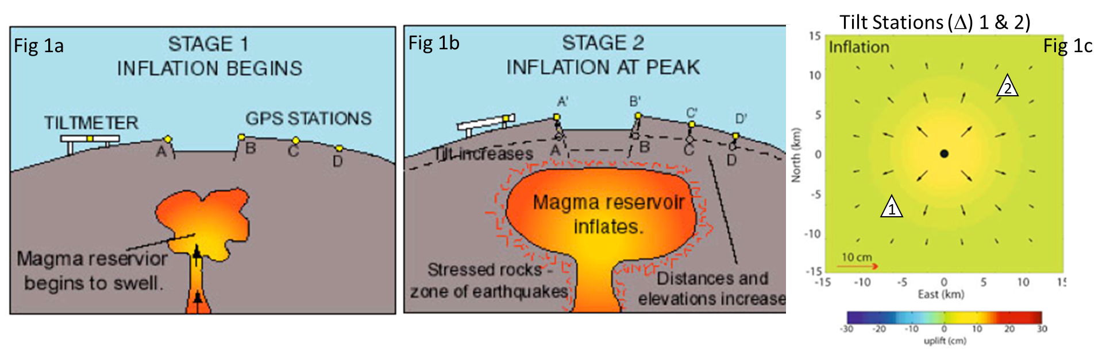
A tiltmeter is a device designed to measure small changes in inclination relative to horizontal. Tiltmeters are used in a variety of fields, including volcano monitoring. Around volcanoes, changes in tilt generally correspond to deformation due to subsurface changes that include an increase or decrease in the volume or pressure of the magma inside the volcano. For example, magma buildup may cause a bulge in the volcano’s surface (Figure 1a–b), resulting in tilt of tiltmeters located away from the center of the bulge (e.g. at sites 1 and 2 on Figure 1c). Similarly, magma flowing out of a volcano’s subsurface reservoir will cause surface deflation, subsidence, and tilt relaxation.
Figure 1 Schematic diagram of a tiltmeter and GPS stations on a volcano before and during inflation. Modified from UNAVCO, 2017

:

How Tiltmeters Work
Tiltmeters use a sensor composed of an electrolytic fluid in a tube or disk several centimeters in size. Three wires in the tube serve as electrodes, with two of the wires running along the top of the tube, each having one end exposed in an air bubble. The third electrode acts as a reference electrode (Figure 2a). Just as with a carpenter’s level, when the apparatus is tilted, the air bubble shifts, which is registered as an electonic pulse to the upper electrodes (Figure 2b). Modern tiltmeters can detect changes smaller than 1 microradian, which corresponds to the tilt that would be created if a dime were inserted under one end of a bar that is 1 kilometer long.

Tiltmeter Network at Kilauea
Figure 2a (above): Schematic diagram of a horizontal tiltmeter and 2b (right): An inclined tiltmeter. Modified from Calderon et al., 2004.
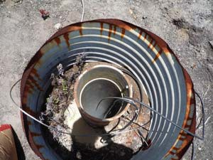
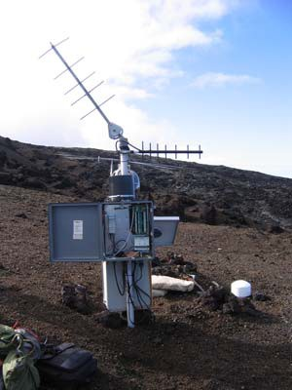
The Hawaiian Volcano Observatory (HVO) monitors volcanic activity in Hawai’i using a network of tiltmeters, including three stations on and around Pu’u O’o. The tiltmeters are installed about 2–3 m deep to reduce artificial tilt signal from thermal effects (Figure 4). Data are collected at least once per minute, allowing for the use of tilt in analyzing rapid deformation transients, like the ''DI'' (Deflation-Inflation) events that commonly affect both the summit of Kilauea and Pu’u O’o. Their sensitivity to rapid changes make tiltmeters an ideal monitoring device for rapidly developing volcanic events. Data from tiltmeters on Kilauea are transmitted electronically to HVO where alarms provide warnings of important changes in activity, like the June 17–19, 2007, east rift zone intrusion and eruption (Episode 56 of the Pu’u O’o- Kupaianaha eruptions. The tiltmeter in Figure 5 is the POC station on the north flank of Pu’u O’o on the east rift zone of Kilauea.
Figure 4: A tiltmeter in an opened buried canister being prepared for deployment. (USGS photo, courtesy M. Poland; 7/2009)
Figure 5: POC tiltmeter on the north flank of Pu’u O’o. USGS photo, courtesy M. Poland (2008/01/25)

Example Data
Tilt data shown in Figure 6 is for station UWE at the summit of Kilauea from May 2018 (see location on Figure 7). Notice the x-axis shows that this data is from May 28, 2018, to May 30, 2018. The y-axis shows a relative amount of tilt, in microradians. This data shows that from 18:00 (6pm) on May 28 until approximately 2 am on May 29, the surface under the tiltmeter was tilting down (deflation) but that the surface rapidly increased and then decreased, representing a quick eruption followed by more deflation.
Note that another graph of tilt would use a different relative scale on the y-axis, so the y-axis should only be used as indicator of inflation and deflation but not a specific amount of tilting.
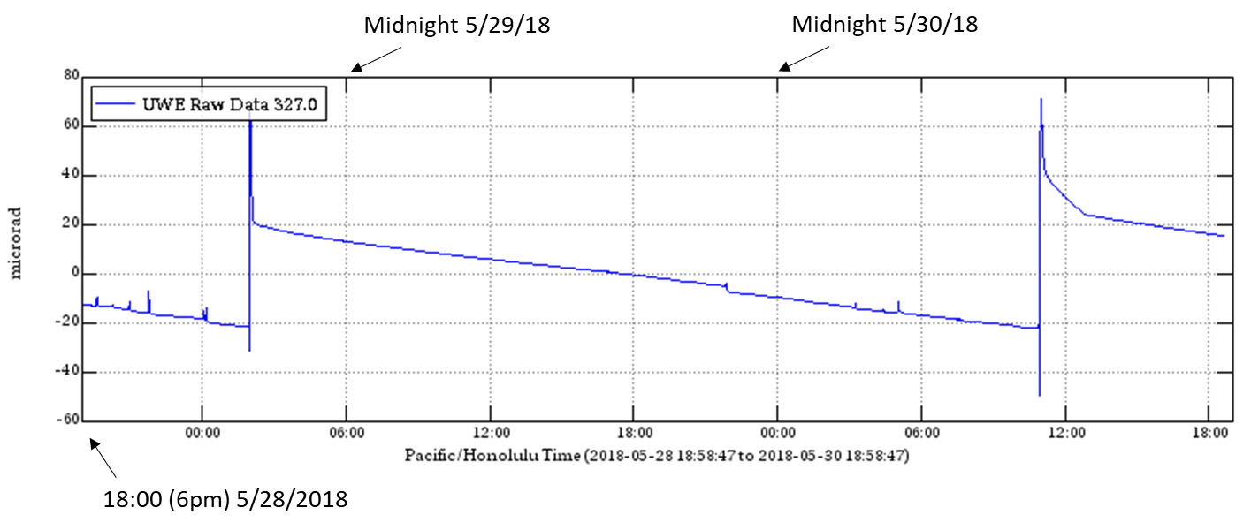
Figure 6: Tilt data for tiltmeter UWE on Kilauea for 5/29/18 through 5/30/18, Modified from USGS, 2018.

The map (Figure 7) shows locations of tiltmeters (POO) on Kilauea, located about 1.8 km northwest of the Pu’u O’o crater and POC located on the flank of Pu’u O’o.

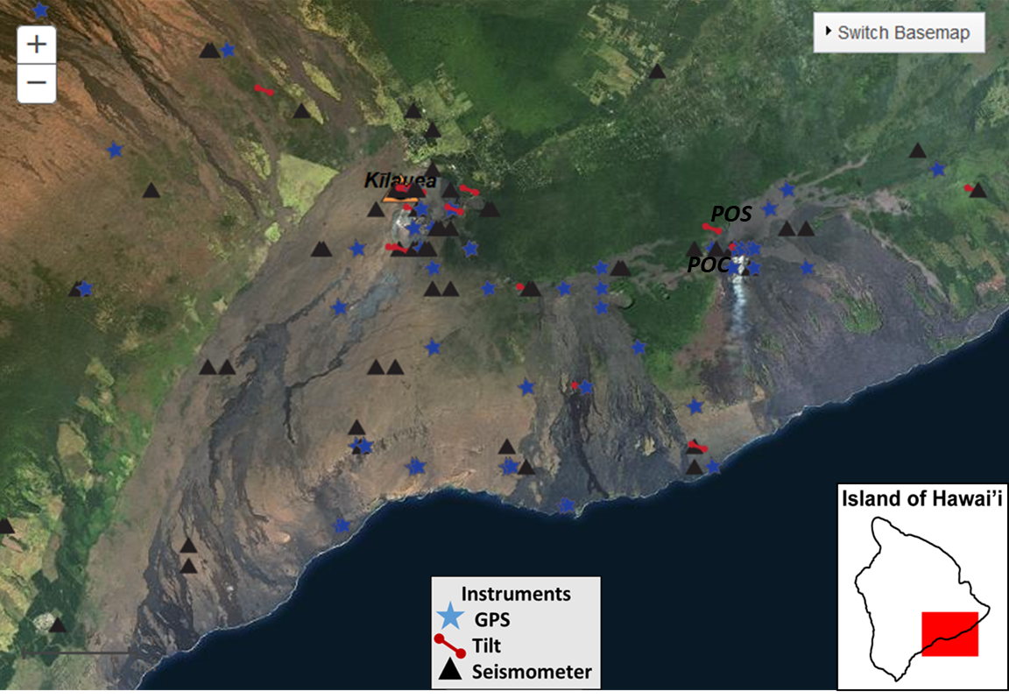
Figure 7: Map of monitoring stations at Kilauea. Modified from USGS map generated at: https://volcanoes.usgs.gov/observatories/hvo/hvo_earthquakes.html
UWE

References and Resources
Map compiled from:
https://volcanoes.usgs.gov/observatories/hvo/hvo_earthquakes.html
Calderon A., Cavo E., Figueroa, C. F., Martinez-Rivero. C., Matoraas, F., Rodrigo, T., Vila, I., Virto, A. L., Arce, P., Barcala, J. M., Ferrando, A., Fuentes, J., Josa, M. I., Luque, J. M., Molinero, A., Navarrete, J., Oller, J. C., Valdivieso, P., Fenyvesi, A., Molnar, J., 2004, Results on neutron and gamma-ray irradiation of electrolytic tiltmeters, Nuclear Instruments and Methods in Physics Researc A, 532, 631–638.
Dzurisin, D., 1992, Electronic tiltmeters for volcano monitoring: lessons from Mount St. Helens, in Ewert, J., and Swanson, D. A., eds., Monitoring volcanoes: techniques and strategies used by the staff of the Cascades Volcano Observatory, 1980–90: U.S. Geological Survey Bulletin 1966, 125–134.
UNAVCO 2017, GPS and Volcanoes. GPS Spotlight, retrieved April 2018 from: https://spotlight.unavco.org/how-gps-works/gps-and-tectonics/gps-and-volcanoes.html
USGS Map, Hawaiian Volcano Observatory, Earthquakes. Retrieved April 2018 from: https://volcanoes.usgs.gov/observatories/hvo/hvo_earthquakes.html
USGS, 2018, Hawaiian Volcano Observatory: Tilt and GPS Deformation Data. USGS, retrieved May 2018 from: https://volcanoes.usgs.gov/vsc/captures/kilauea/summit_uwe_tilt_2weeks.png

