Monitoring Volcanoes & Communicating Risk Unit 4: Comparing risks at different volcanoes in-class student exercise
Kaatje van der Hoeven Kraft (Whatcom Community College) & Rachel Teasdale (California State University Chico)
Answer the following questions with other group members who are examining the same volcano.

Volcano studied: __________________________________
- What are the primary hazards for your volcano?

- In the reading about your volcano, the mean Mean Recurrence Interval (MRI) calculation was discussed in terms of using historical events, only some of which were confirmed and others that are considered uncertain. The MRI of all events was provided. Calculate the second possible MRI using only confirmed events (noted in the reading). Which do you think is a more realistic number (the MRI you calculated or the MRI provided)? Explain.

- How large of a population may be impacted by the hazards of your volcano? What are the primary towns impacted by these hazards

- How much time do these populations have to respond?

- Population density and poverty both play a role in how vulnerable a population is, how do these factors play a role with your volcano and how does that impact the potential vulnerability to volcanic eruptions?

- How might the corruption index for the country influence the impact of a volcanic eruption?

- Volcano monitoring helps to alleviate some of the possible risk to a region. What instruments are available and what do they tell us about the volcano for monitoring purposes?
- Fill in the details in Table 1 for your volcano below.
Table 1 | Mauna Loa | Fuego | Rinjani
Country
Type of volcano
Possible hazards
MRI
Population density (within 10 km of volcano)
Poverty index
Infrastructure
Corruption Index
Monitoring available
Based on information above, assess the risk with: Risk = Hazard x Value x Vulnerability
Hazard (High, Medium, Low)
Value (High, Medium, Low)
Vulnerability (High, Medium, Low)
Risk (highest, middle, lowest)

In mixed groups, fill in the details on Table 1 from the other two volcanoes then answer the following for one of the volcanoes (of your choice or assigned by instructor).
- Based on the monitoring available, how confident would you be to determine an alert level, and why? (Note, see more information on alert levels at the end of this handout).

- Based on the instrumentation available at the volcano, what data signal(s) would be observed if magmatic activity were increasing?

- What additional data or instrumentation would you want to install at this volcano to increase your confidence level? Explain why.

- As an emergency planner, what would you need to know to make decisions about evacuations?

- Combine the volcanology information with the issues addressed by the emergency planner to describe and explain some next steps for responding to the volcanic activity (include possible data collection, communication strategies, infrastructural considerations, economic costs of evacuation, etc…).

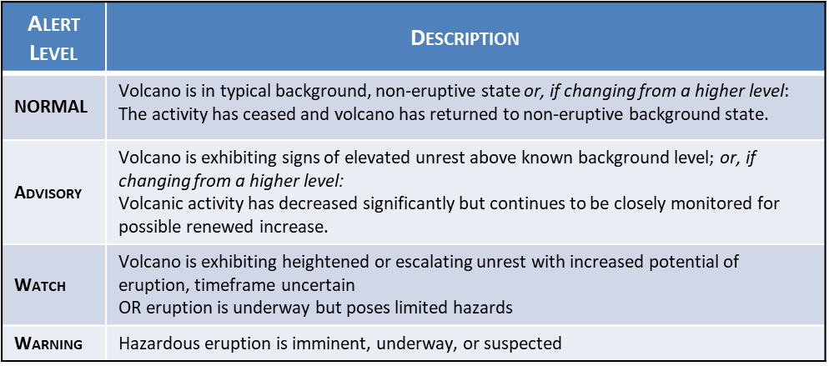
USGS Alert Level Descriptions
USGS volcano alert levels, from: https://volcanoes.usgs.gov/vhp/alert_icons.html

