Monitoring Volcanoes & Communicating Risk Unit 4: Rinjani Factsheet

Rachel Teasdale (California State University Chico) & Kaatje van der Hoeven Kraft (Whatcom Community College)

*Below are the details on Rinjani volcano (Indonesia) that you need for today’s activity.*

# Background

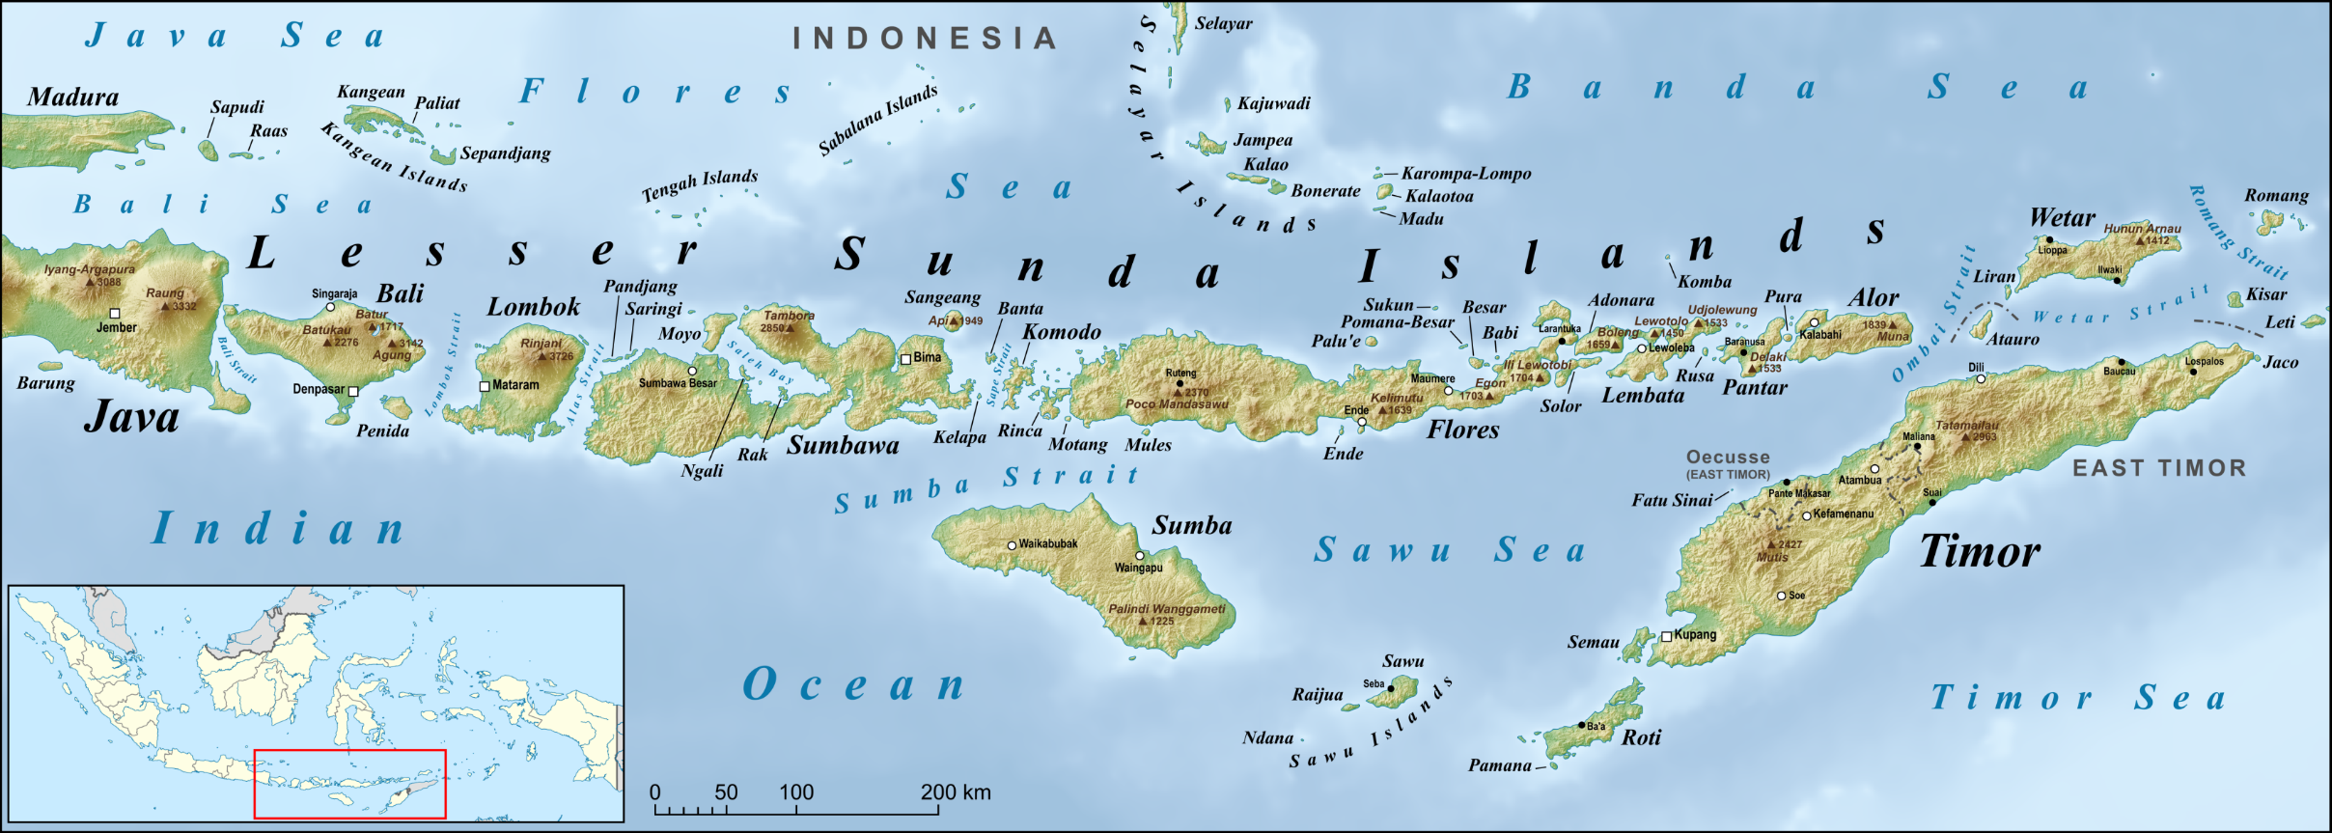

Rinjani Volcano

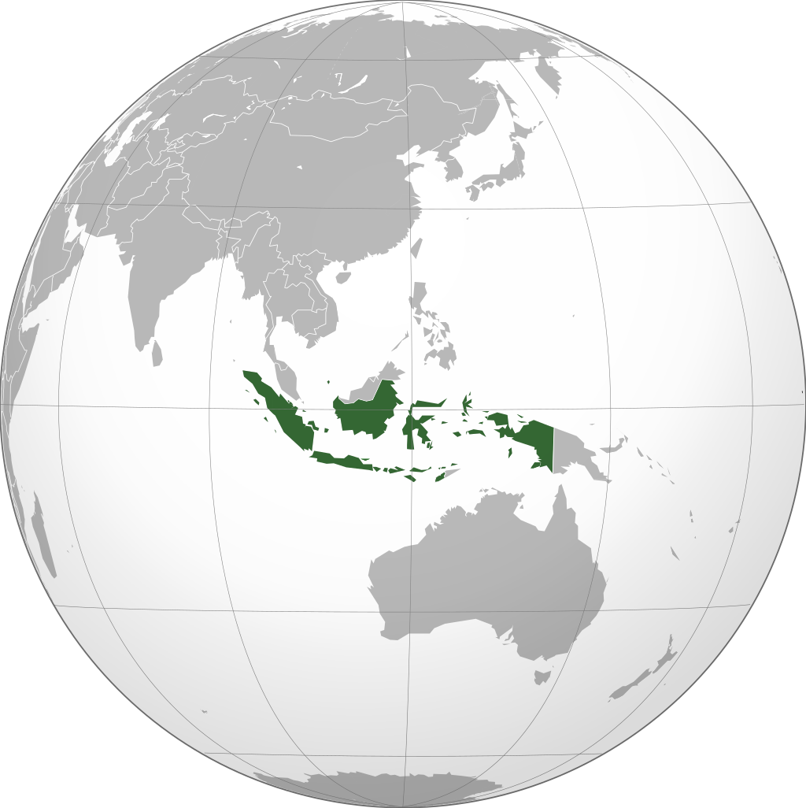

1a

## Tectonic Setting

Rinjani volcano is located in Indonesia on Lombok Island (Figure 1). Indonesia is made of a series of volcanic islands that formed as part of an island arc from the subduction of the Indo-Australian Plate beneath the Eurasian Plate. In the year 1257 a very large eruption of the stratovolcano of Rinjani resulted in the collapse on the west side of the volcano, forming a large caldera that is 3.75 by 5.3 mi (6 x 8.5 km), which has now partly filled with water, forming a 750 ft. (230 m) deep lake. A smaller cone called Barujari has formed from small eruptions in the caldera since 1847 (Figure 1c).

Figure 1 Location of Rinjani volcano on Lombok Island in Indonesia (1a) and views of the volcano from the coast (1b) and inside the caldera (1c). Maps from Wikipedia, 2018; photo from https://volcano.si.edu/volcano.cfm?vn=264030.

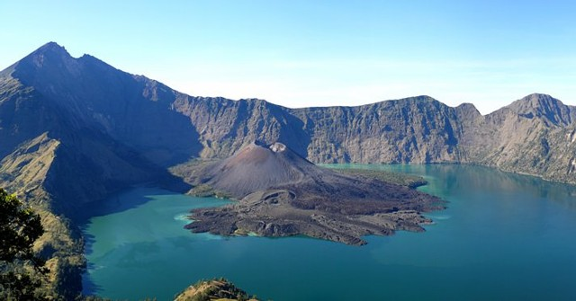

1c

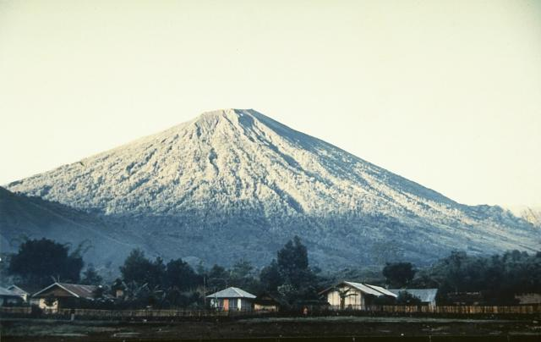

1b

1a

1b

# Information below is provided about Rinjani in terms of the risks of an eruption. Risk is the chance of harm and the extent of that harm caused by a hazard. The risks associated with an eruption of Rinjani are determined based on the hazards of the volcano- the events that can cause the harm, the vulnerability to damage (the factors about the area that determine how bad the damage will be) and value of the harm (e.g. financial costs and human loss or injury). These factors can be approximated with the Risk Equation:

**Risk = Hazard x Value x Vulnerability**

# Hazards

Figure 2 Eruption of Rinjani, November 2015, with ash plume blowing ESE. Image modified from NASA Earth Observatory, 2015. R indicates the summit of Rinjani and S is the summit of Samalas.

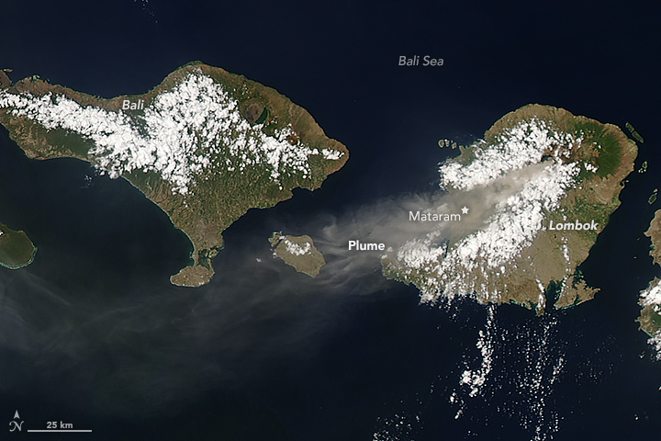

R

S

## Eruption Style and Background (including VEI)

Rinjani is known as the Rinjani Volcano Complex, which is made of two stratovolcanoes: Samalas, Rinjani and Barujari (the small cone in the caldera of Rinjani; Figure 2). At 11,923 ft. (3726 m) above sea level, Rinjani is the second tallest stratovolcano in Indonesia (Figure 1b). Recent eruptions (since 1847) have been from the Barujari cone in the caldera and range from VEI = 0-3, which includes recent eruptions of lava flows, gas and ash plumes, small pyroclastic flows on the flank of Barujari (in 1994; Figure 3)

## Eruptive History

The most recent eruption of the Rinjani Volcano Complex occurred in 2016 from Barujari in the caldera. A similar eruption in 2015 disrupted air travel in Indonesia because gas and ash were windblown to the west and into air traffic routes, causing potential aviation hazards (Figure 2). Given Indonesia’s economic reliance on tourism, airport closures can have a big impact.

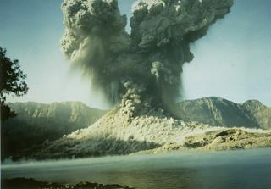

Figure 3 Barujari of Rinjani eruption in 1994, with 2km plume and pyroclastic flow. Image from GVN, 2013.

Eruptions of Rinjani are known to have occurred since 600 BCE and the most recent eruption was from the Barujari cone in the caldera in 2016. These more modern eruptions generally include eruption of gas and ash and some relatively short lava flows that are confined to the Segara Anak Lake in the caldera (Figure 1c).

Recall, we can determine an approximate frequency of eruptions at Rinjani over a known period of time using the Mean Recurrence Interval (MRI)**.**

MRI **= Elapsed time**

**# events**

While this may seem straightforward, volcanologists still need to make decisions about which events to include, especially for eruptions that occurred before consistent records were made. As with other models and calculations, the reliability of MRI relies on the accuracy and completeness of the data. Since 600 BCE, there have been **21 confirmed and suspected eruptions** of Rinjani over this period of **2619 years (from 600 BCE to 2019)**. The MRI of Rinjani using these values is 124.71. However, of those eruptions, only 17 have been confirmed since 1846. Calculate the MRI for this more reliably (confirmed) documented data (on the class worksheet):

MRI **= Elapsed time**

**# events**

## Volcanic Hazards and Hazards Maps

As noted in the description of Rinjani’s recent eruptions from the Barujari cone since 1847 have resulted in ash plumes (up to 6 mi, or 10 km altitude in 2015, 2016), small pyroclastic flows (1994) and lava flows that partly filled the western part of Segara Anak lake in the caldera of Rinjani.

However, in 1257 CE an eruption of Rinjani was much larger (VEI = 7) and caused part of the volcano to collapse, leaving the modern caldera. This eruption is one of the largest eruptions and released the most sulphur of any known eruption in the last thousand years. The eruption caused the summit of the volcano to collapse, forming the modern caldera and lake. Erupted products included pyroclastic flows, a gas and ash plume that rose more than 25 mi (40 km) and sulphur emissions that had significant climate impacts.



Figure 4: Map showing distribution of pyroclastic flows (thickness labeled in meters) and location of charcoal samples used for 14C dates. Modified from Lavigne et al., 2003.

In 2003, climatologists identified a layer in polar ice cores with the largest sulphur spike in the millennium (Vidal et al., 2015). The sulphur spike is larger than that associated with the eruptions of Krakatau (1883) or Tambora (1815), which indicates that the sulphur spike represented a very large eruption, but at that time (2003), the eruption of Rinjani was not well understood. Tree ring growth data had similar deviations at the same time, which also correspond to the timing of an ancient record - written on palm leaves- describing a massive eruption from an ancient pre-cursor volcano of Rinjani (Lavigne et al., 2013). Knowing that Rinjani (and its ancient predecessor) might be the source of the sulphur anomalies, volcanologists used the tree ring data, distribution and composition of ash and pumice to contribute to reconstruct that the caldera-forming eruption of Rinjani in 1257 was responsible for the sulphur spikes. Additional research revealed that sulphur in the atmosphere from Rinjani’s eruption resulted in global impacts of cooler summers and poor crop yields (Lavigne et al., 2003).

Hazard maps are often constructed by volcanologists to show areas where erupted products are likely to occur. However, such maps are not available for the Rinjani Volcano Complex.

**Value (Societal Context)**

## Population Density

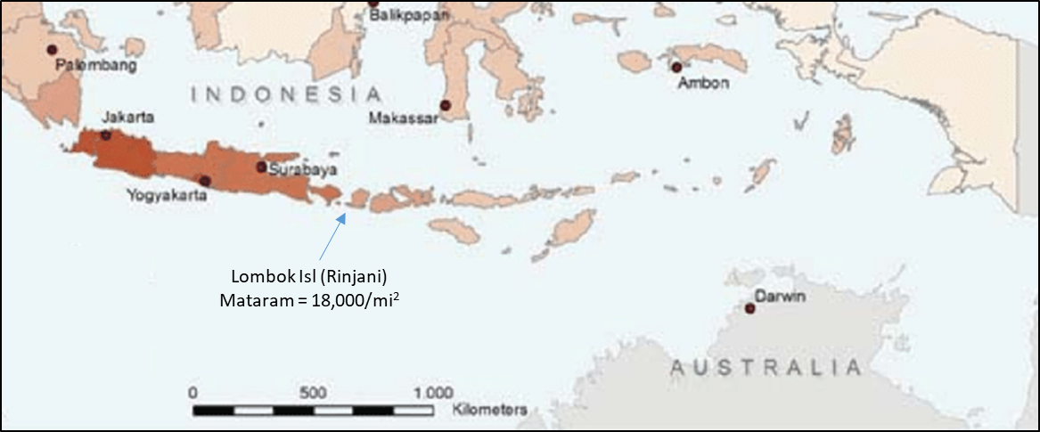

Figure 5a. Population density of Lombok Island, from Obermayr, 2012; 5b. Populations of areas within 5-100 km of the summit of the Rinjani volcanic complex (Data from Smithsonian Global Volcanism Program, 2013).



a

Indonesia is a very highly populated region. While Lombok Island is not as densely populated as other areas like the city of Jakarta (population 9.6 million). More than 3 million people live on Lombok Island, more than 1.3 million people live within 30 km of the volcano (Figure 5a), which includes the capital city of Mataram has a population density of 18,000 mi2, comparable to San Francisco, CA. Another way of analyzing the population near the volcano is that more than 1.3 million people live within 30 km of the volcano (Figure 5b).

b

**Vulnerability**

*Infrastructure*

## Following several other large earthquakes (greater than magnitude 5.0), in August 2018, a magnitude 6.9 earthquake occurred near the north shore of Lombok. The earthquake destroyed hundreds of buildings, killed more than 550 people, and injured more than 7,000 people. Three important bridges collapsed and more than 75,000 houses were destroyed, which displaced nearly half a million people (USGS, 2018). The earthquake also initiated landslides in Rinjani’s caldera. Damage to roads made distribution of aid to impacted areas very difficult, including distribution of medical aid, food and water. While the impacts on Lombok’s infrastructure described here is related to an earthquake, it is useful information to include when considering potential issues associated with damage that pyroclastic flows and other erupted products may have on the vulnerability of Lombok. In addition, the eruption in 2015 caused travel disruptions (fig 3), which should be considered in examining economic impacts (e.g. to tourism).

## Poverty Index

Indonesia is the largest economy in SE Asia and economic growth includes increased GDP from $857 (USD in 2000) to $3847 (USD in 2017; World Bank, 2018). Nearly 10% of the population live in poverty and nearly 21% are in danger of dropping into poverty status. Health indicators suggest there is a continued widening of the gap between the richer and poorer economic classes, but the government, supported by the World Bank and other international organizations is working towards stronger economic growth.

## Corruption Index

Corruption occurs when bribes are used to circumvent inspections and licensing processes along with other activities that compromise the quality of structures through covert activities (Ambraseys & Bilham, 2011). Regions that have higher corruption, are likely to have greater levels of disaster than those with equivalent poverty levels, but lower corruption. A Corruption Index was developed to compare different countries levels of corruption. Indonesia is ranked as the 96th most corrupt country in the world out of 180 (where 1 is the least corrupt; Transparency International, 2017).

**Volcano Monitoring**

Volcano monitoring is a way to inform communities about the hazards (and therefore risks) of eruptions of volcanoes.

Seventy-nine of the more than 120 active volcanoes in Indonesia have erupted in the last 400 years, which makes a challenging situation for monitoring volcanoes there. Sixty-six volcanoes are continuously monitored from 76 volcano observatories (WOVO, 2012). Rinjani has an observatory with a recently installed seismometer as part of the WOVO (World Organization of Volcano Observatories). If increasing volcanic activity is detected, local authorities at the volcano communicate with the Volcanology Survey of Indonesia (VSI) to decide if additional monitoring is needed. Possible responses can include installation of portable seismographs on Rinjani, as well as tiltmeters, and electrical sensing instruments that are used to measure volcano deformation and when appropriate, geochemistry of hydrothermal fluids may also be measured to detect changes in emissions (WOVO, 2012).

## References

Ambraseys & Bilham, 2011, Corruption Kills. *Nature, 469*, 153-155.

Rinjani (264030) *in* Volcanoes of the World, v. 4.7.5. Venzke, E (ed.). Smithsonian Institution. Downloaded 21 Dec 2018 (https://volcano.si.edu/volcano.cfm?vn=264030). <https://doi.org/10.5479/si.GVP.VOTW4-2013>

Lavigne, F., Degeai, J.P., Komorowski, J.C., Guillet, S., Robert, V., Lahitte, P., Oppenheimer, C., Stoffel, M., Vidal, C.M., Pratomo, I. and Wassmer, P., Hajdas, I. Sri Hadmoko, D., de Belizal, E., 2013, Source of the great AD 1257 mystery eruption unveiled, Samalas volcano, Rinjani Volcanic Complex, Indonesia. *Proceedings of the National Academy of Sciences*, v. 110 (42), 16742-16747, DOI: 10.1073/pnas.1307520110.

NASA Earth Observatory, 2015, Eruption of Mount Rinjani, Indonesia, downloaded November 30, 2018 from <https://earthobservatory.nasa.gov/images/86932/eruption-of-mount-rinjani-indonesia>

Obermayr, C., 2012, Introduction to Surakarta (Solo), Figure 5; retrieved December 2018 from <https://www.researchgate.net/profile/Christian_Obermayr/publication/312078233/figure/download/fig8/AS:661854116405253@1534809726230/Population-density-of-Indonesias-regions-2010-Obermayr-2012c.png?_sg=ROppzYQ8GWCwnHorX_LW-KyApzgPYdofeO07Q_AQiMDkSv5y180rAwdIh7P-J5nxt_yi9tXyATw>.

USGS, 2018, USGS Earthquakes Hazards Program, “M6.9 - 0km SW of Loloan, Indonesia” accessed December 2018 from <https://earthquake.usgs.gov/earthquakes/eventpage/us1000g3ub/impact>.

Vidal, C. M., Komorowski, J. C., Métrich, N., Pratomo, I., Kartadinata, N., Prambada, O, Michel, A., Carazzo, G, Fontijn, K., 2015, Dynamics of the major plinian eruption of Samalas in 1257 AD (Lombok, Indonesia). *Bulletin of Volcanology*, *77*(9), 73.

Vidal, C. M., Métrich, N., Komorowski, J. C., Pratomo, I., Michel, A., Kartadinata, N., Robert, V. and Lavigne, F., 2016, The 1257 Samalas eruption (Lombok, Indonesia): the single greatest stratospheric gas release of the Common Era. *Scientific reports*, *6*, 34868.

Wikipedia, 2018, Lesser Sunda Islands, retrieved December 2018 from <https://en.wikipedia.org/wiki/Lesser_Sunda_Islands>.

WOVO, 2012, “WOVO.org” accessed December 2018 from <http://www.wovo.org/1601_1607.html>.