Monitoring Volcanoes and Communicating Risk Unit 4: Mauna Loa Factsheet
Rachel Teasdale (California State University Chico) and Kaatje van der Hoeven Kraft (Whatcom Community College)
Below are the details on Mauna Loa volcano (Hawai‘i) that you need for today’s activity.

Background

Tectonic Setting
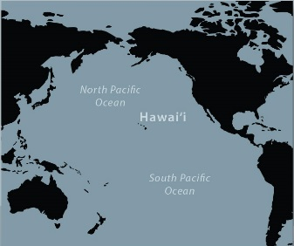
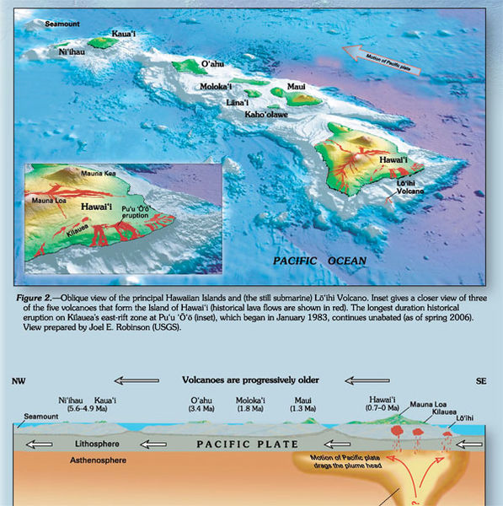
Mauna Loa volcano is located on the island of Hawai‘i, on the Pacific Plate (Figure 1a). The Hawaiian Islands formed through eruptions of the Hawaiian Hot Spot, which has remained stationary as the Pacific Plate has moved northwest, moving older islands away from the hot spot, which has continued to form newer islands (Figure 1b). The island of Hawai‘i is built from five major shield volcanoes, including Mauna Loa, which covers nearly half of the island (Figure 1c).
Figure 1: a) Location of Hawai‘i in the middle of the Pacific Plate; b) Tectonics of the Hawaiian Hot Spot and evolution of Hawaiian Islands as the Pacific Plate moves over the hot spot; c) location of Mauna Loa on the island of Hawai‘i, with major populated areas of Hilo and Kona shown. Modified from USGS.
1a
1b
Hilo
Kona
1c
1b

Information below is provided about Mauna Loa in terms of the risks of an eruption. Risk is the chance of harm and the extent of that harm caused by a hazard. The risks associated with an eruption of Mauna Loa are determined based on the hazards of the volcano—the events that can cause the harm, the vulnerability to damage (the factors about the area that determine how bad the damage will be) and value of the harm (e.g. financial or human damages). These factors can be approximated with the Risk Equation:
Risk = Hazard x Value x Vulnerability

Hazards

Eruption Style and Background (including VEI)
Mauna Loa is the largest active volcano on Earth and covers approximately 5,100 km² (1900 mi²). The summit of Mauna Loa is approximately 13,678 ft (4144 m) above sea level, but the volcano rises from the sea floor, making its total height is 30,085 ft (9,170 m) from the seafloor to its summit. Lavas from Mauna Loa likely first erupted onto the seafloor Mauna Loa sometime between 1.0 and 0.6 million years ago and emerged above sea level about 300,000 years ago.
The basaltic composition of the lavas typically erupted from Mauna Loa are relatively low viscosity (relatively high fluidity), so are able to flow great distances, which has resulted in the broad slopes of the shield volcano (Figure 2). The basaltic composition also generally has low gas concentrations so eruptions are relatively effusive (not as explosive as other compositions, except in cases where magma intersects water). Given the low gas content and low viscosity, eruptions of Mauna Loa are generally VEI = 0–1 and rarely VEI = 2.

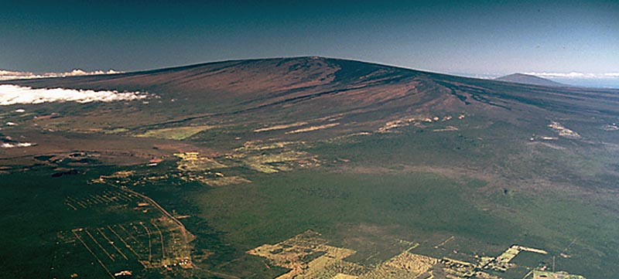
Eruptive History
The most recent eruption occurred in 1984 when lava flowed 29 km (18.1 mi) downslope from Mauna Loa’s Moku‘āweoweo Caldera. Flows were active for 2½ weeks and were emplaced within 6 km (3.8 mi) of the city of Hilo (population, 43,000; see Figure 3).
Figure 2: Mauna Loa, a shield volcano; from USGS.
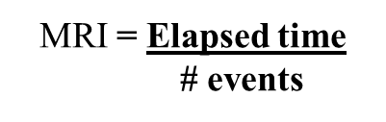
Recall that the Mean Recurrence Interval (MRI) indicates how frequently eruptions have occurred over a known period of time:
While this may seem straightforward, volcanologists still need to make decisions about which events to include, especially for eruptions that occurred before consistent records were made. As with other models and calculations, the reliability of MRI relies on the accuracy and completeness of the data.
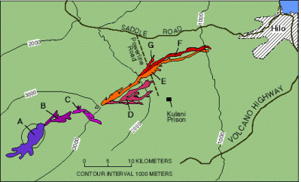
The earliest eruption attributed to Mauna Loa is from 8050 BCE (Before Common Era, sometimes referred to as BC). If we include all historical events since this time (which are not always reliable, and definitely cannot be considered complete records) plus events analyzed with radiocarbon dates and known from modern record keeping, there have been 109 confirmed and uncertain eruptions of Mauna Loa over 10,069 years (from 8050 BCE to 2019). The MRI of Mauna Loa using these values is 92.4. However, of those eruptions, 33 have been confirmed since 1832. Calculate the MRI for this more reliably documented (confirmed) data in your in-class worksheet.
Figure 3 Lava flows erupted from Mauna Loa in 1984. From USGS.
MRI = Elapsed time
# events

Volcanic Hazards and Hazards Maps
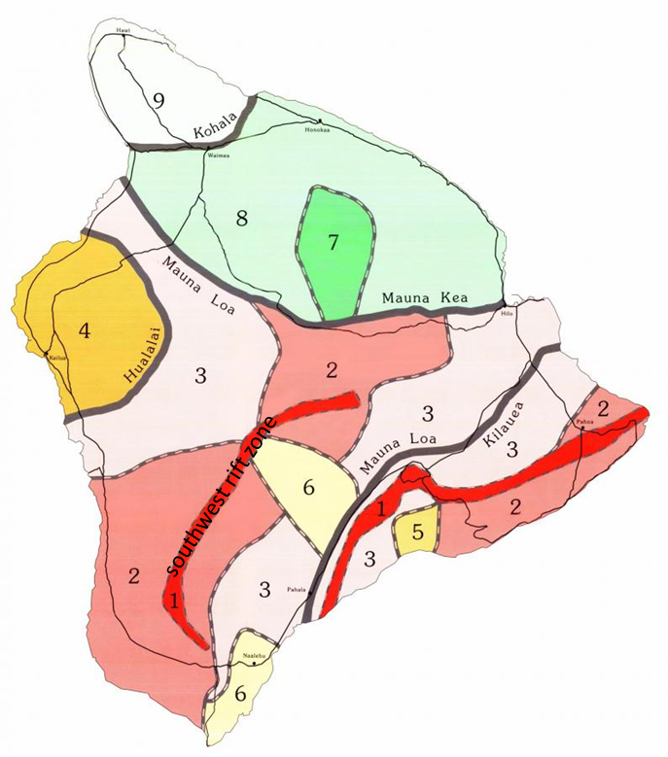
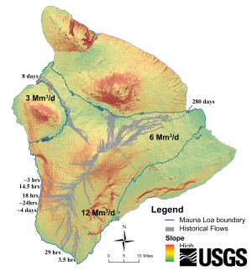
As Earth’s largest active volcano, Mauna Loa is constructed of lava flows erupted from the summit region, as well as lava flows erupted from cinder cones on the southwest rift zone of the shield volcano. Because the island of Hawai‘i is built on lava flows, all populated areas are built on lava flows. In 1984, an eruption of Mauna Loa. Recognizing the lava flow hazards, USGS and other scientists compile the types of hazards associated with volcanoes and show those on hazards maps that show areas where lava flows are most likely to be a hazard and areas of lower hazards (zone 1 and 7, respectively on Figure 3). Similarly, USGS compiled a map predicting the inundation times, which gives estimates for the amount of time it would take for lavas from Mauna Loa to reach different areas of the island (Figure 4).
Hilo
Kona
Hilo
Kona
Figure 4a: Lava flow hazard map; and Figure 4b: Approximate time of lava inundation from Mauna Loa to the coast. From USGS, 2012.

Value (Societal Context)

Population Density
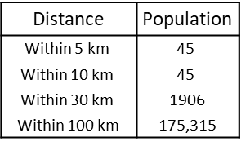
This is not a densely populated area (Figure 5) with fewer than 2000 residents living within 30 km of the summit of the volcano. The general population that surrounds this volcano is:
Figure 5: Population density map of the island of Hawai'i (modified from US Census Bureau, 2010) and population within 5–100 km of Mauna Loa (data from Smithsonian Global Volcanism Program, 2013).

Vulnerability

Infrastructure
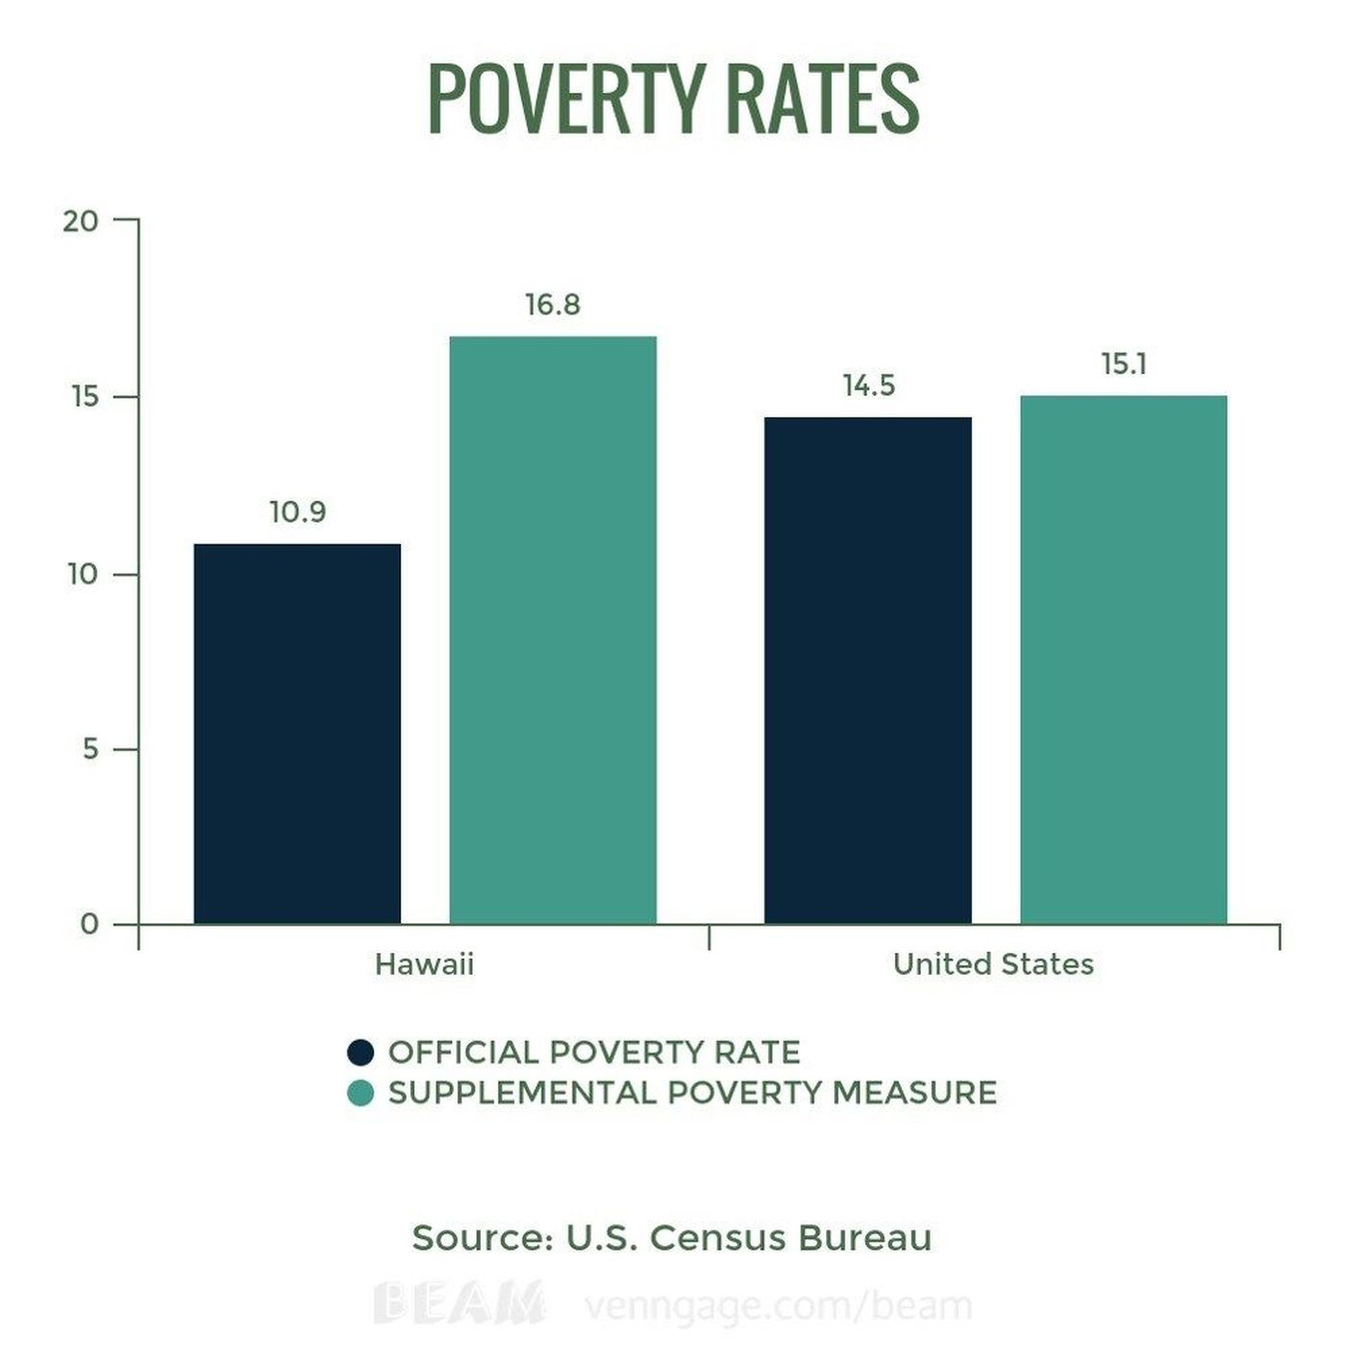
Limited roads in Hawai’i make lava flow hazards an especially important consideration. Once lava flows over a road, it cannot be used until the flow is no longer active in that area and the solid lava rock removed. In some cases, if a lava flows over the only access road for an area, residents might be trapped between a lava flow and the ocean. Generally, planners try to have at least two roads accessible for residents to use, but in rural areas, this may not always be possible. The Kona-Kailua area on the west coast is located at the base of a steep slope, which means lava erupted from Mauna Loa could inundate the area within hours (Figure 4b), including blocking roads that might otherwise be used as escape routes.
Figure 6: Comparison of poverty rate of Hawai’i and the entire United States. Black bars represent poverty rate and green bars represent poverty when cost of living is considered. From US Census data.

Poverty Index
While poverty levels in the United States are generally lower than in other countries, the high cost of living in Hawai‘i results in higher than national poverty rates as indicated by the “Supplemental Poverty Measure” in Figure 6.

Corruption Index
Corruption occurs when bribes are used to circumvent inspections and licensing processes along with other activities the compromise the quality of structures through covert activities (Ambraseys and Bilham, 2011). Regions that have higher corruption, are likely to have greater levels of disaster than those with equivalent poverty levels, but lower corruption. A Corruption Index was developed to compare different countries’ levels of corruption. The United States is ranked as the sixteenth least corrupt country in the world out of 180 (where 1 is the least corrupt; Transparency International, 2017).

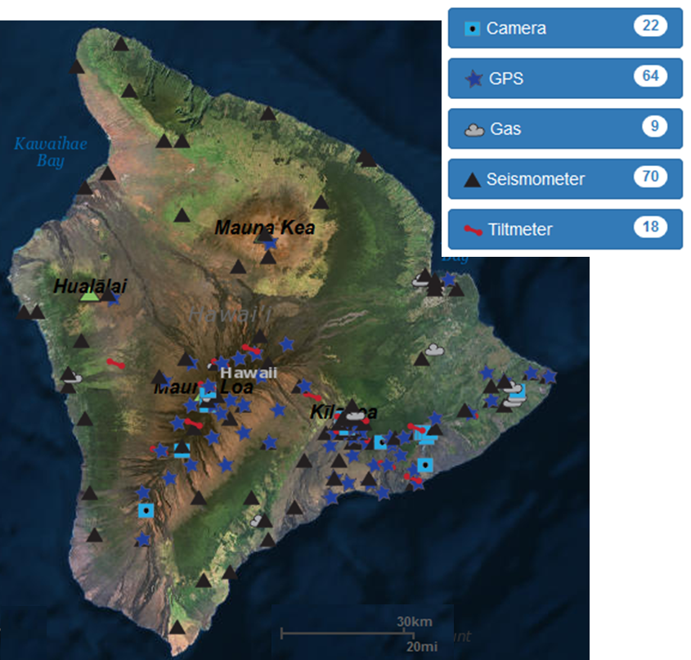
Volcano Monitoring
Hilo
Kona
Figure 7: Location map of seismometers, GPS and tiltmeter stations; from USGS, 2018.
Volcano monitoring is a way to inform communities about the hazards (and therefore risks) of eruptions of volcanoes. Given the hazards and geologic history of Mauna Loa, it is a well-monitored volcano, with 70 seismometers, 64 GPS stations, and 18 tiltmeters, which are all shown in Figure 7. Data are telemetered to the Hawaiian Volcanoes Observatory where geologists can track activity.
InSAR interferogram images are produced from data acquired by the European Space Agency's Environmental Satellite (ENVISAT; Figure 8). The large number of color bands (fringes) in (a) indicates an increased rate of inflation compared to the fewer number of fringes in (b). As depicted in the scale bar (bottom center), concentric and cyclical sets of fringes indicate a ground movement of 2.83 cm toward the satellite's line of sight during the time interval shown in each image.
Figure 8: Interferogram of Mauna Loa from October 2003 to November 2005; Modified, from Smithsonian Global Volcanism Program, 2013.
Caldera
Hazard maps (Figures 4a and 4b) are also useful tools for monitoring volcanoes like Mauna Loa.

References
Ambraseys and Bilham, 2011, Corruption Kills. Nature, 469, 153–55.
Global Volcanism Program, 2013. Volcanoes of the World, v. 4.7.4. Venzke, E. (ed.). Smithsonian Institution. Retrieved December 21, 2018. https://doi.org/10.5479/si.GVP.VOTW4-2013.
Hawai’i Population Density Map, Retrieved November 30, 2018. https://commons.wikimedia.org/wiki/File:Hawaii_population_map.png.
Irwin, J., 2017, Hawai’i Population Map, English Wikipedia, retrieved November 30, 2018. https://commons.wikimedia.org/wiki/File:Hawaii_population_map.png.
Mapbliss, 2018, Hawai’i State Map, retrieved November 30, 2018. https://commons.wikimedia.org/wiki/File:Hawaii_State_Map.jpg.
Simkin, T., Tilling, R. I., Vogt, P. R., Kirby, S. H., Kimberly, P., Stewart, D. B., 2006, This Dynamic Planet: World Map of Volcanoes, Earthquakes, Impact Craters, and Plate Tectonics, USGS Map I-2800, retrieved November 30, 2018. https://pubs.usgs.gov/imap/2800/.

USGS, 2012, Lava Flow Hazards Zones and Flow Forecast Methods, Island of Hawai‘i, retrieved November 30, 2018. https://volcanoes.usgs.gov/observatories/hvo/hawaii_lava_flows.html.

USGS, 2018, Volcano Hazards Program: Volcano Monitoring Data for Mauna Loa, retrieved December 2018. https://volcanoes.usgs.gov/volcanoes/mauna_loa/monitoring_summary.html.

Vorsino, M., 2016, Census: 1 in 6 Hawaii residents live in poverty, Hawai’i News Now, retrieved November 30, 2018. http://www.hawaiinewsnow.com/story/33087891/census-1-in-6-hawaii-residents-live-in-poverty/.
Wright, T. L., Chun, J. Y. F., Exposo, J., Heliker, C., Hodge, J., Lockwood, J. P., Vogt, S. M., 1992, Map Showing Lava-Flow Hazard Zones, Island of Hawaii; Map showing lava-flow hazard zones, Island of Hawaii: U.S. Geological Survey Miscellaneous Field Studies Map MF-2193, scale 1:250,000. https://pubs.usgs.gov/mf/2002/2401/.

Note: Figure 6 is from 2010 census data but the figure was retrieved December 2018 from http://www.hawaiinewsnow.com/story/33087891/census-1-in-6-hawaii-residents-live-in-poverty/.

