Monitoring Volcanic Hazards Unit 1: GPS data of renewed activity at Mount St. Helens in 2004
Kaatje Kraft (Whatcom Community College) & Rachel Teasdale (CSU Chico)

Global Positioning System (GPS) overview:
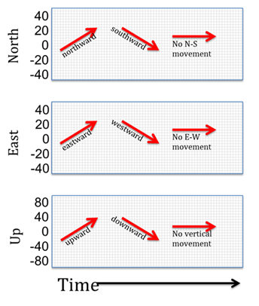
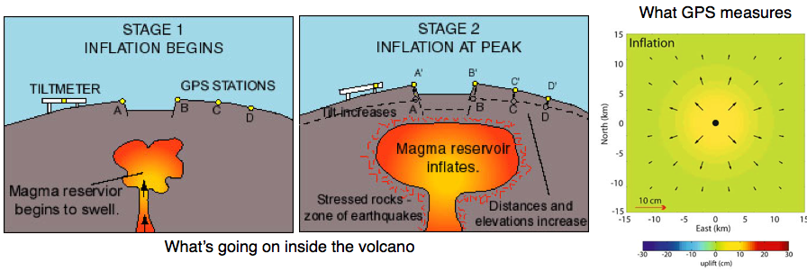
GPS is ubiquitous in our phones and everyday lives, and is critical for monitoring volcanic activity. The surface of the volcano can expand as magma rises and can sink (subside) as magma leaves the volcano. GPS can detect these small, millimeter to centimeter (and sometimes even meter!) scale changes in the ground. When the magma rises, the ground inflates, GPS stations can be detected spreading away from the central point of the injected magma. For example on Figure 1, if magma were injected directly below the black dot in the center of the map, GPS station A would move SW and up from the magma focal point, whereas station B would move NE and up. In contrast, if the magma decreases in supply, the region is likely to deflate, which would result in the volcano’s surface moving toward the central magma point (A would move NE and down and B would move SW and down).
Figure 2: Key to interpreting GPS data.
Figure 1. Note the GPS Stations ABCD and how they indicate that the magma is rising as the ground inflates. Image Credit: USGS and Jessica Murray-Moraleda
A
B
C
D

All measurements are reported relative to north, east and up (figure 2).
Activity Instructions:
Read the GPS overview and as a group write an explanation for your classmates in your own words how the data type presented here indicates magma movement inside the volcano on the space provided on the poster.

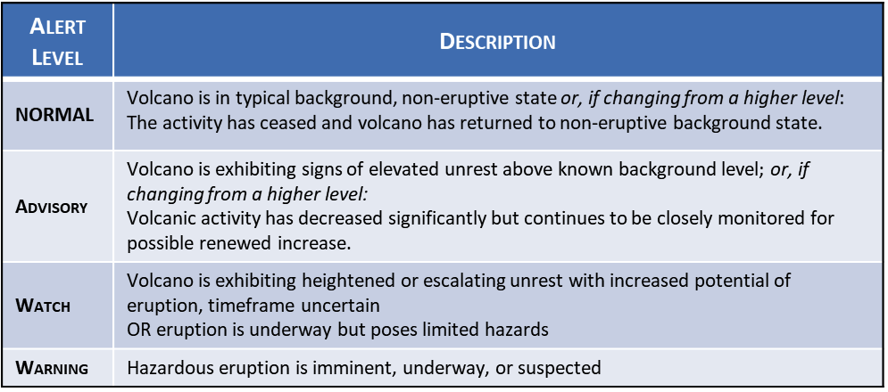

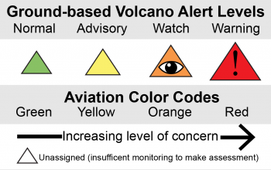

(Image credit: USGS)
Monitoring Volcanic Hazards Unit 1: Lidar data of renewed activity at Mount St. Helens in 2004
Kaatje Kraft (Whatcom Community College) & Rachel Teasdale (CSU Chico)

Lidar overview:
LiDAR or Light Detection and Ranging is way of detecting changes in the ground (as part of a larger system of detailed Digital Elevation Models, or DEMs), or surface topography using remote sensing of a pulsed laser. The pulsing from this laser can detect very precise (to the scale of cm), three-dimensional changes that occur on the ground surface. This laser pulse reflects off the ground surface and the time it takes for the laser to leave the source, hit the ground and return to the sensor can be translated to the distance between the ground and the sensor. One particular benefit to this method is that the lasers are able to travel through tree canopy to the ground, so unlike photogrammetry methods, maps made from lidar reveal features of the earth's surface that are obscured by digital photographs taken of densely vegetated or forested areas. This level of ground detail allows changes at the surface due to magma movement below a volcano to be detected. Lidar is detailed enough that it can be used to calculate the overall volume of displacement in the ground as the surface rises, as well as measure changes in topography related to magma rising in the volcano and inflating its surface. This detail can assist in determining areas of risk associated with volcanic activity, which informs the development of hazard maps. Another benefit of using lidar is that it can expose regions that are otherwise obscured by vegetation (Figure 1).
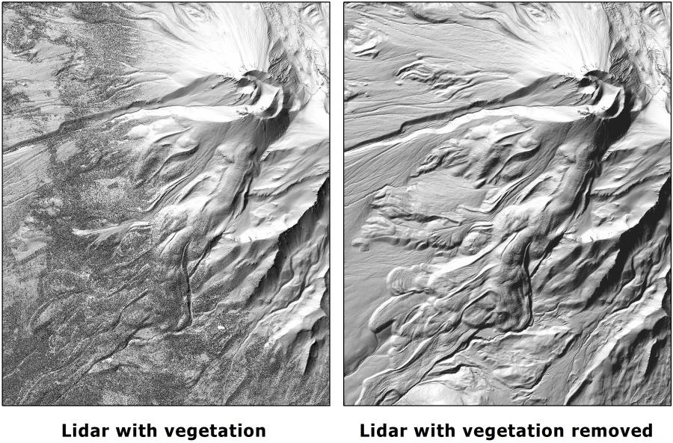
Activity Instructions
Figure 1. Mt. Shasta lidar photogrammetry indicating both with and without vegetation (the photo on the right has been processed to remove the vegetation). Note that when the vegetation is removed, more details on the volcano’s surface are illuminated. Photo from USGS
Read the lidar overview and as a group write an explanation for your classmates in your own words on how the data type presented here indicates magma movement inside the volcano on the space provided on the poster.

(Image credit: USGS)

Monitoring Volcanic Hazards Unit 1: Seismic data of renewed activity at Mount St. Helens in 2004
Kaatje Kraft (Whatcom Community College) & Rachel Teasdale (CSU Chico)

Seismic overview:
Earthquakes happen for many reasons, we tend to note those that occur from plate movement, however earthquakes that occur at volcanoes can reveal magma movement underneath. As magma moves it breaks rocks, which releases energy that is detected as seismic signals. Tracking the location and depth of seismic energy (epicenter or focus location) and the number of earthquakes over time can help inform volcanologists about the location and possibly the intensity of magma movement that can precede an eruption.

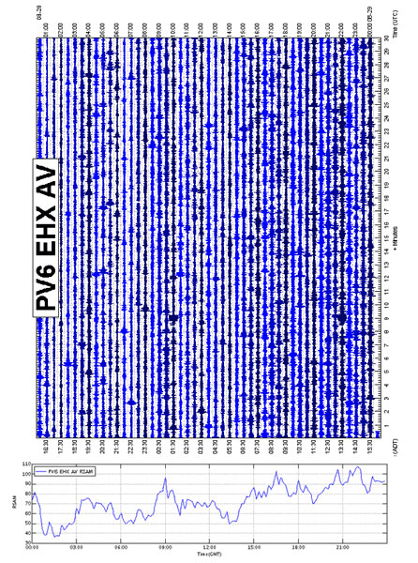
As magmatic activity increases, the number of earthquakes makes it difficult to discern individual events, so seismicity can be represented by the average amplitude of ground shaking every 10 minutes. This method is called Real-time Seismic Amplitude Measurement (RSAM) and is useful to represent a large number of earthquakes but does not indicate the depth and magnitude of each individual earthquake (Figure 1).
Figure 1. Output from Redoubt volcano in Alaska with the individual seismic events on a seismograph and the RSAM plot that shows overall average of activity for a more condensed view of the data. Image from USGS

Activity Instructions
Read the Seismic overview and as a group write an explanation to your classmates in your own words how the data type presented here indicates magma movement inside the volcano on the space provided on the poster.

(Image credit: USGS)

