Measuring Earth with GPS, Unit 3: Glaciers

Introductory Glacier Handout
Karen M. Kortz (Community College of Rhode Island) and Jessica J. Smay (San Jose City College)
In this activity, you will brainstorm about glaciers, how they change size, why that may be relevant, and how GPS can be used to measure it.

Part 1: Brainstorming
1. What could make a glacier become larger? become smaller?

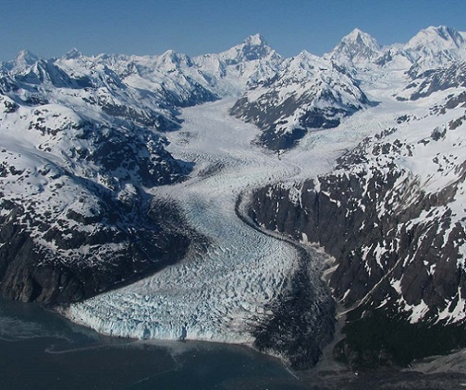2. How can scientists measure whether the amount of ice in a glacier is changing? List at least 4 ways.

Margerie Glacier, Alaska; NPS photo. From https://www.nps.gov/articles/howglaciersmove.htm

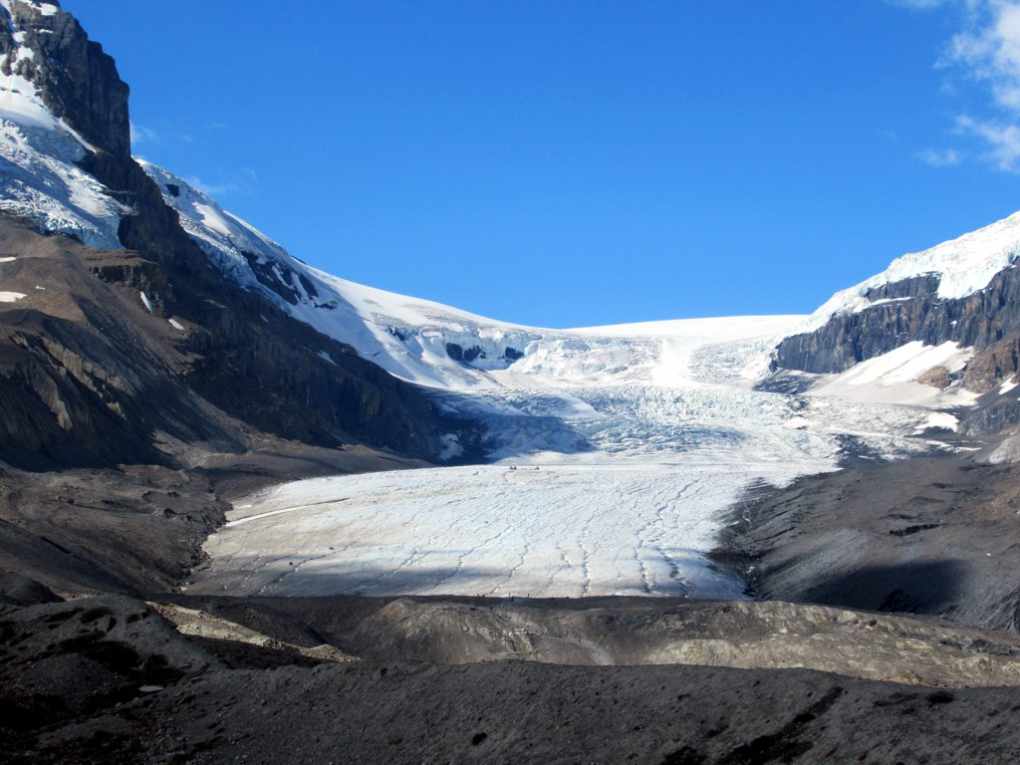3. Should communities care if the size of glaciers is changing? Why?

Athabasca Glacier, Alberta Canada; photo by David Stanley. From https://www.flickr.com/photos/davidstanleytravel/27443088699 (CC BY 2.0)

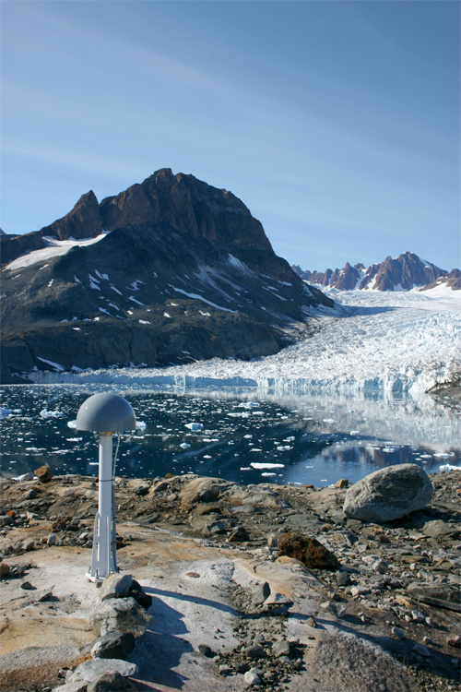4. GPS stations are attached to the bedrock and work like a phone to determine the exact location of the station. However, they are much more precise than phones. How could GPS be used to measure glaciers?

Laube Glacier, Greenland. Photo by Michael Willis, Cornell University. Used with permission.

