Measuring Earth with GPS, Unit 2: Earthquakes

Additional Assessment Questions
Karen M. Kortz (Community College of Rhode Island) and Jessica J. Smay (San Jose City College)
Below are additional summative assessment questions, beyond those in the three activities.

Example #1: Assess Parts 1, 3 (Module Goal 1; Unit Learning Outcomes 1)

Write detailed, step-by-step directions telling someone how to calculate the total horizontal speed and the direction of movement of the station. You do not need to actually calculate it.
Figure 1. Horizontal GPS data from station PABH in Washington from the beginning of January 2006 to the end of December 2017.

Example #2: Assess Parts 1, 3 (Module Goals 1, 2; Unit Learning Outcomes 1, 2, 3, 4)

Figure 1. Horizontal GPS data from stations USGC and P607 in Southern California from the beginning of January 2006 to the end of December 2017.

This area of Southern California needs a new hospital. Would you recommend building a hospital between P480 and USGC or between USGC and P607? Formulate an argument to support your recommendation. Write a letter with your recommendation to avoid earthquake hazards, using the GPS data to support your argument. You will need to explain to your friend how GPS station motion can play a role in learning about earthquakes.

Be sure to include the following points in your letter to receive full credit:
• You include a clear statement about your recommendation for location.
• You use words to describe the data supporting your argument.
• You use numerical rates (numbers plus units) to support your argument. Correctly include what the rate measures.
• You explain the link between GPS motion and plate motion.
• You explain the link between GPS motion and earthquakes.

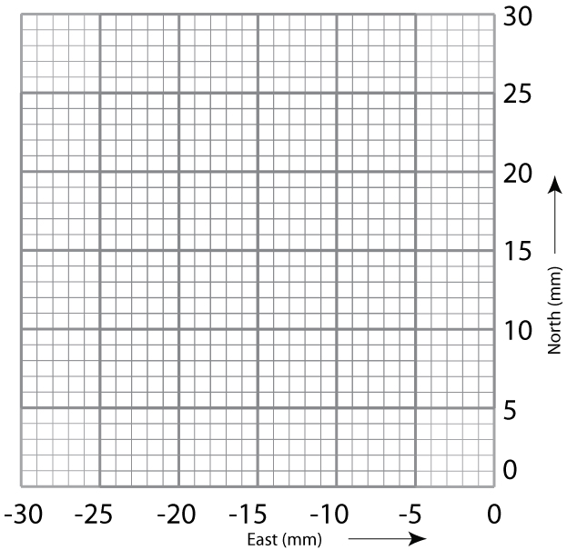
The following may be useful to you:

total rate = √ (north–south rate)² + (east–west rate)²

Example #3: Assess Parts 1, 3 (Module Goals 1, 2; Unit Learning Outcomes 1, 2, 3)

Figure 1. Horizontal GPS data from station P481 in California near the Mexico border from the beginning of January 2006 to the end of December 2018.

Use the graph showing ground motion as measured by GPS over time to answer the following questions.

What is the approximate long-term rate of change in the north–south direction? (Part 3; Module Goal 1; Unit Learning Outcome 1)
a. 25 mm
b. 225 mm
c. 25 mm/year
d. 40 mm/year

What is the most likely explanation that the GPS station is moving? (Part 3; Module Goal 1; Unit Learning Outcome 2)
a. There are constant, small earthquakes near the GPS station.
b. The tectonic plate the GPS station is on is moving.
c. The GPS station was installed on a slowly moving landslide.

What happened in 2010? (Part 3; Module Goal 1; Unit Learning Outcome 2)
a. There was an earthquake.
b. There was a large rainstorm leading to a flood.
c. The entire North American Tectonic Plate shifted.

What is the correct reasoning for a recommendation for building roads based on this GPS data in California? (Part 3; Module Goal 1, 2; Unit Learning Outcomes 1, 2, 3)
a. Avoid building roads near the GPS station because the ground the station is on is moving, so there is likely to be an earthquake there.
b. Avoid building roads near the GPS station because the ground the station is on has moved far enough during earthquakes that roads will no longer connect.
c. You cannot make recommendations based on this single GPS station because you need to know how nearby stations are moving.

